8. ROBBIE IN HOUSE WITH FRIEND WHO IS TAKING A VIDEO

(See Video 8)

Shows the sitting area with coats hanging on the side wall, burning stove, stereo, electric sockets, light hanging from the ceiling, white glass door leading to the kitchen area.

Robbie walking towards one of the internal trees next to his front door saying how the weather has changed drastically. Steps for upper level wedged between the trees, music area with various electrical instruments. Robbie’s Buddhist temple on the wall, reflection of internal of house, sitting area, steps, trees, files etc with Robbie and camera man reflected in the mirror.

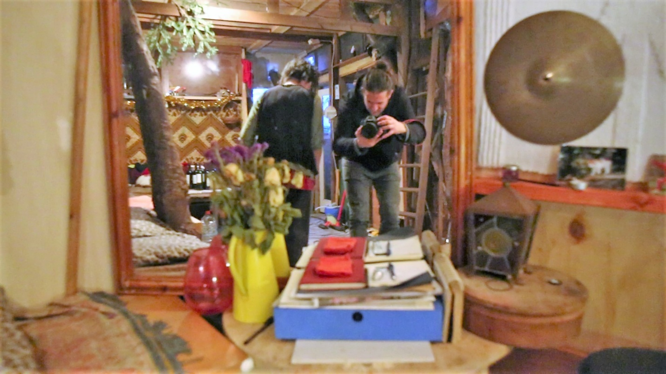

8a Reflection in mirror of house including Robbie and tree

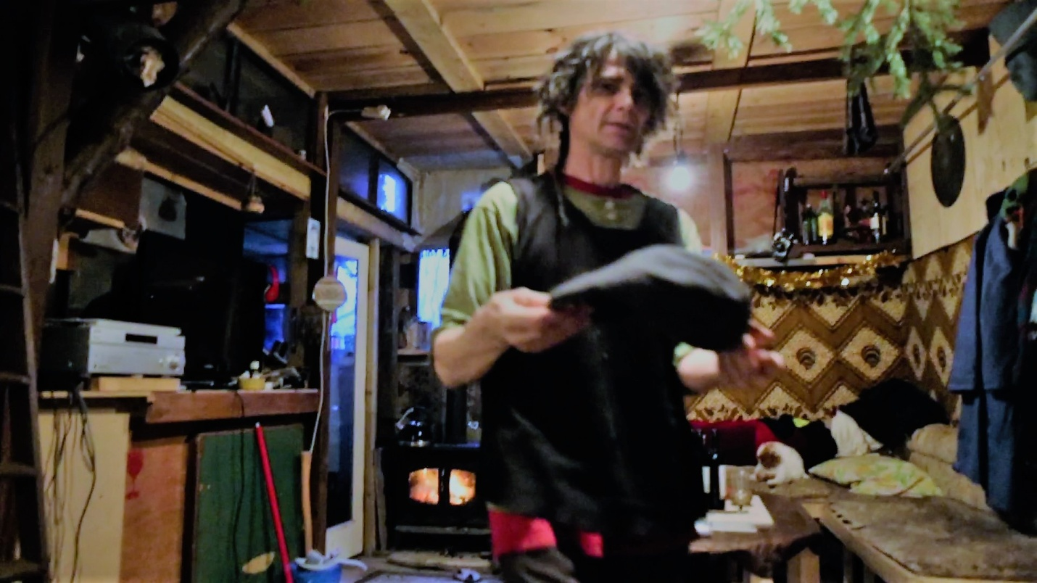

8b Robbie and his home. Cat, burning stove, stereo, computer, steps, trees , sitting room, wine, door to kitchen, coats

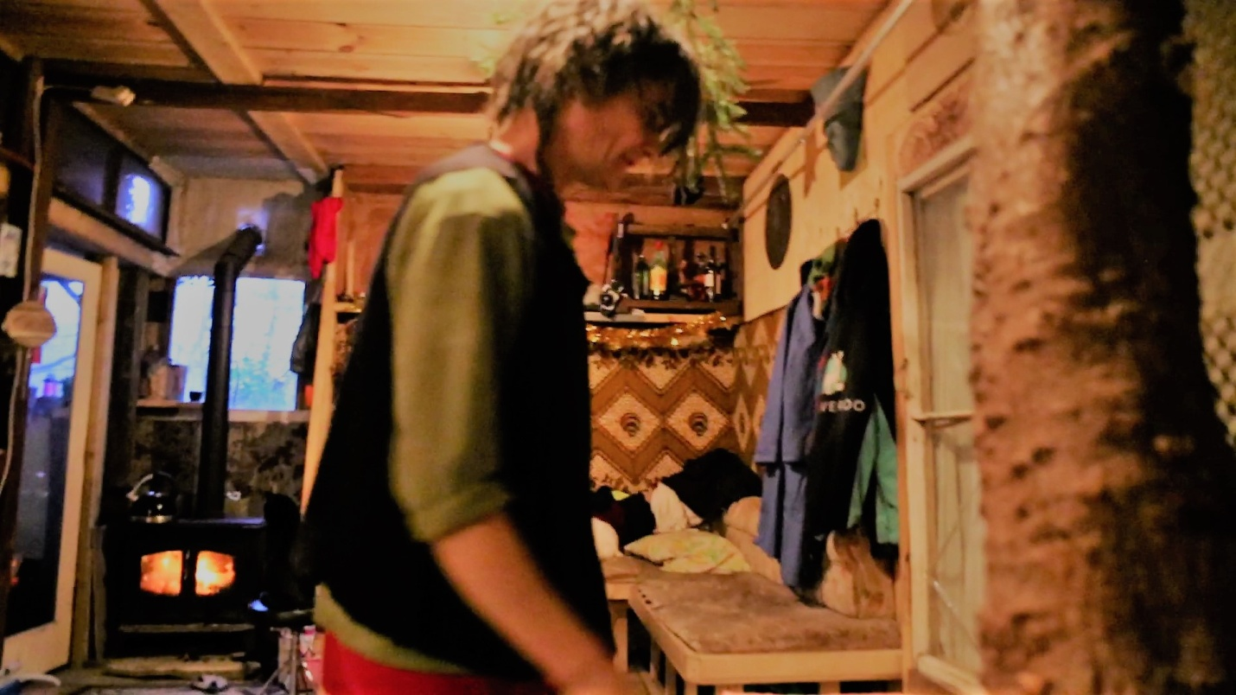

8c. Robbie next to one of the trees inside his house