6. ROBBIE’s BEDROOM AND MUSIC/COMPUTER ROOM

(See Video 6)

See computer/monitor tv/mouse. Synthesizers, numerous cables and sockets with Robbie talking to friend. Hanging socks/wardrobe area/personal pictures and photos on walls. Clip ending showing Robbie’s mattress.

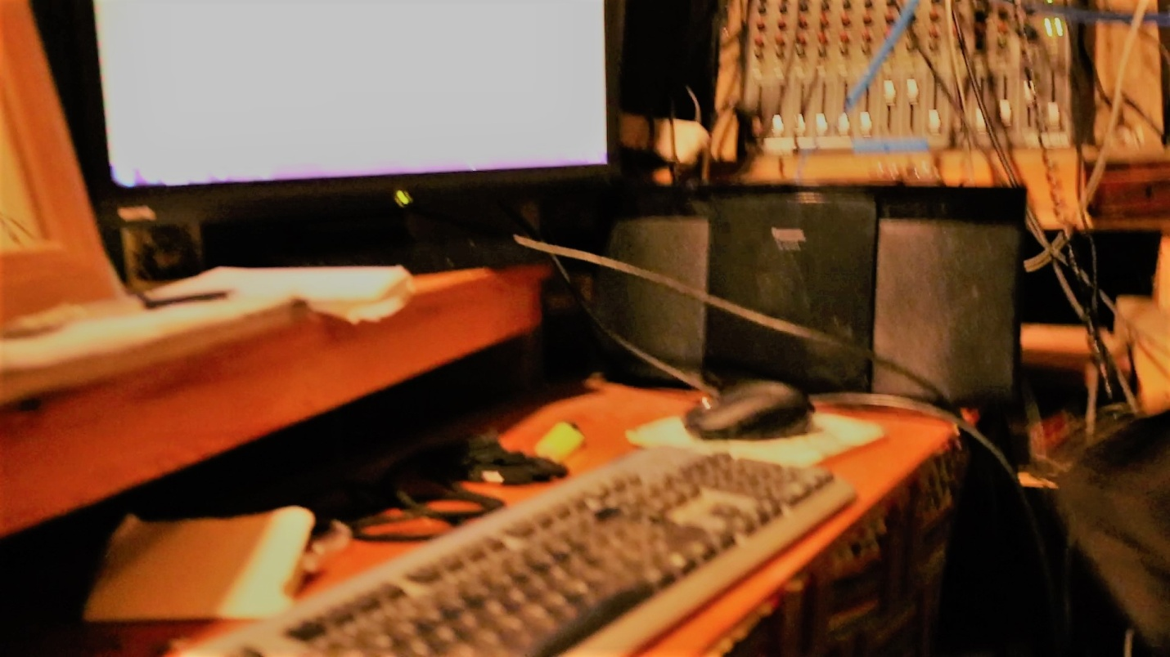

6a Keyboard, speakers,mouse, music instrument control board

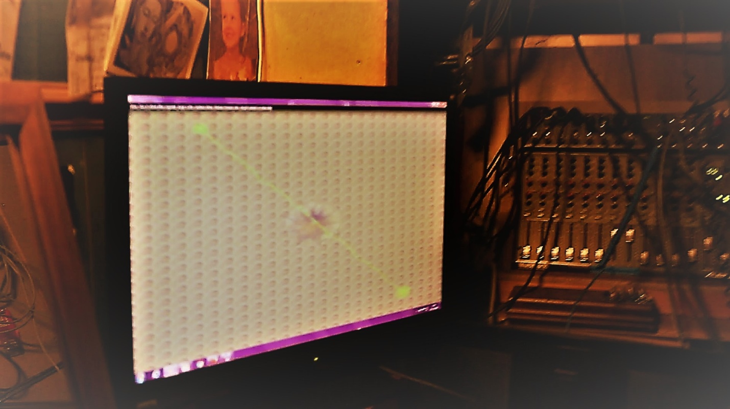

6b Monitor TV, Music Controls, personal photos on walls

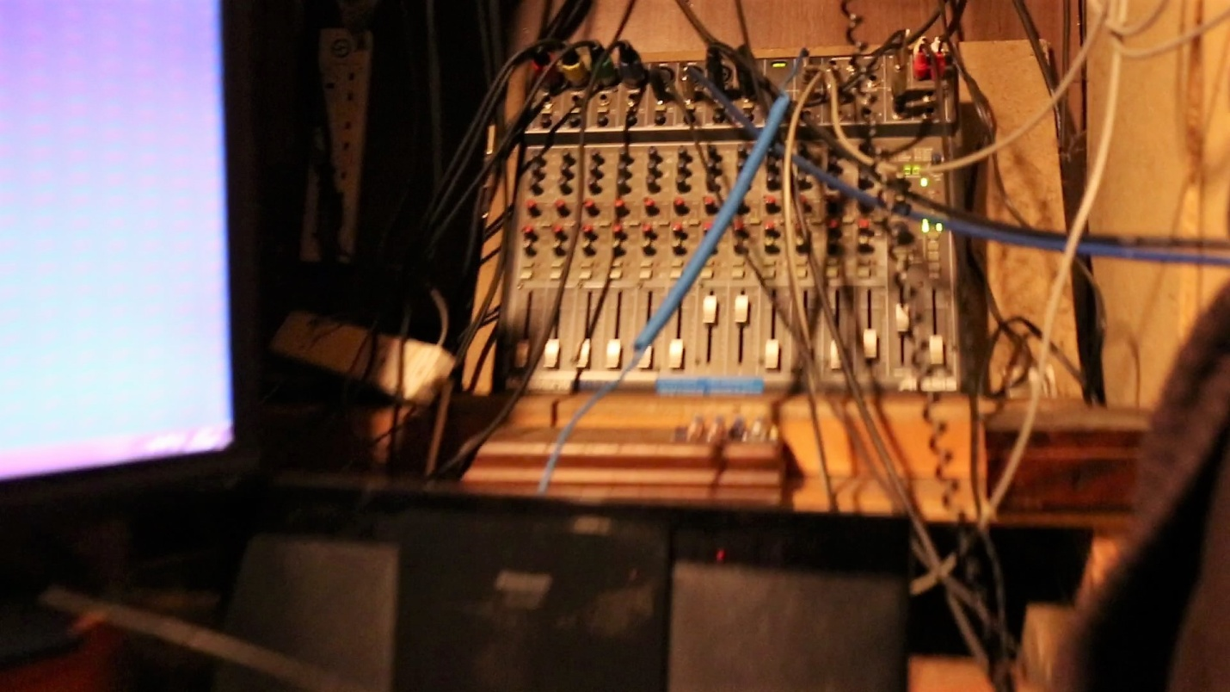

6c Electronic Music Control

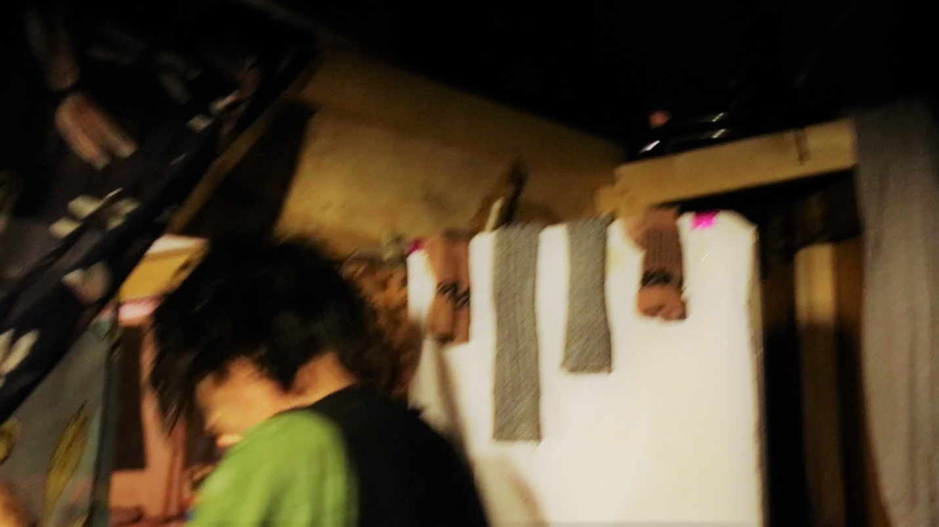

6d Robbie leaving back room. Hanging socks

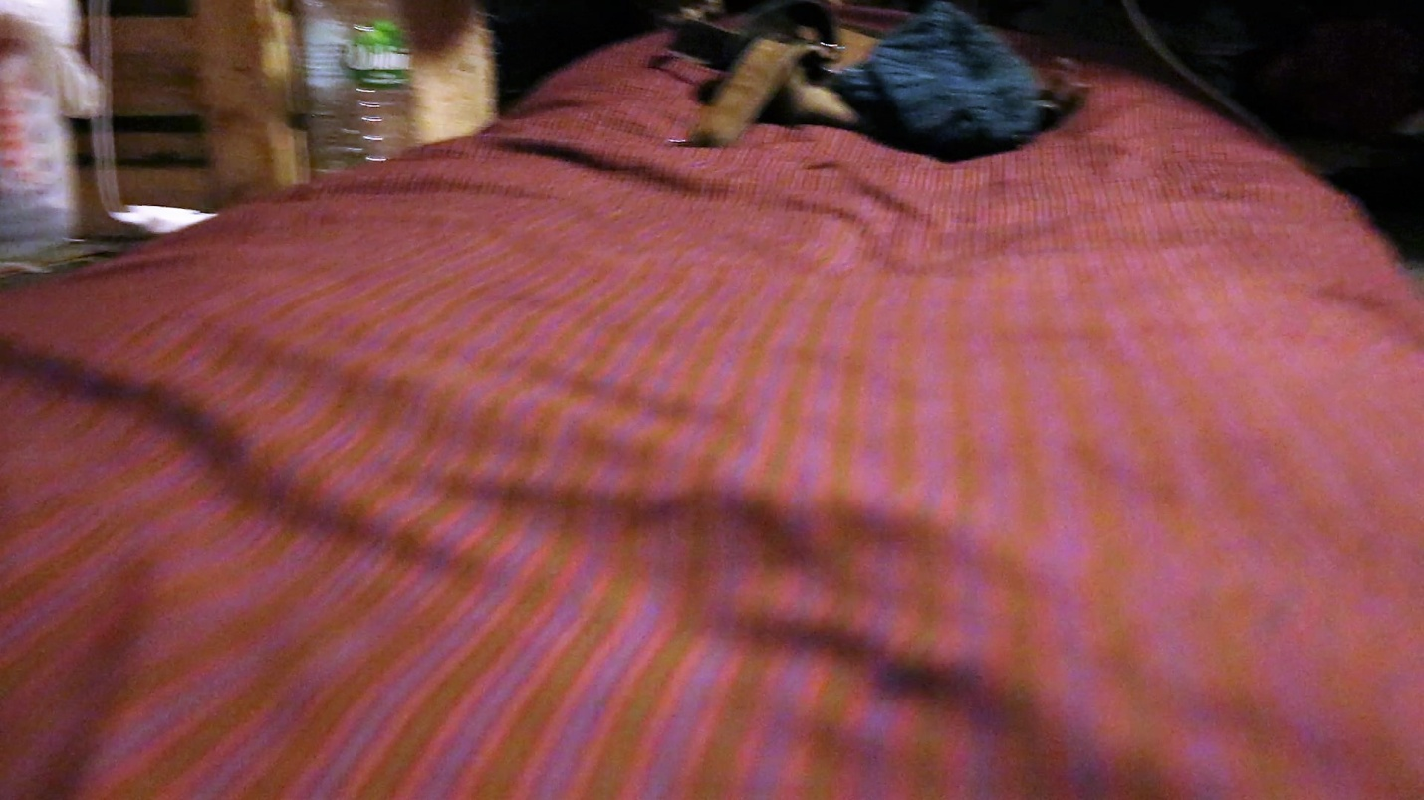

6e Robbie's bedroom