5. EXITING FROM FRONT ROOM TO KITCHEN AND OUTSIDE

(See Video 5)

Opening the Glass door from the living room is the kitchen area on the left. Visible are the electric sockets, hot plate, gas burner connected to pipe, food and water. Postcards on the walls. Moving to the back of the house. Bearing to the right, the picture showing side of Robbie’s house with the sycamore tree to the left and the flue on the right facing the Vale of Health pond. Beyond the terrace in the background is the view of properties on Vale of Health including top floors of Spencer House, Heath and Byron Villas and Athenaeum Hall

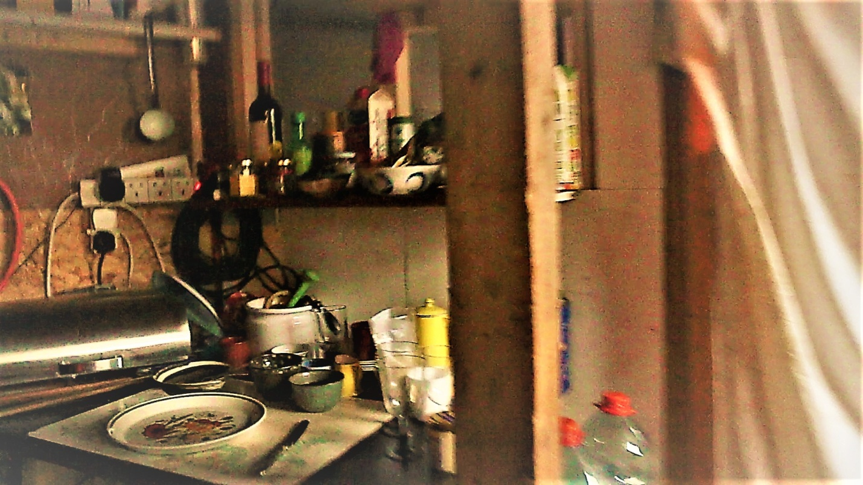

5a Entering the kitchen with electric sockets and hotplate, crockery, cutlery, foodstuff

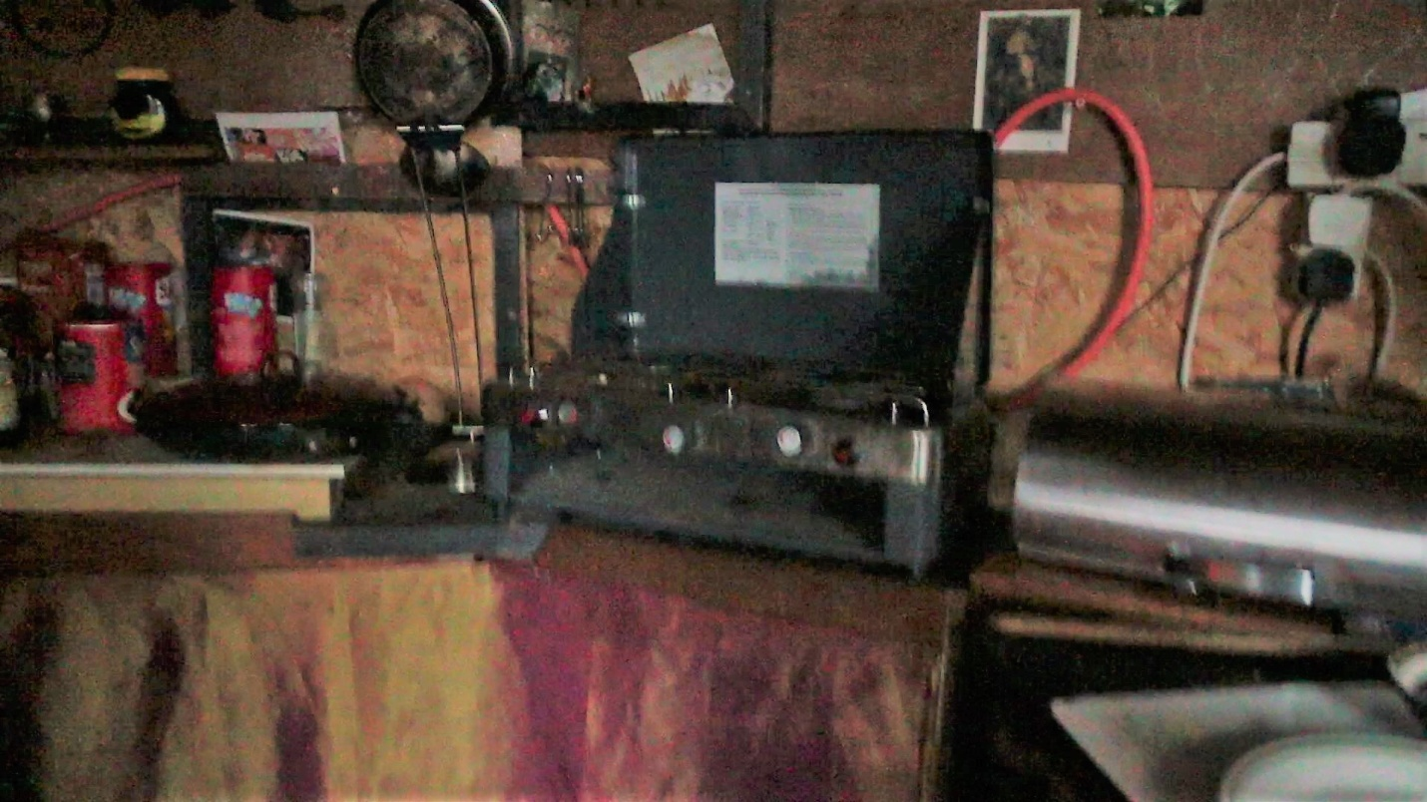

5b Next to hotplate is gas burner with gas pipe visible.

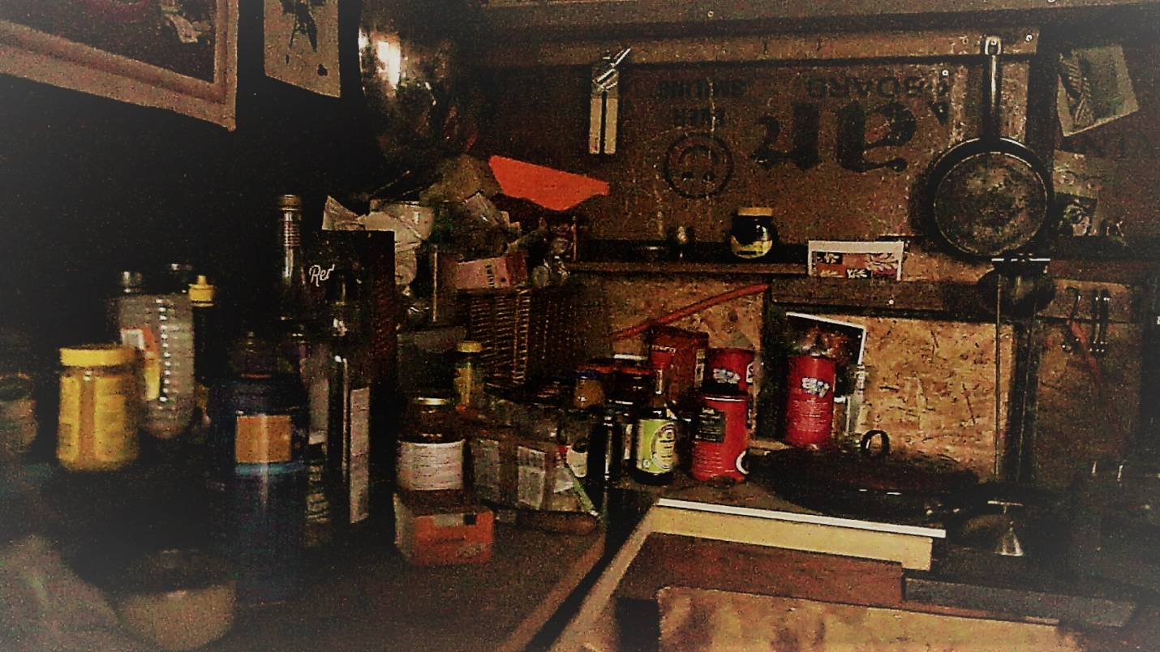

5c Foodstuff left of gas burner

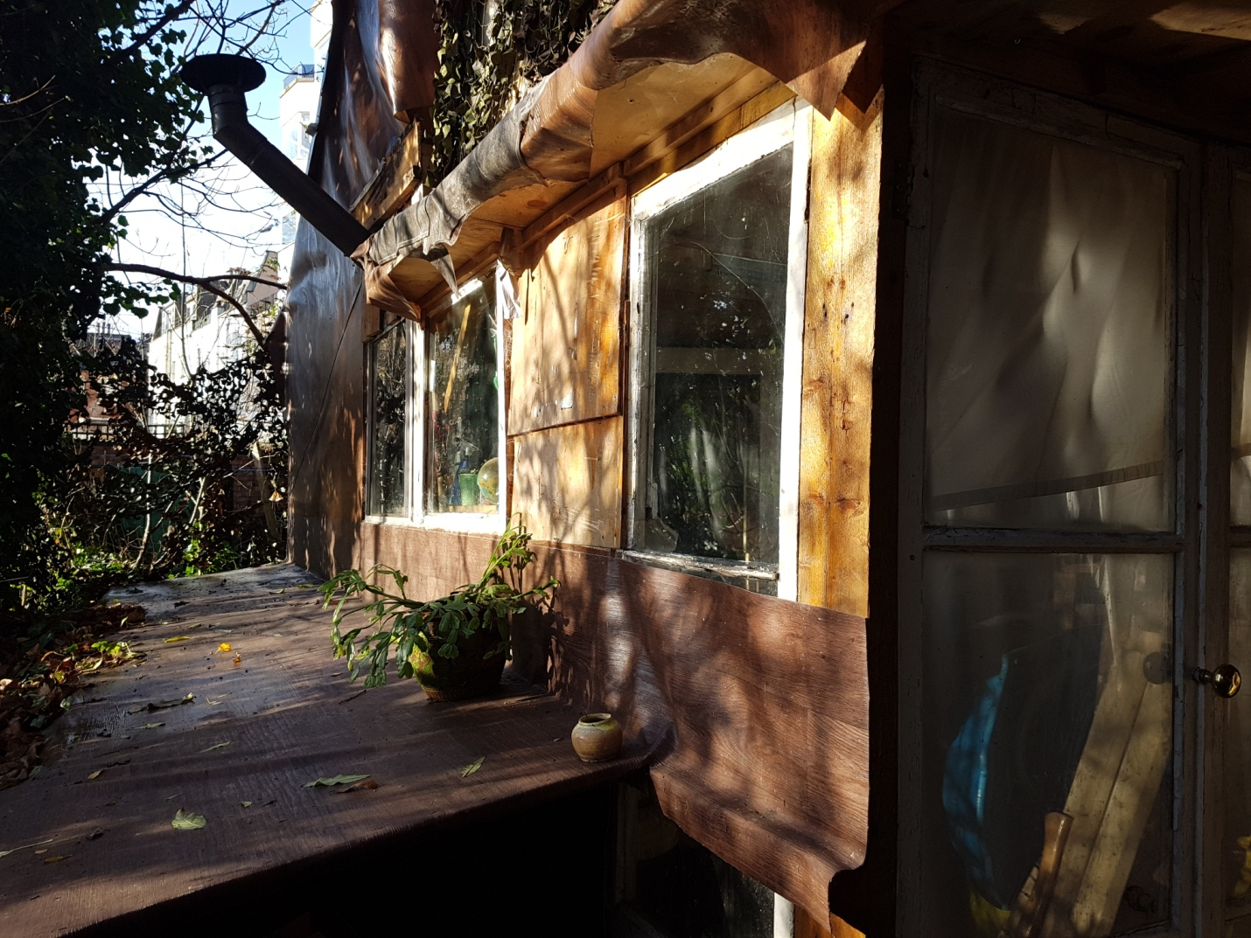

5d Back of Robbie's house with flue facing the Sycamore tree and Vale of Health. In the background, Spencer house, Heath villas and houses on Vale of Health.