4. ROBBIE’s SITTING AREA

(See Video 4)

4a. Photo of Robbie’s friend sitting in front room. Wines, water filter jug with fruit bowl/snacks, mobile phone. At the far end of the wall Robbie’s Buddhist temple.

View from Robbie’s sitting area the stereo on the side cabinets. Tree on the left. The steps centered between the trees on the right (note it growing leaves) as it is presently, which lead to the upper level. Robbie talks of his house built around trees in the newspaper article (See Exhibit C).

4b. Video begins inside Robbie’s home with an outside view of The Vale of Health pond and leafless trees moving to the burning Stove. Robbie talking to the camera with his cat which he mentions in the Camden New Journal (See Exhibit C) sitting on the seat near him.

Coats hanging behind Robbie, camera moving past his front door to the right where there is more sitting wedged between the tree with storage underneath. Then you see Robbie and tree reflected in the mirror, to the right of which is the Buddhist temple. Video ends with Robbie walking towards music area.

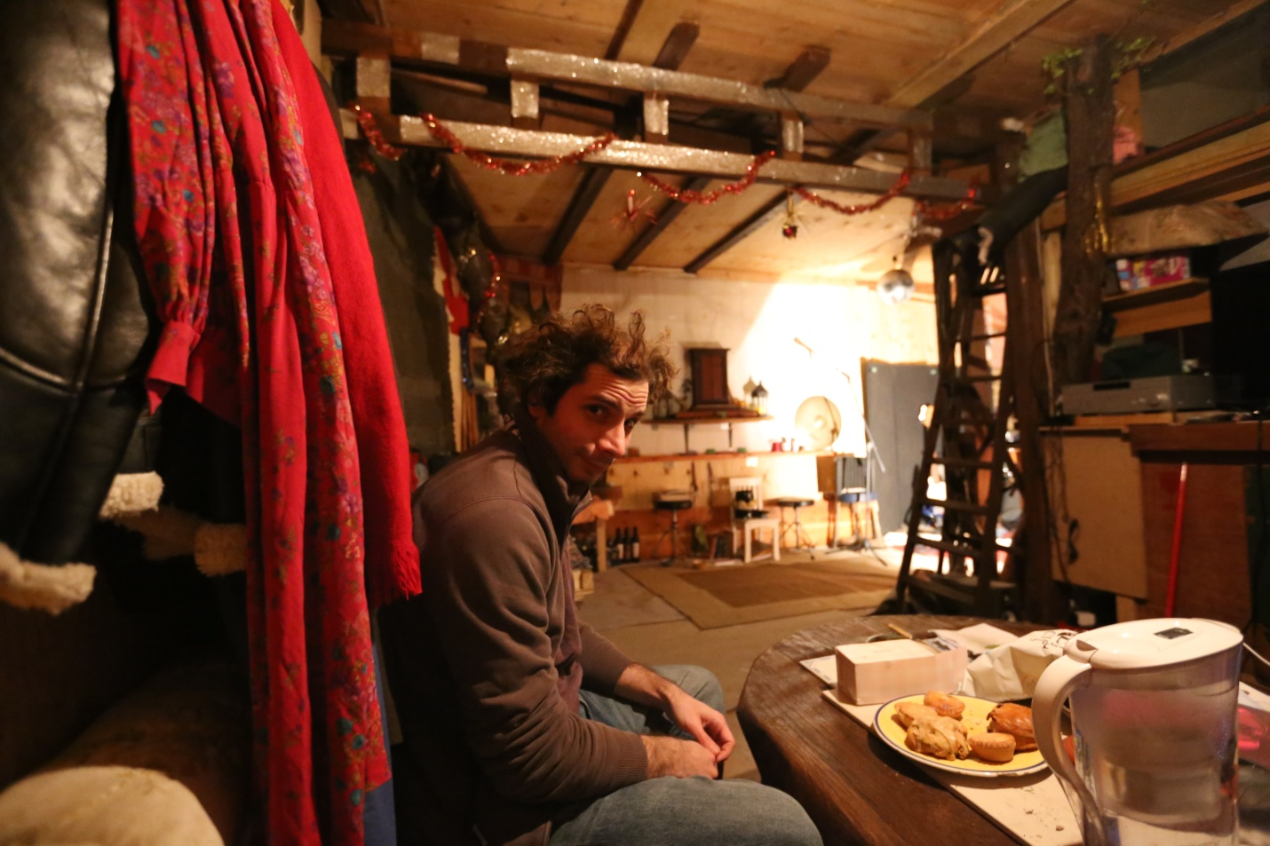

4a Photo of Friend in Robbie's sitting room. View of other side of house

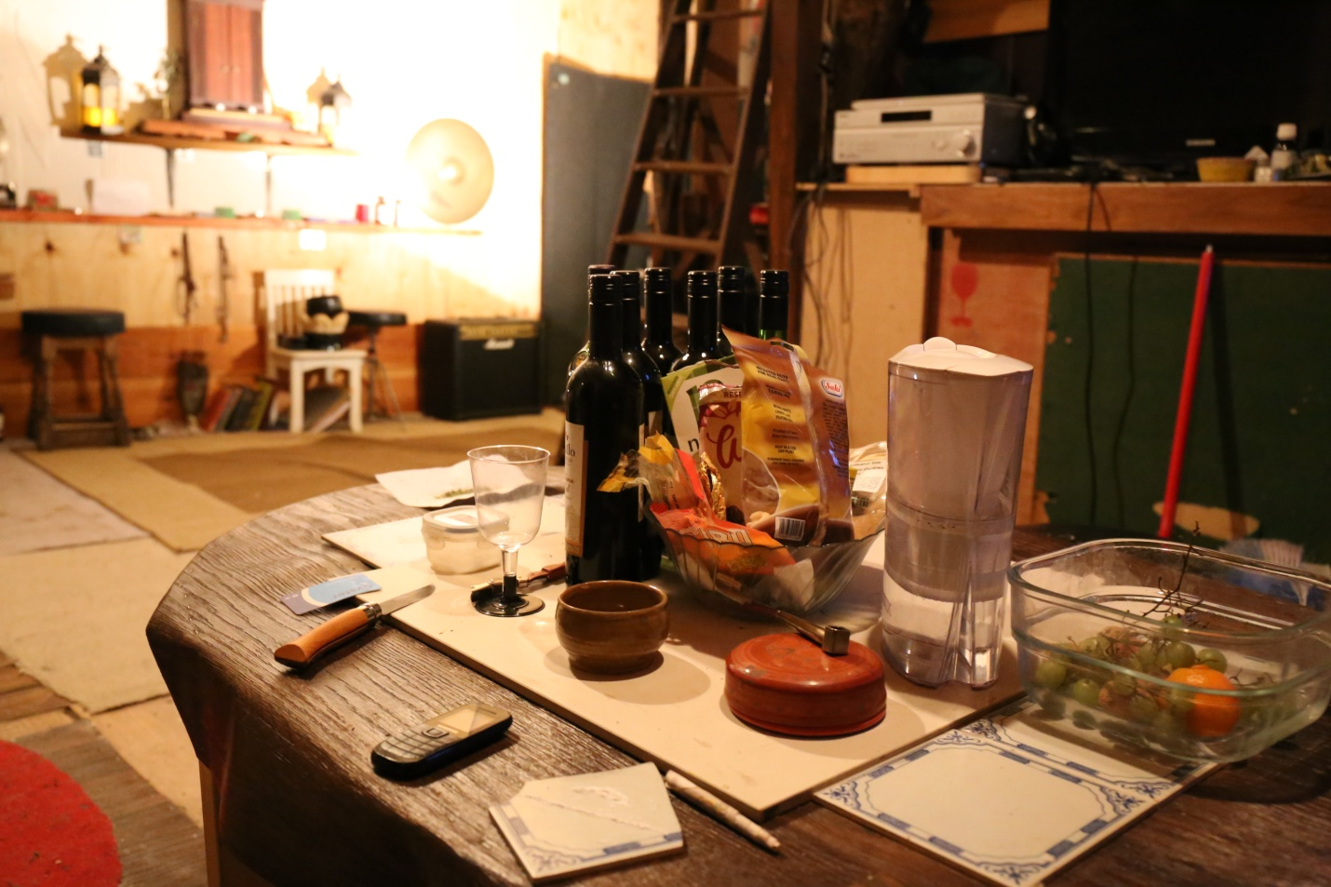

4b Robbie's Dining/Sitting area. Steps next to tree to upstairs. Stereo to the right, Buddhist temple at the back.

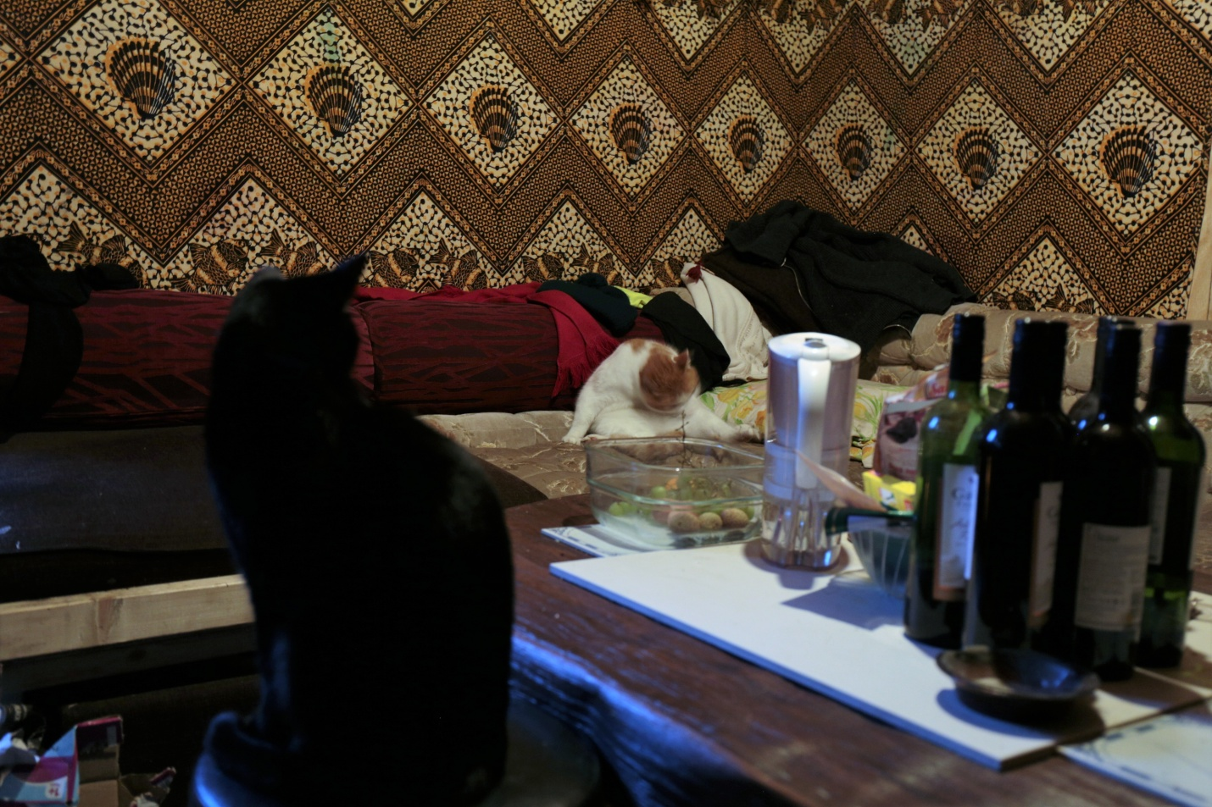

4c. One of Robbie's many cats in Sitting area

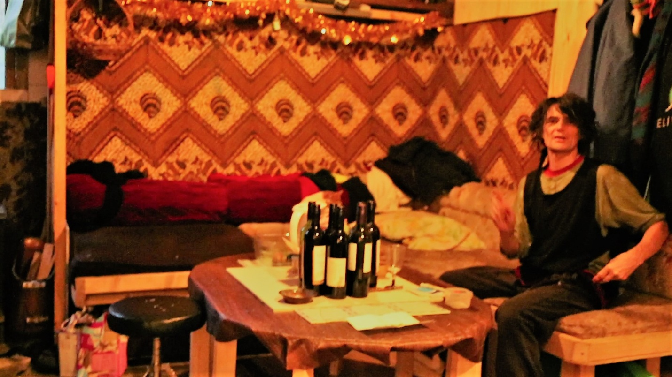

4d. Robbie in his sitting room

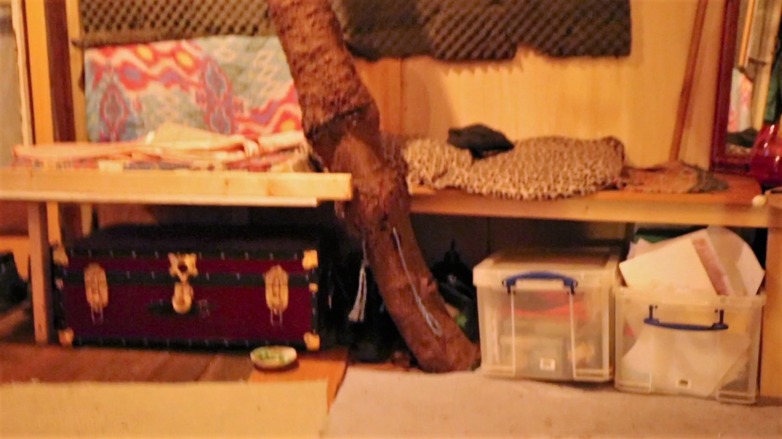4b4 Benching around the tree with storage under

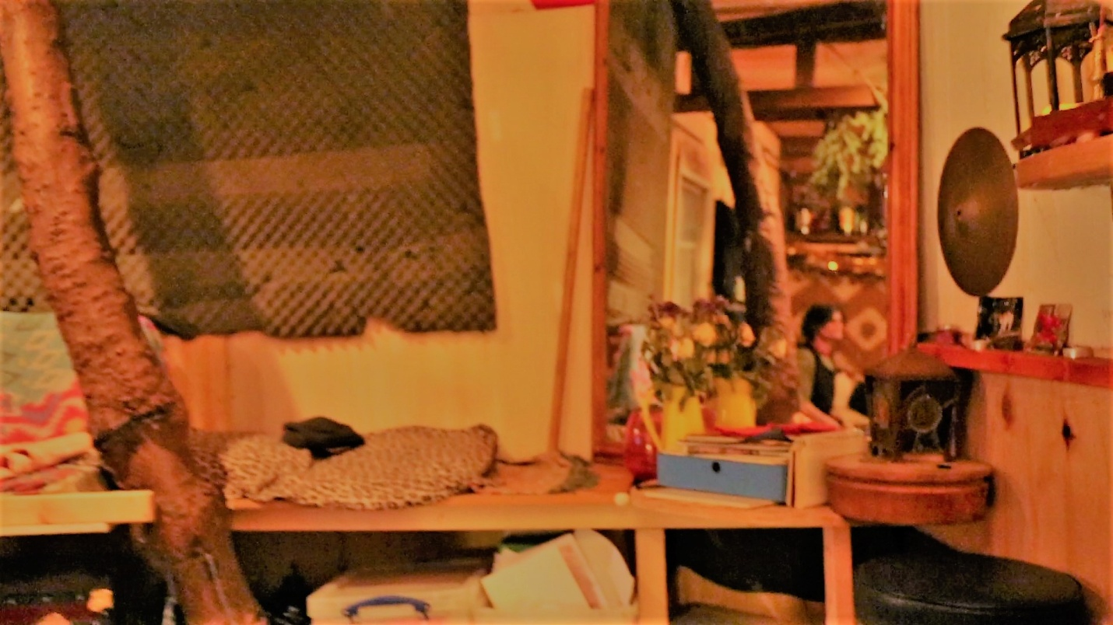

4b5 Reflection of tree and Robbie inside house