1. INTERNAL LAYOUT WITHIN ROBBIE’s HOUSE

(See Video 3)

Entering from the main door is Robbie’s sitting area, wine bottles on the coffee table, the burning stove next to which is white glass door which when open leads to the kitchen and back of the house. On the lit stove is a kettle and saucepan. Household items such as broomstick, dustpan, and medicine bottle on the cabinet. One of Robbie’s many cats on the seat

Bearing left, the stereo and computer sits on the side units with hanging cables connected to the electric sockets. Passing the silhouette of trees and steps which give access to the upstairs room leads to Robbie’s music area with various electric guitar, keyboard, and synthesizers. From there is access to the back room with storage shelves, photos, keyboard and electric control/headphones for the instruments. Also Robbie’s bedroom.

Returning back to the main room, on the right is the Buddhist temple, next to the mirror which reflects one of the trees growing in Robbie’s house.

Robbie being a Buddhist as stated in Camden New Journal (Exhibit C)

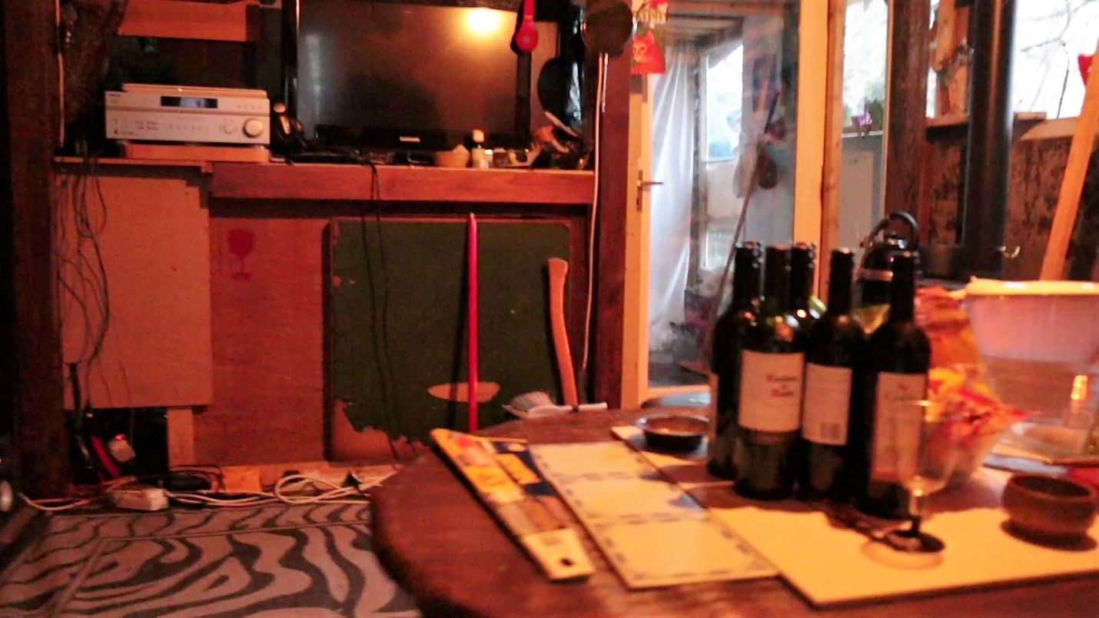

3a . Robbie’s sitting area. Wine bootles on coffee table, stereo, computer plugged into various sockets

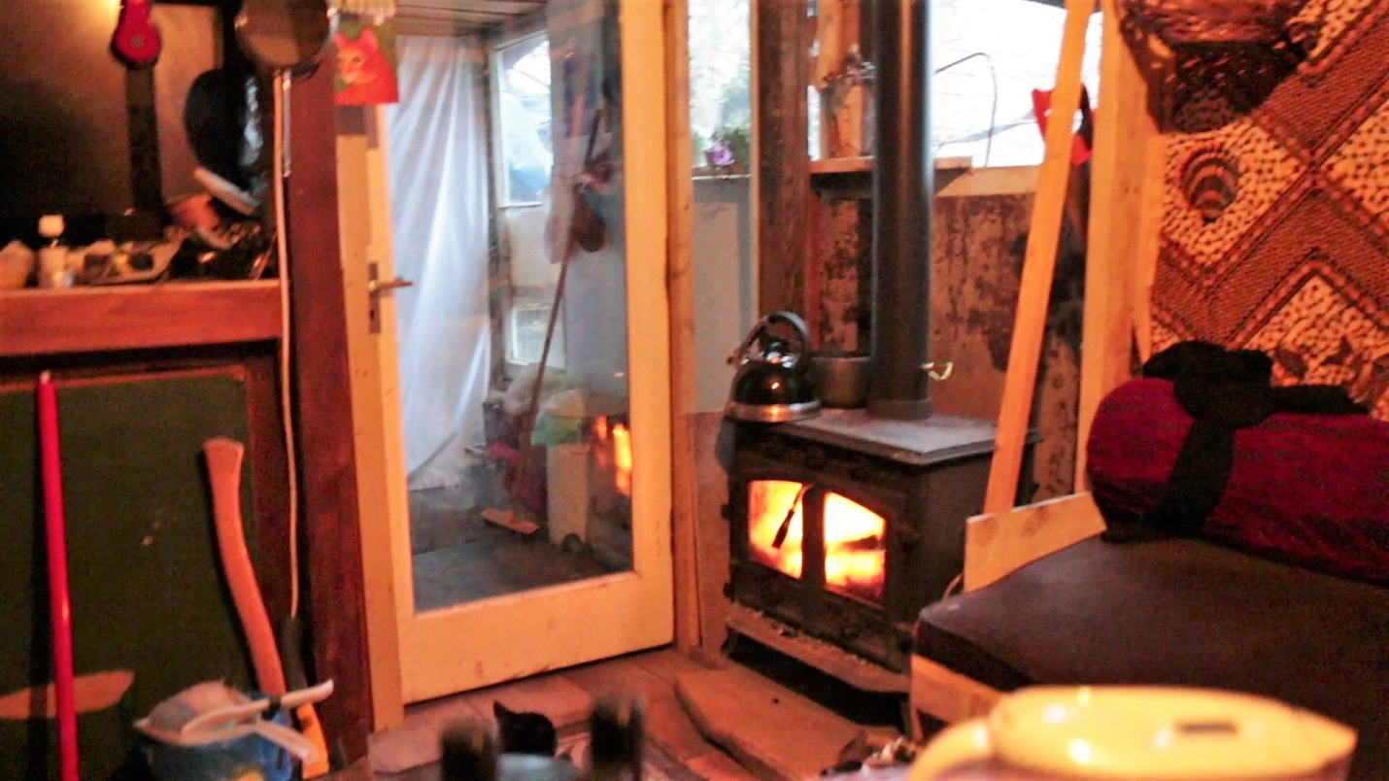

3b. Teapot, Saucepan on lit stove. White door that leads to the kitchen.

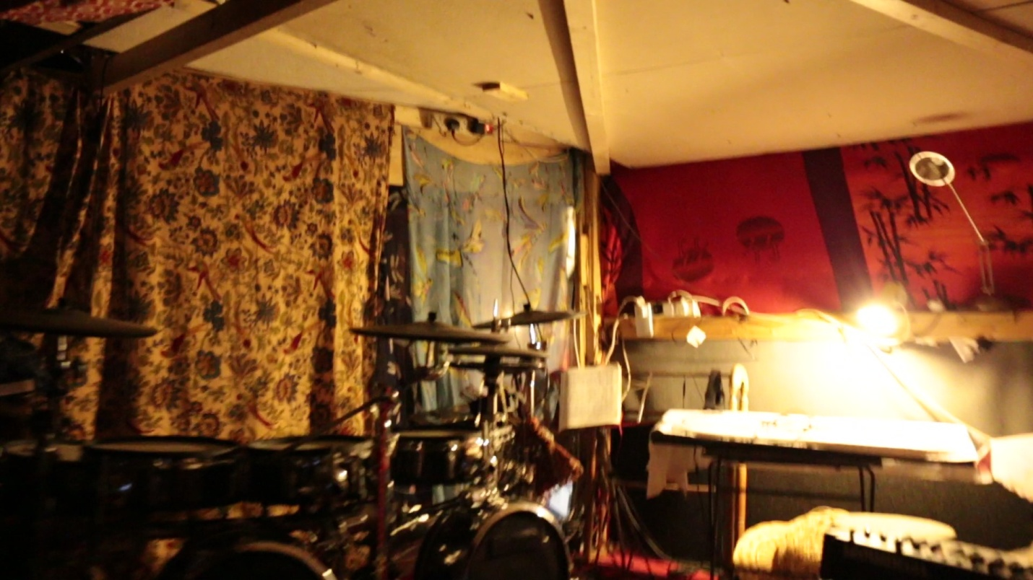

3c. Robbie's music area. Electric sockets on walls and ceiling

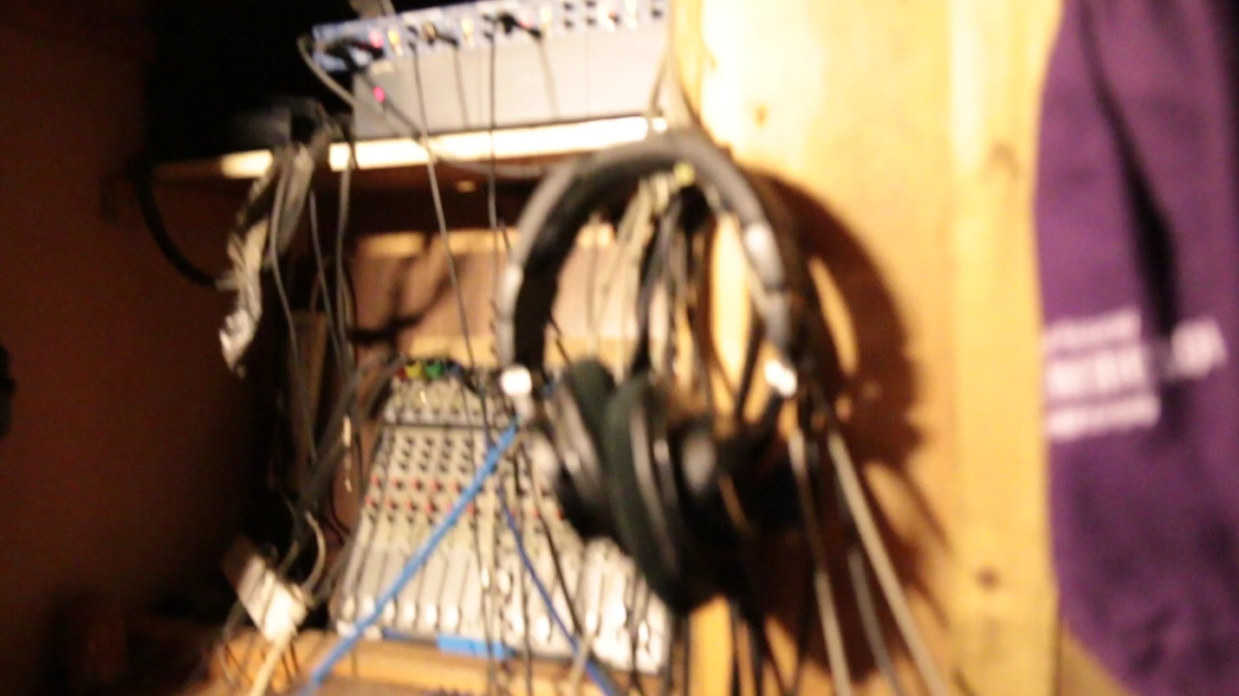

3d. In back room and bedroom of Robbie’s home is control for musical instrument

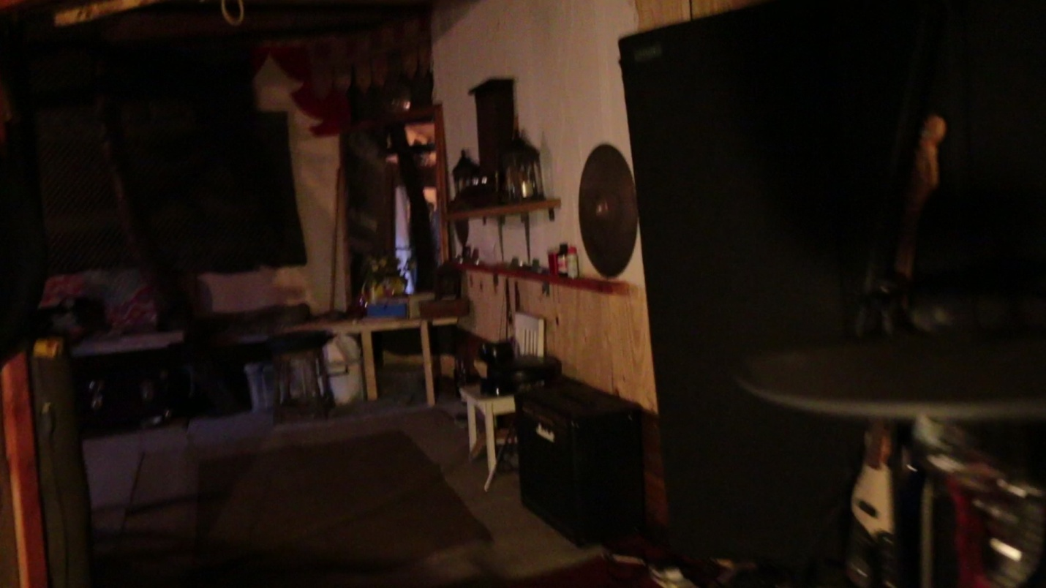

3e. Buddhist temple and reflection inside Robbie’s house of growing tree in mirror