2. AERIAL VIEW FROM ROBBIE’s HOUSE

(See Videos 2a, 2b and 2c)

From the roof of Robbie’s house the videos give a 360 degree view of South Fairground and surrounding area.

2a. Video clip with Robbie enjoying the freshness. Vale of Health pond in the background

2b. Robbie is standing on top the roof next to the side of the upper level of his house.

Video is clearly taken in the colder months due to the lack of foilage on the trees and Robbie’s comment and gesture of how, pointing at a tree, ‘in the summer months that tree from over here overgrowing into a tent’.

2c. Robbie can be seen walking 360 degrees on the roof of his house. Trees that grow from within the house can be seen growing out of the roof. Behind them is the brick sheds next to Ollie’s awning. Beyond that can be seen Spencer House and houses along the Vale of Health including Heath Villas, Byran Villas, Athenaeum Hall.

2ci. The camera then turns, Robbie is walking along the roof facing the roadside. Standing next to the upper level of his house. In the background are the sycamores, birch, goat willow trees which remain today. Also is the aerial view of Joe’s Yurt, caravan and beyond that are houses on the opposite side of the road and the North Fairground site.

The camera turns full circle ending at the Vale of Heath Pond and external side of the upper level of Robbie’s house.

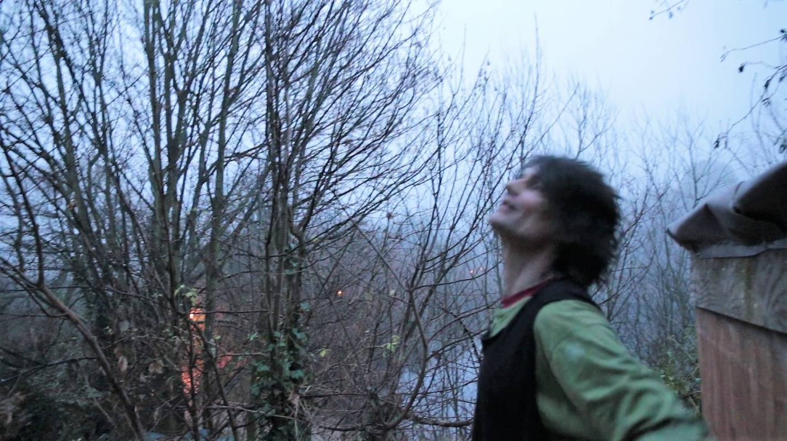

2b Robbie standing on roof beside the upper level of his house looking at the tree that he says overgrows in the summer. Sycamore tree and Vale of Health pond in the background.

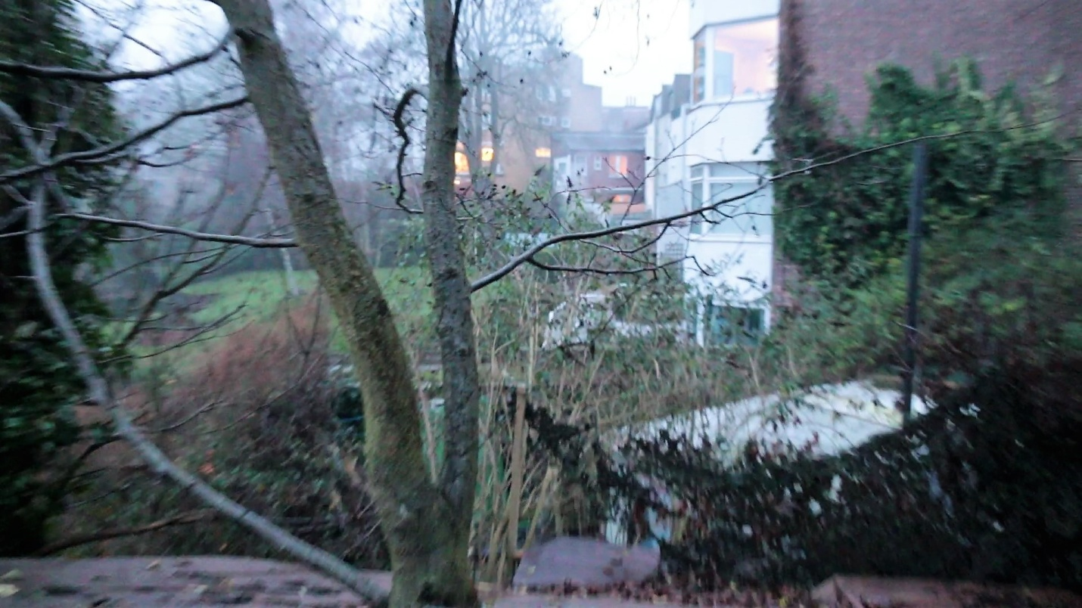

2c Trees growing out of Robbie's house, brick sheds, Ollie’s caravan, Spencer House and houses along the Vale of Health

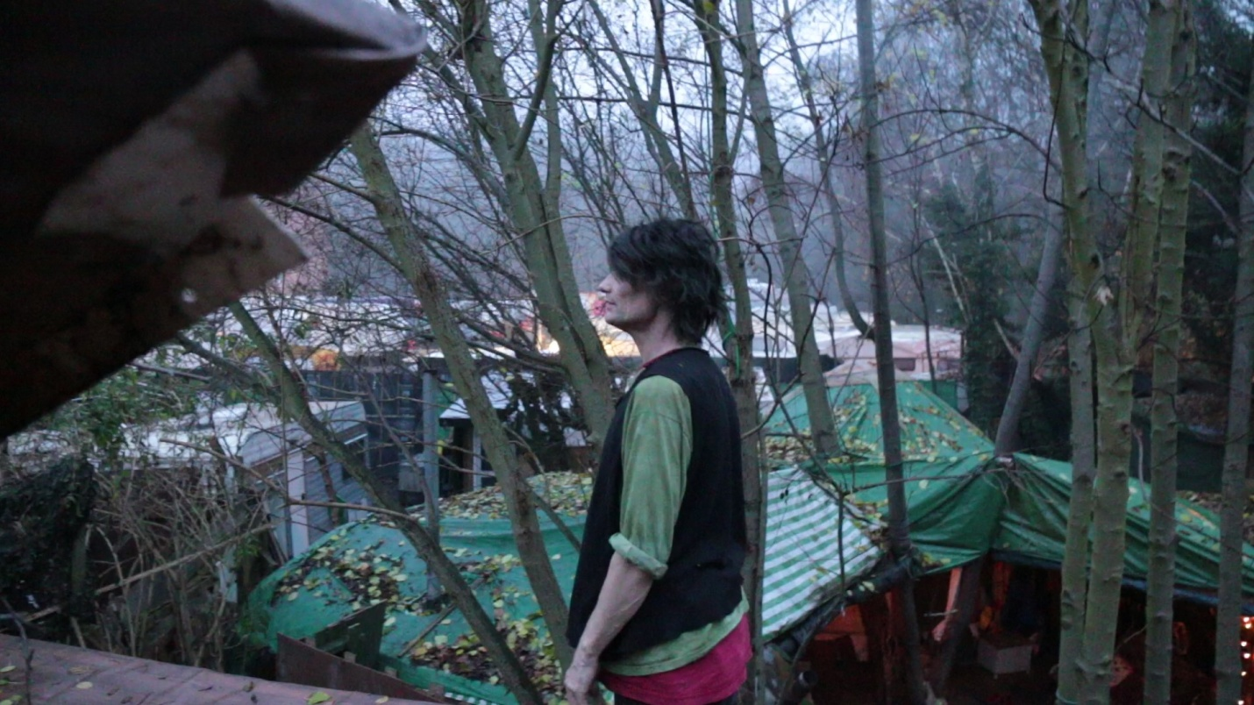

2ci Robbie on roof. In background trees, view of rest of site, the trees presently there and beyond The North Fairground site

.