**Design & Access Statement**

**Project**

**To install thru floor disabled lift from Ground floor up into first floor, within entrance extension 1952**

**Address**

**Cannon Cottage, Well Road, London, NW3 1LH**

**Owners**

**Mr & Mrs Weisz**

**TABLE OF CONTENTS**

**Heritage Statement**

**Scope of proposed works**

**Reason for works**

**Design Access Statement**

**HERITAGE STATEMENT**

**PROVIDENCE CORNER AND CANNON COTTAGE**

[2 contributions](https://historicengland.org.uk/listing/the-list/list-entry/1379161#contributions)

**Overview**

Heritage Category: Listed Building

Grade: II

List Entry Number: 1379161

Date first listed: 11-Aug-1950

Statutory Address: PROVIDENCE CORNER AND CANNON COTTAGE, WELL ROAD

**Map**

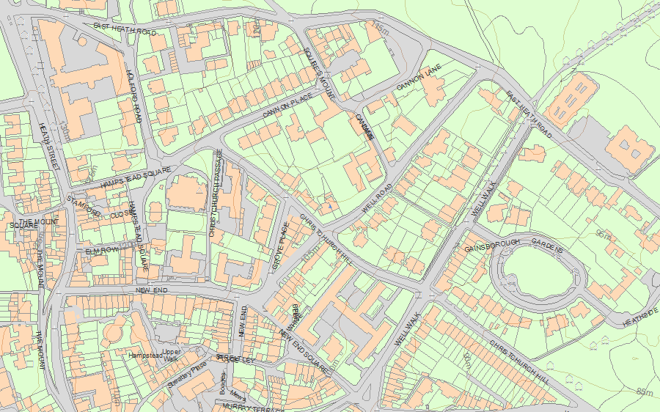© Crown Copyright and database right 2018. All rights reserved. Ordnance Survey Licence number 100024900.  
© British Crown and SeaZone Solutions Limited 2018. All rights reserved. Licence number 102006.006.  
Use of this data is subject to [Terms and Conditions](https://historicengland.org.uk/terms/website-terms-conditions/).

The above map is for quick reference purposes only and may not be to scale. For a copy of the full scale map, please see the attached PDF - [1379161 .pdf](http://mapservices.historicengland.org.uk/printwebservicehle/StatutoryPrint.svc/342109/HLE_A4L_Grade%7CHLE_A3L_Grade.pdf)

The PDF will be generated from our live systems and may take a few minutes to download depending on how busy our servers are. We apologise for this delay.

This copy shows the entry on 12-Oct-2018 at 08:10:44.

**Location**

Statutory Address: PROVIDENCE CORNER AND CANNON COTTAGE, WELL ROAD

The building or site itself may lie within the boundary of more than one authority.

County: Greater London Authority

District: Camden (London Borough)

National Grid Reference: TQ 26604 86075

**Summary**

Legacy Record - This information may be included in the List Entry Details.

**Reasons for Designation**

Legacy Record - This information may be included in the List Entry Details.

**History**

Legacy Record - This information may be included in the List Entry Details.

**Details**

CAMDEN  
  
TQ2686SE WELL ROAD 798-1/17/1691 (North side) 11/08/50 Providence Corner and Cannon Cottage  
  
GV II  
  
2 semi-detached cottages. Early C18, entrance extensions added 1952. Brown brick with red brick dressings. Slated mansard roofs, Providence Corner with dormer. 2 storeys. 3 windows each. C20 Georgian style doorways with bracketed hoods; panelled doors with overlights. Former doorway of Providence Corner blocked; Cannon Cottage doorway altered to French window. Gauged red brick flat arches to recessed sashes with exposed boxing; Providence Corner ground floor windows with keystones. Parapets. INTERIORS: not inspected. Cannon Cottage was listed on 14/05/74.   
  
  
  
Listing NGR: TQ2660286074

**Legacy**

The contents of this record have been generated from a legacy data system.

Legacy System number: 478528

Legacy System: LBS

**Legal**

This building is listed under the Planning (Listed Buildings and Conservation Areas) Act 1990 as amended for its special architectural or historic interest.

End of official listing

Bottom of Form

**2 contributionson PROVIDENCE CORNER AND CANNON COTTAGE**

There aren't any more contributions

**SCOPE OF PROPOSED WORKS**

Please refer to the Trio Lift Schematic Drawings for design and technical information for the Lift.

Lift aperture is to be created in the hall (entrance extension) by cutting through a modern plasterboard ceiling, with square edge modern timber joist to ground floor ceiling, and thru plywood flooring on modern square edge timber joist to 1st floor, Opening size to be 1050mm X 745mm approximately, with new additional joist to be run within existing void between ceiling and floor joist. As requested by Building control. All works will only be to the area of the lift and will have very little impact to the fabric of the property.

REASON FOR WORKS

Mr Weisz, the co-owner of the house, are now having great difficulties with balance and walking. This disability has now reached the stage where assistance is required to use the stairs safely. A lift is required for ease, quality of life and health and safety reasons. Without a lift it is likely that Mr and Mrs Weisz will be unable to remain living in the property for any significant time

**Design & Access Statement for Duo Lift Installation at:**

**Cannon Cottage, Well Road, London, NW3 1LH**

Please refer to the Duo Lift Schematic Drawings for design and technical information for the Duo Lift.

The house is on the corner of Well Road and Christ Church Hill, Access into the house is thru Garden gate up the steps in thru porch door, where lift is to be fitted. No alterations are required for access for the works

.