**Construction Management**

**Plan**

**pro forma** v2.2

## 13 Ferncroft Avenue

## NW3 7PG

**Contents**

**Revisions 3**

**Introduction 4**

**Timeframe 6**

**Contact** **7**

**Site** **9**

**Community liaison** **12**

**Transport** **15**

**Environment** **25**

**Agreement**  **30**

# Revisions & additional material

Please list all iterations here:

|  |  |  |
| --- | --- | --- |
| **Date** | **Version** | **Produced by** |
|  | **V.1** | **Erdol Construction Ltd** |
|  | **V.2** | **KL Builders Ltd** |

**Additional sheets**

Please note – the review process will be quicker if these are submitted as Word documents or searchable PDFs.

|  |  |  |
| --- | --- | --- |
| **Date** | **Version** | **Produced by** |
|  |  |  |

# Introduction

The purpose of the **Construction Management Plan (CMP)** is to help developers to minimise construction impacts, and relates to both on site activity and the transport arrangements for vehicles servicing the site.

It is intended to be a live document whereby different stages will be completed and submitted for application as the development progresses.

The completed and signed CMP must address the way in which any impacts associated with the proposed works, and any **cumulative impacts of other nearby construction sites**, will be mitigated and managed. The level of detail required in a CMP will depend on the scale and kind of development. Further policy guidance is set out in Camden Planning Guidance [**(CPG)** 6: Amenity](http://www.camden.gov.uk/ccm/content/environment/planning-and-built-environment/two/planning-policy/supplementary-planning-documents/camden-planning-guidance.en) and [**(CPG)** 8: Planning Obligations](http://www.camden.gov.uk/ccm/content/environment/planning-and-built-environment/two/planning-policy/supplementary-planning-documents/camden-planning-guidance.en).

This CMP follows the best practice guidelines as described in [Transport for London’s](https://www.tfl.gov.uk/info-for/freight/safety-and-the-environment/improving-construction-safety) (TfL’s Standard for [Construction Logistics and Community Safety](http://www.clocs.org.uk/standard-for-clocs/) (**CLOCS**) scheme) and [Camden’s Minimum Requirements for Building Construction](http://www.camden.gov.uk/ccm/cms-service/download/asset?asset_id=3257318) **(CMRBC)**.

The approved contents of this CMP must be complied with unless otherwise agreed with the Council in writing. The project manager shall work with the Council to review this CMP if problems arise in relation to the construction of the development. Any future revised plan must also be approved by the Council and complied with thereafter.

It should be noted that any agreed CMPdoes not prejudice or override the need to obtain any separate consents or approvals such as for road closures or hoarding licences.

If your scheme involves any demolition, you need to make an application to the Council’s Building Control Service. Please complete the “[**Demolition Notice**](http://www.camden.gov.uk/ccm/content/environment/building-control/file-storage-items/demolition-notice---the-building-act-1984-section-80-notice-bc104-.en)**.**”

Please complete the questions below with additional sheets, drawings and plans as required. The boxes will expand to accommodate the information provided, so please provide as much information as is necessary. **It is preferable if this document, and all additional documents, are completed electronically and submitted as Word files to allow comments to be easily documented. These should be clearly referenced/linked to from the CMP.**

Please notify that council when you intend to start work on site. Please also notify the council when works are approximately **3 months from completion.**

(Note the term 'vehicles' used in this document refers to all vehicles associated with the implementation of the development, e.g. demolition, site clearance, delivery of plant & materials, construction, etc.)

Revisions to this document may take place periodically.Timeframe

**DEVELOPER ACTIONS**

**COUNCIL ACTIONS**

**Post app submission**

**0ommunity liaison**

**Appoint principal contractor**

**Requirement to submit CMP**

**Begin community liaison**

**Council response to second draft**

**Work can commence if draft CMP is approved**

**Resubmission of CMP if first draft refused**

**2ommunity liaison**

**3ommunity liaison**

**1ommunity liaison**

INDICATIVE TIMEFRAME (MONTHS)

**4ommunity liaison**

**Council response to draft**

**Submit draft CMP**

# Contact

1. Please provide the full postal address of the site and the planning reference relating to the construction works.

Address: 13 Ferncroft Avenue, NW3 4XS

Planning reference number to which the CMP applies: 2014/7674/P

2. Please provide contact details for the person responsible for submitting the CMP.

Name: Jim Biek of Bchitecture

Address: 11A Beresford Road, London N2 8A

Email: [bchitecture@gmail.com](mailto:bchitecture@gmail.com)

Phone: 020 3074 1002

3. Please provide full contact details of the site project manager responsible for day-to-day management of the works and dealing with any complaints from local residents and businesses.

Name: Kastro Lulaj

Address: KL Builders Ltd, 9 Muswell Hill Place, London N10 3RP

Email: [kastro@klbuilderslimited.co.uk](mailto:kastro@klbuilderslimited.co.uk)

Phone: 07714 249 372

4. Please provide full contact details of the person responsible for community liaison and dealing with any complaints from local residents and businesses if different from question 3. In the case of [**Community Investment Programme (CIP)**](http://www.camden.gov.uk/ccm/content/environment/planning-and-built-environment/two/placeshaping/twocolumn/the-community-investment-programme.en), please provide contact details of the Camden officer responsible.

Name: Jim Biek of Bchitecture

Address: 11A Beresford Road, London N2 8A

Email: [bchitecture@gmail.com](mailto:bchitecture@gmail.com)

Phone: 020 3074 1002

5. Please provide full contact details including the address where the main contractor accepts receipt of legal documents for the person responsible for the implementation of the CMP.

Name: KL Builders Ltd

Address: 9 Muswell Hill Place, London N10 3RP

Email: [kastro@klbuilderslimited.co.uk](mailto:kastro@klbuilderslimited.co.uk)

Phone: 07714 249 373

# Site

6. Please provide a site location plan and a brief description of the site, surrounding area and development proposals for which the CMP applies.

No. 13 Ferncroft Avenue sits on the south-west side of the avenue and is a semi-detached property, adjoining No.15 (to it’s left, if facing the property). Existing in original condition, it comprises ground level, first floor, and second floor, plus limited basement level. It is set back from the road with an accessible driveway, side-alley access shared with no.11 on its west face that provides access to the large rear garden approx. 20m in length. This garden is fenced at its borders and lined with plants.

Ferncroft Avenue is part of a quiet, tree-lined, residential area of Hampstead, near to the Western Heath segment of Hampstead Heath. The avenue itself is low traffic, though it is wide and accessible, and also within close proximity to the main A41/Finchley Road road nearby that makes up the TfL Road Network. See Appendix A.

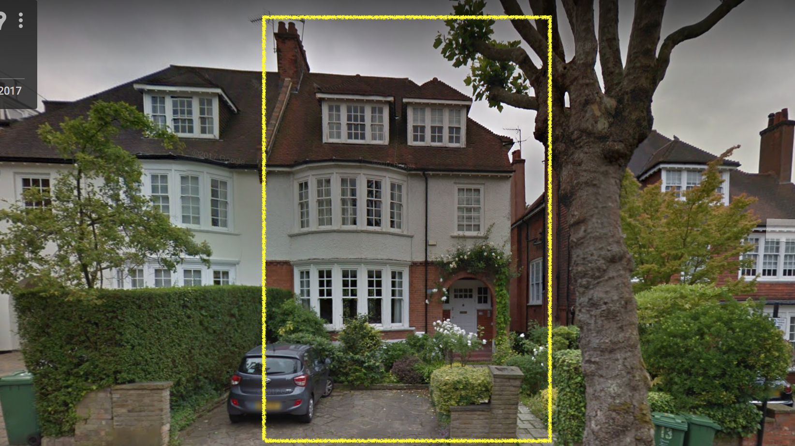 LP-01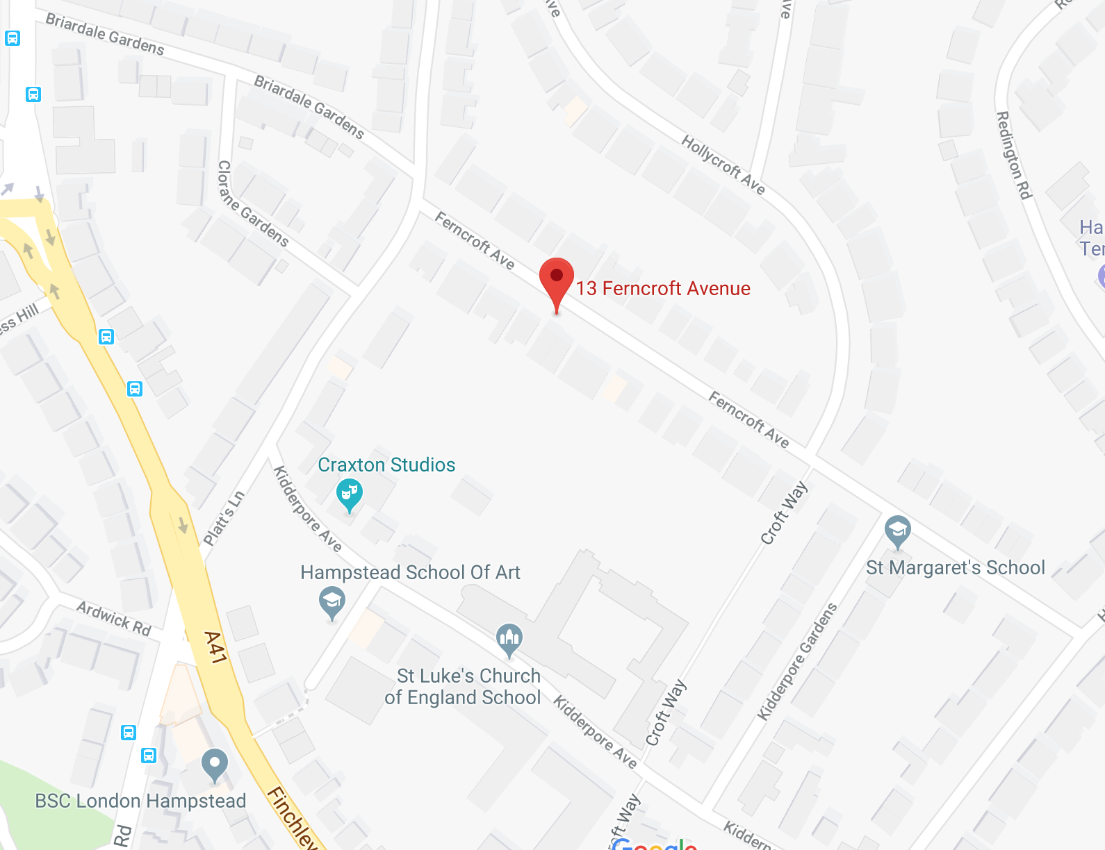LP-02

7. Please provide a very brief description of the construction works including the size and nature of the development and details of the main issues and challenges (e.g. narrow streets, close proximity to residential dwellings etc).

Demolition of single storey rear outrigger in connection with excavation to enlarge existing basement crawl space to create new accommodation including a light well to the front, side and rear elevations, and alteration to windows on side elevation of a single family dwelling (use class C3).

8. Please identify the nearest potential receptors (dwellings, business, etc.) likely to be affected by the activities on site (i.e. noise, vibration, dust, fumes, lighting etc.).

The adjoining and adjacent properties at No.’s 11 & 15 Ferncroft Avenue are the nearest potential receptors. Careful design of appropriate site operations and existing and proposed site hoardings will provide protection to those properties from unacceptable noise, vibration, dust, fumes, lighting, etc.

9. Please provide a scaled plan detailing the local highway network layout in the vicinity of the site. This should include details of on-street parking bay locations, cycle lanes, footway extents and proposed site access locations.

See Appendix A

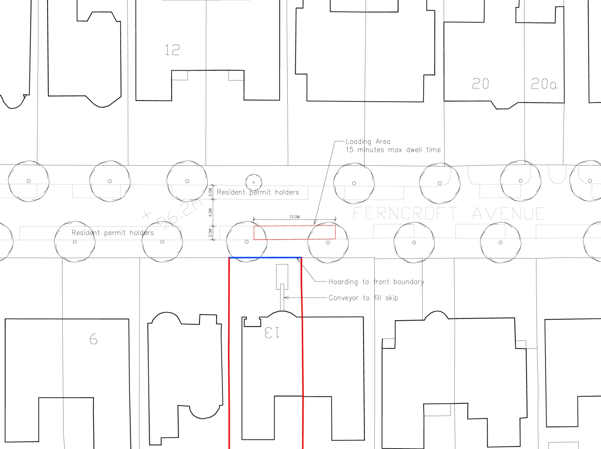 AP-01

10. Please provide the proposed start and end dates for each phase of construction as well as an overall programme timescale. (A Gantt chart with key tasks, durations and milestones would be ideal).

Site Set Up 1 Week

Structure 19 Weeks

Fit Out 16 Weeks

Total: 36 Weeks / approximately 9 months

Works are planned to start on site 22 October 2018 which allow completion by July 2019.

11. Please confirm the standard working hours for the site, noting that the standard working hours for construction sites in Camden are as follows:

* 8.00am to 6pm on Monday to Friday
* 8.00am to 1.00pm on Saturdays
* No working on Sundays or Public Holidays

Standard working hours confirmed.

12. Please indicate if any changes to services are proposed to be carried out that would be linked to the site during the works (i.e. connections to public utilities and/or statutory undertakers’ plant). Larger developments may require new utility services. If so, a strategy and programme for coordinating the connection of services will be required. If new utility services are required, please confirm which utility companies have been contacted (e.g. Thames Water, National Grid, EDF Energy, BT etc.) You must explore options for the utility companies to share the same excavations and traffic management proposals. Please supply details of your discussions.

No changes to the services are proposed to be carried out that would be linked to the site during works.

# Community Liaison

**A neighbourhood consultation process must have been undertaken prior to submission of the CMP first draft. This consultation must relate to construction impacts, and should take place following the granting of planning permission in the lead up to the submission of the CMP. A consultation process specifically relating to construction impacts must take place regardless of any prior consultations relating to planning matters. This consultation must include all of those individuals that stand to be affected by the proposed construction works. These individuals should be provided with a copy of the draft CMP, or a link to an online document. They should be given adequate time with which to respond to the draft CMP, and any subsequent amended drafts. Contact details which include a phone number and email address of the site manager should also be provided.**

Significant time savings can be made by running an effective neighbourhood consultation process. This must be undertaken in the spirit of cooperation rather than one that is dictatorial and unsympathetic to the wellbeing of local residents and businesses.

These are most effective when initiated as early as possible and conducted in a manner that involves the local community. Involving locals in the discussion and decision making process helps with their understanding of what is being proposed in terms of the development process. **The consultation and discussion process should have already started, with the results incorporated into the CMP first draft submitted to the Council for discussion and sign off.**This communication should then be ongoing during the works, with neighbours and any community liaison groups being regularly updated with programmed works and any changes that may occur due to unforeseen circumstances through newsletters, emails and meetings.

Please note that for larger sites, details of a construction working group may be required as a separate S106 obligation. If this is necessary, it will be set out in the S106 Agreement as a separate requirement on the developer.

**Cumulative impact**

Sites located within high concentrations of construction activity that will attract large numbers of vehicle movements and/or generate significant sustained noise levels should consider establishing contact with other sites in the vicinity in order to manage these impacts.

**The Council can advise on this if necessary.**

**13. Consultation**

The Council expects meaningful consultation. For large sites, this may mean two or more meetings with local residents **prior to submission of the first draft CMP**.

Evidence of who was consulted, how the consultation was conducted and a summary of the comments received in response to the consultation should be included. Details of meetings including minutes, lists of attendees etc. should be appended.

In response to the comments received, the CMP should then be amended where appropriate and, where not appropriate, a reason given. The revised CMP should also include a list of all the comments received. Developers are advised to check proposed approaches to consultation with the Council before carrying them out. If your site is on the boundary between boroughs then we would recommend contacting the relevant neighbouring planning authority.

Please provide details of consultation of draft CMP with local residents, businesses, local groups (e.g. residents/tenants and business associations) and Ward Councillors.

Following consultation with the Planning Obligations Team the scope of a public consultation was agreed and organised. A letters summarising the scope of the project, the impacts the works could have on neighbours, and the mitigation methods which will be put in place were hand delivered to the affected properties. These were issued to No.’s 7-20 Ferncroft Avenue with emailed versions to Windsor Court (London) Ltd – the freeholder of the mansion block on Platt’s Lane whose tennis court abuts the rear boundary of No. 13 Ferncroft Avenue – and the 3 Ward Councillors.

No responses or queries have been received to date and the formal consultation period has now closed. However, the line of communication will remain open and if any responses are received before the project commences on site then the CMP will be amended if there are further mitigations which can reasonably be incorporated.

Prior to commencement, communication lines will be established with Erdol to enable neighbours to raise concerns as they occur and the builders to respond in kind.

**14. Construction Working Group**

Please provide details of community liaison proposals including any Construction Working Group that will be set up, addressing the concerns of the community affected by the works, the way in which the contact details of the person responsible for community liaison will be advertised to the local community, and how the community will be updated on the upcoming works i.e. in the form of a newsletter/letter drop, or weekly drop in sessions for residents.

A construction working group is not proposed for this project. The site manager will make personal contact with the neighbours to announce commencement of works and identify him/her as the point of contact for any queries. The contact telephone number will be included on site signage and hoarding.

**15. Schemes**

Please provide details of your ‘Considerate Constructors Scheme’ registration, and details of any other similar relevant schemes as appropriate. Contractors will also be required to follow the “[Guide for Contractors Working in Camden](http://www.camden.gov.uk/ccm/cms-service/download/asset?asset_id=799001)” also referred to as “[Camden’s Considerate Contractors Manual](http://www.camden.gov.uk/ccm/cms-service/download/asset?asset_id=799001)”.

The project site will be registered with the Considerate Contractors Scheme and the Code of Considerate Practice will be fully adhered to.

**16. Neighbouring sites**

Please provide a plan of existing or anticipated construction sites in the local area and please state how your CMP takes into consideration and mitigates the cumulative impacts of construction in the vicinity of the site. The council can advise on this if necessary.

The Site Manager will be responsible for liaising with other developments in the area on a day to day basis. At the moment of preparation of the CMP other building projects are being carried out at No.’s 14 & 32 Ferncroft Avenue. The works at No. 14 comprise a rather modest alteration to the rear outrigger of a 1 bed flat at ground floor level. The works at No. 32 include excavation of a basement but that project, already underway for approximately 1 year, will be completing soon as the approved CMP intended a full duration of 11-12 months. That site is being approached from the opposite direction of Ferncroft and the traffic management schemes are not anticipated to provide conflict.

# Transport

**This section must be completed in conjunction with your principal contractor. If one is not yet assigned, please leave the relevant sections blank until such time when one has been appointed.**

Camden is a CLOCS Champion, and is committed to maximising road safety for Vulnerable Road Users (VRUs) as well as minimising negative environmental impacts created by motorised road traffic. As such, all vehicles and their drivers servicing construction sites within the borough are bound by the conditions laid out in the [CLOCS Standard.](http://www.clocs.org.uk/)

This section requires details of the way in which you intend to manage traffic servicing your site, including your road safety obligations with regard to VRU safety. It is your responsibility to ensure that your principal contractor is fully compliant with the terms laid out in the CLOCS Standard. It is your principal contractor’s responsibility to ensure that all contractors and sub-contractors attending site are compliant with the terms laid out in the CLOCS Standard.

Checks of the proposed measures will be carried out by the council to ensure compliance. Please refer to the CLOCS Standard when completing this section. Guidance material which details CLOCS requirements can be accessed [here](http://www.camden.gov.uk/ccm/cms-service/stream/asset?asset_id=3550016&), details of the monitoring process are available [here](http://www.camden.gov.uk/ccm/cms-service/stream/asset?asset_id=3550014&).

Please contact [CLOCS@camden.gov.uk](mailto:CLOCS@camden.gov.uk) for further advice or guidance on any aspect of this section.

**Please refer to the CLOCS Overview and Monitoring Overview documents referenced above which give a breakdown of requirements.**

**CLOCS Contractual Considerations**

17. Name of Principal contractor:

KL Builders Ltd, 9 Muswell Hill Place, London N10 3RP

18. Please submit the proposed method for checking operational, vehicle and driver compliance with the CLOCS Standard throughout the duration of the contract (please refer to our [CLOCS Overview document](http://www.camden.gov.uk/ccm/cms-service/stream/asset?asset_id=3550016&) and [Q18 example response](http://www.camden.gov.uk/ccm/cms-service/stream/asset?asset_id=3550015&)).

*FORS Bronze accreditation as a minimum will be a contractual requirement, FORS Silver or Gold operators will be appointed where possible. Where FORS Bronze operators are appointed, written assurance will be sought from contractors that all vehicles over 3.5t are equipped with additional safety equipment (as per CLOCS Standard P13), and that all drivers servicing the site will have undertaken approved additional training (eg. Safe Urban Driving + 1 x e-learning module* ***OR*** *Work Related Road Risk Vulnerable Road User training + on-cycle hazard awareness course + 1 x e-learning module etc.). CLOCS Compliance will be included as a contractual requirement.*

*Desktop checks will be made against the FORS database of trained drivers and accredited companies as outlined in the CLOCS Standard Managing Supplier Compliance guide. These will be carried out as per a risk scale based on that outlined in the CLOCS Managing Supplier Compliance guide.*

*Checks of FORS ID numbers will form part of the periodic checks and will be carried out as per an appropriate risk scale.*

*Random spot checks will be carried out by site staff on vehicles and drivers servicing the site at a frequency based on the aforementioned risk scale. These will include evidence of further training, license checks, evidence of routing information, and checks of vehicle safety equipment. Results from these checks will be logged and retained, and enforced upon accordingly.*

*Collision reporting data will be requested from operators and acted upon when necessary*

19. Please confirm that you as the client/developer and your principal contractor have read and understood the [CLOCS Standard](http://www.clocs.org.uk/wp-content/uploads/2015/05/CLOCS-Standard-v1.2-APRIL_15.pdf) and included it in your contracts. Please sign-up to join the [CLOCS Community](http://www.clocs.org.uk/links-to-partners/) to receive up to date information on the standard by expressing an interest online.

I confirm that I have included the requirement to abide by the CLOCS Standard in my contracts to my contractors and suppliers:

(must scan in signatures)

**Clients will sign the approved version of this CMP, just sorting out how to insert this**

Felicia Epstein & Daniel Lightman

Please contact [CLOCS@camden.gov.uk](mailto:CLOCS@camden.gov.uk) for further advice or guidance on any aspect of this section.

**Site Traffic**

**Sections below shown in blue directly reference the CLOCS Standard requirements. The CLOCS Standard should be read in conjunction with this section.**

**20. Traffic routing**: *“Clients shall ensure that a suitable, risk assessed vehicle route to the site is specified and that the route is communicated to all contractors and drivers. Clients shall make contractors and any other service suppliers aware that they are to use these routes at all times unless unavoidable diversions occur.”* (P19, 3.4.5)

Routes should be carefully considered and risk assessed, taking into account the need to avoid where possible any major cycle routes and trip generators such as schools, offices, public buildings,museums etc. Where appropriate, on routes that use high risk junctions (i.e. those that attract high volumes of cycling traffic) installing Trixi mirrors to aid driver visibility should be considered.

Consideration should also be given to weight restrictions, low bridges and cumulative impacts of construction (including neighbouring construction sites) on the public highway network. The route(s) to and from the site should be suitable for the size of vehicles that are to be used.

a. Please indicate routes on a drawing or diagram showing the public highway network in the vicinity of the site including details of how vehicles will be routed to the [Transport for London Road Network](http://www.lscp.org.uk/lrsu/engineering_tlrn.html) (TLRN) on approach and departure from the site.

Diagramme FA-01 illustrates the proposed access and egress routes to and from the site in relation to the A41 Finchley Road which forms part of the TLRN. Site vehicles will be called in, approaching the site from the A41 Finchley Road, via Platts Lane, turning right into Ferncroft Avenue to pull alongside the site on the right hand side of the vehicle, overseen by qualified banksmen.

Departing vehicles will continue along Ferncroft Avenue, turning left into Hollycroft Avenue and left again into Platts Lane to return to the A41. Trucks will not need to pass St Margaret’s School ensuring better protection for vulnerable pedestrians.

This route has been chosen to be the most direct and in order to ensure the least impact on local roads. Blue indicates the approach route and red the exit route.

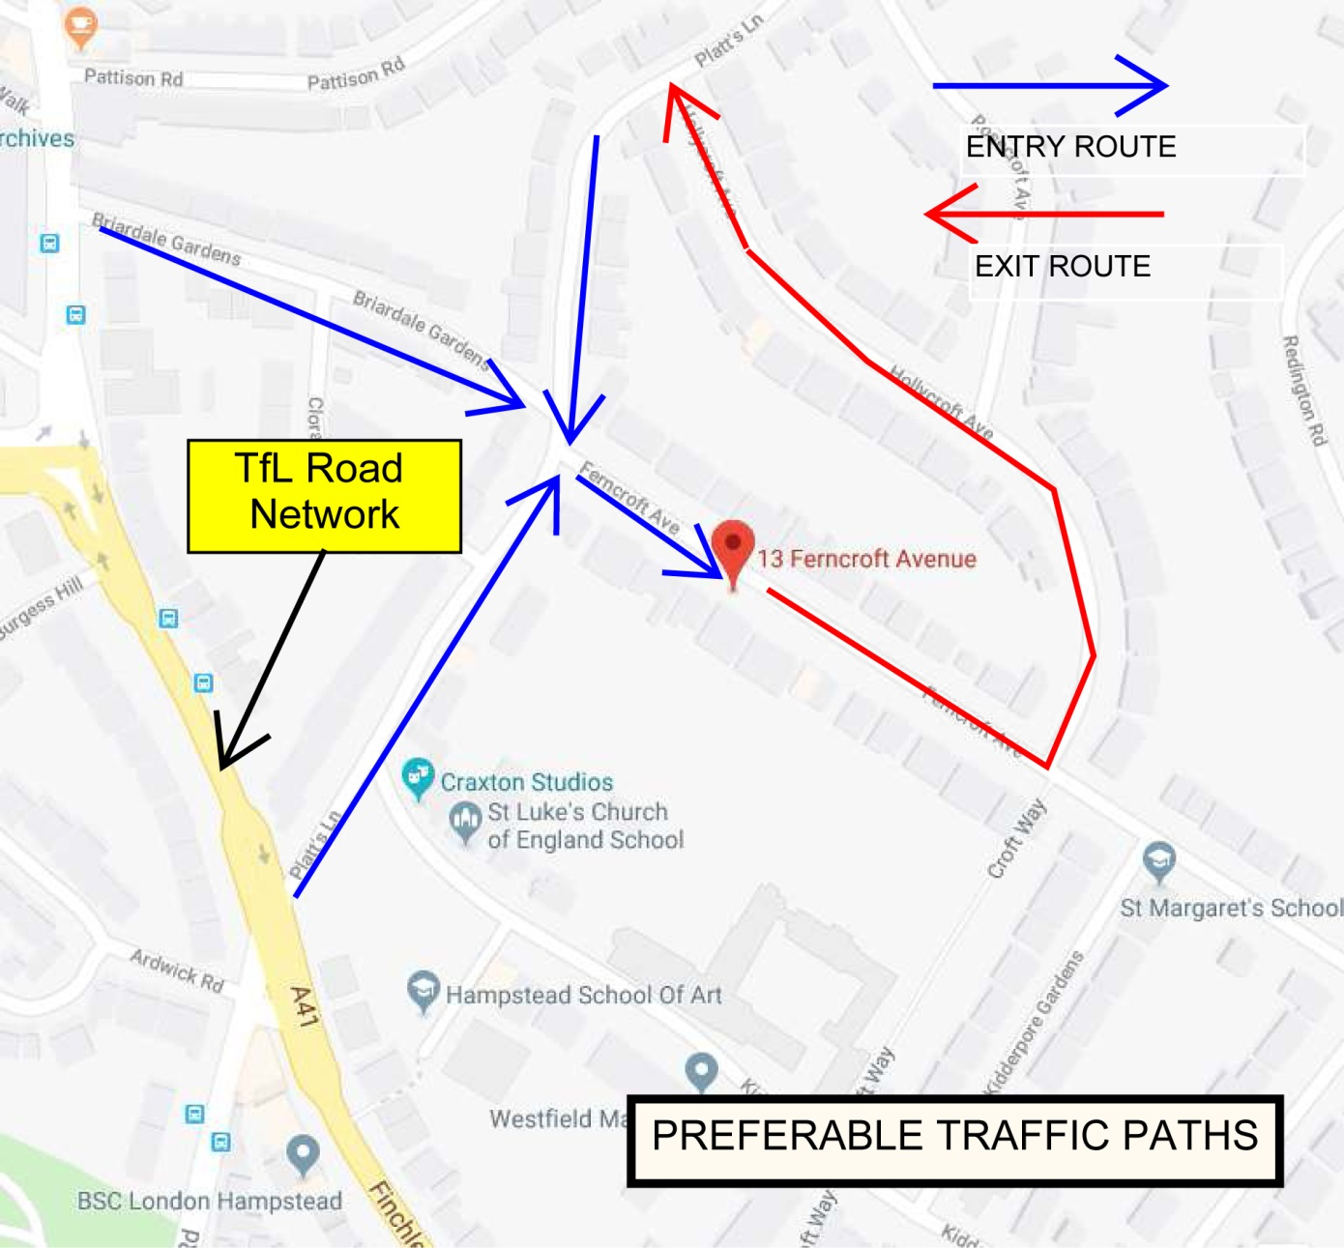 FA-01

b. Please confirm how contractors, delivery companies and visitors will be made aware of the route (to and from the site) and of any on-site restrictions, prior to undertaking journeys.

Deliveries/collections will be pre scheduled. We will provide GPS coordinates to supplement delivery instructions in accordance with the proposed traffic route and maximum dwell times as outlined above. Route details will be relayed by phone, email or in person as is necessary. Suppliers will endeavour to call ahead of delivery time to confirm arrival and to ensure that the single yellow line area outside no.13 is clear. Vehicles will not wait on any other road in the region. Engines of any vehicles will not be left idling during visit/loading/unloading times.

**21. Control of site traffic, particularly at peak hours**: “*Clients shall consider other options to plan and control vehicles and reduce peak hour deliveries”* (P20, 3.4.6)

Construction vehicle movements are generally acceptable between 9.30am to 4.30pm on weekdays and between 8.00am and 1.00pm on Saturdays). If there is a school in the vicinity of the site or on the proposed access and/or egress routes, then deliveries must be restricted to between 9.30am and 3pm on weekdays during term time. (Refer to the [*Guide for Contractors Working in Camden*](http://www.camden.gov.uk/ccm/cms-service/download/asset?asset_id=799001)).

A delivery plan should ensure that deliveries arrive at the correct part of site at the correct time. Instructions explaining such a plan should be sent to all suppliers and contractors**.** Consideration should be given to the location of any necessary holding areas for large sites with high volumes of traffic. Vehicles must not wait or circulate on the public highway. Whilst deliveries should be given set times to arrive, dwell and depart, no undue time pressures should be placed upon the driver at any time.

a. Please provide details of the typical sizes of all vehicles and the approximate frequency and times of day when they will need access to the site, for each phase of construction.You should estimate the average daily number of vehicles during each major phase of the work, including their dwell time at the site. High numbers of vehicles per day and/or long dwell times may require vehicle holding procedures.

The main types of vehicles that will be accessing the site are as follows:

**Structural phase**

Skip lorry: 6.70m long x 2.75m wide / 1-2 visits per day / 20 min max dwell time

Delivery lorry: 7.80m long x 2.60m wide / 1-2 visits per week / 30 min max dwell time

Ready mix lorry: 9.39m long x 3.15m wide / 1-3 visits per project / 40 min max dwell time

**Fit-out phase**

Delivery lorry: 8.10m long x 2.60m wide / 1-2 visits per week / 20 min max dwell time

Ready mix lorry: 9.39m long x 3.15m wide / 1-2 visits per project / 40 min max dwell time

The vehicle dimensions stated above are the largest vehicles that would attend the site.

Site deliveries will be between 9.30am and 3.00pm from Monday to Friday during term time and between 9.30am and 4.30pm from Monday to Friday during school holidays.

Delivery instructions will be sent to all suppliers and contractors including the delivery times specified above. All deliveries will be pre-booked and allocated set arrival times.

Liaison with all nearby construction sites will be undertaken to avoid traffic congestion.

b. Please provide details of other developments in the local area or on the route.

The site manager will be responsible for liaising with other developments in the area on a day to day basis – particularly those at No’s 14 & 32 Fitzjohns Avenue. Contact will also be made with the Hampstead Manor project in Kidderpore Avenue (if still in operation)

c. Please outline the system that is to be used to ensure that the correct vehicle attends the correct part of site at the correct time.

The site is a small semi-detached property with a conventional residential frontage. Therefore all site related vehicle movements will take place to the front of the property. Deliveries will be pre-scheduled in accordance with the frequencies outlined above.

d. Please identify the locations of any off-site holding areas (an appropriate location outside the borough may need to be identified, particularly if a large number of delivery vehicles are expected) and any measures that will be taken to ensure the prompt admission of vehicles to site in light of time required for any vehicle/driver compliance checks. Please refer to question 24 if any parking bay suspensions will be required for the holding area.

There are no offsite holding locations proposed for this development other than supplier source locations. Pre-scheduling of deliveries will obviate the need for a holding location.

e. Please provide details of any other measures designed to reduce the impact of associated traffic (such as the use of [construction material consolidation centres](https://www.google.co.uk/url?sa=t&rct=j&q=&esrc=s&source=web&cd=2&cad=rja&uact=8&ved=0ahUKEwi5hKjPiLjRAhVqLcAKHQduC_gQFggkMAE&url=http%3A%2F%2Fcontent.tfl.gov.uk%2Fdirectory-london-construction-consolidation-centres.pdf&usg=AFQjCNFhB34aaqw3M3fmDpJYUUBw_PjbdA&sig2=KXhGnTR3slzf0kN4XMOcQg&bvm=bv.143423383,d.ZWM)).

We will adhere to a strict vehicle call up procedure and ensure that only one site related vehicle is present at any one time.

**22. Site access and egress:** “*Clients shall ensure that access to and egress from the site is appropriately managed, clearly marked, understood and clear of obstacles.”* (P18, 3.4.3)

Vehicles entering and leaving the site should be carefully managed, using gates that are clearly marked and free from obstacles. Traffic marshals must ensure the safe passage of all traffic on the public highway, in particular pedestrians and cyclists, when vehicles are entering and leaving site, particularly if reversing.

Traffic marshals, or site staff acting as traffic marshals, should hold the relevant qualifications required for directing large vehicles when reversing. Marshals should be equipped with ‘STOP – WORKS’ signs (not STOP/GO signs) if control of traffic on the public highway is required. Marshals should have radio contact with one another where necessary.

a. Please detail the proposed access and egress routes to and from the site

The detailed route is provided at Item 20a (FA-01) above and the site plan at Item 9 (AP-01). This is a single dwelling house and all access is via the public highway as shown. No construction vehicles will enter the property.

b. Please describe how the access and egress arrangements for construction vehicles will be managed.

Suitably qualified banksmen (having the Traffic Marshal qualification as a minimum) will be on hand during all site-related vehicle movements to ensure that site vehicles approach, park and leave the site in a safe manner via the public highway.

c. Please provide swept path drawings for any tight manoeuvres on vehicle routes to and from the site including proposed access and egress arrangements at the site boundary (if necessary).

N/A

d. Provision of wheel washing facilities should be considered if necessary. If so, please provide details of how this will be managed and any run-off controlled.

No vehicles will enter the site so it is highly unlikely that wheel washing would become necessary. However, jet wash equipment will be available at the site and used where required. Run-off will be controlled.

**23. Vehicle loading and unloading:** *“Clients shall ensure that vehicles are loaded and unloaded on-site as far as is practicable.”* (P19, 3.4.4)

If this is not possible, Traffic Marshalls must ensure the safe passage of pedestrians, cyclists and motor traffic in the street when vehicles are being loaded or unloaded.

Please provide details of the parking and loading arrangements for construction vehicles with regard to servicing and deliveries associated with the site (e.g. delivery of materials and plant, removal of excavated material). This is required as a scaled site plan, showing all points of access and where materials, skips and plant will be stored, and how vehicles will access and egress the site. If loading is to take place off site, please identify where this is due to take place and outline the measures you will take to ensure that loading/unloading is carried out safely. Please outline in question 24 if any parking bay suspensions will be required.

All site plant, materials and skip will be contained within the designated hoarding area that makes up the private space of No.13 and does not impact any public environment. Please refer to AP-01 for the access plan with the marked area outside no.13 that shall be used by all delivery/collection vehicles. Please see TP-01 for the proposed traffic plan route for access/exiting the site.

Delivery and removal vehicles will utilise the single line area outside of no.13, and will not affect any passing vehicular traffic. All delivery/collection lorries arriving or leaving will be monitored by a banksman, and pedestrians and vehicles directed by staff in high visibility clothing. All debris and spoil material will be loaded via a conveyor belt into a skip placed within the hoarding on site. The removal of skips from the site will be done using the skip-swap method. The maximum dwell time for loading/unloading will be 20 minutes.

The concrete will be mixed on site during the construction of the basement walls, however up to two ready mix concrete deliveries will be required for the formation of the basement slab. The ready mixed lorry will be positioned outside No.13. The maximum dwell time for the discharge of concrete will be 40 minutes and will be monitored at all times.

See Appendix A

 AP-01

**Highway interventions**

**Please note that Temporary Traffic Orders (TTOs) and hoarding/scaffolding licenses may be applied for prior to CMP submission but won’t be granted until the CMP is signed-off.**

**If the site is on or adjacent to the TLRN, please provide details of preliminary discussions with Transport for London in the relevant sections below.**

**24. Parking bay suspensions and temporary traffic orders**

Please note, parking bay suspensions should only be requested where absolutely necessary. Parking bay suspensions are permitted for a maximum of 6 months, requirement of exclusive access to a bay for longer than 6 months you will be required to obtain [Temporary Traffic Order (TTO)](http://camden.gov.uk/ccm/content/transport-and-streets/traffic-management/temporary-road-restrictions/) for which there is a separate cost.

Please provide details of any proposed parking bay suspensions and TTO’s which would be required to facilitate construction. **Building materials and equipment must not cause obstructions on the highway as per your Considerate Contractors obligations unless the requisite permissions are secured.**

Information regarding parking suspensions can be found [here.](http://www.camden.gov.uk/ccm/navigation/transport-and-streets/parking/parking-bay-suspensions/)

There will not be any parking bay suspensions or need for temporary traffic management orders.

Delivery and spoil removal vehicles will be able to pull into the area in front of the driveway area of No. 13, and there will not be any disruption to passing local traffic.

**25. Scaled drawings of highway works**

Please note that use of the public highway for storage, site accommodation or welfare facilities is at the discretion of the Council and is generally not permitted. If you propose such use you must supply full justification, setting out why it is impossible to allocate space on-site. You must submit a detailed (to-scale) plan showing the impact on the public highway that includes the extent of any hoarding, pedestrian routes, parking bay suspensions and remaining road width for vehicle movements. We prefer not to close footways but if this is unavoidable, you should submit a scaled plan of the proposed diversion route showing key dimensions.

a. Please provide accurate scaled drawings of any highway works necessary to enable construction to take place (e.g. construction of temporary vehicular accesses).

No highway works are required to service the site because the existing private hardstanding will be used to accommodate the compound for skips and storage, separated from the public footpath by a hoarding. Truck visits will be accommodated within the existing length of curb which does not contain any parking bay restrictions. Delivery/collection lorries will pull into the area in front of the driveway, which is otherwise a designated single yellow line. As such, there will be no impact on passing traffic during loading/unloading. Visiting goods vehicles will never be left unattended - All vehicles will be attended to as necessary by marked banksmen to ensure safe passage of vehicles in the vicinity.

 AP-01

b.Please provide details of all safety signage, barriers and accessibility measures such as ramps and lighting etc.

Secure hoarding will be constructed to enclose No. 13 Ferncroft Avenue to a height of 2400mm above ground level, comprising WBP ply sheeting, framing and posts, and a secure entry lock: There will be hoarding at the front of the property between the private driveway and public footpath which will enclose the skip and stored materials. It will also be implemented on front boundaries between neighbouring properties. Hoarding will have appropriate health and safety signage and lights will be installed accordingly.

During scheduled vehicle loading/unloading, all pedestrian traffic outside no 13 Ferncroft Avenue will be temporarily diverted. Warning and diversion signs will be used by marked banksmen to ensure safe passage of pedestrians. This method will be reviewed regularly to establish effectiveness and minimise disruption.

**26. Diversions**

Where applicable, please supply details of any diversion, disruption or other anticipated use of the public highway during the construction period (alternatively a plan may be submitted).

N/A

**27. VRU and pedestrian diversions, scaffolding and hoarding**

Pedestrians and/or cyclist safety must be maintained if diversions are put in place. Vulnerable footway users should also be considered. These include wheelchair users, the elderly, those with walking difficulties, young children, those with prams, the blind and partially sighted. Appropriate ramping must be used if cables, hoses, etc. are run across the footway.

Any work above ground floor level may require a covered walkway adjacent to the site. A licence must be obtained for scaffolding and gantries. The adjoining public highway must be kept clean and free from obstructions. Lighting and signage should be used on temporary structures/skips/hoardings etc.

A secure hoarding will generally be required at the site boundary with a lockable access.

a. Please provide details describing how pedestrian and cyclist safety will be maintained, including any proposed alternative routes (if necessary), and any Traffic Marshall arrangements.

There will be no cycling diversions implemented, nor traffic diversions, except if/when necessary during vehicular loading/unloading outside No.13. All vehicles will be attended by marked banksmen in high visibility clothing. If needed, passing traffic – vehicles and cyclists - will be safely diverted around the visiting vehicle. Such temporary diversions are anticipated to be absolutely minimal in light of the designated area outside no.13.

During scheduled vehicle loading/unloading, all pedestrian traffic outside no 13 Ferncroft Avenue will be temporarily diverted. Warning and diversion signs will be used by marked banksmen to ensure safe passage of all pedestrians. Care will be given to all pedestrians including the vulnerable (elderly, disabled and partially abled, children, those escorting children etc).

Appropriate measures will be employed to protect the public footway and highway from any possible damage arising from construction related activity and to prevent concrete and other detritus from being washed into the public highway drainage system.

b. Please provide details of any temporary structures which would overhang the public highway (e.g. scaffolding, gantries, cranes etc.) and details of hoarding requirements or any other occupation of the public highway.

No temporary structures overhanging the public highway are proposed. Hoarding to the front boundary of the property will be erected as identified above.

SYMBOL IS FOR INTERNAL USE

# Environment

To answer these sections please refer to the relevant sections of **Camden’s Minimum Requirements for Building Construction (**[**CMRBC**](http://www.camden.gov.uk/ccm/cms-service/download/asset?asset_id=3257318)**).**

28. Please list all [noisy operations](http://www.camden.gov.uk/ccm/content/environment/environmental-health--consumer-protection/noise/reducing-noise/noise-from-construction-sites.en?page=2)  and the construction method used, and provide details of the times that each of these are due to be carried out.

Works for this development which have the potential to cause noise are as follows:

Underpinning works - Weeks 1-14

Bulk excavation of basement - Weeks 14 - 16

Works will be carried out during normal site hours with measures implemented to maintain noise levels within permissible limits. Methods will be employed to mitigate against the impact of noise on neighbouring properties and complete the works in as little time as possible. The methods used are described as follows:

* Sections of the existing concrete oversite will be removed using concrete breakers.
* The underlying material will be removed by hand digging.
* Material will be moved to a skip located outside the front of the building in the driveway area by means of an electric conveyor.
* All external plant, tools, conveyor will be housed within the site hoarding area.
* If an area of compacted earth is encountered an SDS spade would be used to loosen the earth.
* If hard material such as rock or concrete is encountered then concrete breakers are used for a limited time.
* At all other times hand digging is used. After the excavation phase, a concrete mixer will be located inside the building and concrete and poured to stabilise that section of the works.

29. Please confirm when the most recent noise survey was carried out (before any works were carried out) and provide a copy. If a noise survey has not taken place please indicate the date (before any works are being carried out) that the noise survey will be taking place, and agree to provide a copy.

An ambient noise survey will be carried out by Venta Acoustics between 4th -5th July 2018 and a copy is provided. See Appendix B.

30. Please provide predictions for [noise](http://www.camden.gov.uk/ccm/content/environment/environmental-health--consumer-protection/noise/reducing-noise/noise-from-construction-sites.en?page=2) and vibration levels throughout the proposed works.

Potential noise levels generated by the construction works have been calculated using the guidance of BS 5228. Noise levels generated are dependent on a variety of factors, which include plant used, distance between source and receptor and % on-time for each item of plant.

The following phases and plant are assumed for a typical similar project:

|  |  |  |
| --- | --- | --- |
|  | **Phase** | **Plant Used** |
| 1 | Cutting section of existing floor slab | Electric conveyor. Electric breaker |
| 2 | Hand digging Electric | Electric conveyor |
| 3 | Breaking down of firm soil | SDS spade, electric conveyor |
| 4 | Removal of hard material, small area | Electric saw/hammer, electric conveyor |
| 5 | Removal of hard material, large area | Electric saw/hammer, electric conveyor |
| 6 | Concreteing concrete | Concrete mixer |

Source noise data for the plant has been obtained from the plant manufacturers or taken from the database contained in BS 5228. The calculations assume an electric motor driven conveyor is located within the site hoarding. The calculations allow for break-out from inside the building through an open window of dimensions 1.5 m x 1.2 m.

As sites are often in close proximity to neighbouring properties, a distance of 6 m between the site and the receiver has been assumed. Calculations (with all assumptions) are summarised below:

|  |  |  |
| --- | --- | --- |
|  | **Phase** | **Façade Construction Noise Level, dB LAeq,12 hour** |
| 1 | Cutting section of existing floor slab | 61 |
| 2 | Hand digging Electric | 60 |
| 3 | Breaking down of firm soil | 65 |
| 4 | Removal of hard material, small area | 62 |
| 5 | Removal of hard material, large area | 61 |
| 6 | Concreteing concrete | 58 |

Where properties are spaced further apart, noise levels are reduced. The predicted noise level for the normal excavation method of hand digging and conveyor operation is 60 dB LAeq,12hr which is well below the assumed limit of 65 dB LAeq, 12hr allowing ample headroom for a contribution from ambient noise. During concreting operations, a noise level of 58 dB LAeq, 12hr is predicted which is considerably lower than the assumed noise limit.

This is a small residential project where vibration impact to the nearest receptor is not expected to be significant, however vibration levels will be kept in line with the London Good Practice Guide for Noise and Vibration. If vibration complaints are received, live monitoring will be undertaken such that any vibrations in excess of 30mms- ppv. 1st action 5.00mms ppv will result in works being stopped. Significant vibration is not expected to be an ongoing or regular occurrence, only likely to occur at all during the first demolition phase where concrete may be excavated. 30min respite windows will be provided in the event of any complaint.

31. Please provide details describing mitigation measures to be incorporated during the construction/[demolition](http://www.camden.gov.uk/ccm/navigation/environment/building-control/demolition/) works to prevent noise and vibration disturbances from the activities on the site, including the actions to be taken in cases where these exceed the predicted levels.

A hand demolition technique is proposed to mitigate against noise levels as far as practicable. Breaking of the concrete oversite does have greater noise potential with conventional pneumatic breaking equipment but will be completed as quickly as possible.

Other specific measures which will be adopted will include selection of ‘silenced’ plant, the pre-cutting of materials off site, prefabrication of plant or service containment and prefabrication and pre-cutting of 1st and 2nd fix materials and elements. Loading broken concrete into a completely empty skip will be avoided by providing a cushioning layer (sub-soil) before loading concrete.

Where any complaint is received, Erdol will incorporate 2hr on/off respite periods subject to the agreement of the receptor party. In addition the proximate receptors/neighbours will be advised at each stage of construction if any particular action is likely to incur noise, dust or vibration nuisance of any kind.

Erdol will measure noise levels with a decibel meter, taking readings on site and building up a log of readings throughout the project duration. They will aim to achieve a daily limit of 70dB (LAeq, 10hr) at the nearest sensitive façade and 73dB (LAeq, 5 minutes) at the first action level trigger. “

32. Please provide evidence that staff have been trained on BS 5228:2009

It will be ensured that the demolition sub-contractor meets all statutory requirements, and is fully competent to carry out these types of work.

All operatives will be trained with CITB Compliant training to BS 5228:2009 and revised standard 2015.

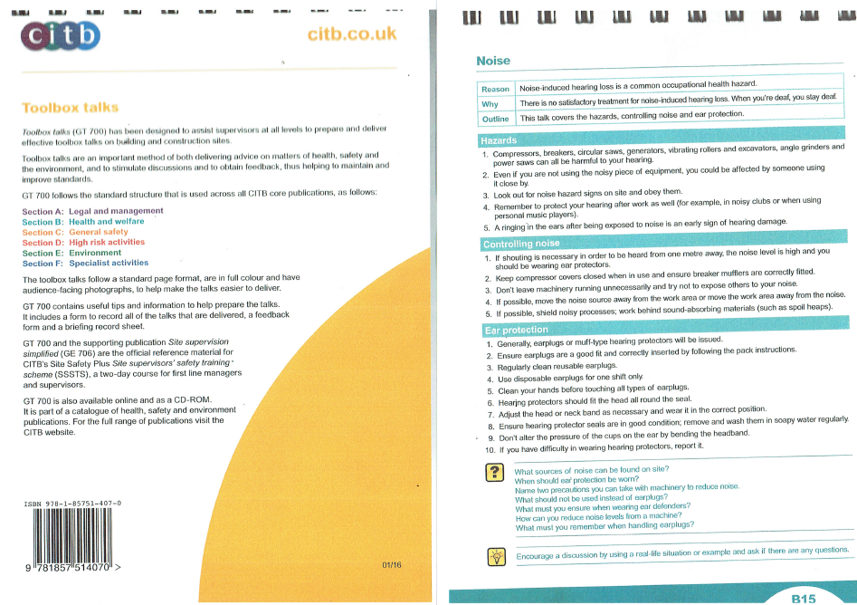

33. Please provide details on how dust nuisance arising from dusty activities, on site, will be prevented.

* Construction of a 2400mm high timber hoarding to the perimeter of the site prior to commencement any dust generating activity on site.
* Keep site fencing, barriers and scaffolding clean using wet methods.
* Site personnel shall be trained in dust mitigation and a manager shall be present for managing dust on site.
* Plant shall be well maintained, with routine servicing of plant and non-road mobile machinery to be completed in accordance with the manufacturers’ recommendations.
* Damp down site during working day and again at the end of the day to reduce the amount of re-suspended dust.
* Ensuring that all plant equipped with dust suppression equipment is checked on first use at site, to ensure that this equipment is functional and is being used.
* using mains electricity or battery powered equipment wherever possible.
* Use of water sprays or poured water to suppress dust during cutting, angle grinding or other dust-generating activities.
* Store materials with dust producing potential away from site boundaries and sheet, seal or damp down stockpiles of excavated materials held on site.
* Concrete delivery trucks will be required to arrive fitted with a chute sock that will be re-fitted after delivery.
* Soil or mud dropped inadvertently onto pavement or roadway will be washed away into main drainage as quickly as possible.
* No smoking by site operatives in public
* Daily dust inspections will be undertaken by the foreman

34. Please provide details describing how any significant amounts of dirt or dust that may be spread onto the public highway will be prevented and/or cleaned.

The loading area will be swept after each load/delivery. A portable jet wash will be used to keep the front driveway and footpath clean and avoid excessive build-up of debris. Periodic road sweeper visits will also be implemented if required throughout the bulk excavation phase of the project, particularly during wet weather when there is a risk of materials being tracked onto the highway networks.

35. Please provide details describing arrangements for monitoring of [noise](http://www.camden.gov.uk/ccm/content/environment/environmental-health--consumer-protection/noise/reducing-noise/noise-from-construction-sites.en?page=2), vibration and dust levels.

During the build stages where noise levels are at their peak sound levels will be monitored to ensure levels remain within acceptable guideline levels. If noise levels exceed the predicted levels by more than 3 dB(A), mitigation measures will be implemented to limit any noise disturbance to local residents.

The selection of the construction methods and plant has been made with reference to minimizing levels of ground transmitted vibration so it is not envisaged that it will be necessary to continually monitor vibration specifically.

The site manager will be responsible for the control and management of dust at the site. Site management will ensure that all personnel on site are adequately trained to implement dust mitigation measures. In the event of a breach of the trigger action level, or a dust nuisance is caused to a nearby sensitive receptor and a complaint is received, then the following action plan will be implemented:

Upon receipt of a complaint the site manager will be immediately notified who will then make a written record. The site manager will carry out a walkover and inspection to identify the source of dust which may have caused complaint. If the complaint relates to previous period of operation, site staff will be consulted to establish the activity that may have caused it.

If an activity has been identified as generating unacceptable levels of dust then that activity shall cease until sufficient measures are adopted to prevent or minimize the dust nuisance. The implementation of the measures will be the responsibility of the site manager and will be recorded along with details of the identified source.

36. Please confirm that a Risk Assessment has been undertaken at planning application stage in line with the GLA policy. [The Control of Dust and Emissions During Demolition and Construction 2104 (SPG)](https://www.london.gov.uk/file/18750/download?token=zV3ZKTpP), that the risk level that has been identified, and that the appropriate measures within the GLA mitigation measures checklist have been applied. Please attach the risk assessment and mitigation checklist as an appendix.

A specific risk assessment with regard to control of dust and emissions has been undertaken in accordance with the GLS SPG on Dust and Emissions. The assessment results are as below:

|  |  |  |  |  |
| --- | --- | --- | --- | --- |
| **Potential Risk** |  | **Risk** |  |  |
|  | **Demolition** | **Earthworks** | **Construction** | **Track Out** |
| Dust Soiling | Medium | Medium | Medium | Negligible |
| Human Health | Low | Low | Low | Negligible |
| Ecological | Negligible | Negligible | Negligible | Negligible |

37. Please confirm that all of the GLA’s ‘highly recommended’ measures from the [SPG](https://www.london.gov.uk/file/18750/download?token=zV3ZKTpP) document relative to the level of risk identified in question 36 have been addressed by completing the [GLA mitigation measures checklist.](https://www.london.gov.uk/what-we-do/planning/implementing-london-plan/supplementary-planning-guidance/control-dust-and)

Confirmed. See GLA Mitigation Measures Checklist attached at Appendix C.

38. If the site is a ‘High Risk Site’, 4 real time dust monitors will be required. If the site is a ‘Medium Risk Site’, 2 real time dust monitors will be required. The risk assessment must take account of proximity to sensitive receptors (e.g. schools, care homes etc), as detailed in the [SPG](https://www.london.gov.uk/file/18750/download?token=zV3ZKTpP). Please confirm the location, number and specification of the monitors in line with the SPG and confirm that these will be installed 3 months prior to the commencement of works, and that real time data and quarterly reports will be provided to the Council detailing any exceedances of the threshold and measures that were implemented to address these.

The site is assessed as a ‘Low Risk, Domestic Site’ according to the Camden SPG; the significant majority of work is confined under the footprint of the house and working with low dust emission, dampened spoil and waste. However, dust will be monitored on a regular basis and dust mitigation measures used as per Q37 will be implemented which in most cases are measures appropriate for higher risk sites.

39. Please provide details about how rodents, including [rats](http://www.camden.gov.uk/ccm/content/environment/environmental-health--consumer-protection/pest-control/about-the-pest-control-service.en), will be prevented from spreading out from the site. You are required to provide information about site inspections carried out and present copies of receipts (if work undertaken).

The site is an occupied domestic residence. No rodents are known to be present on site, and the owner occupier has reported never seeing any in the house or any of the external areas. An inspection has been carried out by a pest control expert and baiting has been laid. A Pest Control Survey has been commenced from 4th July and it’s findings will be appended to the CMP. Work will only commence on site following7 clear days of no bait removal has been recorded.

During the construction period the contractor will ensure the site is not colonised by rats (and install approved rodent bait dispensers as needed). All food waste is stored in bins with closed lids and cleared on a daily basis. All drain covers will be maintained.

40. Please confirm when an asbestos survey was carried out at the site and include the key findings.

We confirm that an asbestos survey has been carried out and the report is attached. The report is clear of asbestos and there is no indication that there is any other location of asbestos in the rest of the house given its age and method of construction.

See Appendix D.

41. Complaints often arise from the conduct of builders in an area. Please confirm steps being taken to minimise this e.g. provision of a suitable smoking area, tackling bad language and unnecessary shouting.

A designated smoking area will be set up adjacent to the site welfare compound. Site personnel will not be permitted to loiter outside the property on Ferncroft Avenue. At all prestart meetings contractors and subcontractors will be informed of the sensitivity of this residential area and the need to keep disturbance to an absolute minimum. Bad language or any inappropriate behaviour etc. will not be tolerated and will be dealt with by the contractor’s disciplinary procedures.

42. If you will be using non-road mobile machinery (NRMM) on site with net power between 37kW and 560kW it will be required to meet the standards set out below. The standards are applicable to both variable and constant speed engines and apply for both PM and NOx emissions.

**From 1st September 2015**

**(i) Major Development Sites** – NRMM used on the site of any major development will be required to meet Stage IIIA of EU Directive 97/68/EC

**(ii) Any development site within the Central Activity Zone -** NRMM used on any site within the Central Activity Zone will be required to meet Stage IIIB of EU Directive 97/68/EC

**From 1st September 2020**

**(iii) Any development site -** NRMM used on any site within Greater London will be required to meet Stage IIIB of EU Directive 97/68/EC

**(iv) Any development site within the Central Activity Zone -** NRMM used on any site within the Central Activity Zone will be required to meet Stage IV of EU Directive 97/68/EC

Please provide evidence demonstrating the above requirements will be met by answering the following questions:

1. Construction time period (mm/yy - mm/yy ): expected to be 36 weeks
2. Is the development within the CAZ? (Y/N): No
3. Will the NRMM with net power between 37kW and 560kW meet the standards outlined above? (Y/N): N/A – no NRMM use anticipated
4. Please provide evidence to demonstrate that all relevant machinery will be registered on the NRMM Register, including the site name under which it has been registered: N/A
5. Please confirm that an inventory of all NRMM will be kept on site and that all machinery will be regularly serviced and service logs kept on site for inspection: N/A
6. Please confirm that records will be kept on site which details proof of emission limits, including legible photographs of individual engine plates for all equipment, and that this documentation will be made available to local authority officers as required: N/A

SYMBOL IS FOR INTERNAL USE

# Agreement

The agreed contents of this Construction Management Plan must be complied with unless otherwise agreed in writing by the Council. This may require the CMP to be revised by the Developer and reapproved by the Council. The project manager shall work with the Council to review this Construction Management Plan if problems arise in relation to the construction of the development. Any future revised plan must be approved by the Council in writing and complied with thereafter.

It should be noted that any agreed Construction Management Plan does not prejudice further agreements that may be required such as road closures or hoarding licences.

**Please notify that council when you intend to start work on site. Please also notify the council when works are approximately 3 months from completion.**

**Signed:** Kastro Lulaj

**Date:** 8 October 2018

**Print Name:** Kastro Lulaj

**Position:** Director, KL Builders Ltd

Please submit to: [planningobligations@camden.gov.uk](mailto:planningobligations@camden.gov.uk)

End of form.