**Construction Management**

**Plan**

**pro forma** v2.2

**Contents**

**Revisions 3**

**Introduction 4**

**Timeframe 6**

**Contact** **7**

**Site** **9**

**Community liaison** **12**

**Transport** **15**

**Environment** **25**

**Agreement**  **30**

# Revisions & additional material

Please list all iterations here:

|  |  |  |
| --- | --- | --- |
| **Date** | **Version** | **Produced by** |
| **September 2017**  **May 2018**  **July 2018**  **August 2018**  **September 2018**  **September 2018** | **Draft #1**  **Draft #2**  **Draft #3**  **Draft #4**  **Draft #5**  **Draft #6** | **STS**  **STS**  **STS**  **STS**  **STS**  **STS** |

**Additional sheets**

Please note – the review process will be quicker if these are submitted as Word documents or searchable PDFs.

|  |  |  |
| --- | --- | --- |
| **Date** | **Version** | **Produced by** |
| **September 2018**  **May 2018** | **Draft #6**  **Draft #3** | * **STS – CTMP drawings 1706-1057-TP1 to TP7 rev P6** * **STS – tracking diagrams drawings 1706-1057-TD1 to TD7 rev P1** * **Consultation Report** * **Lorry Access Site Testing Report** * **NMS Acoustics - Environmental Noise Impact Assessment** * **Protech Pest Solutions - Site Survey Report** |

# Introduction

The purpose of the **Construction Management Plan (CMP)** is to help developers to minimise construction impacts, and relates to both on site activity and the transport arrangements for vehicles servicing the site.

It is intended to be a live document whereby different stages will be completed and submitted for application as the development progresses.

The completed and signed CMP must address the way in which any impacts associated with the proposed works, and any **cumulative impacts of other nearby construction sites**, will be mitigated and managed. The level of detail required in a CMP will depend on the scale and kind of development. Further policy guidance is set out in Camden Planning Guidance [**(CPG)** 6: Amenity](http://www.camden.gov.uk/ccm/content/environment/planning-and-built-environment/two/planning-policy/supplementary-planning-documents/camden-planning-guidance.en) and [**(CPG)** 8: Planning Obligations](http://www.camden.gov.uk/ccm/content/environment/planning-and-built-environment/two/planning-policy/supplementary-planning-documents/camden-planning-guidance.en).

This CMP follows the best practice guidelines as described in [Transport for London’s](https://www.tfl.gov.uk/info-for/freight/safety-and-the-environment/improving-construction-safety) (TfL’s Standard for [Construction Logistics and Community Safety](http://www.clocs.org.uk/standard-for-clocs/) (**CLOCS**) scheme) and [Camden’s Minimum Requirements for Building Construction](http://www.camden.gov.uk/ccm/cms-service/download/asset?asset_id=3257318) **(CMRBC)**.

The approved contents of this CMP must be complied with unless otherwise agreed with the Council in writing. The project manager shall work with the Council to review this CMP if problems arise in relation to the construction of the development. Any future revised plan must also be approved by the Council and complied with thereafter.

It should be noted that any agreed CMPdoes not prejudice or override the need to obtain any separate consents or approvals such as for road closures or hoarding licences.

If your scheme involves any demolition, you need to make an application to the Council’s Building Control Service. Please complete the “[**Demolition Notice**](http://www.camden.gov.uk/ccm/content/environment/building-control/file-storage-items/demolition-notice---the-building-act-1984-section-80-notice-bc104-.en)**.**”

Please complete the questions below with additional sheets, drawings and plans as required. The boxes will expand to accommodate the information provided, so please provide as much information as is necessary. **It is preferable if this document, and all additional documents, are completed electronically and submitted as Word files to allow comments to be easily documented. These should be clearly referenced/linked to from the CMP.**

Please notify that council when you intend to start work on site. Please also notify the council when works are approximately **3 months from completion.**

(Note the term 'vehicles' used in this document refers to all vehicles associated with the implementation of the development, e.g. demolition, site clearance, delivery of plant & materials, construction, etc.)

Revisions to this document may take place periodically.Timeframe

**DEVELOPER ACTIONS**

**COUNCIL ACTIONS**

**Post app submission**

**0ommunity liaison**

**Appoint principal contractor**

**Requirement to submit CMP**

**Begin community liaison**

**Council response to second draft**

**Work can commence if draft CMP is approved**

**Resubmission of CMP if first draft refused**

**2ommunity liaison**

**3ommunity liaison**

**1ommunity liaison**

INDICATIVE TIMEFRAME (MONTHS)

**4ommunity liaison**

**Council response to draft**

**Submit draft CMP**

# Contact

1. Please provide the full postal address of the site and the planning reference relating to the construction works.

Address: 99a Frognal, London NW3 6XR

Planning reference number to which the CMP applies: 2013/ 7195/P

2. Please provide contact details for the person responsible for submitting the CMP.

Name: Sia Sharif of STS Structural Engineering

Address: 58 Crossway, Welwyn Garden City, Herts AL8 7EE

Email: sia@sts-se.co.uk

Phone: [0777 4493000](tel:07774%20493000)

3. Please provide full contact details of the site project manager responsible for day-to-day management of the works and dealing with any complaints from local residents and businesses.

Name: WS Building Contractors Ltd

Address: 14 New Oak Road

Email: info@ws-bc.co.uk

Phone: [07481 258797](tel:07481%20258797)

4. Please provide full contact details of the person responsible for community liaison and dealing with any complaints from local residents and businesses if different from question 3. In the case of [**Community Investment Programme (CIP)**](http://www.camden.gov.uk/ccm/content/environment/planning-and-built-environment/two/placeshaping/twocolumn/the-community-investment-programme.en), please provide contact details of the Camden officer responsible.

Name: WS Building Contractors Ltd

Address: 14 New Oak Road

Email: info@ws-bc.co.uk

Phone: [07481 258797](tel:07481%20258797)

5. Please provide full contact details including the address where the main contractor accepts receipt of legal documents for the person responsible for the implementation of the CMP.

Name: WS Building Contractors Ltd

Address: 14 New Oak Road

Email: info@ws-bc.co.uk

Phone: [07481 258797](tel:07481%20258797)

# Site

6. Please provide a site location plan and a brief description of the site, surrounding area and development proposals for which the CMP applies.

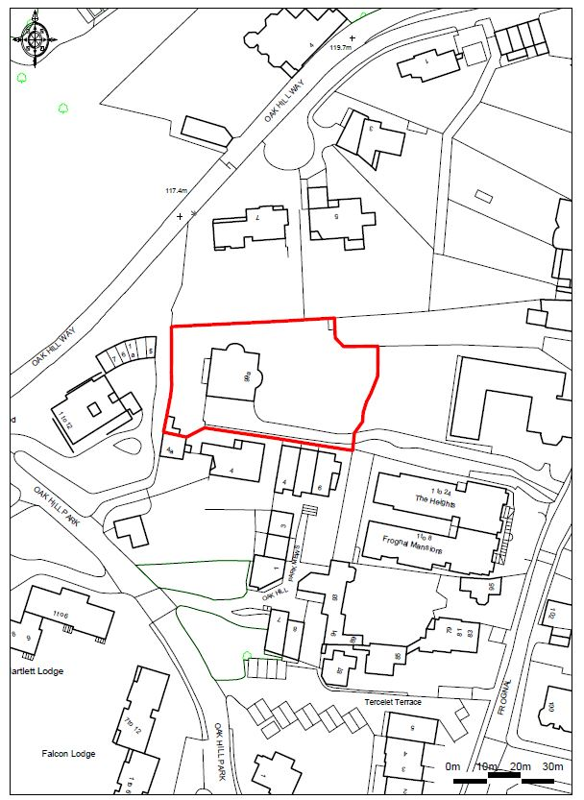

Location Plan (NTS)

The site is located to the rear of St. Dorothy Convent, Frognal. Frognal is a two way local road, connecting Finchley Road (A41) in the south and Branch Hill and Lower Terrace at the north. Its upper end is near Spaniards Road (B519) to the north and Hampstead High Street (A502) to the east. The site has good transport links being within walking distance of Hampstead underground Station providing access to the Northern Line. Several bus routes also run close to the site along Finchley Road, Rosslyn Hill and Fitzjohn’s Avenue.

The site is accessed via a private driveway leading of Frognal, bordered on all sides by residential properties and which negotiates an incline of approx. 5-10 meters level difference. The plot, 99a Frognal was created and developed in the early 70s as a single family house. The site is approximately rectangular in shape measuring 30m north to south and 55m east to west. The area is characterised by relatively steep topography creating many level changes and varies architectural / urban settings.

7. Please provide a very brief description of the construction works including the size and nature of the development and details of the main issues and challenges (e.g. narrow streets, close proximity to residential dwellings etc).

The construction works include the demolition of the existing detached two-storey house and erection of a detached three storey house with basement extending to depths of 4.0m and 6.0m. The proposed construction technique will include contiguous piling as specified in the preliminary construction drawings (please see STS drawings: 1706-1057-P11 and P12). The proposed basement occupies the entire footprint of the house and it will be formed in reinforced concrete with the retaining walls formed using contiguous bored piles all around the perimeter. In total, some 219 piles will be required to form the retaining walls and also further piles to support the superstructure. Further piles will be required to support the base slab and the internal walls. The superstructure is far less complex and comprised of a series of loadbearing walls supporting the steel and timber framed floors and roof.

The proposed square footage of house is in the region of 17,500 sq ft.

Please see the accompanying drawings showing Construction Management Plan: 1706-1057: TP1 to TP7 (revision P6) as well as the tracking diagrams produced.

8. Please identify the nearest potential receptors (dwellings, business, etc.) likely to be affected by the activities on site (i.e. noise, vibration, dust, fumes, lighting etc.).

Whilst the site is large, it is neigbouring a number of properties around all four boundary lines. Furthermore, other properties which adjoin the approach passageway are also likely to be affected. These includes properties in Oak Hill Way, Oak Hill Park and the Frognal. Please see the OS map extract below showing the adjoining properties.

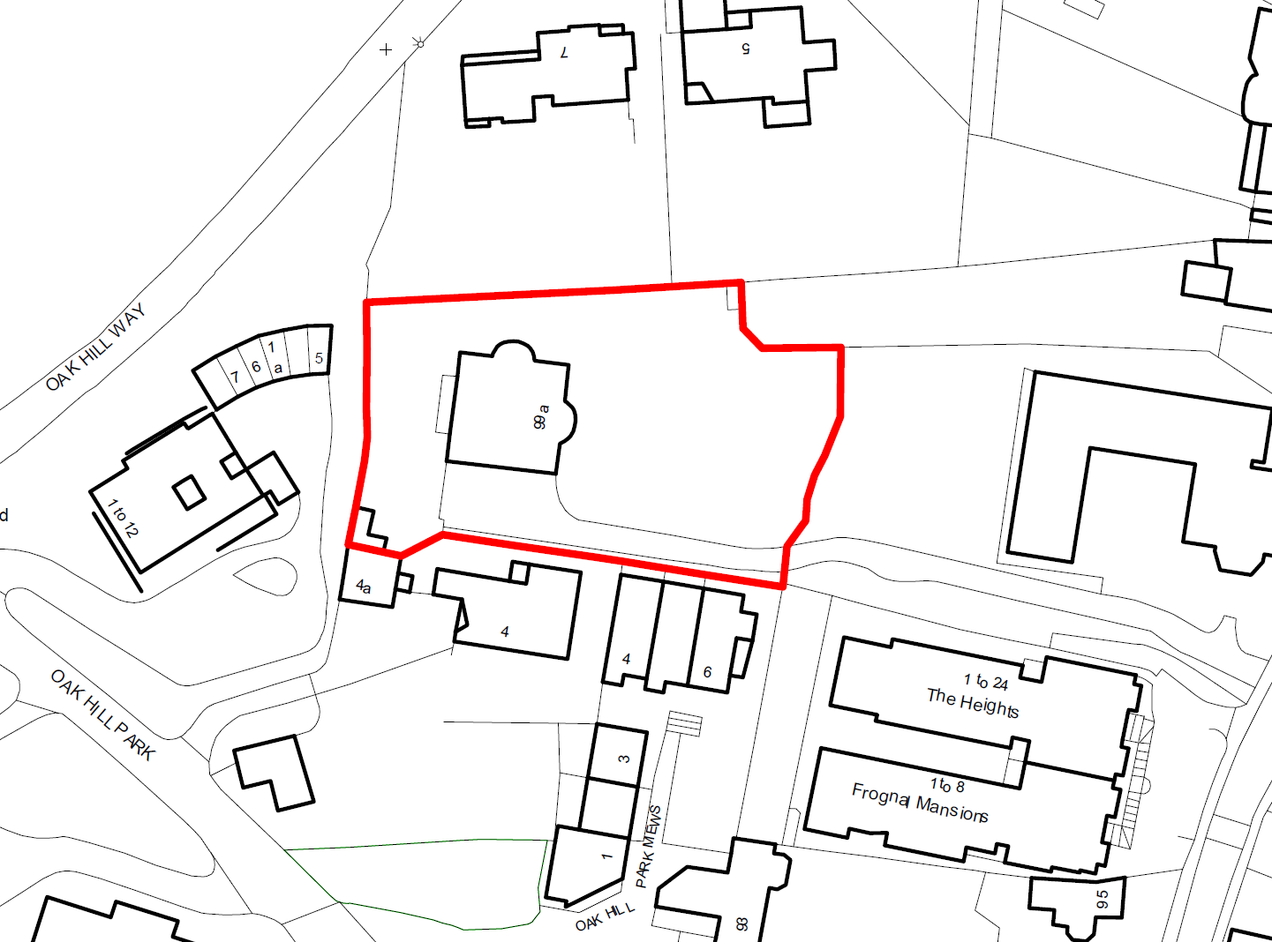

9. Please provide a scaled plan detailing the local highway network layout in the vicinity of the site. This should include details of on-street parking bay locations, cycle lanes, footway extents and proposed site access locations.

A location plan, a wider map of the area and a selection of photographs have been included in the attached drawings 1706-1057-TP1. Please refer to the drawing for more information.

As the site is fairly large and the house is set away from the main road, all of the construction operations will be carried out from within the footprint of the site. Parking spaces (3,4) will be provided on site.

As previously mentioned, the site can only be approached via a private driveway that steeply climbs some 5-10 meters, thus the contractor must coordinate traffic arrangements with other properties in use of private driveway, and liaise accordingly with the council transport department.

10. Please provide the proposed start and end dates for each phase of construction as well as an overall programme timescale. (A Gantt chart with key tasks, durations and milestones would be ideal).

Final time scales to be confirmed. The works are expected to resume in late 2018 or early 2019 and should take around 22 months to complete.

11. Please confirm the standard working hours for the site, noting that the standard working hours for construction sites in Camden are as follows:

* 8.00am to 6pm on Monday to Friday
* 8.00am to 1.00pm on Saturdays
* No working on Sundays or Public Holidays

We confirm that the working hours for the site will be as follows:

* 8.00am to 6pm on Monday to Friday
* 8.00am to 1.00pm on Saturdays
* No working on Sundays or Public Holidays

12. Please indicate if any changes to services are proposed to be carried out that would be linked to the site during the works (i.e. connections to public utilities and/or statutory undertakers’ plant). Larger developments may require new utility services. If so, a strategy and programme for coordinating the connection of services will be required. If new utility services are required, please confirm which utility companies have been contacted (e.g. Thames Water, National Grid, EDF Energy, BT etc.) You must explore options for the utility companies to share the same excavations and traffic management proposals. Please supply details of your discussions.

Please note that existing connections within the site will be utilized (gas, water, etc). The proposed works are unlikely to affect any services outside of the footprint of the site or shared services. A full services search shall be carried out prior to resuming the works.

Community Liaison

**A neighbourhood consultation process must have been undertaken prior to submission of the CMP first draft. This consultation must relate to construction impacts, and should take place following the granting of planning permission in the lead up to the submission of the CMP. A consultation process specifically relating to construction impacts must take place regardless of any prior consultations relating to planning matters. This consultation must include all of those individuals that stand to be affected by the proposed construction works. These individuals should be provided with a copy of the draft CMP, or a link to an online document. They should be given adequate time with which to respond to the draft CMP, and any subsequent amended drafts. Contact details which include a phone number and email address of the site manager should also be provided.**

Significant time savings can be made by running an effective neighbourhood consultation process. This must be undertaken in the spirit of cooperation rather than one that is dictatorial and unsympathetic to the wellbeing of local residents and businesses.

These are most effective when initiated as early as possible and conducted in a manner that involves the local community. Involving locals in the discussion and decision making process helps with their understanding of what is being proposed in terms of the development process. **The consultation and discussion process should have already started, with the results incorporated into the CMP first draft submitted to the Council for discussion and sign off.**This communication should then be ongoing during the works, with neighbours and any community liaison groups being regularly updated with programmed works and any changes that may occur due to unforeseen circumstances through newsletters, emails and meetings.

Please note that for larger sites, details of a construction working group may be required as a separate S106 obligation. If this is necessary, it will be set out in the S106 Agreement as a separate requirement on the developer.

**Cumulative impact**

Sites located within high concentrations of construction activity that will attract large numbers of vehicle movements and/or generate significant sustained noise levels should consider establishing contact with other sites in the vicinity in order to manage these impacts.

**The Council can advise on this if necessary.**

**13. Consultation**

The Council expects meaningful consultation. For large sites, this may mean two or more meetings with local residents **prior to submission of the first draft CMP**.

Evidence of who was consulted, how the consultation was conducted and a summary of the comments received in response to the consultation should be included. Details of meetings including minutes, lists of attendees etc. should be appended.

In response to the comments received, the CMP should then be amended where appropriate and, where not appropriate, a reason given. The revised CMP should also include a list of all the comments received. Developers are advised to check proposed approaches to consultation with the Council before carrying them out. If your site is on the boundary between boroughs then we would recommend contacting the relevant neighbouring planning authority.

Please provide details of consultation of draft CMP with local residents, businesses, local groups (e.g. residents/tenants and business associations) and Ward Councillors.

A copy of the Draft CMP has been be posted to neighbours for consultation and feedback on 12th June 2018.

The feedback was reviewed and constructive feedback implemented within this CMP. Please see the Consultation Report Attached.

**14. Construction Working Group**

Please provide details of community liaison proposals including any Construction Working Group that will be set up, addressing the concerns of the community affected by the works, the way in which the contact details of the person responsible for community liaison will be advertised to the local community, and how the community will be updated on the upcoming works i.e. in the form of a newsletter/letter drop, or weekly drop in sessions for residents.

n/a

**15. Schemes**

Please provide details of your ‘Considerate Constructors Scheme’ registration, and details of any other similar relevant schemes as appropriate. Contractors will also be required to follow the “[Guide for Contractors Working in Camden](http://www.camden.gov.uk/ccm/cms-service/download/asset?asset_id=799001)” also referred to as “[Camden’s Considerate Contractors Manual](http://www.camden.gov.uk/ccm/cms-service/download/asset?asset_id=799001)”.

The contractor will be ‘Considerate Constructors Scheme’ registered. He has worked in the area before and is acquainted with the council and local requirements.

CCS registration number is C1779.

**16. Neighbouring sites**

Please provide a plan of existing or anticipated construction sites in the local area and please state how your CMP takes into consideration and mitigates the cumulative impacts of construction in the vicinity of the site. The council can advise on this if necessary.

We are not aware of any substantial building sites in the immediate proximity of the site.

# Transport

**This section must be completed in conjunction with your principal contractor. If one is not yet assigned, please leave the relevant sections blank until such time when one has been appointed.**

Camden is a CLOCS Champion, and is committed to maximising road safety for Vulnerable Road Users (VRUs) as well as minimising negative environmental impacts created by motorised road traffic. As such, all vehicles and their drivers servicing construction sites within the borough are bound by the conditions laid out in the [CLOCS Standard.](http://www.clocs.org.uk/)

This section requires details of the way in which you intend to manage traffic servicing your site, including your road safety obligations with regard to VRU safety. It is your responsibility to ensure that your principal contractor is fully compliant with the terms laid out in the CLOCS Standard. It is your principal contractor’s responsibility to ensure that all contractors and sub-contractors attending site are compliant with the terms laid out in the CLOCS Standard.

Checks of the proposed measures will be carried out by the council to ensure compliance. Please refer to the CLOCS Standard when completing this section. Guidance material which details CLOCS requirements can be accessed [here](http://www.camden.gov.uk/ccm/cms-service/stream/asset?asset_id=3550016&), details of the monitoring process are available [here](http://www.camden.gov.uk/ccm/cms-service/stream/asset?asset_id=3550014&).

Please contact [CLOCS@camden.gov.uk](mailto:CLOCS@camden.gov.uk) for further advice or guidance on any aspect of this section.

**Please refer to the CLOCS Overview and Monitoring Overview documents referenced above which give a breakdown of requirements.**

**CLOCS Contractual Considerations**

17. Name of Principal contractor:

WS Building Contractors Ltd

Company Reg no: 10250008

Address: 14 New Oak Road N2 8LN

Contact person-Site manager: Mr Mick Niedzwiedz [07481258797](tel:07481%20258797)

18. Please submit the proposed method for checking operational, vehicle and driver compliance with the CLOCS Standard throughout the duration of the contract (please refer to our [CLOCS Overview document](http://www.camden.gov.uk/ccm/cms-service/stream/asset?asset_id=3550016&) and [Q18 example response](http://www.camden.gov.uk/ccm/cms-service/stream/asset?asset_id=3550015&)).

FORS Bronze accreditation as a minimum will be a contractual requirement, FORS Silver or Gold operators will be appointed where possible. Where FORS Bronze operators are appointed, written assurance will be sought from contractors that all vehicles over 3.5t are equipped with additional safety equipment (as per CLOCS Standard P13), and that all drivers servicing the site will have undertaken approved additional training

CLOCS Compliance will be included as a contractual requirement.

Desktop checks: Desktop checks will be made against the FORS database of trained drivers and accredited companies as outlined in the CLOCS Standard Managing Supplier Compliance guide. These will be carried out as per a risk scale based on that outlined in the CLOCS Managing Supplier Compliance guide.

Site checks: Checks of FORS ID numbers will form part of the periodic checks and will be carried out as per an appropriate risk scale. Random spot checks will be carried out by site staff on vehicles and drivers servicing the site at a frequency based on the aforementioned risk scale. These will include: evidence of further training, license checks, evidence of routing information, and checks of vehicle safety equipment.

Results from these checks will be logged and retained, and enforced upon accordingly.

Where the contractors own vehicles and drivers are used the above approach will be modified accordingly.

Collision reporting: data will be requested from operators and acted upon when necessary.

19. Please confirm that you as the client/developer and your principal contractor have read and understood the [CLOCS Standard](http://www.clocs.org.uk/wp-content/uploads/2015/05/CLOCS-Standard-v1.2-APRIL_15.pdf) and included it in your contracts. Please sign-up to join the [CLOCS Community](http://www.clocs.org.uk/links-to-partners/) to receive up to date information on the standard by expressing an interest online.

I confirm that I have included the requirement to abide by the CLOCS Standard in my contracts to my contractors and suppliers:

A signed confirmation letter shall be provided by the contractor prior to the start of the works and forwarded to the council stating that the he has read and understood the CLOCS Standard.

Please contact [CLOCS@camden.gov.uk](mailto:CLOCS@camden.gov.uk) for further advice or guidance on any aspect of this section.

**Site Traffic**

**Sections below shown in blue directly reference the CLOCS Standard requirements. The CLOCS Standard should be read in conjunction with this section.**

**20. Traffic routing**: *“Clients shall ensure that a suitable, risk assessed vehicle route to the site is specified and that the route is communicated to all contractors and drivers. Clients shall make contractors and any other service suppliers aware that they are to use these routes at all times unless unavoidable diversions occur.”* (P19, 3.4.5)

Routes should be carefully considered and risk assessed, taking into account the need to avoid where possible any major cycle routes and trip generators such as schools, offices, public buildings,museums etc. Where appropriate, on routes that use high risk junctions (i.e. those that attract high volumes of cycling traffic) installing Trixi mirrors to aid driver visibility should be considered.

Consideration should also be given to weight restrictions, low bridges and cumulative impacts of construction (including neighbouring construction sites) on the public highway network. The route(s) to and from the site should be suitable for the size of vehicles that are to be used.

a. Please indicate routes on a drawing or diagram showing the public highway network in the vicinity of the site including details of how vehicles will be routed to the [Transport for London Road Network](http://www.lscp.org.uk/lrsu/engineering_tlrn.html) (TLRN) on approach and departure from the site.

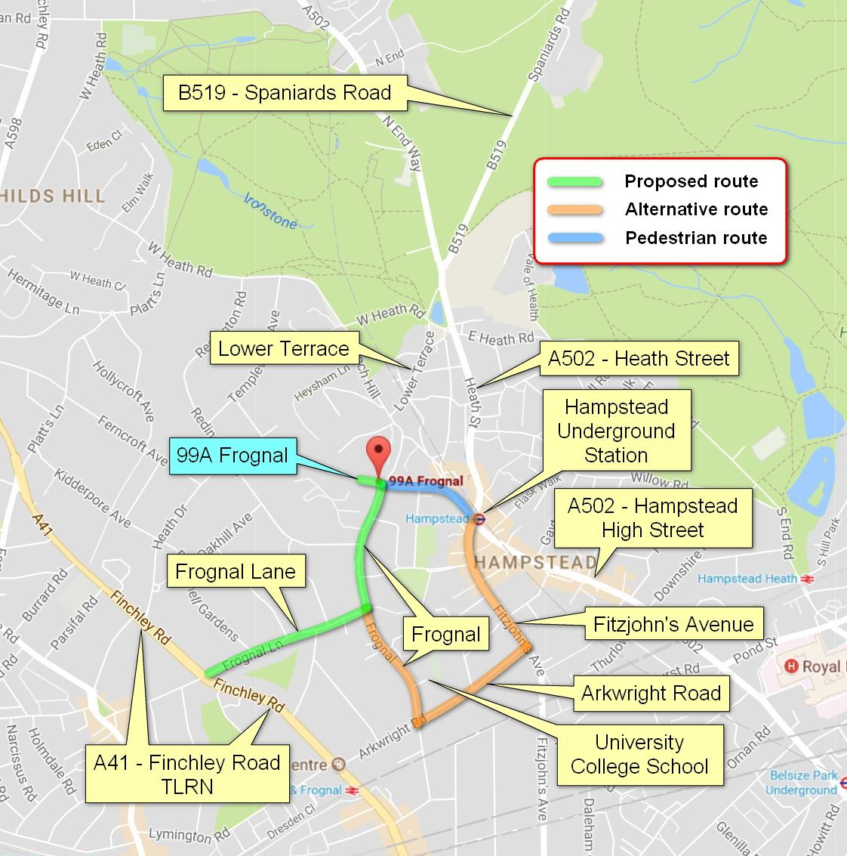Map Showing Proposed Traffic Routes (NTS) - Courtesy of Google Maps

Frognal is a two way road, connecting Finchley Road (A41) in the south and Branch Hill and Lower Terrace at the north. Its upper end is near Spaniards Road (B519) to the north and Hampstead High Street (A502) to the east.

Proposed route for all construction vehicles, for both approach and departure, will be: Finchley Road (A41) – Frognal Lane – Frognal. Proposed route for those vehicles is shown in green on the map above and is the nearest possible route to *Transport for London Road Network* (TLRN).

A41 - Finchley Road is part of this network.

If vehicles need to be routed from the East, alternative route is shown in orange and will be: Heath Street – Fitzjohn’s Avenue – Arkwright Road – Frognal. Proposed route via Finchley Road and Frognal Lane is still preferable. Lower Terrace is not suitable as an HGV route and should be avoided.

Proposed pedestrian route from Hampstead Underground Station is shown in blue and will be: Underground Station – Holly Hill, up to the footpath by the left side – left to Mount Vernon – path to Fronal. (approx. 5 min walk)

b. Please confirm how contractors, delivery companies and visitors will be made aware of the route (to and from the site) and of any on-site restrictions, prior to undertaking journeys.

All deliveries will be planned to take place outside both the morning and afternoon peak hours, and will be limited between 09:30 and 16:30hrs, Monday to Friday. As a school is near the private driveway, deliveries will be restricted to between 9.30am to 3pm, Monday to Friday, during term time. There will be no deliveries or collections on Saturdays, Sundays or Bank Holidays. Particularly noisy operations should also be limited to these hours to minimise disturbance to the residents. These will normally be carried out on daily basis, but should not take longer than 20-30 minutes. The deliveries will be co-ordinated to prevent multiple traffic movements during the same period and reduce congestion during the busy hours. The Traffic Information Leaflet included in the Appendix shall be distributed to all sub-contractors and deliveries drivers.

**21. Control of site traffic, particularly at peak hours**: “*Clients shall consider other options to plan and control vehicles and reduce peak hour deliveries”* (P20, 3.4.6)

Construction vehicle movements are generally acceptable between 9.30am to 4.30pm on weekdays and between 8.00am and 1.00pm on Saturdays). If there is a school in the vicinity of the site or on the proposed access and/or egress routes, then deliveries must be restricted to between 9.30am and 3pm on weekdays during term time. (Refer to the [*Guide for Contractors Working in Camden*](http://www.camden.gov.uk/ccm/cms-service/download/asset?asset_id=799001)).

A delivery plan should ensure that deliveries arrive at the correct part of site at the correct time. Instructions explaining such a plan should be sent to all suppliers and contractors**.** Consideration should be given to the location of any necessary holding areas for large sites with high volumes of traffic. Vehicles must not wait or circulate on the public highway. Whilst deliveries should be given set times to arrive, dwell and depart, no undue time pressures should be placed upon the driver at any time.

a. Please provide details of the typical sizes of all vehicles and the approximate frequency and times of day when they will need access to the site, for each phase of construction.You should estimate the average daily number of vehicles during each major phase of the work, including their dwell time at the site. High numbers of vehicles per day and/or long dwell times may require vehicle holding procedures.

A series of drawings have been produced detailing the proposed site arrangement during all stages of construction. This section of the report should be read in conjunction with the attached drawings 1706-1057-TP1 to TP7 (revision P6).

Two distinct stages of works can be identified which will require very different construction traffic and temporary storage strategies. Stages 2, 3, 4 and 5 involve the large amount of demolitions and clearing works with the demolition of the existing house, the excavation and concreting of the new basement shell. Such works involve the removal of large amount of spoil and other materials and the delivery of concrete. All spoil shall be removed from site using 3.5t vehicles. Concrete will be mixed on-site – 2No. mixing silos to be provided. Concrete constituents to be brought in using 3.5t vehicles and shall be stockpiled on-site for larger pours. A small pump shall be provided near the mixing silos. A banksmen will be in attendance to ensure that the traffic is regulated and to assist all driver when entering and leaving the approach driveway from the Frognal. It is also task to ensure that any debris are swept from the road on completion of these activities.

The use of HGVs shall be discouraged and limited to 2 per week max for the delivery of plant and oversized materials only.

All deliveries and collection of site rubbish will be planned to take place outside both the morning and afternoon peak hours, and will be limited between 09:00 and 17:00hrs.

Delivery vehicles will only attend site between 10am and 3pm to avoid residential disruption. Particularly noisy operations should be also limited to these hours to minimise disturbance to the residents. Assistance will be provided to ensure safe and efficient passage for these vehicles. Given that driveway to the site is not a major through-route, this arrangement should be adequate.

The amount of waste removals and materials deliveries should decrease significantly once the new basement shell has been constructed. Again, vans sized vehicles shall be used.

All site visitors and consultants in charge of the Project Management, H&S, Building Control, etc. are not allowed to wait on the street for such reasons and should use local garages and pay&display car parks; vehicles are only allowed to stop at the site to load/unload of goods/materials or actively engage on construction activity.

The amount of construction traffic will vary with each stage of the works. Therefore, we anticipate a frequent debris and refuse removals during the demolition and excavation works and frequent concrete deliveries during construction of the basement, with a number of specialist deliveries vehicles as the works progress towards the finishing stages. However, as a general guidance, we provide the following numbers for smaller vehicles during all stages of construction works:

**Who Purpose Frequency Approximate Vehicle  
 Duration Type**

***Stages 2, 3, 4, 5 & 6 - Substructure and superstructure works***

The Main Contractor General Delivery/Collection Daily (2-3) 20-30 minutes 2

The Main Contractor Project Management Daily 20-30 minutes 1

Building Control Review of Works Twice a week 20-30 minutes 1

The Main Contractor Health & Safety Weekly 20-30 minutes 1

Furthermore, we have provided following numbers for delivery vehicles (types 2&3) and each construction stage, as their number will vary from stage to stage:

**Who Purpose Frequency Approximate Vehicl Duration Type**

***Stage 2 - Demolition works***

The Main Contractor Removal of Refuse Daily (8-10) 20-30 minutes 2

The Main Contractor Plant Delivery / Oversize Refuse 2 weekly max 20-30 minutes 3

***Stage 3 - Piling works***

The Main Contractor Removal of Spoil Daily (3-4) 20-30 minutes 2

The Main Contractor Concrete Constituents Daily (3-4) 20-30 minutes 2

The Main Contractor Plant Delivery / Oversized Materials 2 weekly max 20-30 minutes 3

***Stage 4 - Excavation of the new basement shell***

The Main Contractor Removal of Spoil Daily (8-10) 20-30 minutes 2

The Main Contractor Plant Delivery / Oversized Materials 2 weekly max 20-30 minutes 3

***Stage 5 - Construction of the basement shell***

The Main Contractor Removal of Spoil Daily (1-2) 20-30 minutes 2

The Main Contractor Concrete Constituents Daily (8-10) 20-30 minutes 2

The Main Contractor Plant Delivery / Oversized Materials 2 weekly max 20-30 minutes 3

***Stage 6 - Superstructure works***

Construction suppliers Construction materials Daily (5-6) 20-30 minutes 2

The Main Contractor Removal of Refuse Daily 20-30 minutes 2

The Main Contractor Plant Delivery / Oversized Materials 2 weekly max 20-30 minutes 3

Vehicle type: 1=car/small van, 2=Large van / 3.5t lorry, 3=4 Wheel Delivery lorry 18t or Equivalent

Note that this does not include visits by the professional supervision, party wall surveyors and other parties involved in the project, as well as other sub-contractors involved in the later stages of the works. N.B. Delivery vehicles (vehicle type 2 & 3) can only attend site between 10am and 3pm to avoid residential disruption.

**Typical size of vehicles** (overall dimensions)

Vehicle Length Width Height

Delivery lorry 6.62m 2.50m 3.35m

Large van / 3.5t Lorry 5.88m 2.00m 2.58m

Trailer mounted concrete pump 5.26m 1.93m 2.00m

Maximum size of the vehicle that can attend the site is: 7.4m in length (2 axles), 2.5m in width and 18t (weight fully loaded). Vehicles larger than this must not attend the site.

b. Please provide details of other developments in the local area or on the route.

No other developments are proposed currently on the route that we are aware of.

c. Please outline the system that is to be used to ensure that the correct vehicle attends the correct part of site at the correct time.

Driveway towards 99a Frognal is a private driveway, thus this arrangement should be adequate for the duration of the works. Assistance will be provided to ensure safe and efficient passage for large vehicles. As the road cannot be closed and because of need to maintain vehicle and pedestrian flow, two banksman will be in attendance for the duration of all loading and offloading operations. It is also his task to ensure that any debris are swept from the road on completion of these activities.

Again, all site visitors and consultants in charge of the Project Management, H&S, Building Control, etc. are not allowed to wait on the street for such reasons and should use local garages and pay&display car parks; vehicles are only allowed to stop at the site to load/unload of goods/materials or actively engage on construction activity.

d. Please identify the locations of any off-site holding areas (an appropriate location outside the borough may need to be identified, particularly if a large number of delivery vehicles are expected) and any measures that will be taken to ensure the prompt admission of vehicles to site in light of time required for any vehicle/driver compliance checks. Please refer to question 24 if any parking bay suspensions will be required for the holding area.

There will be no off-site holding areas.

e. Please provide details of any other measures designed to reduce the impact of associated traffic (such as the use of [construction material consolidation centres](https://www.google.co.uk/url?sa=t&rct=j&q=&esrc=s&source=web&cd=2&cad=rja&uact=8&ved=0ahUKEwi5hKjPiLjRAhVqLcAKHQduC_gQFggkMAE&url=http%3A%2F%2Fcontent.tfl.gov.uk%2Fdirectory-london-construction-consolidation-centres.pdf&usg=AFQjCNFhB34aaqw3M3fmDpJYUUBw_PjbdA&sig2=KXhGnTR3slzf0kN4XMOcQg&bvm=bv.143423383,d.ZWM)).

Appropriate call-up procedures shall be employed to ensure that vehicles are not waiting in the road and the deliveries shall be stacked.

No deliveries will take place during the morning and afternoon peak hours.

All delivery vehicles attending the site will be fitted with white noise audible reverse alerts, or alerts that can be disabled. The vehicles should avoid reversing up the driveway as it is possible to perform a three point turn on-site. If reversing into the site for whatever reason, the audible warning must be disabled and only white noise reverse alerts shall be utilised.

HGVs reversing onto site to service the project will be kept under review. If this proves to be unworkable and results in excessive disruption to the surrounding residents and/or excessive disruption to the local highway whilst vehicles access the site at any point during the project, then the CMP will be revised accordingly at the Council’s request.

The general use of HGVs to service the project is discouraged. The bulk of refuse removal and materials delivery shall be handled using 3.5t vehicles. The use of HGVs to be limited to 2 per week for the delivery and removal of plant and oversized materials only. If this proves to be unworkable and results in excessive disruption to the surrounding residents and/or excessive disruption to the local highway whilst vehicles access the site at any point during the project, then the CMP will be revised accordingly at the Council’s request.

All workers, external consultants etc. shall be encouraged to use public transport to access the site. Only limited on-site parking provisions for vans shall be made available.

**22. Site access and egress:** “*Clients shall ensure that access to and egress from the site is appropriately managed, clearly marked, understood and clear of obstacles.”* (P18, 3.4.3)

Vehicles entering and leaving the site should be carefully managed, using gates that are clearly marked and free from obstacles. Traffic marshals must ensure the safe passage of all traffic on the public highway, in particular pedestrians and cyclists, when vehicles are entering and leaving site, particularly if reversing.

Traffic marshals, or site staff acting as traffic marshals, should hold the relevant qualifications required for directing large vehicles when reversing. Marshals should be equipped with ‘STOP – WORKS’ signs (not STOP/GO signs) if control of traffic on the public highway is required. Marshals should have radio contact with one another where necessary.

a. Please detail the proposed access and egress routes to and from the site

As previously stated, access and egress routes are from Frognal through private driveway. Driveway to the property is narrow making it difficult for large vehicles (6 wheelers or larger) to access the site. Therefore, access is limited to 2 axle - 4 wheelers with shorter wheelbase and improved turning circle. However, to limit disturbance, the bulk removal and delivery of material is to be handled w 3.5t vehicles.

The contractor shall take all necessary measures to prevent damage to the driveway. Entrance to the driveway shall be protected and clearly marked. All corners at the narrow zone of the driveway to be clearly marked and protected from damage during the site development. All vehicles should carefully go through the entrance and the driveway. The contractor should allow for all repairs due to the normal use of the driveway. Any undue damage shall be made good by the contractor, and it is his responsibility to ensure that the driveway remains undamaged as far as reasonable possible.

All vehicles should be able to perfirm a a three point turn on-site. can reverse up the driveway and exit the site facing forward. A traffic marshal shall be in attendance to assist all vehicles entering and leaving the driveway. Two traffic marshals are to be in attendance for the duration of all loading and offloading operations of HGVs. and shell ensure that the traffic is regulated. Traffic marshals to use STOP – WORKS signs for control of traffic on the highway. Please see the accompanying drawings showing Construction Transport Management Plan: 1706-1057: TP1 to TP7 (revision P6).

b. Please describe how the access and egress arrangements for construction vehicles will be managed.

Assistance will be provided to ensure safe and efficient passage for large vehicles. Vehicles entering and leaving the site should be carefully managed and a traffic marshal would be engaged to control traffic and particularly, large vehicles when reversing. Two marshals are required to assist all HGVs. If vehicles should reverse onto or off the site and the traffic on the highway is to be held in both directions, there may need to be three marshals in attendance (two of them controlling the traffic, whilst the manoeuvre is overseen by a third marshal).

It is also his task to ensure that any debris are swept from the road on completion of these activities.

c. Please provide swept path drawings for any tight manoeuvres on vehicle routes to and from the site including proposed access and egress arrangements at the site boundary (if necessary).

Please see the accompanying drawings showing Swept Path Analysis: 1706-1057: TD1 to TD7 (revision P1).

d. Provision of wheel washing facilities should be considered if necessary. If so, please provide details of how this will be managed and any run-off controlled.

Before any vehicle leaves the site it shall be checked for mud, detritus and spoil on the tyres and if required the tyres will be cleaned using jet wash. Wheel washing facilities will be provided and must be utilized for all vehicles leaving the site.  
Where the deposition of some dirt on the driveway is unavoidable, any mud/detritus shall be expeditiously cleared using street cleansing vehicles or similar.

**23. Vehicle loading and unloading:** *“Clients shall ensure that vehicles are loaded and unloaded on-site as far as is practicable.”* (P19, 3.4.4)

If this is not possible, Traffic Marshalls must ensure the safe passage of pedestrians, cyclists and motor traffic in the street when vehicles are being loaded or unloaded.

Please provide details of the parking and loading arrangements for construction vehicles with regard to servicing and deliveries associated with the site (e.g. delivery of materials and plant, removal of excavated material). This is required as a scaled site plan, showing all points of access and where materials, skips and plant will be stored, and how vehicles will access and egress the site. If loading is to take place off site, please identify where this is due to take place and outline the measures you will take to ensure that loading/unloading is carried out safely. Please outline in question 24 if any parking bay suspensions will be required.

A series of drawings has been produced detailing the proposed site arrangement during all stages of construction. The report should be read in conjunction with the attached drawings 1706-1057-TP1 to TP7 (revision P6).

**Highway interventions**

**Please note that Temporary Traffic Orders (TTOs) and hoarding/scaffolding licenses may be applied for prior to CMP submission but won’t be granted until the CMP is signed-off.**

**If the site is on or adjacent to the TLRN, please provide details of preliminary discussions with Transport for London in the relevant sections below.**

**24. Parking bay suspensions and temporary traffic orders**

Please note, parking bay suspensions should only be requested where absolutely necessary. Parking bay suspensions are permitted for a maximum of 6 months, requirement of exclusive access to a bay for longer than 6 months you will be required to obtain [Temporary Traffic Order (TTO)](http://camden.gov.uk/ccm/content/transport-and-streets/traffic-management/temporary-road-restrictions/) for which there is a separate cost.

Please provide details of any proposed parking bay suspensions and TTO’s which would be required to facilitate construction. **Building materials and equipment must not cause obstructions on the highway as per your Considerate Contractors obligations unless the requisite permissions are secured.**

Information regarding parking suspensions can be found [here.](http://www.camden.gov.uk/ccm/navigation/transport-and-streets/parking/parking-bay-suspensions/)

No parking suspensions proposed

**25. Scaled drawings of highway works**

Please note that use of the public highway for storage, site accommodation or welfare facilities is at the discretion of the Council and is generally not permitted. If you propose such use you must supply full justification, setting out why it is impossible to allocate space on-site. You must submit a detailed (to-scale) plan showing the impact on the public highway that includes the extent of any hoarding, pedestrian routes, parking bay suspensions and remaining road width for vehicle movements. We prefer not to close footways but if this is unavoidable, you should submit a scaled plan of the proposed diversion route showing key dimensions.

a. Please provide accurate scaled drawings of any highway works necessary to enable construction to take place (e.g. construction of temporary vehicular accesses).

No highway works proposed – all proposed works to be carried out within the confines of the site.

b.Please provide details of all safety signage, barriers and accessibility measures such as ramps and lighting etc.

As the site is fairly large and the house is set away from the main road, it is proposed to carry out all of the works from within the site, and the site hoarding will need to be put up all around the perimeter of the property. It will provide protection to the pedestrians and vehicles and also acts as a noise barrier. Adequate lighting and signage will be provided to the temporary hoarding. The material warehouses, site offices, welfare facilities, etc will be located on-site during all stages of the works.

Site entrance warning signs won’t be necessary given the use of marshals. These will unnecessarily clutter up the footway.

We recommend a traffic mirror to be installed at the junction between Frognal and Oak Hill Park in order to assist drivers turning right out of Oak Hill Park during construction.

**26. Diversions**

Where applicable, please supply details of any diversion, disruption or other anticipated use of the public highway during the construction period (alternatively a plan may be submitted).

No diversions proposed. Please note that no vehicles are to enter or use the private roads of the Oak Hill Park Estate. If access is required for whatever reason, please contact Claire Newbrook of Faraday Property Management on 020 3206 0066

**27. VRU and pedestrian diversions, scaffolding and hoarding**

Pedestrians and/or cyclist safety must be maintained if diversions are put in place. Vulnerable footway users should also be considered. These include wheelchair users, the elderly, those with walking difficulties, young children, those with prams, the blind and partially sighted. Appropriate ramping must be used if cables, hoses, etc. are run across the footway.

Any work above ground floor level may require a covered walkway adjacent to the site. A licence must be obtained for scaffolding and gantries. The adjoining public highway must be kept clean and free from obstructions. Lighting and signage should be used on temporary structures/skips/hoardings etc.

A secure hoarding will generally be required at the site boundary with a lockable access.

a. Please provide details describing how pedestrian and cyclist safety will be maintained, including any proposed alternative routes (if necessary), and any Traffic Marshall arrangements.

A secure hoarding will be provided at the site boundary with a lockable access as indicated in the attached CTMP drawings for each stage of works.

No diversion of pedestrian and cycling routes proposed.

b. Please provide details of any temporary structures which would overhang the public highway (e.g. scaffolding, gantries, cranes etc.) and details of hoarding requirements or any other occupation of the public highway.

No temporary structures which would overhang the public highway are proposed.

There will be a need to erect scaffolding at some stage of the works - however it shall be contained fully on-site.

SYMBOL IS FOR INTERNAL USE

# Environment

To answer these sections please refer to the relevant sections of **Camden’s Minimum Requirements for Building Construction (**[**CMRBC**](http://www.camden.gov.uk/ccm/cms-service/download/asset?asset_id=3257318)**).**

28. Please list all [noisy operations](http://www.camden.gov.uk/ccm/content/environment/environmental-health--consumer-protection/noise/reducing-noise/noise-from-construction-sites.en?page=2)  and the construction method used, and provide details of the times that each of these are due to be carried out.

Please refer to the noise/vibration&dust report done by noise consultant company - NMS Acoustics (Principal consultant: Mr Simon Longo).

29. Please confirm when the most recent noise survey was carried out (before any works were carried out) and provide a copy. If a noise survey has not taken place please indicate the date (before any works are being carried out) that the noise survey will be taking place, and agree to provide a copy.

A noise survey was carried prior to resuming the works. Please refer to the noise/vibration&dust report done by noise consultant company - NMS Acoustics (Principal consultant: Mr Simon Longo).

30. Please provide predictions for [noise](http://www.camden.gov.uk/ccm/content/environment/environmental-health--consumer-protection/noise/reducing-noise/noise-from-construction-sites.en?page=2) and vibration levels throughout the proposed works.

Please refer to the noise/vibration&dust report done by noise consultant company - NMS Acoustics (Principal consultant: Mr Simon Longo).

31. Please provide details describing mitigation measures to be incorporated during the construction/[demolition](http://www.camden.gov.uk/ccm/navigation/environment/building-control/demolition/) works to prevent noise and vibration disturbances from the activities on the site, including the actions to be taken in cases where these exceed the predicted levels.

Please refer to the noise/vibration&dust report done by noise consultant company - NMS Acoustics (Principal consultant: Mr Simon Longo).

In addition, all delivery vehicles attending the site will be fitted with white noise audible reverse alerts, or alerts that can be disabled. The vehicles should avoid reversing up the driveway as it is possible to perform a three point turn on-site. If reversing into the site for whatever reason, the audible warning must be disabled and only white noise reverse alerts shall be utilised.

32. Please provide evidence that staff have been trained on BS 5228:2009

To be provided

33. Please provide details on how dust nuisance arising from dusty activities, on site, will be prevented.

As above, all debris must be wetted out to. Dust will be produced only in first stages of demolition works. Dust screens shall be installed if necessary to protect the adjoining properties. For more information, please refer to the Environtmental report by NMS Acoustics (Principal consultant: Mr Simon Longo).

34. Please provide details describing how any significant amounts of dirt or dust that may be spread onto the public highway will be prevented and/or cleaned.

The proposed works will involve the removal of large quantities of spoil. Wheel washing facilities will be provided and must be utilized for all vehicles leaving the site.

Where the deposition of some dirt on the driveway is unavoidable, any mud/detritus shall be expeditiously cleared using street cleansing vehicles or similar.

Please refer to the noise/vibration&dust report done by noise consultant company - NMS Acoustics (Principal consultant: Mr Simon Longo).

35. Please provide details describing arrangements for monitoring of [noise](http://www.camden.gov.uk/ccm/content/environment/environmental-health--consumer-protection/noise/reducing-noise/noise-from-construction-sites.en?page=2), vibration and dust levels.

To be detailed following the noise survey. Please refer to the noise/vibration&dust report done by noise consultant company - NMS Acoustics (Principal consultant: Mr Simon Longo).

36. Please confirm that a Risk Assessment has been undertaken at planning application stage in line with the GLA policy. [The Control of Dust and Emissions During Demolition and Construction 2104 (SPG)](https://www.london.gov.uk/file/18750/download?token=zV3ZKTpP), that the risk level that has been identified, and that the appropriate measures within the GLA mitigation measures checklist have been applied. Please attach the risk assessment and mitigation checklist as an appendix.

To be provided by the contractor prior to resuming the works.

37. Please confirm that all of the GLA’s ‘highly recommended’ measures from the [SPG](https://www.london.gov.uk/file/18750/download?token=zV3ZKTpP) document relative to the level of risk identified in question 36 have been addressed by completing the [GLA mitigation measures checklist.](https://www.london.gov.uk/what-we-do/planning/implementing-london-plan/supplementary-planning-guidance/control-dust-and)

To be provided by the contractor prior to resuming the works.

38. If the site is a ‘High Risk Site’, 4 real time dust monitors will be required. If the site is a ‘Medium Risk Site’, 2 real time dust monitors will be required. The risk assessment must take account of proximity to sensitive receptors (e.g. schools, care homes etc), as detailed in the [SPG](https://www.london.gov.uk/file/18750/download?token=zV3ZKTpP). Please confirm the location, number and specification of the monitors in line with the SPG and confirm that these will be installed 3 months prior to the commencement of works, and that real time data and quarterly reports will be provided to the Council detailing any exceedances of the threshold and measures that were implemented to address these.

n/a

39. Please provide details about how rodents, including [rats](http://www.camden.gov.uk/ccm/content/environment/environmental-health--consumer-protection/pest-control/about-the-pest-control-service.en), will be prevented from spreading out from the site. You are required to provide information about site inspections carried out and present copies of receipts (if work undertaken).

The site is currently inhabited and is not expected to house a large population of rats. Please refer to the Site Survey Report by Protech Pest Solutions.

40. Please confirm when an asbestos survey was carried out at the site and include the key findings.

To be provided prior to resuming the works. No immediately identifiable asbestos materials identified (such as corrugated roofs or molded ceilings).

41. Complaints often arise from the conduct of builders in an area. Please confirm steps being taken to minimise this e.g. provision of a suitable smoking area, tackling bad language and unnecessary shouting.

This is a large site and the adjoining properties will not be in the immediate vicinity of the adjoining properties. Nevertheless, a suitable smoking area shall be provided and all complaints will be addressed immediately.

42. If you will be using non-road mobile machinery (NRMM) on site with net power between 37kW and 560kW it will be required to meet the standards set out below. The standards are applicable to both variable and constant speed engines and apply for both PM and NOx emissions.

**From 1st September 2015**

**(i) Major Development Sites** – NRMM used on the site of any major development will be required to meet Stage IIIA of EU Directive 97/68/EC

**(ii) Any development site within the Central Activity Zone -** NRMM used on any site within the Central Activity Zone will be required to meet Stage IIIB of EU Directive 97/68/EC

**From 1st September 2020**

**(iii) Any development site -** NRMM used on any site within Greater London will be required to meet Stage IIIB of EU Directive 97/68/EC

**(iv) Any development site within the Central Activity Zone -** NRMM used on any site within the Central Activity Zone will be required to meet Stage IV of EU Directive 97/68/EC

Please provide evidence demonstrating the above requirements will be met by answering the following questions:

1. Construction time period (mm/yy - mm/yy ): 22 months
2. Is the development within the CAZ? (Y/N): N
3. Will the NRMM with net power between 37kW and 560kW meet the standards outlined above? (Y/N):N
4. Please provide evidence to demonstrate that all relevant machinery will be registered on the NRMM Register, including the site name under which it has been registered:
5. Please confirm that an inventory of all NRMM will be kept on site and that all machinery will be regularly serviced and service logs kept on site for inspection:
6. Please confirm that records will be kept on site which details proof of emission limits, including legible photographs of individual engine plates for all equipment, and that this documentation will be made available to local authority officers as required:

SYMBOL IS FOR INTERNAL USE

# Agreement

The agreed contents of this Construction Management Plan must be complied with unless otherwise agreed in writing by the Council. This may require the CMP to be revised by the Developer and reapproved by the Council. The project manager shall work with the Council to review this Construction Management Plan if problems arise in relation to the construction of the development. Any future revised plan must be approved by the Council in writing and complied with thereafter.

It should be noted that any agreed Construction Management Plan does not prejudice further agreements that may be required such as road closures or hoarding licences.

**Please notify that council when you intend to start work on site. Please also notify the council when works are approximately 3 months from completion.**

**Signed:** 

**Date:** 01.08.2018

**Print Name:** Siavash Sharif

**Position:** Managing Director

Please submit to: [planningobligations@camden.gov.uk](mailto:planningobligations@camden.gov.uk)

End of form.

## 

## APPENDIX 1 Traffic Information Leaflet for Contractors, Deliveries and Visitors

**Traffic Information Leaflet and Call-up Procedure for Contractors, Deliveries and Visitors**

**99a Frognal London NW3 6XR**

**Ref:** **1706-1057-TIL**



1. All The delivery/collection vehicles shall enter the site from Frognal. Smaller vehicles can approach the road from the south from Finchley Road via Frognal Lane or from the north from Spaniard’s Road and North End Way via Lower Terrace and Frognal Rise, or from the south-east from Fitzjohn’s Avenue and Hampstead High Street (A502) via Holly Hill or Lower Terrace and Frognal Rise.
2. All site visitors and consultants in charge of the Project Management, H&S, Building Control, etc. can either park on-site or use the available on-street parking spaces.
3. Proposed route for all construction vehicles, for both approach and departure, will be: Finchley Road (A41) – Frognal Lane – Frognal. Proposed route for those vehicles is shown in green on the map above and is the nearest possible route to *Transport for London Road Network* (TLRN).

A41 - Finchley Road is part of this network.

If vehicles need to be routed from the East, alternative route is shown in orange and will be Heath Street – Fitzjohn’s Avenue – Arkwright Road – Frognal. Proposed route via Finchley Road and Frognal Lane is still preferable. Lower Terrace is not suitable as an HGV route and should be avoided.

Proposed pedestrian route from Hampstead Underground Station is shown in blue and will be: Underground Station – Holly Hill, up to the footpath by the left side – left to Mount Vernon – path to Fronal. (approx. 5 min walk)

1. Delivery vehicles can only attend site between 10am and 3pm to avoid residential disruption. The site is accessed through a narrow lane. All drivers must ensure that they are able to approach the site before attempting the journey. All drivers must be FORS Bronze or better accredited.
2. All refuse will be removed from site and all construction materials using 3.5t or equivalent vehicles. The use of HGVs to be limited to delivery and removal of plant and oversized materials only and will not exceed two HGV operations per week! Maximum size of the vehicle that can attend the site is: 7.4m in length (2 axles), 2.5m in width and 18t (weight fully loaded). Vehicles larger than this must not attend the site.
3. No vehicle holding should take place on Frognal or on the public highways. __________________________________ (* insert the name of the contractor’s site coordinator) is to be in charge of organizing all site visits, deliveries and material removals are stacked and that there are no ‘double bookings’. All drivers shall contact ________________ on ___________________ (* insert the name and telephone number of the contractor’s site coordinator) before attempting any journeys to the site. Liaise with refuse collection times to ensure no conflict in terms of deliveries etc.
4. In order to minimise the impact of traffic movements in Frognal and nearby roads, all construction vehicles should be timed to avoid the busiest hour periods and vehicle only should attend the site at any one time. Delivery vehicles should only be called to site when Frognal is safe and free from traffic and no stacking of vehicles should be allowed on the public highway. Employ 5 minutes call-up procedure to ensure no double booking
5. All delivery vehicles attending the site will be fitted with white noise audible reverse alerts, or alerts that can be disabled. The vehicles should avoid reversing up the driveway as it is possible to perform a three point turn on-site. If reversing into the site for whatever reason, the audible warning must be disabled and only white noise reverse alerts shall be utilised.
6. In the event that a complaint or concern is raised by residents on the number of incoming construction vehicles and disruptive effects to the local residents’, an immediate review and corrective action should be taken to address the problem.
7. Please see the Construction Management Plan ref. 1706-1057-CMP for further information.