ARichardson, Architect |  | 27 East Field, Oxford OX3 7SH  07860 919562  anthonyrichardson2@hotmail.co.uk

DESIGN & ACCESS STATEMENT
67 Minster Road
NW2 3SJ

Author: Mr A Richardson, Architect
Date: 4th October 2018
Proposal
This is a resubmission of application 2018/2668/P for changes to the roof which was withdrawn.

The new proposal has been simplified -
Add 3 new Velux windows to the front elevation and 1 Velux to the side elevation.
Add a window into the brick gable of the front elevation.

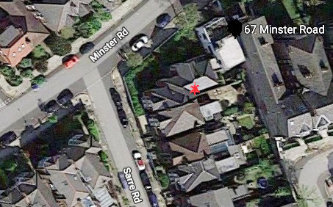
Aerial view. No.67 has a red asterisk

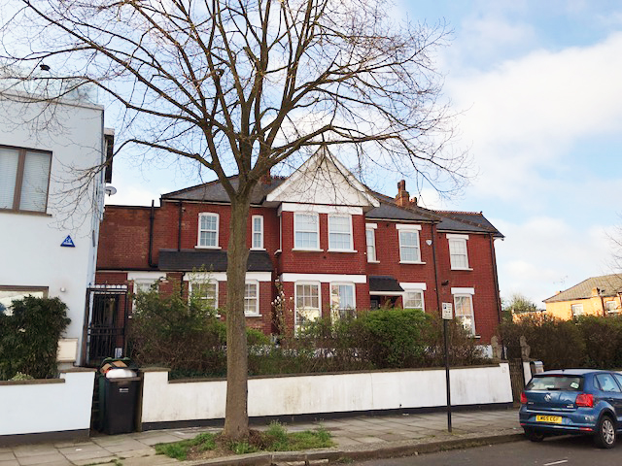
Front elevation
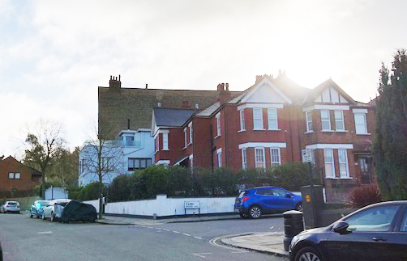
Side elevation
Design Proposals
Add 3 new Velux windows to the front elevation and 1 Velux to the side elevation.
Add a window into the brick gable of the front elevation.

This will provide light into the loft which will become usable as a recreation space for the children.

The is a current application for a Certificate of Lawfulness, 2018/4497/NEW, to create dormers on the rear elevation under permitted development.

Access Statement
There are no proposals to change the access to the front or rear yard.

