Agar Grove noise policy for

Demolition works.

Prevention

Demolition by nature is the period within a construction project with the highest potential to create noise pollution.

All noisy operation will be carried out within the stipulated time periods as listed below:

Time of operations and ancillary works which are audible at the site boundary shall normally be carried out between the following hours:

Mondays to Fridays 08.00 – 18.00

Saturdays 08.00 – 13.00

And at no time Sundays and Bank Holidays.

We will ensure our demolition contractor considers the production of noise within their demolition method statement, we will ensure they review the methodology of the actual dismantling of each building to minimise sound pollution during this period.

We will ensure the selection of the demolition plant is the quietest and newest vehicles/plant machinery available as reasonably practicable, all vehicles and mechanical plant used for the purpose of the works shall be fitted with effective exhaust silencers. All plant will be maintained in good and efficient working order. We will ensure all plant is operated in such a manner as to minimise noise emissions.

Any works being carried out within the buildings prior to demolition that will emit noise will be carried out with the windows and door shut where reasonably practicable.

Suppression

Suppression of noise during the demolition phase will be carried via a number of methods.

Installation of fully boarded perimeter fencing.

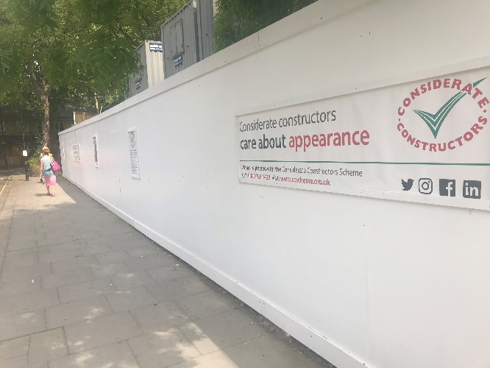

Noise control fencing material:

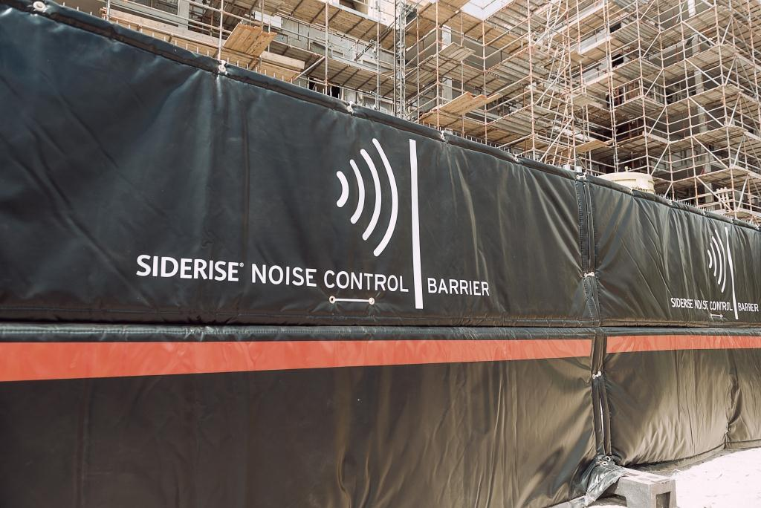

Soft drop zones:

Where reasonably practicable demolition material will be dropped onto a soft ground surface rather than a hard surface to reduce impact sound.

This could one of or a mixture of the following:

1. Grassed areas.
2. The use of hay bales to prevent impact sound
3. Ground protection matting.
4. Spoil heaps of sand or other soft aggregate materials.

Containment

Prior to any demolition works commencing and enabling period will take place, this will include the following:

1. Installation of fully boarded perimeter fencing.
2. Installation or establishing monitoring locations.
3. Selection, installation or purchasing of monitoring equipment.
4. Notification to surround properties.

The containment of noise is controlled via the suppression controls, however we need to measure the efficiency of the suppression to ensure the dust is being contained.

Therefore we will establish monitoring point around the boundary to allow measurement to be taken routinely.

**The measurement will be taken via two methods**:

The use of handheld device for short periods:

Product description:

Sound test-master: Noise level measuring instrument with integrated long-term storage. (See data sheet attached

The use of live monitoring points for prolonged periods of noisy works.

Product description:

Sound test-master: Noise level measuring instrument with integrated long-term storage. Mounted on a tripod or fixed to hoarding. (See data sheet attached)

Set points:

The Control of Noise at Work Regulations 2005 states:

The level at which employers must provide hearing protection and hearing protection zones is now 85 decibels (daily or weekly average exposure) and the level at which employers must assess the risk to workers' health and provide them with information and training is now 80 decibels. There is also an exposure limit value of 87 decibels, taking account of any reduction in exposure provided by hearing protection, above which workers must not be exposed.

Therefore where reasonably practicable the noise level at the boundary will not exceed 80 decibels for prolonged periods.

Prior to any works commencing we will carry out prediction of noise levels. These predicted noise levels will be include in the pre start onsite noise report. Where the measured noise levels are more than 3 dB (A) above the predicted noise levels or in the event of a complaint of noise an investigation shall be carried out to ascertain the cause of the exceedance or the complaint and to check that Best Practicable Means are being used to control the noise in accordance with the steps set out in the application for ‘prior consent’. Noise levels shall be reduced further if it is reasonably practicable to do so.

In the event of a Breach of set points:

In the event of a breach in the set point levels the live or hand held monitoring system will alert the site manager, who will cease all works and carry out an investigation.

The investigation will seek to answer the following questions:

1. What was the source of the breach?
2. Were prevention measures in place and being adhered to?
3. Were suppression measure in place and were they sufficient?

Once the investigation is carried out the following questions will be asked:

1. Can the methodology be changed?
2. Can the prevention measure be improved?
3. Can the suppression be improved or addition suppression measures put in place?

Once a remedial method, prevention measure and suppression measure has been agreed the works can proceed and will be monitored to ensure an improvement.