Agar Grove Dust Policy for

Demolition works.

Prevention

Demolition by nature is the period within a construction project with the highest potential to create dust.

Therefore we will ensure our demolition contractor considers the release of dust particles within their demolition method statement, we will ensure they review the methodology of the actual dismantling of each building to minimise the release of dust throughout there works.

We will ensure the demolition contactor removes all fixtures and fitting within the properties where reasonably practicable prior to the commencement of mechanical demolition. This will reduce the production of dust during the mechanical demolition phase.

All waste material will be stored in large metal bins/skips and will not be left on the floor for prolonged periods to reduce the risk of high winds moving dust particles around the project or into the surrounding area.

Hard core and concrete material will be store in stock piles and will be positioned away from site boundaries and the stock piles will be routinely damped down to minimise the release of dust particles.

Suppression

The main form of suppression that will be utilised during the demolition phase will be water suppression. Prior to any works commencing the demolition contactor will carry out an assessment for the amount and size of water supplies require to adequately facilitate their works.

Once this assessment has been carried out the relevant permits or applications will be made for metered water supplies from the local water distributor.

Various forms of water suppression will be used during demolition works they will be a mixture of the following:

*Cutting operations*

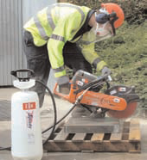

Proprietary water suppression will be used on all cutting devices.

Mechanical Demolition

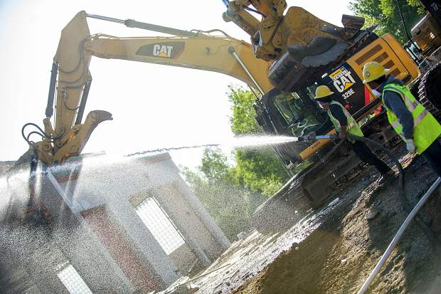

A fire hose will be used for direct suppression during mechanical demolition.

Mechanical Demolition

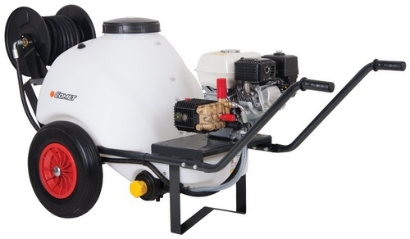

Jet washes with water storage tanks will be used to supress air born dust in difficult to reach locations.

Throughout demolition works

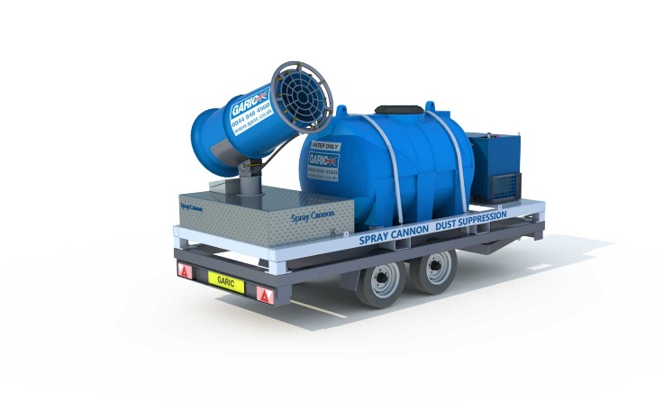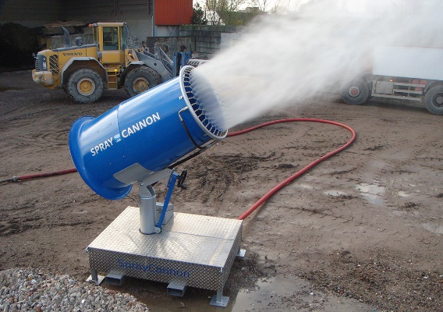

Purpose built dust suppression cannons will be used throughout the demolition phase to damp down areas and minimise airborne dust particles.

Containment

Prior to any demolition works commencing and enabling period will take place, this will include the following:

1. Installation of fully boarded perimeter fencing.
2. Installation or establishing monitoring locations.
3. Selection, installation or purchasing of monitoring equipment.
4. Notification to surround properties.

The containment of dust is controlled via the suppression controls, however we need to measure the efficiency of the suppression to ensure the dust is being contained.

Therefore we will establish monitoring point around the boundary to allow measurement to be taken routinely.

**The measurement will be taken via two methods**:

The use of handheld device for short periods:

Product description:

DustMate is a hand-held detector ideal for short term sampling. Highly effective for monitoring air quality within buildings and clean rooms. It measures TSP, PM10, PM2.5 and PM1 simultaneously in real time. Data can then be transferred to a PC via PC-Link. (see attached product information)

The use of live monitoring points throughout the project:

Product description:

The Osiris is a small and compact instrument that can be used to study short to long term particulate monitoring. Powered by various power options to suit your application. The Osiris can be used effectively to determine exceedance areas. (See attached product information)

Set points:

We will employ a specialist to install, commission and maintain the dust monitoring stations, prior to installation taking place a back ground dust level will taken and the set points will be agreed.

In the event of a Breach of set points:

In the event of a breach in the set point levels the live monitoring system will alert the site manager, who will cease all works and carry out an investigation.

The investigation will seek to answer the following questions:

1. What was the source of the breach?
2. Were prevention measures in place and being adhered to?
3. Were suppression measure in place and were they sufficient?

Once the investigation is carried out the following questions will be asked:

1. Can the methodology be changed?
2. Can the prevention measure be improved?
3. Can the suppression be improved or addition suppression measures put in place?

Once a remedial method, prevention measure and suppression measure has been agreed the works can proceed and will be monitored to ensure an improvement.