**Flat 4, 46 Chalcot Crescent, London, NW1 8YD**

**Design and Access Statement**

**The Proposal**

The proposal relates to the replacement of a defective uPVC double glazed window to the rear of the third floor. The new window will be of a different specification as outlined further below.

**The Property**

The property sits within a listed terrace of houses and dates from the mid 1800’s. The property is end of terrace on the east side of Chalcot Crescent, with an aspect over Chalcot Square and Sharples Hall Street to the front. To the rear there are views across private rear gardens and Central London. The building comprises of four flats set over five floors to include the lower ground, raised ground, first, second and third floors. The third floor comprises a modern extension with a mansard roof with views to the rear.

The building is of traditional construction with rendered elevations painted pastel blue. There is a two storey, single bay window to the front and there are wrought iron railings providing access to the lower ground floor flat and the bin enclosure. The front entrance comprises a porch with pillars and a Juliet balcony with wrought iron railings above. A series of five steps lead up to the porch from pavement level.

The subject property is accessed via the first floor and is situated over the second and third floor. The flat comprises two bedrooms, one bathroom and an open plan kitchen off the entrance hall.

**Planning History**

Recent and historic planning permission includes the following;

Reference: 2018/0915/L

Description: Removal of partition walls, installation of new bathroom and creation of new access to the roof.

Date: 5/7/18

Decision: Granted

Reference: 2004/3026/L

Description: Demolition of internal stud partition wall and its replacement with a new glass door and window at second floor level and proposed new structural glass floor to part of second floor, new pipe connection on front elevation and vent terminations on side elevation.

Date: 24/9/04

Decision: Granted

There has also been ongoing maintenance of a sycamore tree to the rear garden as part of TPO works dating back to 1986.

**The Proposed Design and Layout**

The proposed change includes the removal of a defective uPVC double glazed window with trapped condensation between the panes of glass. Furthermore the current design interrupts the view with thick uPVC plastic panelling. The proposed new window will include a new bespoke frame in a SSS finish. The new glass will comprise a triple glazed unit (glass specifications compromise of, from inside of the room 6mm Toughened Glass, 12mm BL12 Thermo bar, 6mm Toughened Glass, 14mm BL14 Thermo bar, 8mm Toughened Glass with Climaguard A+1.2)

**Summary**

The proposal is designed to replace a defective window that is obscuring the view with a new fully functional window as well as an uninterrupted view.

**Existing window**

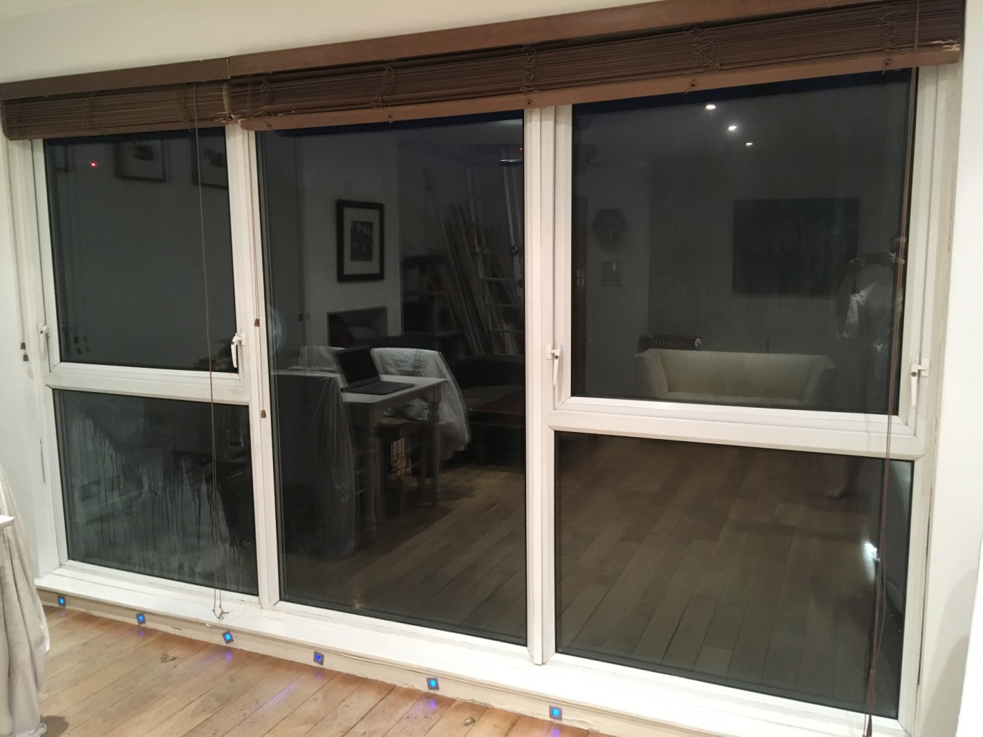

**Proposed New Window**

