**TOWN AND COUNTRY PLANNING ACT 1990, SECTION 78**

**TOWN AND COUNTRY PLANNING ACT (CONTROL OF ADVERTISEMENTS) (ENGLAND) REGULATIONS 2007, SCHEDULE 4**

**APPEAL BY MOE WURR, GOLDSCHMIDT & HOWLAND LIMITED**

**LONDON BOROUGH OF CAMDEN**

**COUNCIL REF.: 2017/5628/A**

**LAND AT DELANCEY STREET CAR PARK, LONDON, NW1**

**GROUNDS OF APPEAL**

**Introduction**

1. This is an appeal made under section 78 of the Town and Country Planning Act 1990 (“the 1990 Act”) and Schedule 4 to the Town & Country Planning  (Control of Advertisement) Regulations 2007 (“the 2007 Regulations”) against the decision of the London Borough of Camden (“the Council”) to refuse advertisement consent in relation to the display of an advertisement to a boundary wall (“the Advertisement”) on land at the Delancey Street Car Park, London, NW1 (“the Site”) by a decision notice dated 8 December 2017 (“the DN”) (Appendix 1) .
2. Schedule 5 of the Town and Country Planning (Development Management Procedure) (England) Order 2015 (“the DMPO”) provides a list of information regarding appeals which must be given when planning permission is refused pursuant to Article 35(3) of the DMPO. The DN did not include, nor was it accompanied with any of the above required information and was defective in this regard.
3. The reason for refusal was:

“*The display of the advertisement, by reason of its size, scale, material, and prominent location, is an incongruent addition resulting in visual clutter which is harmful to the visual amenity of the streetscene, the character and appearance of the conservation area and the setting of the surrounding listed buildings, contrary to policies A1, D2 and D4 of the Camden Local Plan 2017*.”

1. The application was made without prejudice to the Applicant’s position that the Advertisement benefits from deemed consent. The application was made in order to attempt to regularise the position in the mind of the local planning authority without recourse to the Courts or PINS. That has not been achieved. The Appellant, therefore, asks that the Inspector makes a ruling as part of this appeal on whether or not express consent is required in accordance with ***Thomas v National Assembley for Wales*** [2009] EWHC 1734 (Admin).

**Factual background**

1. There has been an advertisement on the Site since at least 2005. Consent was granted on 15 October 1998 to Parkways (an estate agent) for the display of painted advertisements on the single storey brick boundary wall (Appendix 2) (“the Parkways Consent”). The Parkways Consent was limited to a five year term (Condition 1, Appendix 2). Parkways implemented its consent. It is understood this was shortly after the consent was granted but the appellant is unable to be definitive as to the exact date. The Parkways advertisements were painted directly on the wall. They were large format and substantially covered the whole wall (there were small gaps between the advertisements). An image is attached at Appendix 3. The image is taken from a 2005 advertisement (demonstrating that the Site was in use at least from 2005 for advertising). The auction particulars below (figures 1 – 4) also demonstrate the Site was so used in 2005.

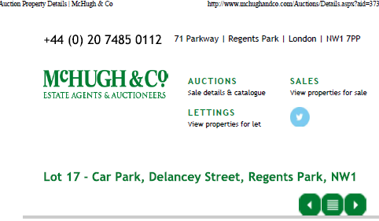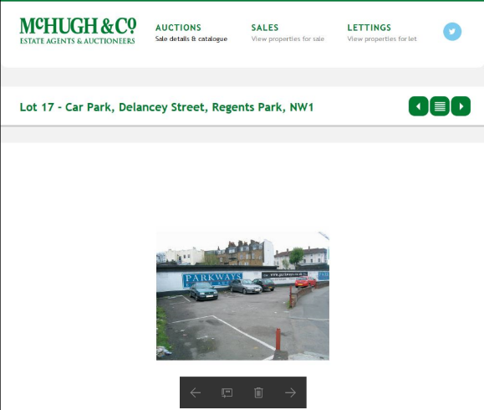

Figures 1 and 2: McHughs Auction Particulars

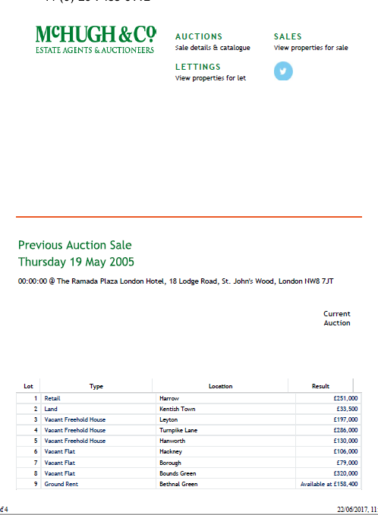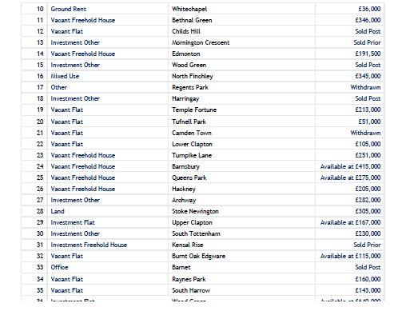

Figures 3 and 4: McHugh’s Auction Particulars

1. Another estate agent, Olivers, took over the wall from Parkways and also displayed an advertisement that was painted directly onto the wall and extended to its entire width. The Olivers advertisement is shown in Appendix 4.
2. Goldschmidt & Howland Limited (“G&H”) took possession of the wall on 1 January 2017. G&H have a 5 year lease of the wall. The current advertisement was put up in the first few weeks of January 2017. The advertisement is not simply painted onto the wall. It is printed onto a 3mm diagem composite (a form of printed vinyl with a vandal resistant plastic coating (allowing any graffito to be wiped off)). It is matt laminated to avoid reflections. The 3mm vinyl is then affixed to 12mm ply which is in turn mounted onto the wall. The current advertisement can be seen at Appendix 5.
3. In a letter dated 29 March 2017 the Council alleged that G&H are displaying the Advertisement without the benefit of advertising consent. G&H maintains that it has the benefit of deemed consent. The Council do not accept this. In order to try and resolve the planning status of the advertisement definitively G&H applied for express consent. It was that application that has led to the refusal which is the subject of this appeal.

*The Site*

1. A Site plan showing the location of the site is provided at Figure 1 below. The Site is an existing car park next to and over an operational railway line. The wall on which the Advertisement is sited separates the car park from the railway. The Site is outside of but adjacent to the Camden Town Conservation Area. Figures 2 to 5 below show general views of the surroundings, which consist partly of 19th century terraces and partly of modern commercial and residential buildings.

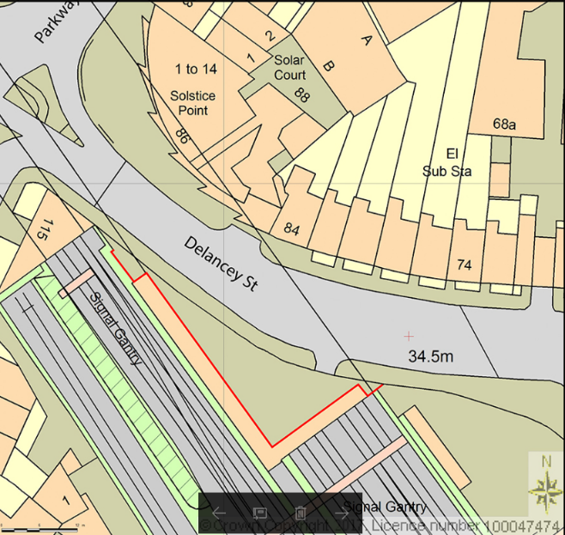

Figure 5: Site plan

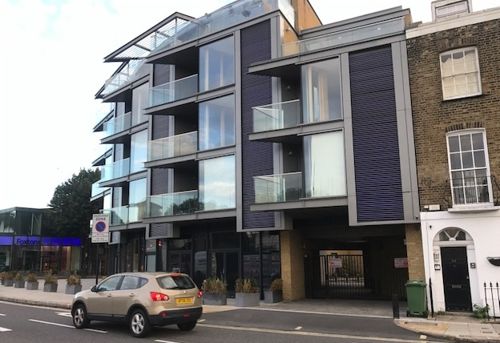

Figure 6: Solstice Point - modern residential opposite site

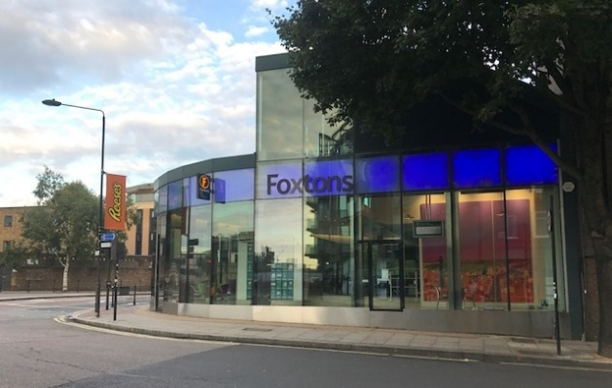

Figure 7: Foxtons Office modern commercial opposite site

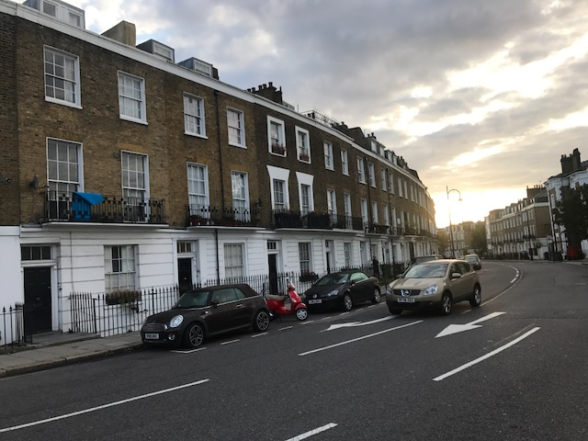

Figure 8: Delancey Street Nineteenth century terraces

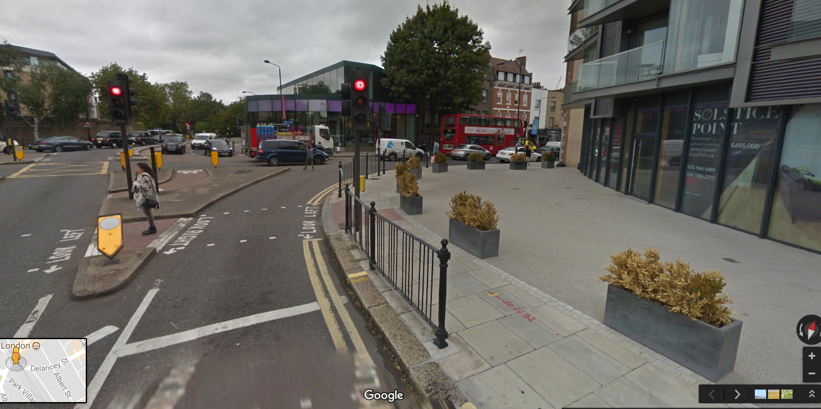

Figure 9: Google maps view of Parkway Junction

1. There are a number of listed buildings in the locality (see Appendix 6). There is a terrace opposite the car park which is Grade II listed. To the south east on Mornington Terrace there is a listed public house and a further listed terrace of housing. There is limited intervisibility between Mornington Terrace and the Site.

**Law**

1. Advertisements need advertisement consent (express or deemed) (Regulation 4(1) of the 2007 Regulations) unless the advertisement in question falls within column 1 of Schedule 1 to the 2007 Regulations (see Regulations 4(1) and (2) and Regulation 1(3)).
2. By virtue of Regulation 3 (“Powers to be exercised in the interests of amenity and public safety”) a local planning authority must exercise its powers under the 2007 Regulations in the interests of (i) amenity and (ii) public safety taking into account the provisions of the development plan so far as they are material and any other relevant factors (Regulation 3(1)). In so far as amenity is concerned any other relevant factors includes: the general characteristics of the locality, including the presence of any feature of historic, architectural, cultural or similar interest (Regulation 3(2)).
3. Regulation 6 grants deemed consent for the classes of advertisements specified in Schedule 3 to the 2007 Regulations.
4. Class 13 of Schedule 3 reads: “*An advertisement displayed on a site that has been used continually for the preceding ten years for the display of advertisements without express consent.*”
5. Class 13 is subject to certain conditions and limitations. Limitation (1) is relevant to the present case. It provides:

“*(1) An advertisement does not fall within this description if, during the relevant 10-year period, there has been either a material increase in the extent to which the site has been used for the display of advertisements or a material alteration in the manner in which it has been so used*.”

1. The following case law is applicable:
   1. The meaning of ‘used continually’ has been considered by the courts (see **Westminster CC v Moran** [1998] 4 PLR 79. It is sufficient for the purposes of Class 13 if the site in question is regularly used for advertising but not necessarily without any break at all.
   2. It is relevant to note that the limitation relates to the manner in which the *site* is used. The site is the land on which the advertisement is displayed.
   3. The question of whether there has been a material alteration in the use of the site is a question of fact and degree. The Courts have had to grapple with this question over the years as advertising techniques have changed (e.g. from paint to billboard to tronic and then to digital displays). See for example:
      1. In **Arthur Maiden Ltd v Lanark CC (No.2)** [1958] JPL 422 an advertisement painted directly onto a wall was replaced with a billboard. This was held not to be a substantial alteration and so did not negate the deemed consent.
      2. The correct approach is to consider the question of material alteration in the context of Regulation 3 and having regard to the effect on amenity and public safety (see **R (Maiden Outdoor Advertising) v Lambeth LBC** [2004] JPL 820).
2. Deemed consent for an advertisement is not lost where there is a change which offends limitation (1) of Class 13 (see the Court of Appeal decision in **R (Clear Channel UK Ltd) v Southwark LBC** [2007] EWCA Civ 1328).

**Grounds of appeal**

Deemed consent

1. It is the Appellant’s primary case that it has deemed consent for the Advertisement and that consequently express consent is not required. As set out above, the Inspector is asked to rule on this point.
2. The Council accept (due to the evidence set out above) that there has been an advertisement painted directly on the wall for a continual period in excess of 12 years. As such, it follows from the legal principal set out above that there is deemed consent for such a form of advertisement.
3. However, the Council suggest the current display does not benefit from that deemed consent due to material alterations.
4. In so far as the Council rely on a change in the contents of the advert, that is immaterial for the reasons set out above.
5. As to the change in materials (mural to vinyl), this plainly does not involve in a material alteration to the use of the site. The change is not really discernible save by close examination. Accordingly, there is no real basis for saying it could have a material impact on amenity such that the change amounts to a material alteration when the correct legal approach is taken (i.e. it is not the contents of the advert that is relevant). This case is similar to the change that occurred in **Arthur Maiden** (see above) and the same answer should result.
6. In so far as it is suggested that there has been a material increase in the extent of the use of the site for the display of adverts, on any fair reading the whole of the width of the wall has been used for advertising in the past.
7. Accordingly, the current display benefits from deemed consent.

Express consent

1. Even if the Advertisement did not benefit from deemed consent contrary to the Appellant’s primary position, the Advertisement and its acceptability must be seen and understood in the context of the continual use of the Site for large scale advertisements since around 1998 (and the decision of the Council at that date (in the light of the both the listed buildings within the locality and the Conservation Area) to grant express consent for large scale advertisements over the entire wall (Appendix 2).
2. It is instructive that since 15 October 2003 (the date the Parkways consent expired) the Site has not had the benefit of advertising consent. During that period both the Parkways and the Olivers advertisements have been on Site. At no stage did the Council take any action. It is clear that the Council has consistently felt that advertisements covering substantially all of the wall have been acceptable over a prolonged period of time.

*Public safety*

1. The Council take no issue with public safety (see DN and Officer’s Delegated Report (Appendix 7)). There is no public safety basis on which to refuse this consent.

*Amenity*

1. The only issue, therefore, is the impact of the advertisement on amenity.
2. Seen in the light of the above history of advertisements on Site, it is difficult to see how the change from painted to the current display has any material impact on amenity.
3. The content of the advert (the consultation responses refer to the depiction of estate agent signs) is not relevant in this regard. It is the use of the Site for displaying an advert that must be considered.
4. The Council’s objection boils down (as expressed in the Officers’ Delegated Report) to the contents (which consideration is not material for the reasons set out above) and the change in materials.
5. As to the latter, the Council state that the “*textured* *character of the historic wall*” visible under the painted advertisement would be obscured and that that as well as the use of vinyl would have an adverse effect on the conservation area and the setting of the listed buildings.
6. That approach is wholly unrealistic and unsubstantiated:
   1. The wall is not an historic wall in the sense that it is not listed or part of the Conservation Area;
   2. There is no analysis in the Officer’s Delegated Report (or elsewhere) of the characteristics of the listed buildings and the Conservation Area;
   3. There is no analysis of the setting of the listed buildings and the Conservation Area and their contribution to the significance of the historic assets;
   4. In such circumstances it is not possible to come to a proper conclusion as to the impacts on the historic assets. The Council’s case is pure assertion;
   5. The assertion is bad. The allegation in so far as it relates to the Conservation Area is that there is an impact upon it. However, the Site is not within the Conservation Area. It is impossible, therefore, for there to be a direct impact as alleged. The most that could be asserted is an impact on setting;
   6. It is hard to see how the change from paint on brick to a printed image mounted on the same wall and seen from within the Conservation Area or any of the listed buildings could: (a) be perceived at all (the texture of individual bricks of the railway wall cannot be seen at that distance); and (b) be sensibly suggested that these bricks in (a non-historic) wall have any material effect on the significance of the historic assets.
7. Accordingly, the suggestion that there are heritage impacts – even ignoring the display of advertisements on the Site since 2005 – is not only unsustainable, it is unreasonable.

Conclusion

1. The Advertisement benefits from deemed consent.
2. Even if it does not, it ought to be granted express consent. This is an urban site on the edge of a conservation area. It is a car park. It will not be developed because it lies over a railway tunnel. It is surrounded by a mix of modern commercial and residential buildings as well as nineteenth century terraced houses. It has been used for advertising since at least 2005. Advertising in this location has therefore a long history. This long advertising history has not lead to any material complaints in relation to either (a) safety and (b) amenity (the relevant considerations). The Council object on the basis of (a) the contents and (b) heritage impacts. As to (a) this is impermissible it is the use of the site for the display of advertisements that is relevant not their content. As to (b), there are zero direct impacts, a history of advertisements on this site and, for the reasons set out above the Council’s objections on this issue are unsustainable.

**Mode of appeal**

1. The appropriate mode of appeal in this case is an inquiry. Having regard to the Appendix K criteria:
   1. The evidence needs to be tested. The Council have alleged heritage impacts. The heritage case needs a detailed examination of the significance of the heritage assets, the setting of those assets, the contribution of the setting to the significance and the impact of the advertisement on the significance. It is not at all clear the Council has understood this and there needs a proper opportunity to explore this issue by written evidence and cross examination;
   2. Formal questioning is further appropriate given the complexity of the issues including the fallback and deemed consent;
   3. The rigour of cross examination is appropriate where the result of a failed appeal will be a prosecution; and
   4. The fallback issue raises complex legal issues that are best addressed at an inquiry.

**Conclusions**

1. For the reasons set out above, advertisement consent ought to be granted for the retention of the Advertisement.

**MARK WESTMORELAND SMITH**

**25 January 2018**

**Francis Taylor Building,**

**Inner Temple,**

**London, EC4Y 7BY.**

**List of appendices**

1. The decision notice
2. Parkways Advertisement Consent October 1998
3. Photograph of the Parkways’ Advertisements
4. Photograph of the Olivers’ Advertisement
5. Photograph of G&H’s Advertisement
6. Listed buildings near the Site
7. Officer’s delegated report