* + [Search the List](https://historicengland.org.uk/listing/the-list/)
  + [Enrich the List](https://historicengland.org.uk/listing/enrich-the-list/)
  + [Apply for Listing](https://historicengland.org.uk/listing/apply-for-listing/)
  + [What is Listing?](https://historicengland.org.uk/listing/what-is-designation/)
  + [Listing Guidance](https://historicengland.org.uk/listing/selection-criteria/)
* [Advice](https://historicengland.org.uk/advice/)
  + [Your Home](https://historicengland.org.uk/advice/your-home/)
  + [Planning](https://historicengland.org.uk/advice/planning/)
  + [Latest Advice & Guidance](https://historicengland.org.uk/advice/latest-guidance/)
  + [Caring for Heritage](https://historicengland.org.uk/advice/caring-for-heritage/)
  + [Technical Guidance](https://historicengland.org.uk/advice/technical-advice/)
  + [Heritage at Risk](https://historicengland.org.uk/advice/heritage-at-risk/)
  + [Constructive Conservation](https://historicengland.org.uk/advice/constructive-conservation/)
  + [Heritage Protection Guide](https://historicengland.org.uk/advice/hpg/)
* [Research](https://historicengland.org.uk/research/)
  + [Our Research Strategy and Agenda](https://historicengland.org.uk/research/agenda/)
  + [Research Methods](https://historicengland.org.uk/research/methods/)
  + [Current Research](https://historicengland.org.uk/research/current/)
  + [Research Results](https://historicengland.org.uk/research/research-results/)
  + [Support & Collaboration](https://historicengland.org.uk/research/support-and-collaboration/)
  + [Inclusive Heritage](https://historicengland.org.uk/research/inclusive-heritage/)
  + [Heritage Counts](https://historicengland.org.uk/research/heritage-counts/)
* [Images & Books](https://historicengland.org.uk/images-books/)
  + [Find Photos](https://historicengland.org.uk/images-books/photos/)
  + [Search All Publications](https://historicengland.org.uk/images-books/publications/)
  + [Buy Books](https://historicengland.org.uk/images-books/books/)
  + [The Historic England Archive](https://historicengland.org.uk/images-books/archive/)
  + [Be an Archive Detective](https://historicengland.org.uk/images-books/archive-mysteries/)
* [Services & Skills](https://historicengland.org.uk/services-skills/)
  + [Education](https://historicengland.org.uk/services-skills/education/)
  + [Grants](https://historicengland.org.uk/services-skills/grants/)
  + [Our Planning Services](https://historicengland.org.uk/services-skills/our-planning-services/)
  + [Training & Skills](https://historicengland.org.uk/services-skills/training-skills/)
  + [Archive Services](https://historicengland.org.uk/services-skills/archive-services/)
  + [Heritage Action Zones](https://historicengland.org.uk/services-skills/heritage-action-zones/)
* [Get Involved](https://historicengland.org.uk/get-involved/)
  + [100 Places](https://historicengland.org.uk/get-involved/100-places/)
  + [Support Us](https://historicengland.org.uk/get-involved/support-us/)
  + [Volunteer in Heritage](https://historicengland.org.uk/get-involved/volunteer/)
  + [Visit Your Heritage](https://historicengland.org.uk/get-involved/visit/)
  + [Protect Your Heritage](https://historicengland.org.uk/get-involved/protect/)
  + [Help Write History](https://historicengland.org.uk/get-involved/help-write-history/)
  + [Angel Awards](https://historicengland.org.uk/get-involved/angel-awards/)
* [What's New](https://historicengland.org.uk/whats-new/)
  + [News](https://historicengland.org.uk/whats-new/news/)
  + [In Your Area](https://historicengland.org.uk/whats-new/in-your-area/)
  + [Latest Listings](https://historicengland.org.uk/whats-new/listing/)
  + [Latest Research](https://historicengland.org.uk/whats-new/research/)
  + [Heritage Online Debate](https://historicengland.org.uk/whats-new/debate/)
  + [Statements](https://historicengland.org.uk/whats-new/statements/)
  + [Stay Up To Date](https://historicengland.org.uk/whats-new/stay-up-to-date/)
  + [50 Years of Conservation Areas](https://historicengland.org.uk/whats-new/conservation-areas-50-years/)
  + [First World War Centenary](https://historicengland.org.uk/whats-new/first-world-war-home-front/)
  + [What We Do](https://historicengland.org.uk/about/what-we-do/)
  + [Who We Are](https://historicengland.org.uk/about/who-we-are/)
  + [Jobs](https://historicengland.org.uk/about/jobs/)
  + [Contact Us](https://historicengland.org.uk/about/contact-us/)
  + [Volunteer with Historic England](https://historicengland.org.uk/about/volunteering/)
  + [Website Terms and Conditions](https://historicengland.org.uk/terms/website-terms-conditions/)
  + [Privacy and Cookies Policy](https://historicengland.org.uk/terms/privacy-cookies/)
  + [Links Policy](https://historicengland.org.uk/terms/links-policy/)
  + [Historic England Blog and Social: House Rules](https://historicengland.org.uk/terms/blog-house-rules/)
  + [Photo Competition Terms and Conditions](https://historicengland.org.uk/terms/photo-competition-terms-conditions/)
  + [Angel Awards 2017 Voting Terms and Conditions](https://historicengland.org.uk/terms/angel-awards-voting-terms-and-conditions/)
* [Home](https://historicengland.org.uk/)
* [...](https://historicengland.org.uk/listing/the-list/list-entry/1379079)
* [Listing](https://historicengland.org.uk/listing/)
* [Search the List](https://historicengland.org.uk/listing/the-list/)
* List Entry

[This browser is not fully supported](https://www.historicengland.org.uk/access/) by Historic England. Please update your browser to the latest version so that you get the best from our website.

We use cookies to give you the best possible experience online. By using this website, you consent to cookies being used in accordance with our [Cookie Policy](https://historicengland.org.uk/terms/).

* [Section Navigation](https://historicengland.org.uk/listing/the-list/list-entry/1379079)
  + [Map Search](https://historicengland.org.uk/listing/the-list/map/)
  + [Advanced Search](https://historicengland.org.uk/listing/the-list/advanced/)
  + [Minor Amendments](https://historicengland.org.uk/listing/the-list/minor-amendments/)
  + [Download Listing Data](https://historicengland.org.uk/listing/the-list/data-downloads/)
  + [Non-Listed Sites](https://historicengland.org.uk/listing/the-list/non-listed-sites/)
  + [About The List](https://historicengland.org.uk/listing/the-list/about-the-list/)
  + [Enrich the List](https://historicengland.org.uk/listing/the-list/enrich/)
  + [Understanding List Entries](https://historicengland.org.uk/listing/the-list/understanding-list-entries/)

**NORTH VILLA AND SOUTH VILLA AND ATTACHED RAILINGS AND GATES**

**List Entry Summary**

This building is listed under the Planning (Listed Buildings and Conservation Areas) Act 1990 as amended for its special architectural or historic interest.

Name: NORTH VILLA AND SOUTH VILLA AND ATTACHED RAILINGS AND GATES

List entry Number: 1379079

**Location**

NORTH VILLA AND SOUTH VILLA AND ATTACHED RAILINGS AND GATES, VALE OF HEALTH

The building may lie within the boundary of more than one authority.

County: Greater London Authority

District: Camden

District Type: London Borough

Parish:

National Park: Not applicable to this List entry.

Grade: II

Date first listed: 14-May-1974

Date of most recent amendment: Not applicable to this List entry.

**Legacy System Information**

The contents of this record have been generated from a legacy data system.

Legacy System: LBS

UID: 478445

**Asset Groupings**

This list entry does not comprise part of an Asset Grouping. Asset Groupings are not part of the official record but are added later for information.

**List entry Description**

**Summary of Building**

Legacy Record - This information may be included in the List Entry Details.

**Reasons for Designation**

Legacy Record - This information may be included in the List Entry Details.

**History**

Legacy Record - This information may be included in the List Entry Details.

**Details**

CAMDEN  
  
TQ2686SW VALE OF HEALTH 798-1/16/1661 North Villa and South Villa and 14/05/74 attached railings and gates   
  
GV II  
  
Semi-detached pair of houses with main frontage on west side. Early C19. Yellow stock brick. Stucco band at 1st floor level, cornice and blocking course. 3 storeys and semi-basements. 1 window each. Basement doorways with half glazed doors. South Villa with canopy carried on cast-iron columns. Architraved tripartite sashes, ground floor of North Villa with blind box. INTERIORS: not inspected. SUBSIDIARY FEATURES: attached cast-iron railings and gates with brick gateway piers.   
  
  
  
Listing NGR: TQ2648586485

**Selected Sources**

Legacy Record - This information may be included in the List Entry Details

National Grid Reference: TQ 26485 86485

**Map**

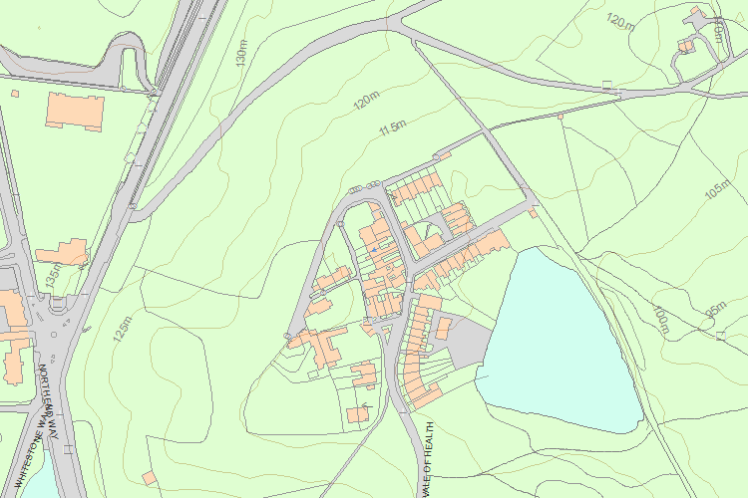© Crown Copyright and database right 2018. All rights reserved. Ordnance Survey Licence number 100024900.  
© British Crown and SeaZone Solutions Limited 2018. All rights reserved. Licence number 102006.006.  
Use of this data is subject to [Terms and Conditions](https://historicengland.org.uk/terms/website-terms-conditions/).

The above map is for quick reference purposes only and may not be to scale. For a copy of the full scale map, please see the attached PDF - [1379079 .pdf](http://mapservices.historicengland.org.uk/printwebservicehle/StatutoryPrint.svc/342040/HLE_A4L_Grade%7CHLE_A3L_Grade.pdf)

The PDF will be generated from our live systems and may take a few minutes to download depending on how busy our servers are. We apologise for this delay.

This copy shows the entry on 16-Aug-2018 at 10:58:12.

End of official listing