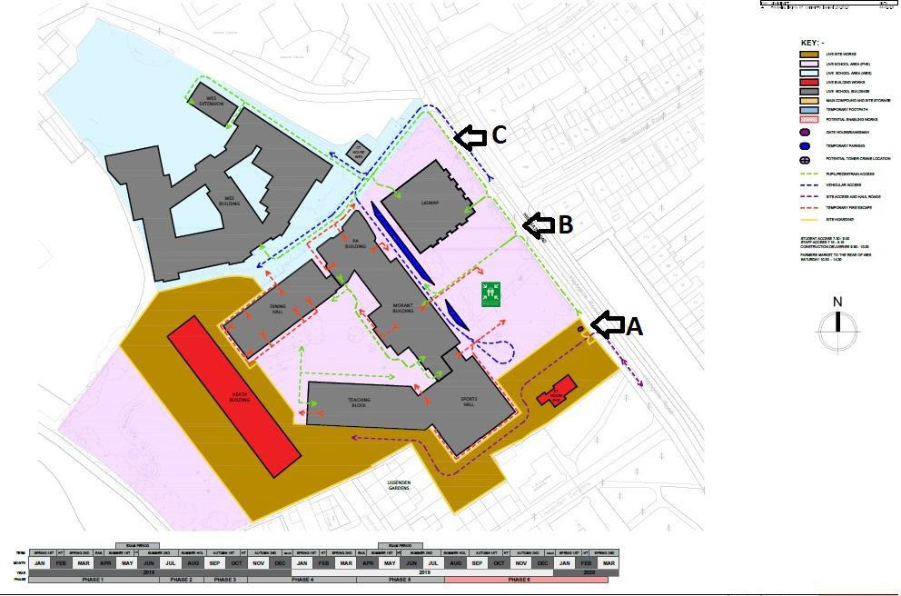

Advertising locations – Parliament Hill, William Ellis and LaSWAP site

**Advertising locations, street view from Highgate Road**

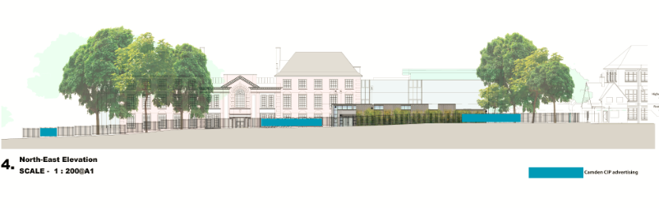

Parliament Hill, William Ellis and LaSWAP site

Community Investment Programme hoarding boards: location A

One Di-bond panel, 1400mm x 2900mm

2900mm

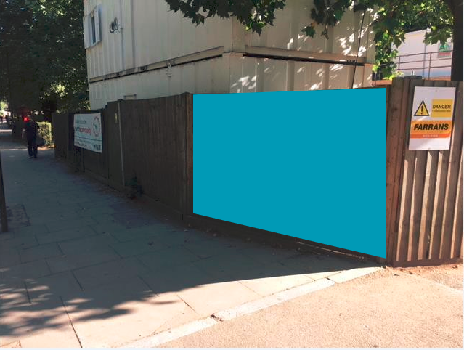

Parliament Hill, William Ellis and LaSWAP site

Community Investment Programme hoarding boards: location B

Four mesh PVC banners, 1400mm x 2800mm each, total width 11,200mm

2800mm

2800mm

2800mm

2800mm

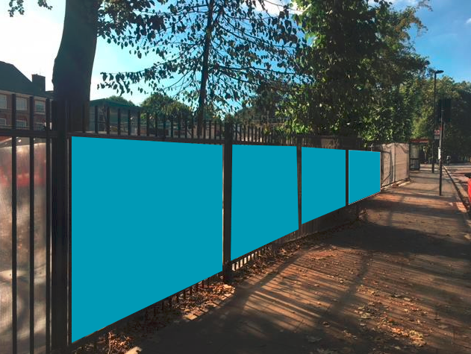

Parliament Hill, William Ellis and LaSWAP site

Community Investment Programme hoarding boards: location C

Four mesh PVC banners, 1400mm x 2800mm each, total width 11,200mm

2800mm

2800mm

2800mm

2800mm

