Enforcement Delegated Report |  |  |  |  | Receipt date: | 30/07/2018
Officer |  |  |  | Enforcement Case
Josh Lawlor |  |  |  | EN16/0027
Breach Address |  |  |  | Photos & Other material
6 Bolton Road, London, NW8 0RJ |  |  |  | 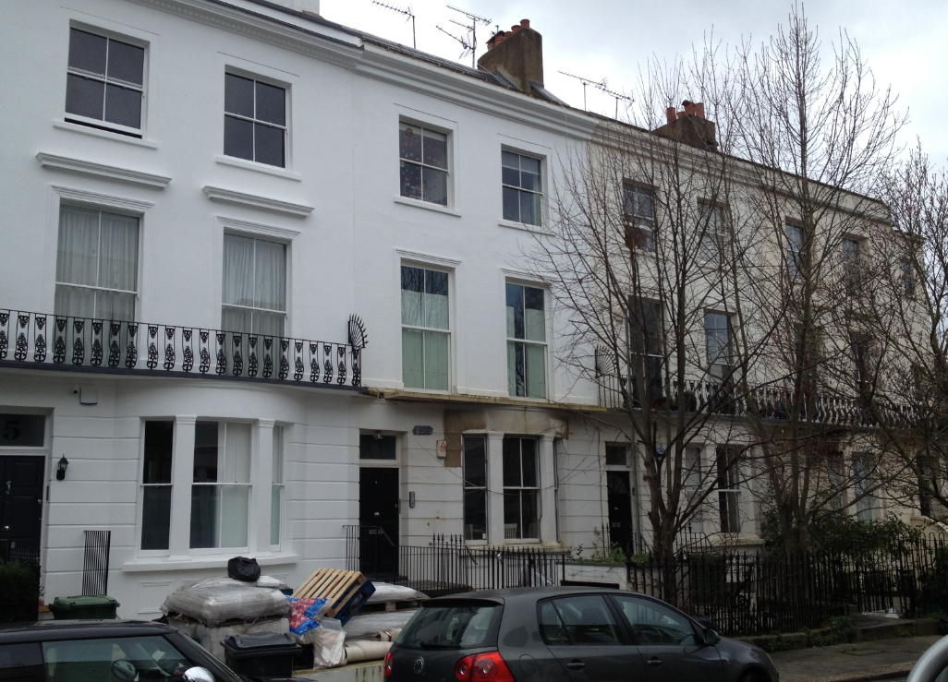  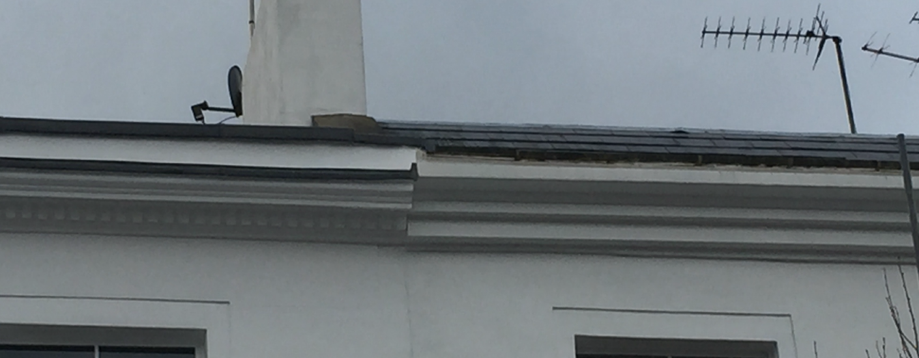
PO 3/4 | Area Team Signature |  | C&UD | Authorised Officer Signature
 |  |  |  | 13th August 2018

Alleged Breach
Reinstatement of the first floor stone balcony with cast iron railings, reinstatement of window pediments and dentil course on external cornice.

Recommendation(s): |  | Issue an
Priority: |  | P3

Site Description
The site is a three storey plus basement property located on the south-west side of Bolton road. The site forms part of a terrace of eight mid to late stucco townhouses.

Investigation History
Two letters sent on the 29/01/2018 and 23/03/2018 were sent to the address requesting for the required works to be completed and for confirmation of a timeline for the works to be completed. Numerous emails were also sent. The requests for a timeline for the works to be completed have not been provided with no response to recent email requests.

Relevant policies / GPDO Category
Town & Country Planning Act 1990, s.72 of the Planning (Listed Buildings and Conservation Areas) Act 1990 as amended by the Enterprise and Regulatory Reform Act 2013

Camden Local Plan 2017 – D1 Design and D2 Heritage

St Johns Wood Conservation Area Appraisal June 2009

The Camden Guidance Design 1

London Plan 2016

NPPF 2012

Assessment
Planning history:
No Relevant Planning history
Issues:
Design
Camden Local Plan Policy D1 and Camden Guidance Design 1
The Camden Local Plan 2017 Policy D1 Design states the council will require development preserves or enhances the historic environment and heritage assets in accordance with Policy D2 heritage.
The Camden Guidance Design 1 states the council will only permit development within a conservation area that preserves and enhances the character and appearance of the area.
It is considered that removal of the original stone balcony with decorative cast iron balustrade, removal of the window pediment and replacement of the cornice without the dentil course from the front elevation not only detracts from the visual amenity of the property but also the terrace whose properties still contain these details and the wider St. John’s Wood conservation area.
Heritage
Camden Local Plan Policy D2 and the St Johns Wood Conservation Area Appraisal June 2009
The Camden Local Plan 2017 D2 Heritage states that ‘the Council will preserve and, where appropriate, enhance Camden’s rich and diverse heritage assets and their settings, including conservation areas’ The Council will not permit the loss of or substantial harm to a designated heritage asset, including conservation areas, unless it can be demonstrated that the substantial harm or loss is necessary to achieve substantial public benefits that outweigh that harm or loss. The Council will not permit development that results in harm that is less than substantial to the significance of a designated heritage asset unless the public benefits of the proposal convincingly outweigh that harm. The works represent substantial harm to a positive contributor within the St Johns wood Conservation area with no public benefits.
The St Johns Wood Conservation Area Appraisal June 2009 states that ‘on the south-west side of Bolton Road stands a complete surviving terrace of eight mid- to late-Victorian townhouses. The first-piano nobile is emphasised by a continuous decorative iron balcony. The square second-floor windows also have simple stucco architraves and the parapet has a decorative cornice.
The St Johns Wood Conservation Area Appraisal June 2009 states that in addition to the buildings that are on the statutory list there are many individual buildings and groups of buildings that contribute to the character of their immediate surroundings and the Conservation Area as a whole. The appraisal designates Nos 1-7, 9a & 10 Bolton Road as making a positive group contribution to the conservation area. The appraisal, has a section titled ‘elements of streetscape that make a positive contribution to the conservation area’. On Bolton road the cast iron railings to the front of properties are noted as making this contribution.
All the Victorian stucco townhouses from numbers 1-6 have the external decorative cornice with dentil course and window pediments save for No.6. These are seen to be details that should be preserved and they contribute to the character and appearance of the terrace and wider conservation area. A conservation officer has been consulted on the breach and considers that there is harm to the conservation area.
Recommendation:
That the Borough Solicitor be instructed to issue an Enforcement Notice under Section 172 of the Town and Country Planning Act 1990 as amended to reinstate the original first floor stone balcony with cast iron railings and reinstate the first floor window pediments and third floor external cornice with dentil course and officers be authorised in the event of non-compliance, to commence legal proceedings under Section 179 or other appropriate power and/or take direct action under Section 178 in order to secure the cessation of the breach of planning control.

WHAT ARE YOU REQUIRED TO DO:

Remove the new external cornice and replace to match the original external cornice with dentil course in design, shape and material. Reinstate the window pediments to match original in design, shape and material. Reinstatement of the first floor stone balcony with cast iron railings to match original in design, shape and material.

PERIOD OF COMPLIANCE:
6 Months from receipt of this notice
REASONS WHY THE COUNCIL CONSIDER IT EXPEDIENT TO ISSUE THE NOTICE:
The removal of the first floor stone balcony with cast iron railings and removal of window pediments and new incorrect external cornice without dentil course causes substantial harm to a designated heritage asset, and is therefore contrary to Camden Local Plan 2017 D1 (Design) D2 (Heritage), St John's Wood Conservation Area Appraisal Report 2009 and the Camden Guidance Design 1

