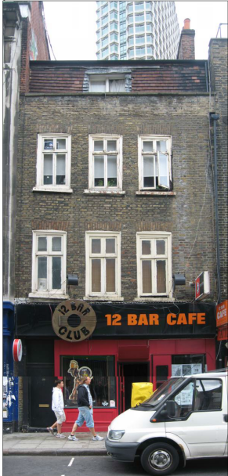

St Giles Circus

**Denmark Street**

**PHASE 2 works**

**Listed Building Consent**

2018/1081/L

Scaffold erection

(Tying details into listed buildings)

**Rev 00**

**14th May 2018**

Graham Beach

**Table of Contents**

1.00 Introduction3

1.01 Existing structure / condition

2.00 Hierarchy supporting statement 4

2.01 conclusion

3.00 Methodology 5

3.01 Typical tie detail to be used when fixing into listed buildings

3.02 Typical scaffold tie location detail

**1.00 Introduction:**

This application seeks approval for the use of scaffold ties into listed buildings numbers 20 & 26 Denmark Street and 16 Denmark Place under listed building consent 2018/1081/L.

This document has been prepared to explain and seek authorisation for the works to commence.

In order to reduce the impact on the surrounding retained heritage fabric, the proposed tying of the scaffold to the existing façade will be controlled by a *hierarchy of events* and in all instances the 1st and foremost option will be to tie the scaffold to the none listed buildings, this will be described later within this application.

**1.01 Existing structure / condition:**

The front façade of numbers 20, 26 Demark Street and 16 Denmark Place are of masonry construction with windows at each floor. The original masonry structure at ground floor has been removed to form the façade to the shopfront / bar.

The condition of the listed building at 26 Denmark Street has been identified as a cause of concern and the building has been placed on the Historic England’s at risk register of listed buildings, No tying into number 26 will be permitted until the façade has been strengthened and stabilised, whereas number 20 and 16 appear to be in much better condition.

It is apparent that the structure of both 20 & 26 have experienced significant differential settlement and that the ongoing cracking within the building of 26 was reported by the facility’s manager back in 2012. Movement monitoring has been installed in this area since May 2014 and there has been little sign of further movement

The external masonry walls of the 18th century houses have experienced considerable movement with the front façade of 26 and rear façade of 20 having settled considerably on the side adjacent number 27 and 21. This has resulted the windows and cills being out of level.

# 

# **2.00 Hierarchy supporting statement**

As per our previous statement relating to consent application number 2018/1081/L we will be following the said hierarchy proposed:

1. At the 1st instance we will be tying the scaffold to the adjacent buildings so as to limit any tie requirements into or within the listed buildings 20, 26 Denmark Street and 16 Denmark Place
2. Use a non-intrusive tie through windows that will brace the scaffold by clamping tubes to the front and back face of the building façade. Foam protection will be in place to ensure there is no damage to the building fabric when using this method.
3. Use of mechanical tie (no chemical resin required) into the perp or bed joints of the brickwork with a view to making good with like for like mortar to match the 14mm diameter holes once ties are removed.

# **2.01 The conclusion and tie detail proposal:**

# 

In all instances the design for the tying of the scaffold has followed item 1 of the hierarchy (the scaffold will be tied to the non-listed buildings either side of the listed buildings 20 & 26 and 16), However we have looked at the other two hierarchy methods and the conclusions are as follows:

We then looked at the non- intrusive tie through the windows and unfortunately this does not look viable as the amount off scaffold that we would require to brace out within and through the buildings would greatly restrict our internal works and new window installation and will prevent us from carrying out our safety critical permanent facade and floor joist strengthening to number 26 Denmark Street.

If and as a very last resort we do need to tie into the listed building we propose using the **AF-6135 nylon plug and AF-61 scaffold screw eyes** as noted and described later on in this report attached.

# **3.00 Methodology**

The independent scaffold will be erected along the front and rear façade from 20 to 26 Denmark Street. The scaffold has been designed so as any tying requirements are within the non-listed buildings i.e. either side of 20/16 (19 & 21) and either side of 26 (25 & 27) however and as a very last resort we do need to tie into listed building 20 and 16 we propose using the **AF-6135 nylon plug and AF-61 scaffold screw eyes** as attached. It is worth noting at this stage that no tying into 26 will be permitted until the façade is fully strengthened and stabilised and confirmation from the engineers is received to do so.

The proposed ties are the smallest and least intrusive tie we can use at $∅$ 14mm and they are **not** chemically fixed, the ties will fixed into the perp or bed joint wherever possible, pull out test will be carried out on the said ties so as to ensure the ties can achieve the required imposed load.

If the required pull out specification cannot be achieved with the tie in the mortar bed or perp joint then we will need to fit the odd tie into the centre of a brick by drilling a $∅$ 14mm hole and inserting the AF-6135 nylon plug and AF-61 scaffold screw eyes (these will be clearly marked and recorded on the elevation drawings)

On completion of the works and the scaffold removal the said screw eye and nylon plug will be carefully unscrewed and removed, the effected mortar joint will be carefully repointed to match existing like for like.

In the event of a tie being tied into the said brick, the brick will be carefully cut out using hand tools by the specialist conservation contractor and replaced like for like using the carefully selected reclaimed bricks that have been saved from the earlier demolition works and are safely stored off site in Blackhores Rd. The methodology for carefully cutting out and replacing bricks and mortar pointing will be issued for acceptance in its own consent report soon, as we are looking to appoint the specialist conservation contractor imminently.

The other typical tie details identified below will be used to tie the scaffold into the non-listed buildings i.e. 19, 21 to 25 and 27 it is worth noting that these ties are of a $∅$ 15mm and these holes will also be made good by the conservation contractor to match like for like on completion of the works.

# **3.01 Typical tie detail to be used when fixing into listed buildings**

(AF-6135 nylon plug and AF-61 scaffold screw eyes)

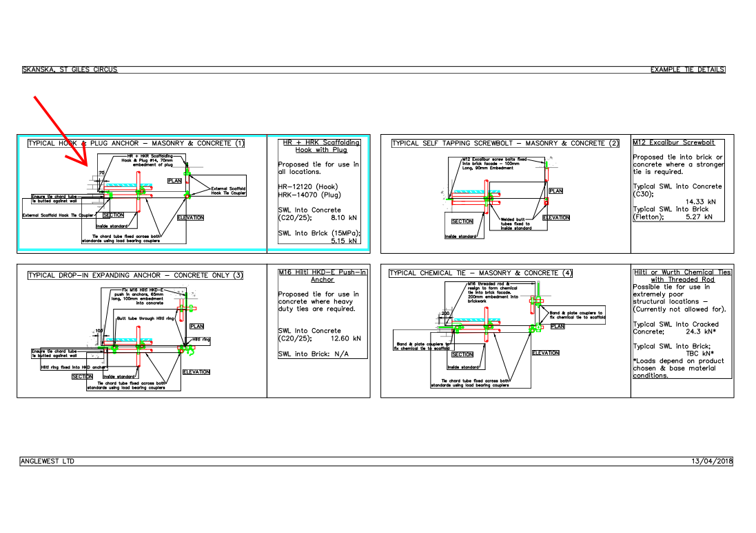

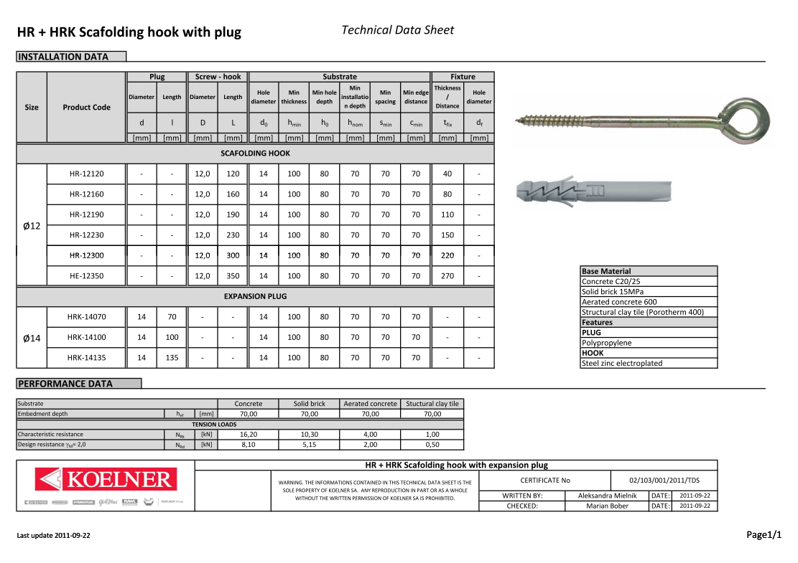

**3.02 Typical scaffold tie locations detail**

