Zachary Macaulay Memorial in St George’s Gardens - Design and Access Statement

Location

The memorial will be placed on the north wall at the west end of the gardens, in the last bay beside a border, going east, before a wall section with benches. It will be a little above eye level and centred between the pillars at each end of the bay. This photo shows the proposed location using a card which is precisely the size of the planned plaque – 700mm v 420mm. White card was used for clarity but the plaque will be dark slate.

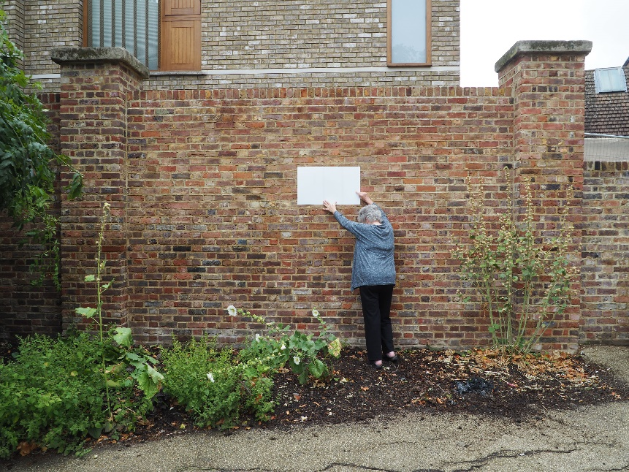

Deisgn

The memorial will be made of Welsh (Aberllefenni) architectural slate, honed smooth but not highly polished and not textured or natural riven. The plaque design is in a separate supporting document. It will use Roman and Italic script, with the following inscription:

Zachary Macaulay FRS

1768-1838

*Anti-slavery activist, Statistician.*

*One of the founders of*

*University College London – UCL.*

*Buried in these Gardens.*

The inscription will be V-cut with a chisel so that the sides of the letters are cut at an equal slope and form a V section. The lettering will be finished with off white/pale grey paint which simulates the colour of freshly carved slate. This improves legibility, especially when conditions are damp or wet since the natural contrast disappears when wet. The letters will be painted with two coats of craft satin enamel and then rubbed down with 600 grit wet and dry abrasive paper to remove any traces of paint on the surface. This will leave the letters sharp and legible and the surface smooth.

The stonemason is Bernard Johnson. He was chosen with advice from the Diocese of London’s staff. Examples of his work can be found on the Memorials by Artists website. Mr Johnson provided this example of lettering similar to that proposed for Zachary Macaulay’s memorial (though this uses Lake District slate rather than Welsh slate):

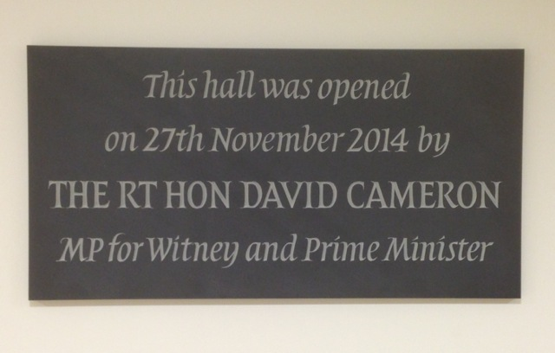

Fixing method

Mr Johnson has provided the following statement of method for fixing the plaque to the wall. This has been approved by Camden’s Structures Manager (Shane Greig Telephone: 020 7974 8980). It has been agreed that Mr Johnson will carry out the installation.

*I locate and mark two positions on the wall for a secure fixing. Check that these are level with a spirit level. I also locate two matching positions on the rear top of the plaque.*

*Access to power will be needed. I drill the plaque to a depth to take a secure fixing, and having removed all dust, insert two stainless steel threaded dowels and fix these in with a two-part stone adhesive (Harbro Strongbond). I make sure as the glue hardens that the dowels remain square to the plaque.*

*I drill the wall to take the dowels to a secure depth, and when I have removed the dust and when the dowels have set firm, I position the plaque on the wall and check for level. Having made any necessary adjustments (by enlarging slightly one of the holes), I then, locate a third fixing toward the bottom of the plaque in a central position and fix a third dowel into the rear of the plaque and drill a hole to take it.*

*The dowels will be approximately 65mm with 15mm in the plaque and 50mm in the wall.*

*When I am satisfied, that the position is correct, I then fill the holes in the wall with stone adhesive and insert the plaque again for a permanent fixing.*

*Throughout the process I keep the front and sides of the plaque covered to avoid scratches and dirty marks from glue and sweat. When I have cleaned up, I remove the cover and if necessary give the plaque a wipe-over with a moist cloth.*

Faculty

The project was discussed with the Diocese of London earlier this year. On 26 April, Kevin Rogers, Head of Parish Property Support wrote to the Friends as follows:

*I am pleased to attach the forms to petition for a faculty for the proposal put forward by the Friends of St George’s Gardens. The Friends will be responsible for the registry fees of approximately £290. We note on the forms that Planning Permission may be required and that a faculty will not be granted until the matter is resolved with the local authority.*

The Gardens are in the parish of Holy Cross and we have a parish resolution in support of the proposal. Notices were on display in the Gardens and at the church so that any objections could be raised. There were no objections.

Conclusion

We hope this gives you all the information you need and that you will be able to tell us that we can proceed with the petition for faculty.

We began discussions with Camden once we knew that the Church processes were on course. Our first contact with Camden was on April 4 when we sent an online enquiry (ref 21170669) asking about the process that we should follow. Unfortunately, we did not receive a reply and it has been difficult to find out exactly what is required.

If the plaque can be made in September/early October there will be a dedication on October 19 during the Bloomsbury Festival. We very much hope that it will be possible to keep to this timetable.

Friends of St George’s Gardens

30 July 2018