Gavin Sexton

Principal Planner

London Borough of Camden

5 Pancras Square

London 4th July 2018

Dear Mr Sexton,

I am writing to you to provide further evidence regarding the application for the Certificate of Lawfulness concerning 2014/4270/P. Site Address. End Corner Plots at Grafton Road, Lamble Street, Barrington Court London NW5.

I believe you have been informed that the photograph below used in the application in Appendix A is not from the site in question, and have asked to see further evidence.

This photograph is presumably being submitted to show the supposed 'foundation trench' was dug to the correct depth, a submission that has been disputed.

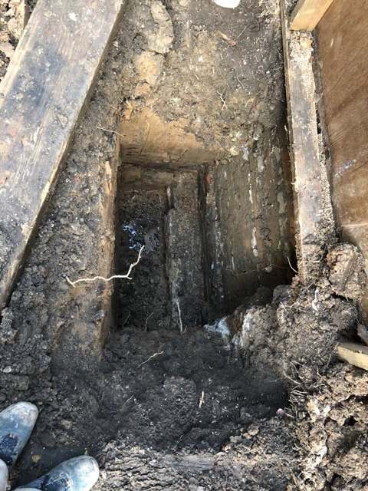

The above is a copy of the submitted photograph from the application.

Please note the foundations of this wall starts at least 8 brick courses below ground level.

There are no hoarding posts in the ground on either side of the hole.

There is a fence or hoarding down to ground level on the boundary side of the hole which is clearly old (it is weathered and warped) and firmly fixed in place with a ground runner.

Please see below our photographs of site B:

Site B 26/4/18 – Pre ‘foundation trench begun’

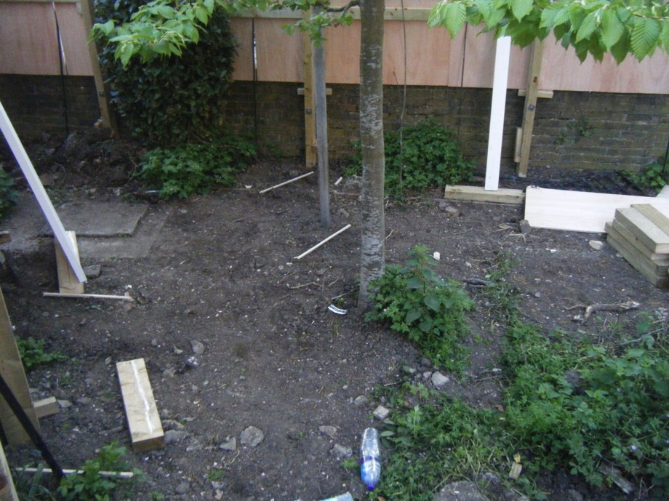

As you can see from this photograph the hoarding posts were already in place by 26/4/18, and these hoarding posts are in the ground either side of where the pits will be dug. The hoarding itself does not go all the way to the ground.

Site B 27/4/18 and 28/4/18 – showing ‘foundation trench’ as dug. You can see that the existing wall’s foundations jut out from the base of the wall at 4 brick courses below ground level. Again please note the hoarding posts either side of the holes and the exposed brick wall at ground level. 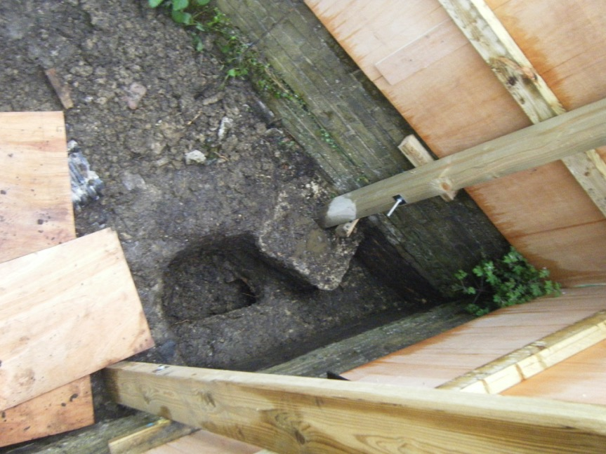 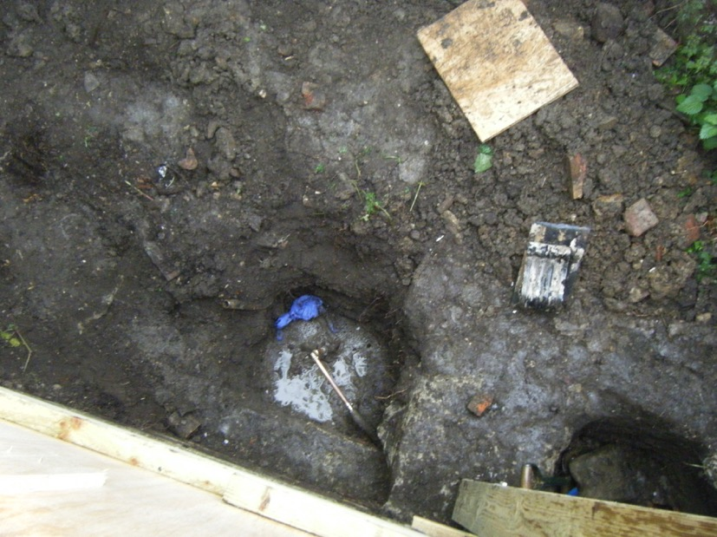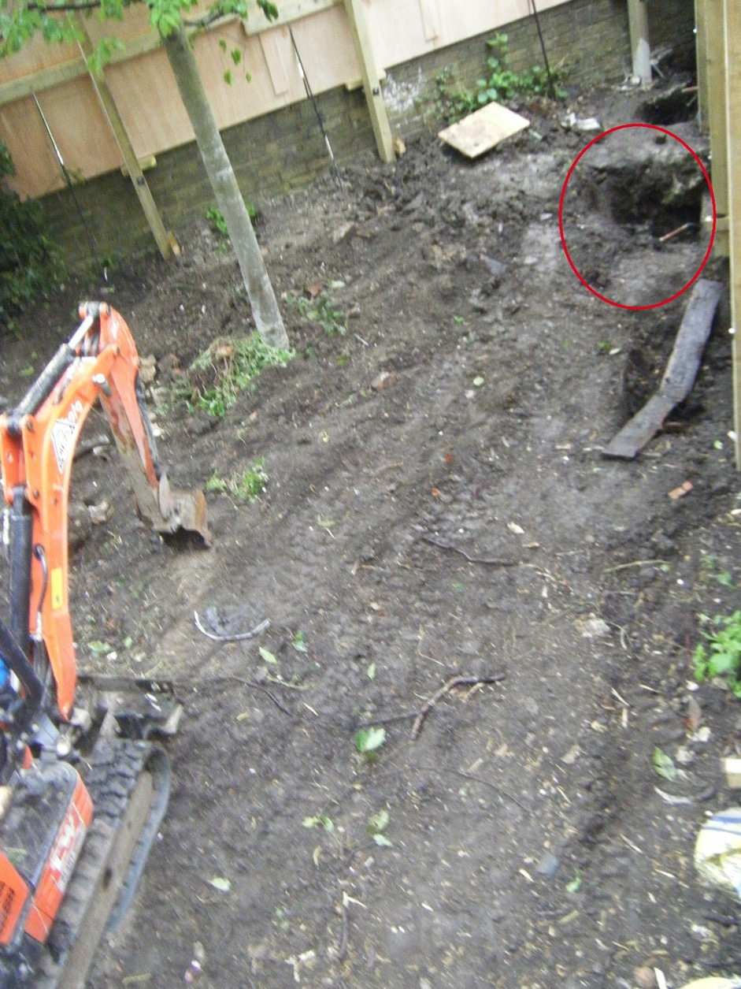

Site B 29/4/18 – After the ‘foundation trench’ has been dug and filled. Again please note the exposed brick wall to ground level and the position of the hoarding posts either side of each of the three holes.

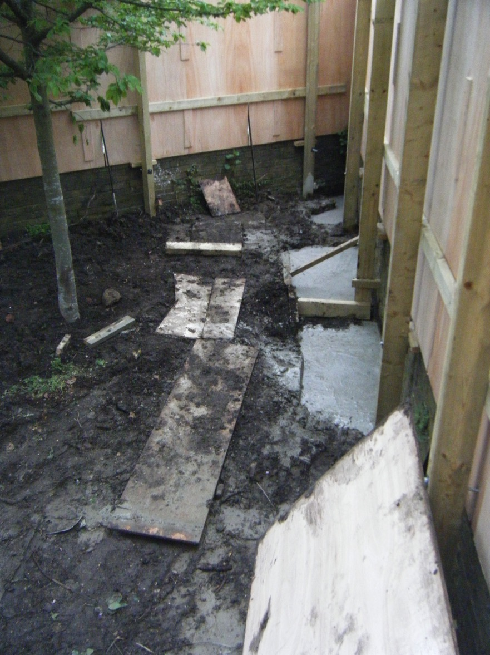

Site B 29/4/18 – After the ‘foundation trench’ has been dug and filled. Again please note the exposed brick wall to ground level and the position of the hoarding posts.

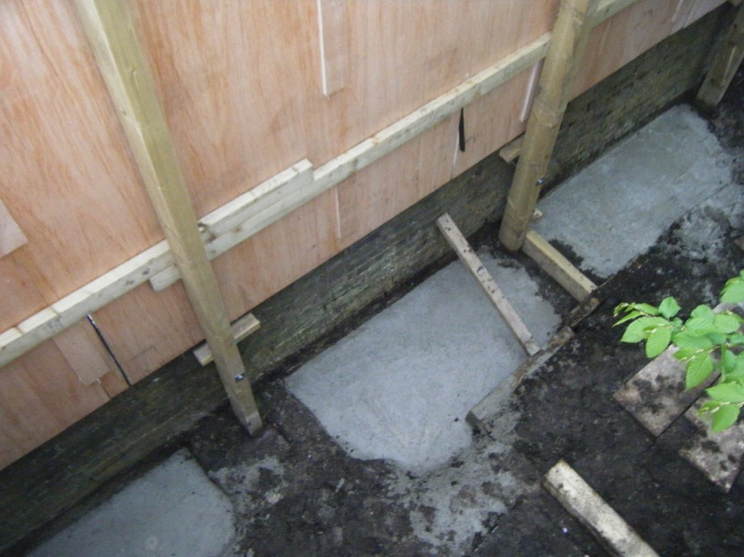

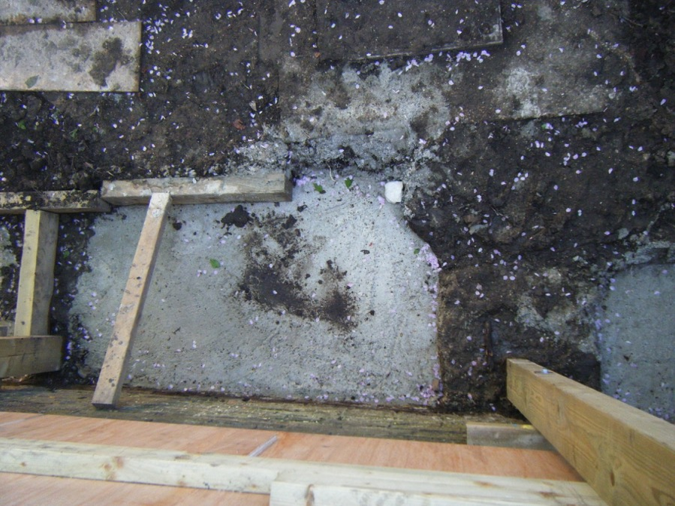

To conclude.

The photograph used in evidence shows:

A wall that has a foundation around 8 brick courses below ground.

- The wall at site B foundations starts 4 brick courses below ground.

The photograph used in evidence shows:

A hole with no hoarding posts in the ground on either side.

- Site B’s hoarding posts were in the ground before the holes were begun. These posts are very clearly the same in the ‘pre hole’ photographs as in the ‘after concrete poured’ photographs, they have not been removed and replaced.

The photograph used in evidence shows:

A hole next to a boundary fence/or hoarding that continues to ground level.

- Site B has brick to ground level, has no fence or hoarding to ground level.

This evidence shows that the submitted photograph in Appendix A in the application is not from this site and therefore calls into question the veracity of the entire application but particularly the evidence that a correct depth ‘foundation footing’ has been made.

I will attach the above seven photographs used as evidence in separate emails so you so that you have access to the original photographs and can examine them in greater detail.

Yours sincerely,

James Marshall

On behalf of

‘Save Gospel Oak’s Green Spaces’.