**The Italian Hospital Chapel**

The Italian Hospital (Queen Square, Bloomsbury) closed in 1990 and the property was bought by the Great Ormond Street Hospital Charity. Since 1991, Great Ormond Street Hospital (GOSH) has used the building for non-clinical functions.

The original chapel of the Italian Hospital, located on the top (3rd) floor, was retained but has not been used for formal Christian worship during GOSH’s ownership of the building. The space continues to be made available to staff and parents that are resident in the building although there is little evidence that many people choose to use the space and the focus of Christian prayer and worship for GOSH is the historic chapel of St Christopher in the main hospital building.

GOSH is in the process of investigating future use of the Italian Hospital as an outpatient facility and the chapel space is required for an alternative function. Whilst the plans would include retention of the historic fabric of the space (including stained glass windows, decorative columns, carved frieze and feature domed ceiling) GOSH would like to relocate the altar, so that it can be brought back into ecclesial use. In its current home, this will not happen. Relocation of the altar will be subject to listed building consent from Camden Borough Council.

The altar is approximately 2850mm x 2550mm at its widest and, at its tallest, reaches 2500mm in height (see images and sketch below). The relic appears to remain in situ.

Having established that neither the Italian Church in Clerkenwell nor our local parish church of St Anselm and St Cecilia can accommodate the altar, GOSH is seeking to find a church that would like to have it, if removal is permitted. The logistics and costs associated with the removal and relocation of the altar will be the responsibility of whichever church agrees to have it.

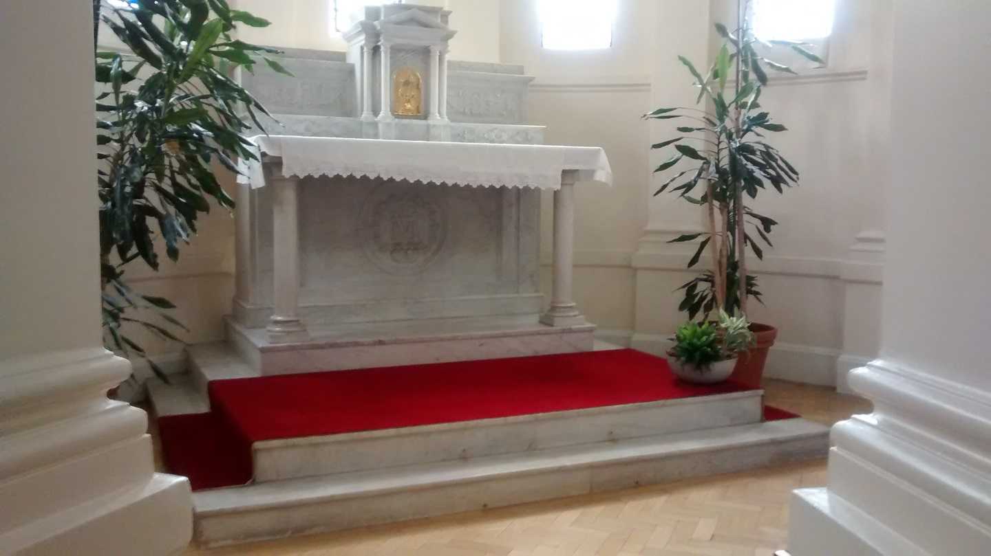

**Plan View (not to scale)**



**Images of Design Details**

|  |  |
| --- | --- |
|  |  |
|  |  |
|  | |
|  |  |
|  |  |

The Italian Hospital provided healthcare to the Italian community of London from the late 19th century until 1990, when the building transferred to GOSH. The image below shows the chapel in 1903, when the hospital was administered by the Sisters of Charity of St Vincent de Paul. The emblem of the order (from the miraculous medal given to St Catherine Labouré by the Virgin Mary in 1830) features in the altar carvings and in a stained glass window in the chapel. The sisters that were resident in the hospital used the chapel for praying the liturgy of the hours as well as for prayer and worship for patients and families.

Although a small tabernacle is incorporated into the reredos of the altar, the location of the key is not known.

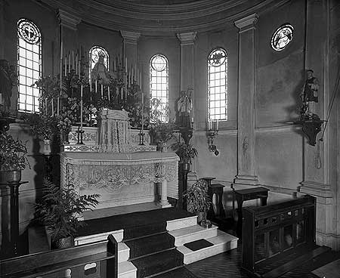

**Further Information**

To obtain further information or to arrange a viewing, please contact:

Crispin Walkling-Lea

Head of Healthcare Planning

Development & Property Services

Great Ormond Street Hospital for Children NHS Trust

E-mail: [Crispin.Walkling-Lea@gosh.nhs.uk](mailto:Crispin.Walkling-Lea@gosh.nhs.uk)

Tel: 020 7405 9200 ext. 6351

Mob: 07590 625486