Reverend Robbie O’Callaghan

Our Lady & St Joseph Catholic Church

1 St Joseph Street

Matlock

Derbyshire

DE4 3NG

7th August 2017

Mr Crispin Walkling-Lea

Head of Healthcare Planning

Development & Property Services

Great Ormond Street Hospital for Children

NHS Foundation Trust

Mezzanine Floor

40 Bernard Street

London

WC1N 1LE

Dear Crispin Walkling-Lea,

I am writing in response to the information you sent me in reference to The Italian Hospital Chapel and its said marble altar dedicated to St Christopher. I have read the beautiful background of the use of the chapel and understand the space is no longer heavily used as a Christian worship space.

I wish to submit an application on behalf of Our Lady & St Joseph to acquire the altar from the Trust and bring it back to liturgical use. Our side Lady Chapel within the church has never had over the many years a descent altar, even now it has a wooden altar surround not in keeping with the age of our building. We have behind our main altar the most beautiful reredos (see photograph) which would be complimented by an ornate matching Lady Chapel altar. We could accommodate the altar and steps after removing our wooden structure and clearing and facing up the site to receive it. It would then be re-consecrated by our Bishop. I have sought to contact a local firm which works nationally after speaking to the network of stonemasons here in Derbyshire and there is one company that specialises in such large and fragile ventures. They have quoted an estimate of £4000.00 to remove and reinstitute the altar here in Matlock. Of course the site would need inspecting and the practicalities of how they might remove the numbered stones from the hospital site. All Health & Safety aspects would also need to be discussed.

The altar would be brought to life once more and be respected and loved for the future prayers of the Church. We would place a plaque on the side wall highlighting your kindness and write and thank the Italian community. I attach photographs of the church and its history. It would be my hope as a priest to transfer daily Mass from our main altar to the Lady altar a few times a week and on her feast days. You shall be in my prayers for all the great work your Trust does for so many.

Yours faithfully

Fr Robbie O’Callaghan

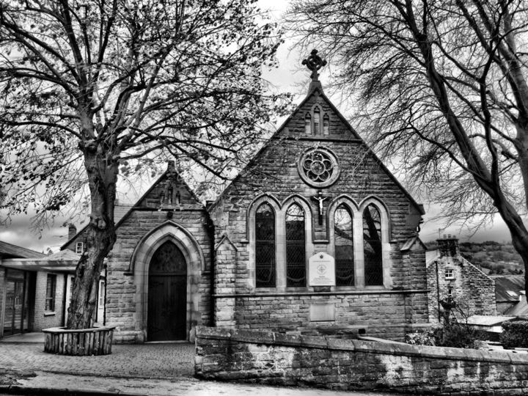

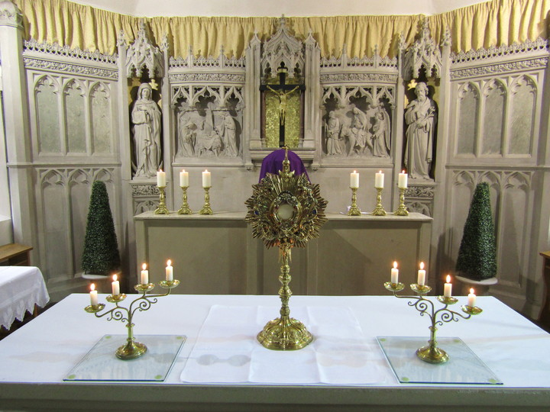

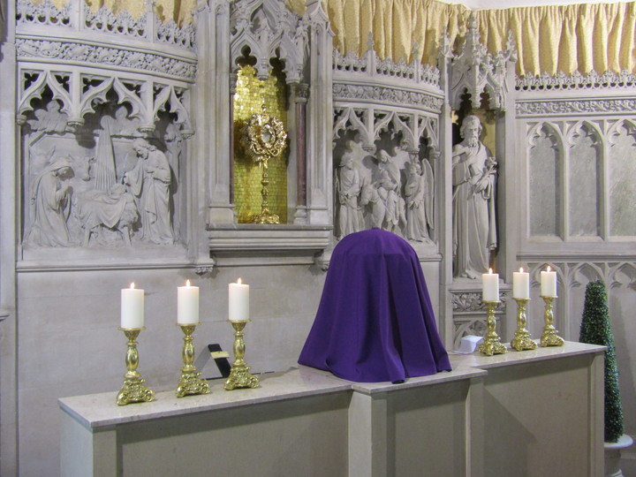

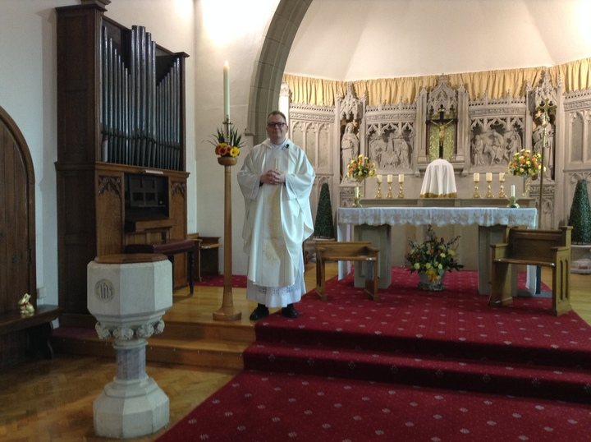

**Stonemasons for the Midlands**

*At Stone & Marble Ltd we believe presentation is everything to a home or business. Whether it's a domestic property, new build, monument or bank, the marble, brick and stone surfaces should be kept in pristine condition.*

With over 40 years of industry experience our team of expert stonemasons guarantee superb craftsmanship and an extraordinary attention to detail. We offer a 24 hour service, travelling anywhere in the country, completing any size job, while bringing the best price for the best in natural stone cleaning, repair and restoration.

**Our stonemason services include:**

* Marble, brick and natural stone restoration
* Marble, brick and natural stone repair
* Marble, brick and natural stone cleaning

**We have carried out stonemasonry for the following companies:**

* Kier
* Derby City Council
* RAF Bases
* Barclays Bank
* Lloyds TSB
* Marks and Spencer

*We carry full public and employer’s liability insurance and all of our staff are fully trained, CSCS registered and CHAS approved. We also provide method statements and risk assessments on request.*

*Enjoy fine craftsmanship and competitive pricing on your marble, brick and stone cleaning.*

Our Lady & St Joseph, Matlock

Parish History

**Before 1895**

Matlock, originally known as Metesford, a name derived no doubt from the circumstances of being a ford across the Derwent where Matlock now stands, can boast a record in the pages of the Doomsday Book.

There is scant evidence of Catholicism in the Matlock area during the years immediately following the Reformation, although Hathersage and Hassop were more fortunate probably due to the presence of notable catholic families. It is thought Mass was celebrated on a regular basis in Matlock by a priest who travelled on horseback from Derby.

In 1880 a house in Holt Lane was rented and a Chapel opened on the first floor. The first Mass was celebrated there on April 23rd 1880.

During 1880 a site on Bank Road Matlock was bought. Building began to the design of a Mr E. Fryer an Architect from Derby. The construction was undertaken by the Matlock firm B. Askew at a cost of approximately £700.

On July 16th 1883 the Church of Our Lady and St. Joseph was opened in a ceremony attended by the Bishop of Nottingham. High Mass was celebrated and the choir from St. Mary’s in Derby sang Mozart’s Mass No. 1

The catholic population in Matlock and District at this time is not known but it is interesting to note that between the years 1880-1920 there were only two occasions when baptisms for any one year reached double figures. Indeed between 1887- 1895 no baptisms were recorded at all.

There are two main factors which might have influenced the sparse baptisms, one being that the majority of the congregation were over child-bearing age or unmarried, the other that the greater part of the congregation would consist of visitors to the then popular hydros, whose baptisims would have been recorded elsewhere. Whatever the cause, the indication is that the Catholic numbers were small compared within the indigenous local population.

For the first ten years the church was served from Saint Mary’s Derby, but in 1890 Father Robert Browne became the first resident Priest.

In 1884, a further piece of land had been secured for the purpose of a presbytery but the house was not completed until 12 years later, in September 1896.

**1895 to 1965**

Father George Le Roy, a native of Belgium came to the parish in 1895. It was he who was largely responsible for the success of the funding for the church in these early days. He used to appeal to visitors to Matlock to help pay the interest on the money borrowed for the church and presbytery buildings. This financial struggle continued up to and shortly after Father Le Roy’s death in 1920. A stained glass window is dedicated to the memory of Father Le Roy.

The priest following Father Le Roy in 1920 was Father Crowther. Little has been recorded about Father Crowther. It is known he left the parish in 1926 and was succeeded by Father Cossins.

Father Charles Cossins came to Our Lady & Saint Joseph’s church in 1926. He was a dedicated priest. Parishioners spoke highly of his capacity for hard work in the parish.

It was during this time that the Presentation Sisters came to Matlock. The Convent was opened in 1927 in the former Chesterfield House Hydro. The foundation was made by members of the community who had spent many years in the mission fields in India. The Presentation Sisters had built up a high reputation for the quality of their education in Madras. Father Cossins assisted in the purchase of the house and grounds where the Presentation Convent now stands. Father Cossins stayed for five years.

Father Hugh Atkinson came to the parish in 1931. During his period as Parish Priest Father Hugh Atkinson made several improvements to the church including an extension to the nave to extend the sanctuary in 1934.  A dated stone can be seen on the outside of the church.

The extension was made financially possible by the generosity of Mrs Wildsmith.

Father Cyril Restieaux (later Bishop of Plymouth) came to Matlock in 1934. Father Restieaux continued to improve the church building and its contents. He renewed the seating and had the main aisle tiled. He also installed Stations of the Cross. Three stained glass windows were put in and a new high altar and organ installed. The original wooden altar and organ were moved to Saint Theresa’s Church in Wirksworth.

Father Restieaux was parish priest for 12 years. He moved to Nottingham Cathedral in 1948.

Father John Goodwin came to the parish in 1948. It was his great desire to a build a school for the Catholic children of the parish. Although a piece of land was selected for the building project the number of children in the parish was too small to warrant the building of a new school. He died in 1965.

A special day for the parish and especially the Johnson family was February 23rd 1955. The then Bishop of Nottingham, The Right Reverend Dr. Edward Ellis, visited the church to baptise a sister for seven brothers. Bishop Ellis made a practice of travelling to any part of his diocese to baptise the eighth and subsequent children of Catholic families.

**The Parish since 1965**

Father Hugh O’Brien succeeded Father Goodwin and came to the parish in 1965. Father O’Brien continued with the task of building a Parish Hall. He was successful and the hall was opened in 1967.  
From 1969 to 1971 the parish was served by Canon Thornhill assisted by Father Michael Bell.

An important event in the church was the placing of a new Liturgical altar in 1969. The altar, made from Stancliffe Darley Dale Stone, was designed by Smith and Roper, Architects for the Sanctuary alterations. The altar was donated by the sons of Mary Katherine Smith, in memory of their mother who died on 5th June 1960. The relics of Saint Hedwig, taken from the original wooden altar, were subsequently embedded in the new altar by the Right Reverend James McGuinness, Bishop of Nottingham, on the 1st October 1978. In 1983 Saint Joseph’s Church celebrated its centenary. During this centenary year Father Anthony Colebrook became Parish Priest.

Farther Jonathan Cotton became Parish Priest in 1990. Father Cotton was ordained in 1976 and was assistant director at the Diocesan residential Youth Training Centre at the Briars, Crich, for four years before becoming Parish Priest at Matlock and Wirksworth.

**Saint Joseph’s Primary School Matlock.**

On 6th September 1990 Saint Joseph’s School was opened. The Headmistress Sister Dolores Cooney a member of the Presentation Order, opened the school with 116 children. It was a very important and long awaited day by the Catholic Community in the Matlock area. The following year on 7th November 1991 the school was officially opened and blessed by Bishop James McGuinness. The school flourishes and presently has two hundred children enrolled.

In 1995 Father Jonathan was released from the parish and appointed the first full time director of the Nottingham Pilgrims working with Sister Angela Murphy a member of the Presentation Order.

Father Paul Newman came to Matlock in 1995. Father Paul was Assistant Vocations Director and Ecumenical Officer for North Derbyshire linking with other Christian churches. In 2000 he was transferred to Ripley and from there appointed Diocesan Youth Officer in residence at the Briars Residential Youth Centre, Crich.

Canon Bernard Needham succeeded Father Newman as parish priest in 2000. Work had just begun on demolishing the old parish hall and a fine replacement made possible by a grant from the Community Fund. The new hall was blessed by Bishop Malcolm McMahon, O.P., Bishop of Nottingham and officially opened by the Rt. Hon. Michael Martin, Speaker of the House of Commons on 7th September 2001.  Father Bernard retired in 2016 after serving 16years as parish priest.

Father Robert O’Callaghan succeeded Father Bernard in September 2016.

**Parish Priests of Our Lady & St Joseph’s**

|  |  |
| --- | --- |
| 1890 | Father Robert Browne |
| 1895 | Father George Le Roy |
| 1920 | Father Aloysius Crowther |
| 1926 | Father Charles Cossins |
| 1931 | Father Hugh Atkinson |
| 1934 | Father Cyril Restieaux |
| 1948 | Father John Goodwin |
| 1965 | Father Hugh O’Brien |
| 1969 | Canon Robert Thornhill |
| 1971 | Father Gerald Collins |
| 1983 | Father Anthony Colebrook |
| 1990 | Father Jonathan Cotton |
| 1995 | Father Paul Newman |
| 2000  2016 | Canon Bernard Needham  Father Robbie O'Callaghan |