**Design and Access Statement**

**Revision A – July 2018**

**8 – 12 LEEKE STREET LONDON WC1X 9HT**

Prepared

by

Aaron Yap AA Dipl MA (Hons) RIBA  
Architect

YD logo sm  
  
15 Cloudesley Road  
London N1 0EL

Mobile: 07768 652 013

09 July 2018

**CONTENTS**

1. SUMMARY

2. BACKGROUND

3. REFURBISHMENT

4. AIR SOURCE HEAT PUMPS

5. LAWFUL DEVELOPMENT CERTIFICATES

6. PROPOSED DEVELOPMENT

7. POLICY DP28 – NOISE AND VIBRATION

8. APPENDIX A

9. APPENDIX B

**REVISED DESIGN AND ACCESS STATEMENT**

**8 – 12 LEEKE STREET LONDON WC1X 9HT**

**1. SUMMARY**

Planning Application ref 2018/1253/NEW in this matter was submitted on 9th March 2018. However, due to a backlog, instead of the usual 5 working days, the validation process was delayed until 16th May 2018. At this time, the Planning Officer requested an Acoustic Report. This report is now complete and submitted. It is titled “Acoustic Impact Assessment”.

The acoustic report shows that an acoustic barrier is required with a minimum sound reduction of 13 dB. The proposed plans have been updated to incorporate a sound barrier that has an attenuation of 27 dB. which exceeds the minimum specification that recommended by the sound engineer. The sound barrier specifications can be found on APPENDIX B.

This revised Supporting DAS has been prepared on behalf of Blue Suede Limited (‘Blue Suede’) who is the freeholder of 8-12 Leeke Street, London WC1X 9HT (‘the Building’). It accompanies the planning application for upgrading and replacing 5 Air Source Heat Pump Condensers (ASHP) in their existing location and upgrading and re-siting one condenser from a vertical wall at the rear of the Building to the flat roof of the Building. The Building is within a conservation area but is not listed. ASHP units on roof tops are common in the Borough and eco-friendly. All 6 replacement units will not be out of character and will be hidden by the acoustic barriers when viewed from neighbouring properties. The replacement installations will have on average lower decibel readings than the existing units and when screened will comply with the noise criteria of DP28. 3. Please see the submitted “Acoustic Impact Assessment”.

**2.** **BACKGROUND**

In 2004/2005, Blue Suede carried out an extensive refurbishment of the Building as B1 offices. In April 2005, the Building was let to Japanese retailer Muji as its European Headquarters. By 2018, Muji had expanded its retail operations and needed more space and in April 2018 moved to larger office premises.

**3. REFURBISHMENT**

The Applicant plans to refurbish the Building with a view to finding a new tenant. Part of the refurbishment involves the upgrading of the heating and cooling equipment being ASHP’s which, 14 years on, have reached the end of their functional lives. Please see Drawing LSE02 with list of existing equipment.

**4. AIR SOURCE HEAT PUMPS**

In 2005, the Applicant installed 2 ASHP condensers designated E1 and E2 on Drawing LSE02 on the roof of the Building replacing 2 existing condensers. See APPENDIX A – Drwg. No. LSP03B – dated February 2004.

The Building was let to Muji in April 2005, and as part of their fit-out, Muji installed 3 additional but smaller condensers (E3 and E4), on the roof against the parapet to service 2 meeting rooms and their IT communications room (E5). In addition, a condenser (E6) was affixed to a high level wall on First Floor at the rear to service the reception area of the Building. Please see Existing Drawing No. LSE02 - Due to an oversight, no application for planning permission was made for these installations.

**5. LAWFUL DEVELOPMENT CERTIFICATES**

All 6 condensers E1 to E6 have been in situ at the Building unchanged for in excess of 10 years and, under section 191 of the Town and Country Planning Act 1990, the Applicant has applied with full aerial photographic evidence and other supporting documentation for Lawful Development Certificates in relation to the 6 condensers under Application Ref. 2018/1748/P

**6. PROPOSED DEVELOPMENT**

The Applicant wishes to replace Condensers E1, E2, E3, E4 and E5 which have reached the end of their functional life with new quieter models of similar capacity and, in addition, for health and safety reason to upgrade and re-site Condenser E6 from a vertical wall at the rear to the roof of the Building. The existing location of E6 makes it unsafe for service and maintenance.

**7. POLICY DP28 – NOISE AND VIBRATION**

The new condensers (See Drawing No. LSP02) Outside Units P1 to P6 will continue to be situated against parapet and other walls and screened on all sides to ensure that noise and vibration is controlled and managed, will not generate noise pollution and will not exceed Camden’s Noise and Vibration Thresholds. Please see the submitted “Acoustic Impact Assessment”.

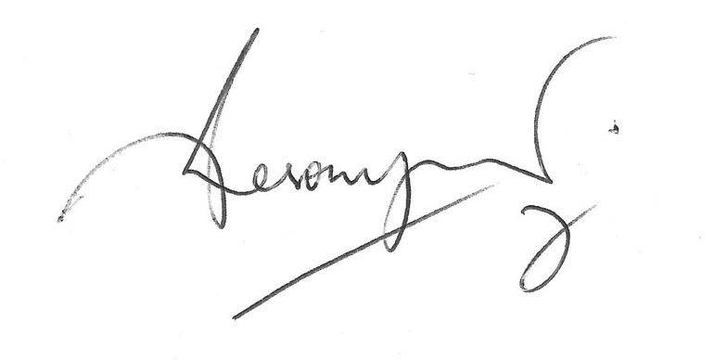

Aaron Yap AA Dipl MA (Hons) RIBA  
Architect

**APPENDIX A**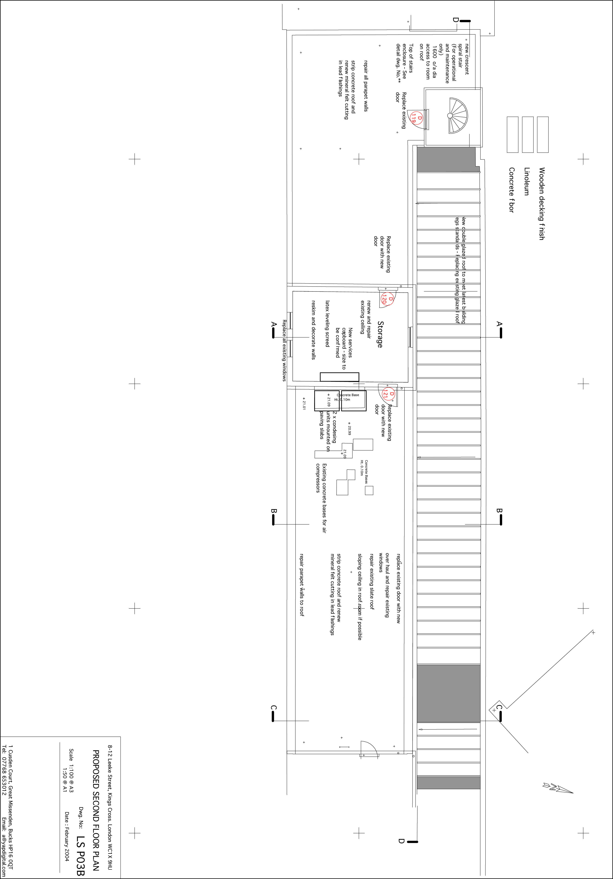

**APPENDIX B**

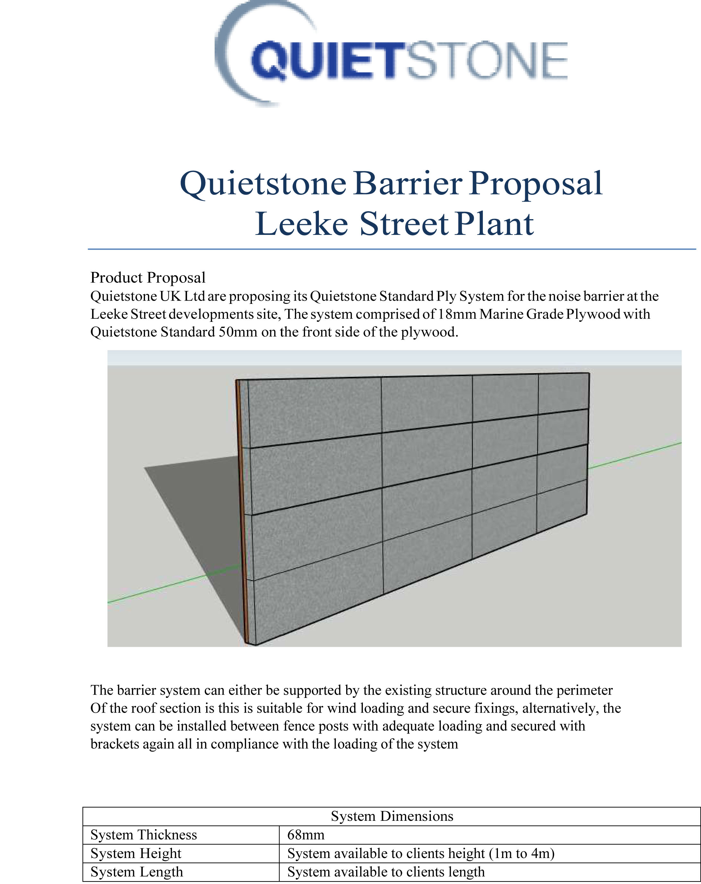

Quietstone Page 1

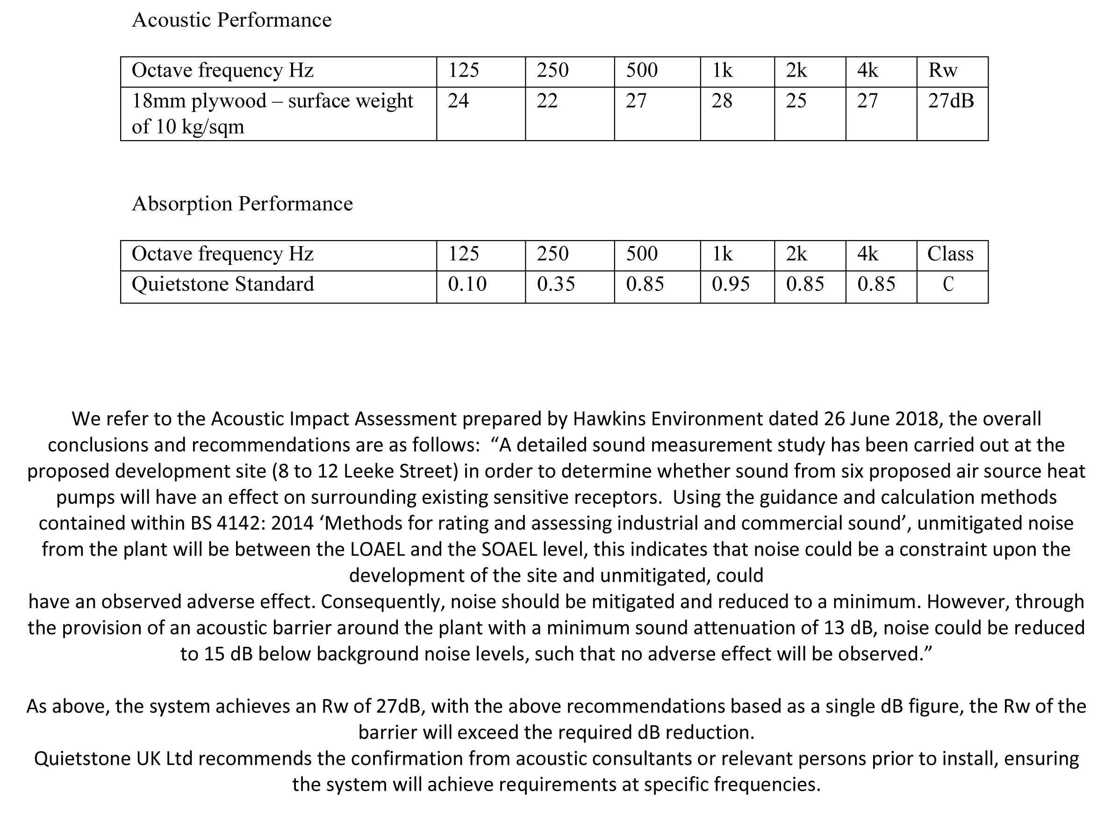

END

Quietstone Page 2