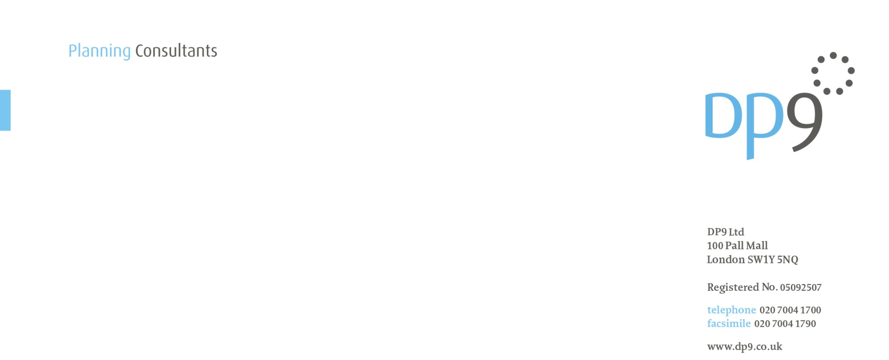DP4129/TH/DF/GR

22 June 2018

Mr David Peres da Costa

London Borough of Camden

Regeneration and Planning

Culture and Environment

2nd Floor, 5 Pancras Square

c/o Town Hall

Judd Street

London

WC1H 9JE

Dear David

**1 TRITON SQUARE & ST ANNE’S CHURCH (REF. 2016/6069/P) – CONDITION 13 (SUStainable urban drainage systems) part a) commercial element**

**APPROVAL OF DETAILS APPLICATION**

We write on behalf of our client, British Land Property Management Limited, to submit details via the Planning Portal to discharge Condition 13(a) in respect of the commercial element of the development attached to the above planning permission.

The submission is made in accordance with the amended condition wording as approved under Non-Material Amendment application ref: 2017/6573/P). Part (a) of Condition 13 reads as follows:

*‘Prior to the commencement of relevant drainage works within either the commercial or residential element of the development, full details of the sustainable drainage system within that element including (where relevant to that element):*

*o Rainwater harvesting*

*o Landscaping on Longford Place*

*o Brown roofs (commercial element only)*

*o Living roofs (residential element only)*

*o 280m3 attenuation tank with pumped flow control*

*shall be submitted to and approved in writing by the local planning authority. Such a system should be designed to accommodate all storms up to and including a 1:100 year storm with a 40% provision for climate change, such that flooding does not occur in any part of a building or in any utility plant susceptible to water, and shall demonstrate a maximum run-off rate of 35 l/s. Details shall include a lifetime maintenance plan.”*

This application relates to the sustainable drainage system within the commercial element only and provides full details of rainwater harvesting, landscaping on Longford Place, brown roofs and the attenuation tank with pumped control flow.

The details provided in respect of the brown roofs are reflective of the brown roofs as proposed to be amended via the currently pending non-material amendment application which has been submitted via the planning portal with reference PP-07014875.

We look forward to receiving confirmation of receipt and would ask you to contact Georgina Redpath or Dan Fyall at the above office if you require any further information.

Yours sincerely,

cid:image001.jpg@01D08DA4.8FA43240

**DP9 LTD.**