Application for tree works: works to trees subject to a tree preservation order (TPO)

and/or notification of proposed works to trees in a conservation area.

Town and Country Planning Act 1990

Publication of applications on planning authority websites
Mr.
Please note that the information provided on this application form and in supporting documents may be published on the
Authority’s website. If you require any further clarification, please contact the Authority’s planning department.

Please complete using block capitals and black ink.
You must use this form if you are applying for work to trees protected by a tree preservation order (TPO). (You may also use it to give notice of works to trees in a conservation area).
It is important that you read the accompanying guidance notes before filling in the form. Without the correct information, your application /
notice cannot proceed.

1. Applicant Name and Address
2. Agent Name and Address

Title: First name:
Mrs
Dara
Tony
Title:
First name:

Last name:
Last name: Sullivan

Company
Black Katz Management
(optional):
Company
(optional):
Tally-Ho Landscapes Contracts Ltd.

Unit:
27
House number:
House suffix:

Unit:

17
Friary Road

House number:
House suffix:

House name:
Flat 1
House name:

Address 1:
27 Agar Grove
Address 1:

Address 2:
Address 2:

Address 3:
Address 3:

Town:
Town:

County:
County:

Country:
Country:

Postcode:
NW1 9UG
Postcode:

$Date: 2009/02/24 14:34:12 $ $Revision: 4.3 $
London
N12 9PD

3. Trees Location
If all trees stand at the address shown in Question 1, go to Question
4. Otherwise, please provide the full address/location of the site
4. Trees Ownership
Is the applicant the owner of the tree(s): If 'No' please provide the address of the

Yes No
x
First name:
House House number: suffix:

where the tree(s) stand (including full postcode where available)
owner (if known and if different from the trees location)

Title:

Unit:

House name:

Address 1: Address 2: Address 3: Town:
County:

Postcode
(if known):

House number:
House suffix:

Last name: Company
(optional):
Unit: House
name:

Address 1: Address 2: Address 3:
Town:

If the location is unclear or there is not a full postal address, either describe as clearly as possible where it is (for example, 'Land to the rear of 12 to 18 High Street' or 'Woodland adjoining Elm Road') or provide an Ordnance Survey grid reference:

Description:

County: Country: Postcode:
Telephone numbers

Extension

Country code:
National number:
number:

Country code:
Mobile number (optional):

Country code:
Fax number (optional):

Email address (optional):

5. What Are You Applying For?

Are you seeking consent for works to tree(s)
X
subject to a TPO?

Yes No
6. Tree Preservation Order Details

If you know which TPO protects the tree(s), enter its title or number below.

Are you wishing to carry out works to tree(s)
X
in a conservation area?

Yes No

7. Identification Of Tree(s) And Description Of Works
Please identify the tree(s) and provide a full and clear specification of the works you want to carry out. Continue on a separate sheet if necessary. You might find it useful to contact an arborist (tree surgeon) for help with defining appropriate work. Where trees are protected by a TPO, please number them as shown in the First Schedule to the TPO where this is available. Use the same numbers on your sketch plan (see guidance notes).
Please provide the following information below : tree species (and the number used on the sketch plan) and description of works. Where trees are protected by a TPO you must also provide reasons for the work and, where trees are being felled, please give your proposals for planting replacement trees (including quantity, species, position and size) or reasons for not wanting to replant.
E.g. Oak (T3) - fell because of excessive shading and low amenity value. Replant with 1 standard ash in the same place.

On further inspecting the big mature Lime tree by the rear boundary, this tree is completely covered in Ivy. To remove all the Ivy out of this tree where possible and to cut the Ivy down to ground level

I then recommend to pollard back the same Lime tree and to de-sucker this tree

$Date: 2009/02/24 14:34:12 $ $Revision: 4.3 $

7. Identification Of Tree(s) And Description Of Works continued ...

8. Trees - Additional Information

Additional information may be attached to electronic communications or provided separately in paper format.

For all trees
A sketch plan clearly showing the position of trees listed in Question 7 must be provided when applying for works to trees covered by a TPO. A sketch plan is also advised when notifying the LPA of works to trees in a conservation area (see guidance notes).
It would also be helpful if you provided details of any advice given on site by an LPA officer.

For works to trees covered by a TPO
Please indicate whether the reasons for carrying out the proposed works include any of the following. If so, your application must be accompanied by the necessary evidence to support your proposals. (See guidance notes for further details)

1. Condition of the tree(s) - e.g. it is diseased or you have fears that it might break or fall: If YES, you are required to provide written arboricultural advice or other diagnostic information from an appropriate expert.
Yes X No

2. Alleged damage to property - e.g. subsidence or damage to drains or drives.
If YES, you are required to provide for:

Subsidence

Yes X No

A report by an engineer or surveyor, to include a description of damage, vegetation, monitoring data, soil, roots and repair proposals. Also a report from an arboriculturist to support the tree work proposals.

Other structural damage (e.g. drains, walls and hard surfaces)
Written technical evidence from an appropriate expert, including description of damage and possible solutions.

Documents and plans (for any tree)
Are you providing separate information (e.g. an additional schedule of work for Question 7)?

Yes X No

If YES, please provide the reference numbers of plans, documents, professional reports, photographs etc in support of your application. If they are being provided separately from this form, please detail how they are being submitted.

$Date: 2009/02/24 14:34:12 $ $Revision: 4.3 $

9. Application For Tree Works - Checklist

Only one copy of the application form and additional information (Question 8) is required. Please use the guidance and this checklist to make sure that this form has been completed correctly and that all relevant information is submitted. Please note that failure to
supply precise and detailed information may result in your application being rejected or delayed. You do not need to fill out this section, but it may help you to submit a valid form.

Sketch Plan

A sketch plan showing the location of all trees (see Question 8)
X

For all trees
(see Question 7)
Clear identification of the trees concerned
X

A full and clear specification of the works to be carried out
X

For works to trees protected by a TPO
(see Question 8) Have you:
X
stated reasons for the proposed works?

provided evidence in support of the stated reasons? in particular:
if your reasons relate to the condition of the tree(s) - written evidence from an appropriate expert
if you are alleging subsidence damage - a report by an appropriate engineer or surveyor and one from an arboriculturist.
in respect of other structural damage - written technical evidence

included all other information listed in Question 8?

10. Declaration - Trees
I/we hereby apply for consent/give notice for tree work as described in this form and the accompanying plans and additional information.
T. Sullivan

Signed - Applicant:
Or signed - Agent:

Date (DD/MM/YYYY):

(This date must not be before the date
of sending or hand-delivery of the form)

11. Applicant Contact Details

Telephone numbers

Country code: National number:

Extension number:
12. Agent Contact Details

Telephone numbers

Country code: National number:
0208

Extension number:
445 3216

Country code: Mobile number (optional):
Country code: Mobile number (optional):

Country code: Fax number (optional):
Country code: Fax number (optional):

Email address (optional):
Email address (optional):

03.07.18
contact@tallyho.garden

Electronic communication - If you submit this form by fax or e-mail the LPA may communicate with you in the same manner.

(Please see guidance notes)

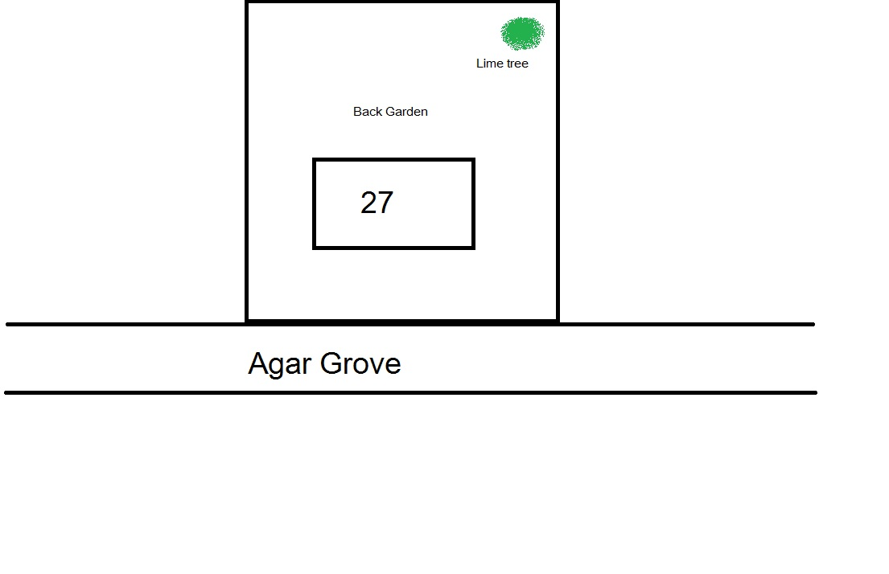

$Date: 2009/02/24 14:34:12 $ $Revision: 4.3 $

