* [Listing](https://historicengland.org.uk/listing/)
  + [Search the List](https://historicengland.org.uk/listing/the-list/)
  + [Enrich the List](https://historicengland.org.uk/listing/enrich-the-list/)
  + [Apply for Listing](https://historicengland.org.uk/listing/apply-for-listing/)
  + [What is Listing?](https://historicengland.org.uk/listing/what-is-designation/)
  + [Listing Guidance](https://historicengland.org.uk/listing/selection-criteria/)
* [Advice](https://historicengland.org.uk/advice/)
  + [Your Home](https://historicengland.org.uk/advice/your-home/)
  + [Planning](https://historicengland.org.uk/advice/planning/)
  + [Latest Advice & Guidance](https://historicengland.org.uk/advice/latest-guidance/)
  + [Caring for Heritage](https://historicengland.org.uk/advice/caring-for-heritage/)
  + [Technical Guidance](https://historicengland.org.uk/advice/technical-advice/)
  + [Heritage at Risk](https://historicengland.org.uk/advice/heritage-at-risk/)
  + [Constructive Conservation](https://historicengland.org.uk/advice/constructive-conservation/)
  + [Heritage Protection Guide](https://historicengland.org.uk/advice/hpg/)
* [Research](https://historicengland.org.uk/research/)
  + [Our Research Strategy and Agenda](https://historicengland.org.uk/research/agenda/)
  + [Research Methods](https://historicengland.org.uk/research/methods/)
  + [Current Research](https://historicengland.org.uk/research/current/)
  + [Research Results](https://historicengland.org.uk/research/research-results/)
  + [Support & Collaboration](https://historicengland.org.uk/research/support-and-collaboration/)
  + [Inclusive Heritage](https://historicengland.org.uk/research/inclusive-heritage/)
  + [Heritage Counts](https://historicengland.org.uk/research/heritage-counts/)
* [Images & Books](https://historicengland.org.uk/images-books/)
  + [Find Photos](https://historicengland.org.uk/images-books/photos/)
  + [Search All Publications](https://historicengland.org.uk/images-books/publications/)
  + [Buy Books](https://historicengland.org.uk/images-books/books/)
  + [The Historic England Archive](https://historicengland.org.uk/images-books/archive/)
  + [Be an Archive Detective](https://historicengland.org.uk/images-books/archive-mysteries/)
* [Services & Skills](https://historicengland.org.uk/services-skills/)
  + [Education](https://historicengland.org.uk/services-skills/education/)
  + [Grants](https://historicengland.org.uk/services-skills/grants/)
  + [Our Planning Services](https://historicengland.org.uk/services-skills/our-planning-services/)
  + [Training & Skills](https://historicengland.org.uk/services-skills/training-skills/)
  + [Archive Services](https://historicengland.org.uk/services-skills/archive-services/)
  + [Heritage Action Zones](https://historicengland.org.uk/services-skills/heritage-action-zones/)
* [Get Involved](https://historicengland.org.uk/get-involved/)
  + [100 Places](https://historicengland.org.uk/get-involved/100-places/)
  + [Support Us](https://historicengland.org.uk/get-involved/support-us/)
  + [Volunteer in Heritage](https://historicengland.org.uk/get-involved/volunteer/)
  + [Visit Your Heritage](https://historicengland.org.uk/get-involved/visit/)
  + [Protect Your Heritage](https://historicengland.org.uk/get-involved/protect/)
  + [Help Write History](https://historicengland.org.uk/get-involved/help-write-history/)
  + [Angel Awards](https://historicengland.org.uk/get-involved/angel-awards/)
* [What's New](https://historicengland.org.uk/whats-new/)
  + [News](https://historicengland.org.uk/whats-new/news/)
  + [In Your Area](https://historicengland.org.uk/whats-new/in-your-area/)
  + [Latest Listings](https://historicengland.org.uk/whats-new/listing/)
  + [Latest Research](https://historicengland.org.uk/whats-new/research/)
  + [Heritage Online Debate](https://historicengland.org.uk/whats-new/debate/)
  + [Statements](https://historicengland.org.uk/whats-new/statements/)
  + [Stay Up To Date](https://historicengland.org.uk/whats-new/stay-up-to-date/)
  + [50 Years of Conservation Areas](https://historicengland.org.uk/whats-new/conservation-areas-50-years/)
  + [First World War Centenary](https://historicengland.org.uk/whats-new/first-world-war-home-front/)
  + [What We Do](https://historicengland.org.uk/about/what-we-do/)
  + [Who We Are](https://historicengland.org.uk/about/who-we-are/)
  + [Jobs](https://historicengland.org.uk/about/jobs/)
  + [Contact Us](https://historicengland.org.uk/about/contact-us/)
  + [Volunteer with Historic England](https://historicengland.org.uk/about/volunteering/)
  + [Website Terms and Conditions](https://historicengland.org.uk/terms/website-terms-conditions/)
  + [Privacy and Cookies Policy](https://historicengland.org.uk/terms/privacy-cookies/)
  + [Links Policy](https://historicengland.org.uk/terms/links-policy/)
  + [Historic England Blog and Social: House Rules](https://historicengland.org.uk/terms/blog-house-rules/)
  + [Photo Competition Terms and Conditions](https://historicengland.org.uk/terms/photo-competition-terms-conditions/)
  + [Angel Awards 2017 Voting Terms and Conditions](https://historicengland.org.uk/terms/angel-awards-voting-terms-and-conditions/)
* [Home](https://historicengland.org.uk/)
* [...](https://historicengland.org.uk/listing/the-list/list-entry/1378713)
* [Listing](https://historicengland.org.uk/listing/)
* [Search the List](https://historicengland.org.uk/listing/the-list/)
* List Entry

[This browser is not fully supported](https://www.historicengland.org.uk/access/) by Historic England. Please update your browser to the latest version so that you get the best from our website.

We use cookies to give you the best possible experience online. By using this website, you consent to cookies being used in accordance with our [Cookie Policy](https://historicengland.org.uk/terms/).

* + [Map Search](https://historicengland.org.uk/listing/the-list/map/)
  + [Advanced Search](https://historicengland.org.uk/listing/the-list/advanced/)
  + [Minor Amendments](https://historicengland.org.uk/listing/the-list/minor-amendments/)
  + [Download Listing Data](https://historicengland.org.uk/listing/the-list/data-downloads/)
  + [Non-Listed Sites](https://historicengland.org.uk/listing/the-list/non-listed-sites/)
  + [About The List](https://historicengland.org.uk/listing/the-list/about-the-list/)
  + [Enrich the List](https://historicengland.org.uk/listing/the-list/enrich/)
  + [Understanding List Entries](https://historicengland.org.uk/listing/the-list/understanding-list-entries/)

**MORNINGTON CRESCENT LONDON RAILWAY TRANSPORT STATION INCLUDING FEATURES UNDERGROUND**

**List Entry Summary**

This building is listed under the Planning (Listed Buildings and Conservation Areas) Act 1990 as amended for its special architectural or historic interest.

Name: MORNINGTON CRESCENT LONDON RAILWAY TRANSPORT STATION INCLUDING FEATURES UNDERGROUND

List entry Number: 1378713

**Location**

MORNINGTON CRESCENT LONDON RAILWAY TRANSPORT STATION INCLUDING FEATURES UNDERGROUND, HAMPSTEAD ROAD

The building may lie within the boundary of more than one authority.

County: Greater London Authority

District: Camden

District Type: London Borough

Parish:

National Park: Not applicable to this List entry.

Grade: II

Date first listed: 24-Apr-1987

Date of most recent amendment: Not applicable to this List entry.

**Legacy System Information**

The contents of this record have been generated from a legacy data system.

Legacy System: LBS

UID: 478047

**Asset Groupings**

This list entry does not comprise part of an Asset Grouping. Asset Groupings are not part of the official record but are added later for information.

**List entry Description**

**Summary of Building**

Legacy Record - This information may be included in the List Entry Details.

**Reasons for Designation**

Legacy Record - This information may be included in the List Entry Details.

**History**

Legacy Record - This information may be included in the List Entry Details.

**Details**

CAMDEN  
  
TQ2983SW HAMPSTEAD ROAD 798-1/83/770 (East side) 24/04/87 Mornington Crescent LRT station including features underground   
  
II  
  
London Underground station. 1907. By Leslie Green. Maroon glazed faience. 2 storeys. 2 bays to Hampstead Road and 1 bay left return. Giant arches to each bay of pilasters supporting architraved heads with keystones. Upper parts of arches treated as glazed tympana and flanked by lugged architraved sashes. Entrance to right and lifts in left hand bay. C20 shop in return bay. White band at 1st floor level. Modillion cornice and blocking course above white faience frieze bearing words "Mornington Crescent Station" on both facades. Hampstead Road facade with original cast-iron lamp brackets and lamps to entrances. INTERIOR: with some original features including panelled exterior lift doors, Art Nouveau decorative grilles above and indicators, lift interiors. Tiles restored and ticket-office window replaced.   
  
  
  
Listing NGR: TQ2918583352

**Selected Sources**

Legacy Record - This information may be included in the List Entry Details

National Grid Reference: TQ 29185 83352

**Map**

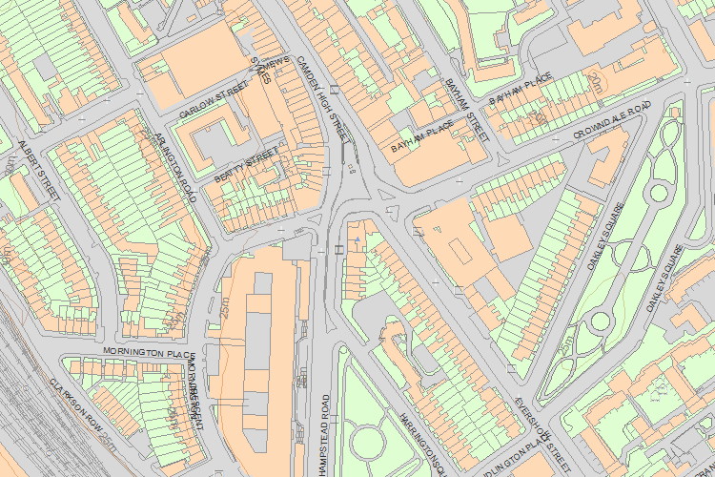© Crown Copyright and database right 2018. All rights reserved. Ordnance Survey Licence number 100024900.  
© British Crown and SeaZone Solutions Limited 2018. All rights reserved. Licence number 102006.006.  
Use of this data is subject to [Terms and Conditions](https://historicengland.org.uk/terms/website-terms-conditions/).

The above map is for quick reference purposes only and may not be to scale. For a copy of the full scale map, please see the attached PDF - [1378713 .pdf](http://mapservices.HistoricEngland.org.uk/printwebservicehle/StatutoryPrint.svc/402235/HLE_A4L_Grade%7CHLE_A3L_Grade.pdf)

The PDF will be generated from our live systems and may take a few minutes to download depending on how busy our servers are. We apologise for this delay.

This copy shows the entry on 03-Jul-2018 at 02:47:41.

End of official listing