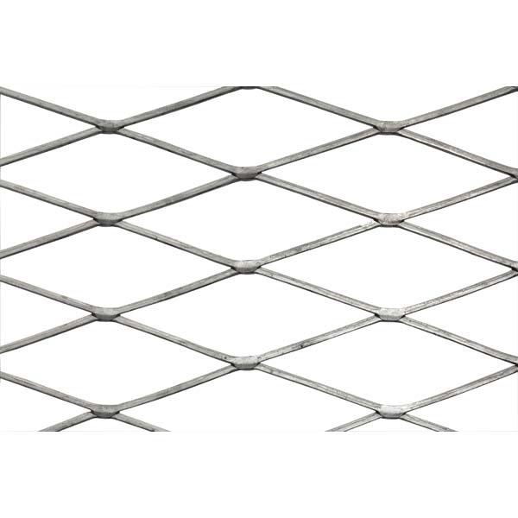

**Expanded Mild Steel No 8F 2440 x 1220mm Large Pattern No 8 Flattened to be Powder Coated to RAL 9011 30% gloss.**

Mesh Size LW: 190MM

Mesh Size SW: 60MM

Strand Width: 6.00MM

Strand Thickness: 2.80MM