**Lead Local Flood Authority comments**

|  |  |
| --- | --- |
| Scheme Address | 46 Holmedale Road, NW6 1BL |
| Planning Reference | 2018/0599/P |
| Date | 21/06/2018 |



This site is in an area identified in Camden’s Strategic Flood Risk Assessment as being at risk of surface water flooding.

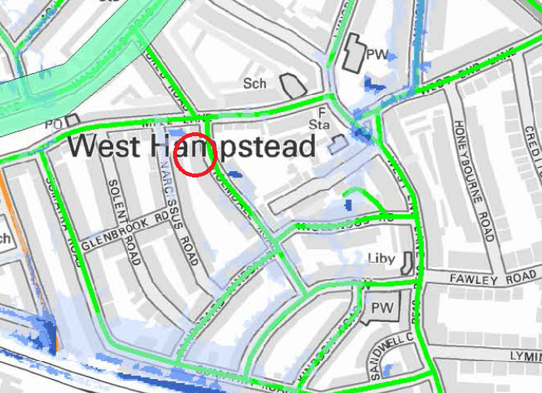

The map extract above taken from the SFRA shows that Holmedale Road was flooded in 2002 (roads marked green).

The BGS map of the borough also from the SFRA, shows the site in an area with opportunities for bespoke infiltration SuDS (darker purple in extract below):

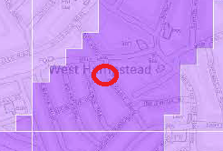

**Policy**

CC3 requires that where a site is known to have a particular drainage issue, development should not place additional strain on adjoining sites or the existing drainage infrastructure. It also requires that the development is designed to cope with being flooded.

8.63 requires a Flood Risk Assessment for all basement development on streets identified as being at flood risk. A Flood Risk Assessment should identify how a development will be designed to cope with flooding and how the risk will be mitigated without increasing the risk

elsewhere. Recommendations in the FRA will be secured by planning condition.

8.67 states that a drainage report should be submitted with all basement developments and other vulnerable development in areas identified at risk of flooding. This should include:

• identification of flood risk;

• assessment of existing run-off rates;

• calculation of greenfield run-off rates;

• identification of measures, in line with the drainage hierarchy, to reduce runoff

rates; and

• calculation of proposed run-off rates.

Developments are required to reduce their water consumption, the pressure on the combined sewer network and the risk of flooding by:

1. incorporating water efficient features and equipment and capturing, retaining and re-using surface water and grey water on-site;
2. limiting the amount and rate of run-off and waste water entering the combined storm water and sewer network through the methods outlined in part a) and other sustainable urban drainage methods to reduce the risk of flooding
3. reducing the pressure placed on the combined storm water and sewer network from foul water and surface water run-off and ensuring developments in the areas identified.... as being at risk of surface water flooding are designed to cope with the potential flooding

*The applicant must demonstrate how methods outlined in a), b) and c) above will be included in the proposals to ensure:*

* + *there is no additional strain on adjoining sites or the existing drainage infrastructure*
  + *the development will cope with being flooded. E.g. by:*
  + *No self-contained basement dwellings*
  + *Limiting flood waters entering and damaging the building fabric; or*
  + *Allowing flood water to enter the building but limiting the damage it will cause*

*Consideration of the cumulative impact of small prior approvals in high risk areas should be borne in mind (Residential use typically has a much higher water use than offices, resulting on increased impact on the sewer system due to generation of more waste water).*

**Documents reviewed**

‘Flood Risk Assessment’ dated 29 January 2018, prepared by LBH Wembley Engineering on behalf of Alex Wills and Artemis Doupa.

‘SuDS Strategy’ dated 15 May 2018, prepared by LBH Wembley Engineering on behalf of Alex Wills and Artemis Doupa.

**Comments**

The FRA states that “the development should not result in any significant impact to flood risk elsewhere” and there is “not deemed to be a requirement to mitigate against flood risk”. However the risk to the property itself, in particular the new basement use is not addressed.

The FRA also states that “following the 2002 flood event, it is understood that a flood alleviation scheme was created at Sumatra Road, West Hampstead.”

**Issue** the FRA cites the Sumatra Road storage tank but does not go on to demonstrate how flood risk is reduced at the scheme site by this means. No mitigation measures to protect the lightwell and basement are highlighted.

**Further action** In the absence of quantified detailed modelling demonstrating that the surface water risk is adequately reduced by the above nearby public scheme, in order to protect the new basement the applicant should be asked to show how the design includes measures for

* mitigation to prevent ingress of flood water into the property
* internal strategies to cope with any flooding.

The SuDs strategy proposes 1) attenuation via a pumped chamber in the front garden and 2) discharge to combined sewer. These are amongst the least preferable.

**Issue** The SuDS Strategy rules out infiltration SuDS on the broad basis of geology without conducting infiltration trials. See above regarding bespoke opportunities.

**Further action:** The applicant should be asked to undertake such trials using the BRE method.

**Issue** The following items are missing to support the SuDS strategy conclusions and proposals:

* MicroDrainage calculations
* Scheme-specific lifetime maintenance schedule. Must show how proposed discharge rates will be maintained given future risk of blockage.
* Camden drainage pro-forma (available from Camden website)

**Further action:** The above should be submitted to support the final SuDS strategy following incorporation of SuDS higher up the drainage hierarchy where feasible (following trials).

**Recommendation**: Further information required, see items in red above.