**Lead Local Flood Authority comments**

|  |  |
| --- | --- |
| Scheme Address | 29 St Alban’s Road, NW5 1RG |
| Planning Reference | 2018/1377/P |
| Date | 21/06/2018 |



This site falls within one of our Local Flood Risk Zones as defined within figure 6 of the SFRA (circled red in SFRA map extract below).

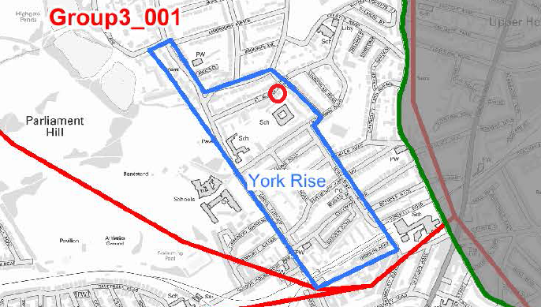

CC3 requires that where a site is known to have a particular drainage issue, development should not place additional strain on adjoining sites or the existing drainage infrastructure. It also requires that the development is designed to cope with being flooded.

The policy requires developments to reduce their water consumption, the pressure on the combined sewer network and the risk of flooding by:

1. incorporating water efficient features and equipment and capturing, retaining and re-using surface water and grey water on-site;
2. limiting the amount and rate of run-off and waste water entering the combined storm water and sewer network through the methods outlined in part a) and other sustainable urban drainage methods to reduce the risk of flooding
3. reducing the pressure placed on the combined storm water and sewer network from foul water and surface water run-off and ensuring developments in the areas identified.... as being at risk of surface water flooding are designed to cope with the potential flooding

**Comments**

There are no plans for a basement within the scheme. No increase in habitable area is proposed such that a greater strain is placed on the local combined sewer network.

There appears to be no significant increase in impermeable area as the new stone patio will largely replace the existing conservatory.

However, it is not clear how drainage of the new rear area is to be effected under the proposals. The new strategy should not increase flood risk and should strive to improve the situation by allowing for proper drainage, ideally with sustainable principles at its heart.

The aspects of greatest interest to us as the LLFA are therefore:

* Drainage provision for the new stone patio – including opportunities for sustainable drainage systems (SuDS) such as an infiltration soakaway, or related equipment such as rainwater butts for garden irrigation use.
* Alterations to walls and boundaries – opportunities to improve flood resilience.

***Action for applicant****: The applicant should demonstrate how methods outlined in a), b) and c) above will be included in the proposals to ensure that:*

* + *there is no additional strain on adjoining sites or the existing drainage infrastructure*

e.g. via a drainage strategy for the new patio which does not increase flood risk to the site or its neighbouring properties, with measures selected based upon the sustainable drainage hierarchy, and

* + *the development will cope with future flooding,*

e.g. via design details for the boundaries and entrances, to limit flood waters entering the site and the property

Consideration of the cumulative impact of small prior approvals in high risk areas should be borne in mind.

The above could be secured by condition prior to commencement, if not submitted prior to determination.

**Recommendation**: Approve subject to condition (see below)

***Recommended Condition***

*Prior to commencement, full details to demonstrate:*

1. *the proposed sustainable drainage strategy and/or water recycling equipment to ensure that the development will pose no additional strain on adjoining sites or the existing drainage infrastructure; and*
2. *the proposed internal site measures to ensure the development has been designed to cope with potential flooding;*

*should be submitted to the Local Planning Authority and approved in writing prior to commencement.*