TS_83 |  |  |  | Date: | 22/05/2018
262 High Holborn
To: | Yannis Lekkas |  |  | From: | Darren Roberts
Company: | Synergy Property |  |  | Company: | ALUMINATE
Copy to: DESIGN TEAM
Sample Submission
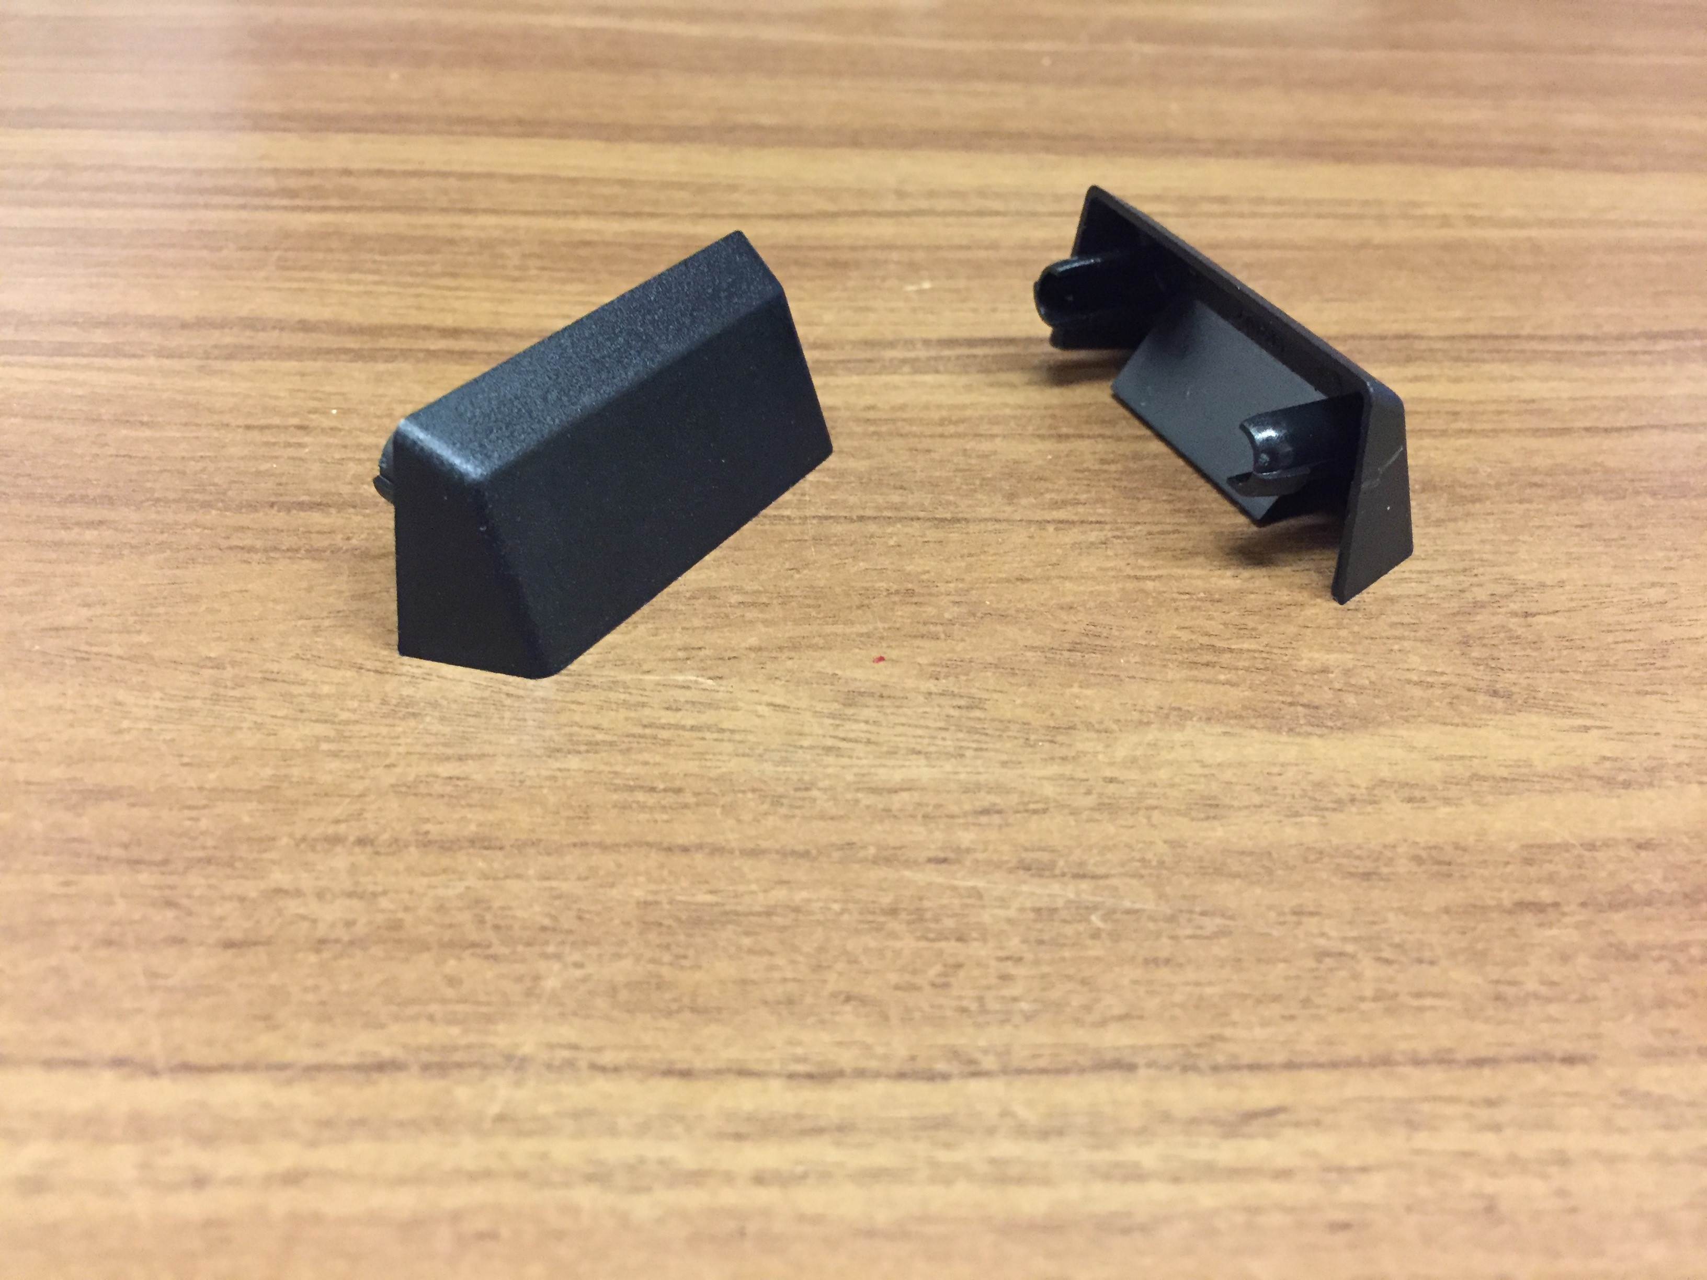

Kawneer AA 541 Black drainage cap(X2).

Response required by: 05/06/2018
Comments:
Date: |  | Company: | Name: |  |  | Sign:

