TS_82 |  |  |  | Date: |  | 22/05/2018
262 High Holborn
To: | Yannis Lekkas |  |  |  | From: |  | Darren Roberts
Company: | Synergy Property |  |  |  | Company: |  | ALUMINATE
Copy to: DESIGN TEAM
Sample Submission
PPC Kawneer Capping Sample of AA100 Ral 9011 Matt (1xmullion 3x Transom).
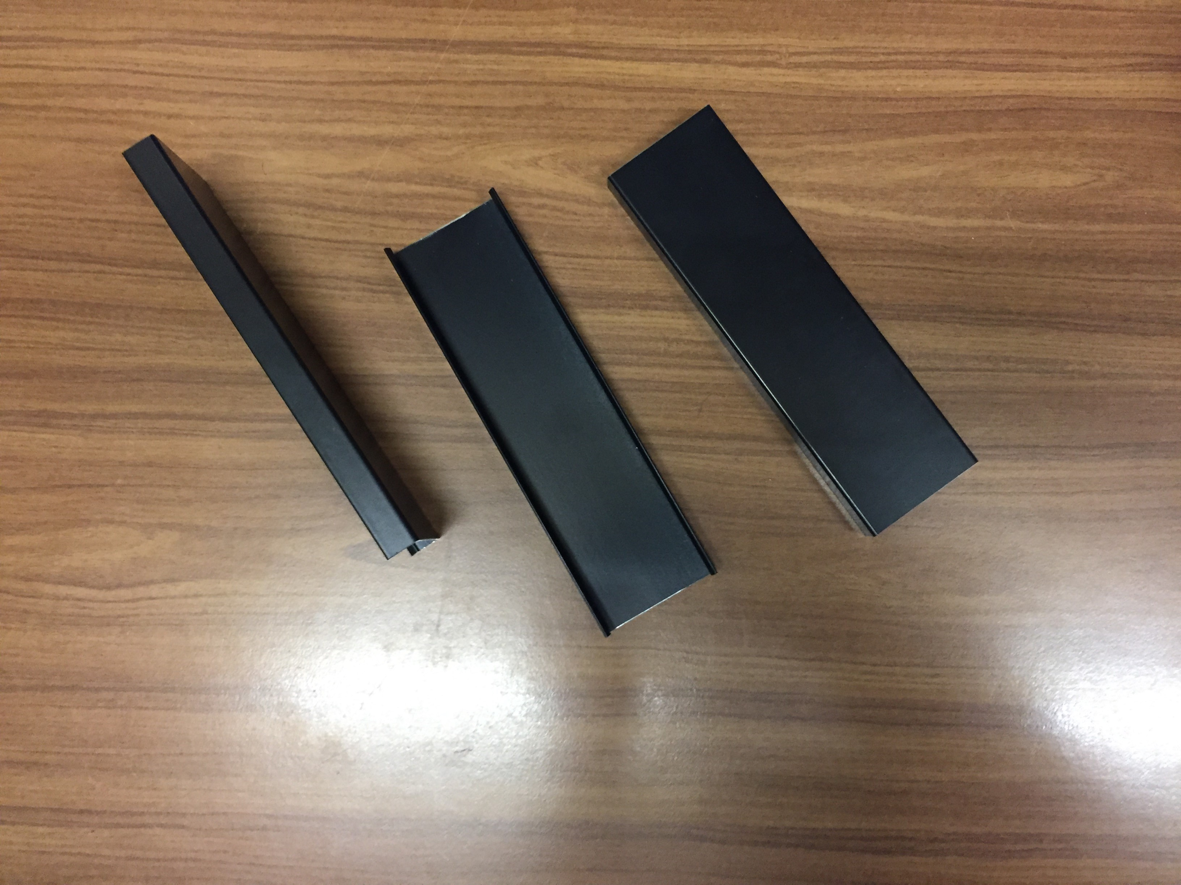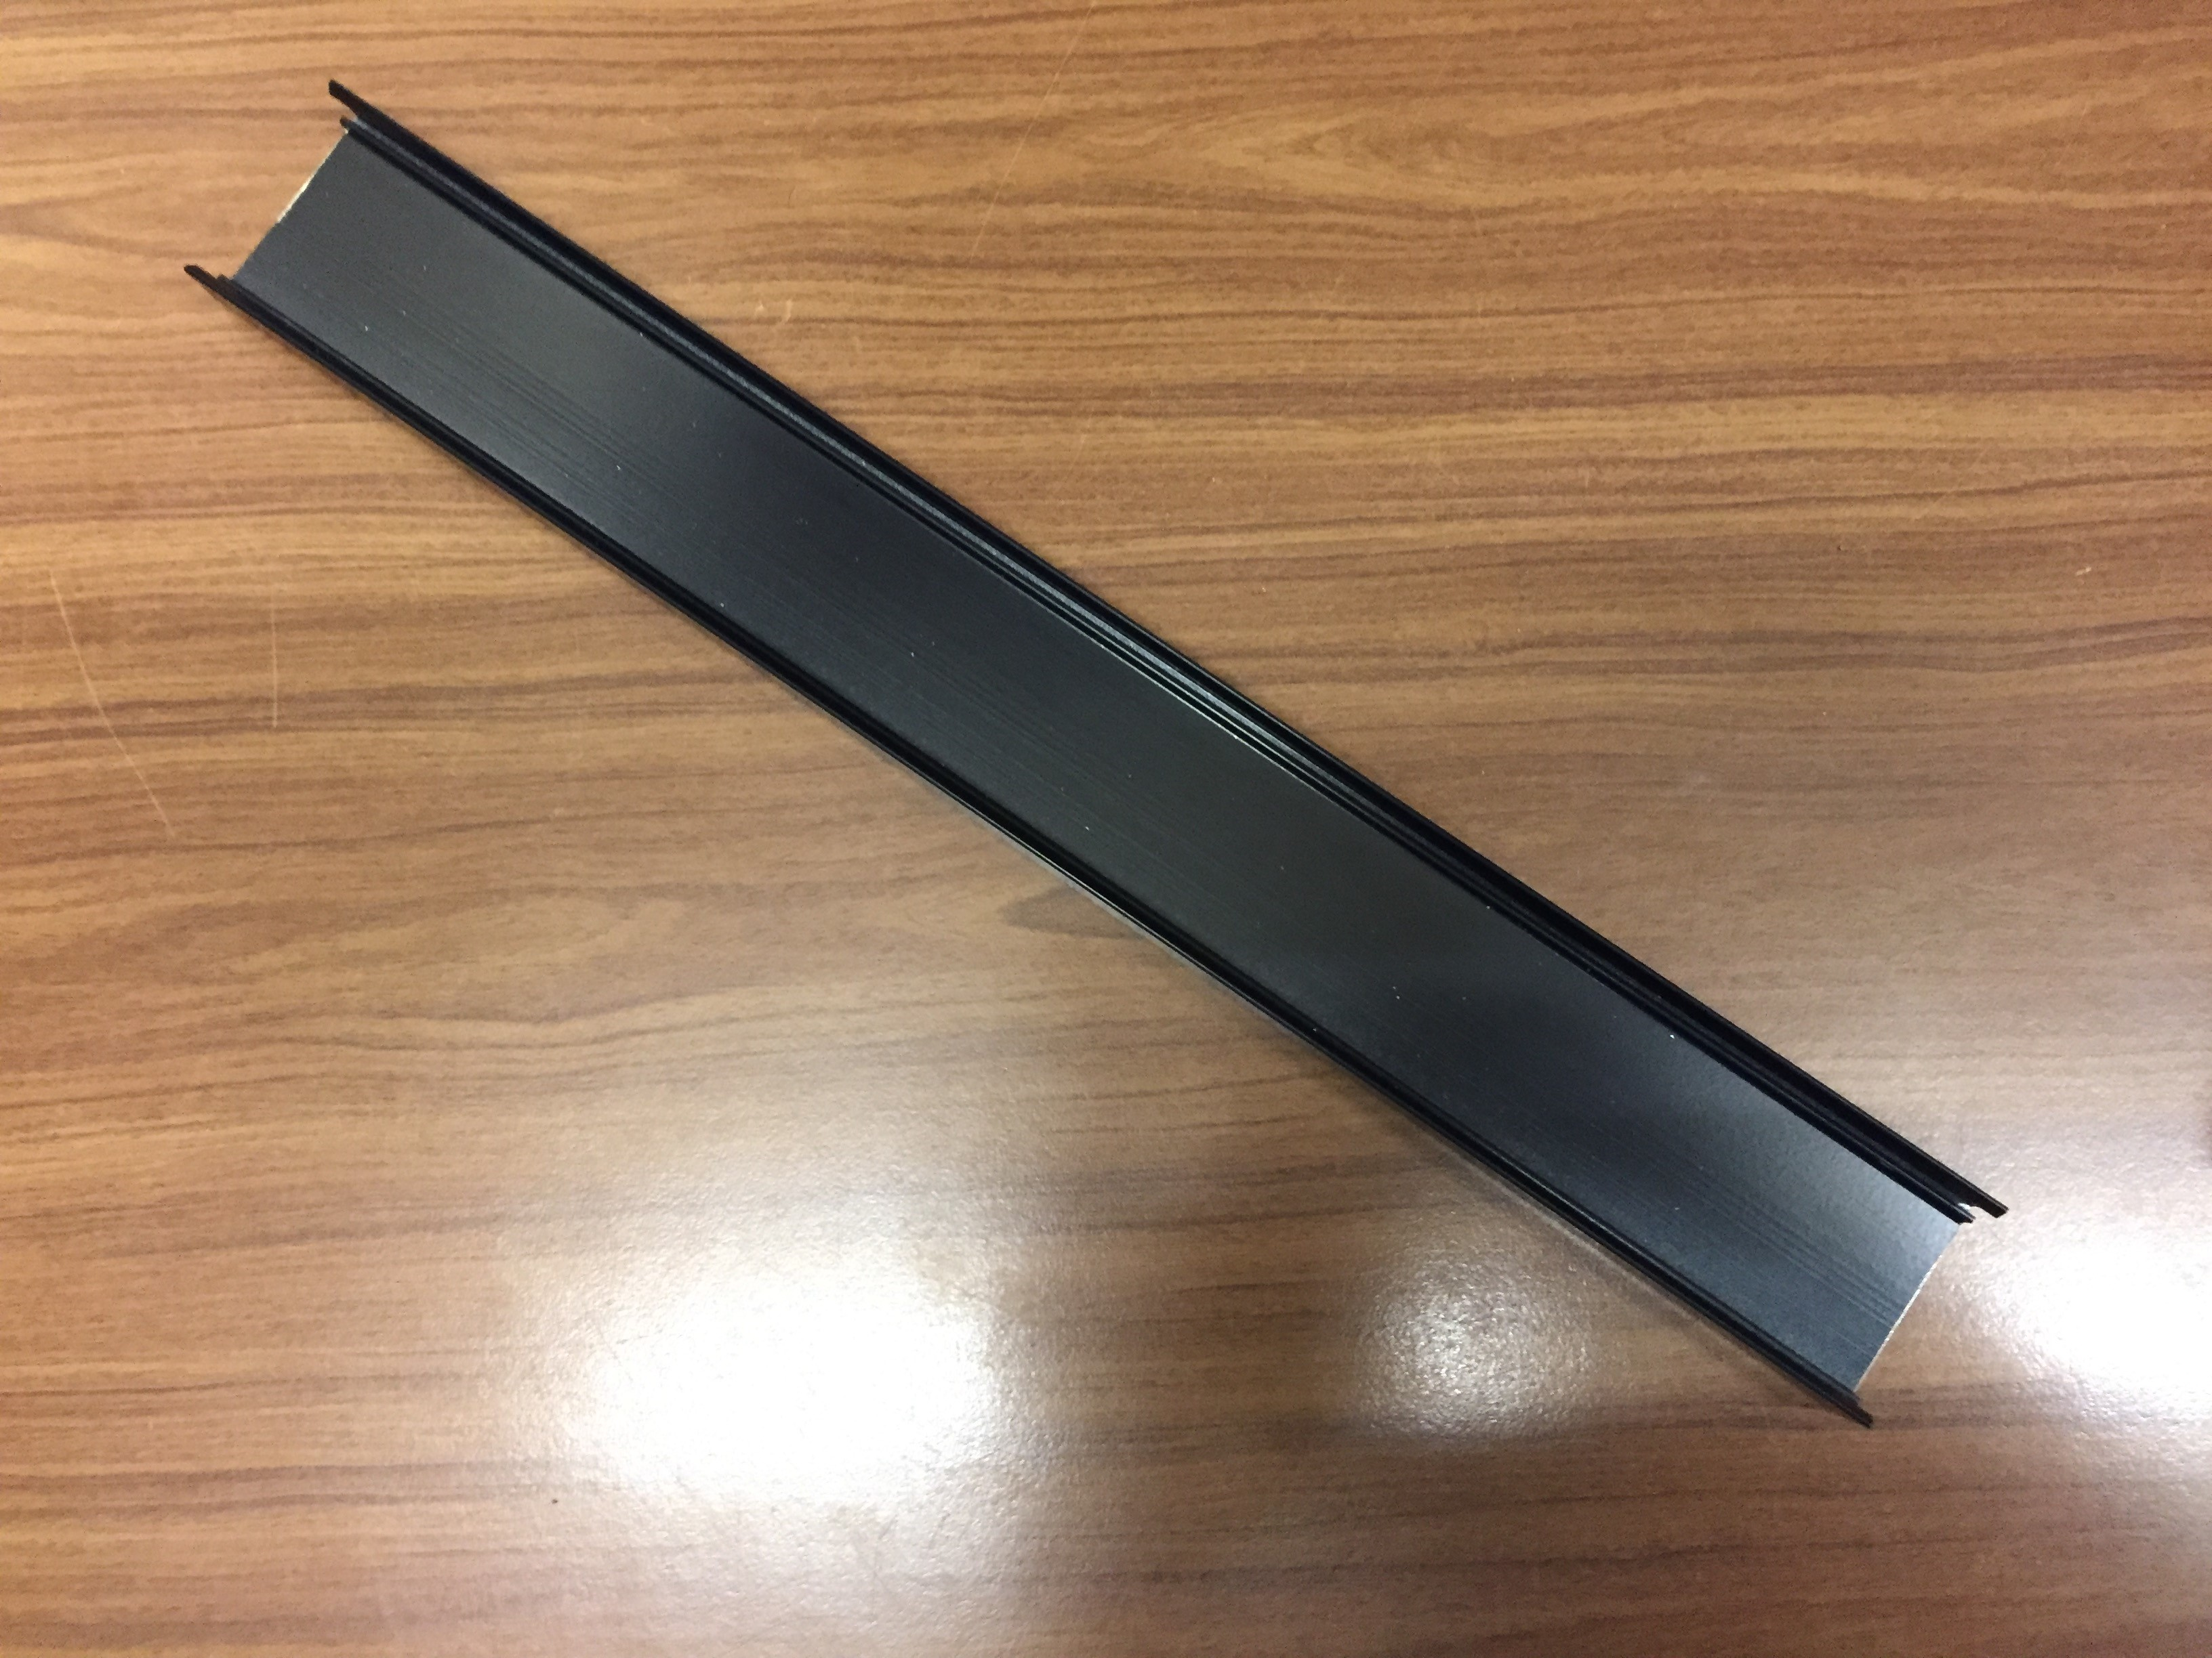

Response required by: 05/06/2018
Comments:
Date: |  | Company: | Name: |  |  |  |  | Sign:

