TS_74 |  |  |  | Date: |  | 25/04/2018
262 High Holborn
To: | Yannis Lekkas |  |  |  | From: |  | Darren Roberts
Company: | Synergy Property |  |  |  | Company: |  | ALUMINATE
Copy to: DESIGN TEAM
Submission
Sample No: 8692
Colour: 9001 MOH
Powder Ref: V- 2613

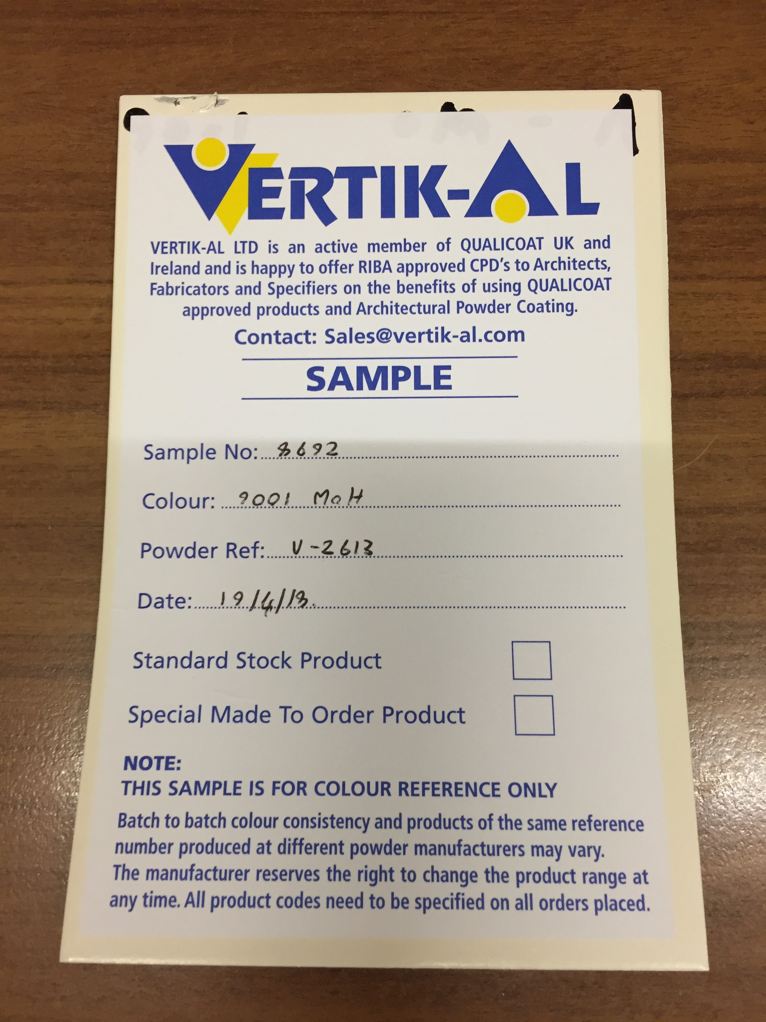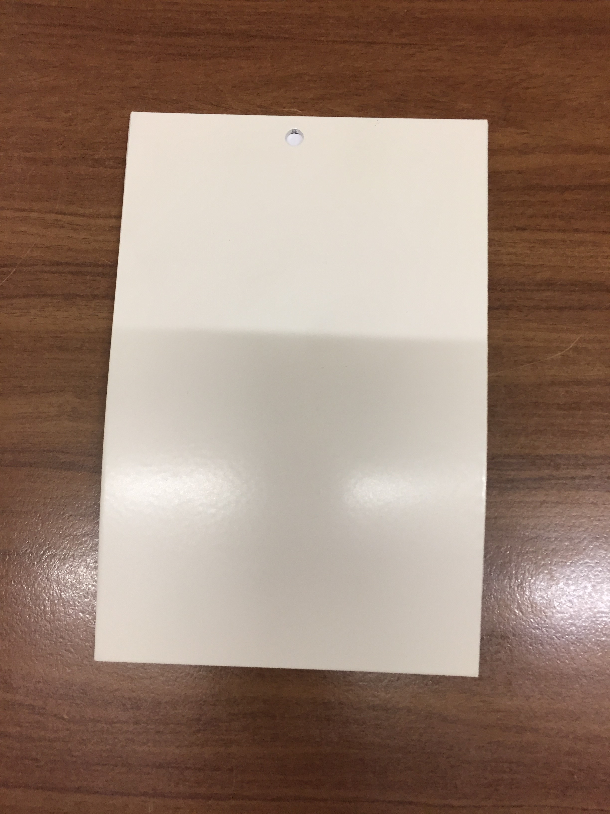

Response required by: 01.05.18
Comments:
Date: |  | Company: | Name: |  |  |  |  | Sign:

