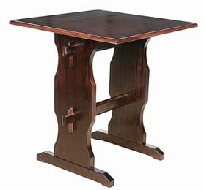

60 x 60 cm square table top height 71.5 CMS excluding top

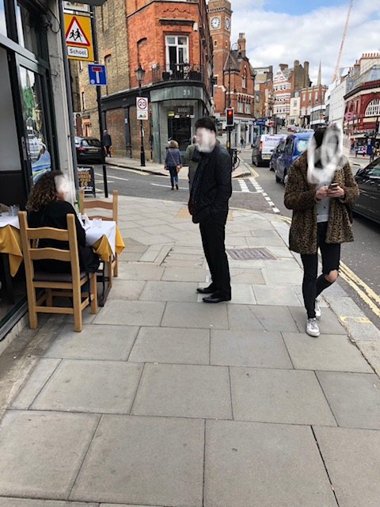This photograph was taken specifically for demonstrating how our table will look and to show the space remaining on sidewalk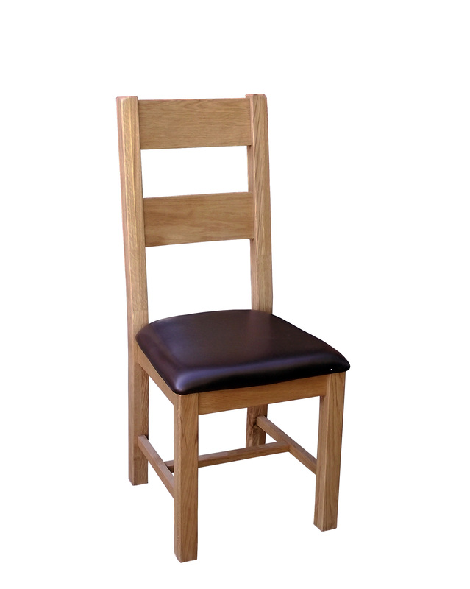h 100x w 40 x dx 40