
Pembrook Design LTD
Summit House
Horsecroft Road
The Pinnacles
Harlow
CM19 5BN

DESIGN & ACCESS STATEMENT

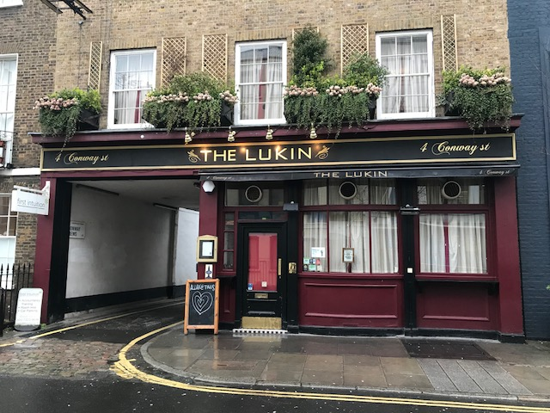

The Lukin – 4 Conway Street, Fitzrovia, London. W1T 6BB

DESIGN & ACCESS STATEMENT
Client:
Project: The Lukin, Public House
Site Address:
The Lukin –
4 Conway Street, Fitzrovia, London. W1T 6BB

- INTRODUCTION
New shopfront to reinstate Georgian style windows and new lantern light within the rear area of the ground floor.
- SITE LOCATION
The site is located in Conway Street, Fitzrovia.

- SITE DESCRIPTION
This site is an existing public house over five stories (basement to third floor). The premises has a main elevation fronting Conway Street with vehicular access servicing a rear yard. A single staircase joins the basement to the second floor and the third floor is served by a separate stair from the second floor. The ground floor has a full height shopfront with a single entrance and houses the main bar, toilets and store areas. The basement is used to store cask and bottles beers and spirits. It also houses the office and additional store areas. The first floor was used as a kitchen with a restaurant and small bar with a ladies toilet on the half landing. The second and third floors were used as accommodation for both the manager and staff.

- DESIGN PRINCIPLES & CONCEPTS
The Lukin is an existing Public House/Restaurant that is being refurbished and re named The Lore of the Land providing trade areas on Ground ( 57 covers drinking and restaurant) , First ( 42 covers restaurant ) and Second Floor levels ( 20 covers ). The basement will be used for the storage of cask and bottled beers and both the male and female toilets will be located on this level. A new disabled toilet will be situated on the ground flood and the kitchen will be located on the first floor. New food hoists will be installed in order to provide the same food offer at all levels. The second floor will be used a restaurant with a small bar servery. The third floor will be used as manager’s accommodation, office, storage and stall toilets.

The existing glazed mono pitched roof at the rear of the ground floor will be replaced with a new flat roof with a new lantern light in place of the 3no. existing roof lights over the toilets and store. This lantern light will provide natural light into the rear bar area on the ground floor.
- ACCESSIBILITY
The existing entrance at ground floor has a 60mm high threshold which existing customers using wheelchairs are able to negotiate. Our client has the ability to employ people in wheelchairs to work within the ground floor bar area. Unfortunately, due to the small size of the premises and its constraints, it would not be viable to install a wheelchair lift within the already limited premises. Therefore, access to the basement area and upper floors is not possible. Employing kitchen staff who rely on the use of wheelchairs would not be practical or safe to do so in this instance.
For wheelchair customers the offer on the ground floor will be the same as the offer on the upper trading floors. We are unable to provide lift access for wheelchair users, due to the sites size and limited room available. This also prevents the possibility of provide a safe protected holding area for any diners restricted to wheelchairs. It is therefore considered that the safest option would be to ensure that all offers are available over all floors.

- CONSULTATION
No public consultation has been undertaken as part of this application.

