**Construction Management**

**Plan**

**pro forma** v2.1

**Contents**

**Revisions 3**

**Introduction 4**

**Timeframe 6**

**Contact 7**

**Site 9**

**Community liaison 12**

**Transport 15**

**Environment 25**

**Agreement 30**

**Revisions & additional material**

Please list all iterations here:

|  |  |  |
| --- | --- | --- |
| **Date** | **Version** | **Produced by** |
|  | **V.2** | **Knowles & Associates Ltd** |

**Additional sheets**

Please note – the review process will be quicker if these are submitted as Word documents or searchable PDFs.

|  |  |  |
| --- | --- | --- |
| **Date** | **Version** | **Produced by** |
|  |  |  |

**Introduction**

The purpose of the **Construction Management Plan (CMP)** is to help developers to minimise construction impacts, and relates to both on site activity and the transport arrangements for vehicles servicing the site.

It is intended to be a live document whereby different stages will be completed and submitted for application as the development progresses.

The completed and signed CMP must address the way in which any impacts associated with the proposed works, and any **cumulative impacts of other nearby construction sites**, will be mitigated and managed. The level of detail required in a CMP will depend on the scale and kind of development. Further policy guidance is set out in Camden Planning Guidance [**(CPG)** 6: Amenity](http://www.camden.gov.uk/ccm/content/environment/planning-and-built-environment/two/planning-policy/supplementary-planning-documents/camden-planning-guidance.en) and [**(CPG)** 8: Planning Obligations](http://www.camden.gov.uk/ccm/content/environment/planning-and-built-environment/two/planning-policy/supplementary-planning-documents/camden-planning-guidance.en).

This CMP follows the best practice guidelines as described in [Transport for London’s](https://www.tfl.gov.uk/info-for/freight/safety-and-the-environment/improving-construction-safety) (TfL’s Standard for [Construction Logistics and Cyclist Safety](http://www.clocs.org.uk/standard-for-clocs/) (**CLOCS**) scheme) and [Camden’s Minimum Requirements for Building Construction](http://www.camden.gov.uk/ccm/cms-service/download/asset?asset_id=3257318) **(CMRBC)**.

The approved contents of this CMP must be complied with unless otherwise agreed with the Council in writing. The project manager shall work with the Council to review this CMP if problems arise in relation to the construction of the development. Any future revised plan must also be approved by the Council and complied with thereafter.

It should be noted that any agreed CMPdoes not prejudice or override the need to obtain any separate consents or approvals such as for road closures or hoarding licences.

If your scheme involves any demolition, you need to make an application to the Council’s Building Control Service. Please complete the “[**Demolition Notice**](http://www.camden.gov.uk/ccm/content/environment/building-control/file-storage-items/demolition-notice---the-building-act-1984-section-80-notice-bc104-.en)**.**”

Please complete the questions below with additional sheets, drawings and plans as required. The boxes will expand to accommodate the information provided, so please provide as much information as is necessary. **It is preferable if this document, and all additional documents, are completed electronically and submitted as Word files to allow comments to be easily documented. These should be clearly referenced/linked to from the CMP.**

Please notify that council when you intend to start work on site. Please also notify the council when works are approximately **3 months from completion.**

(Note the term 'vehicles' used in this document refers to all vehicles associated with the implementation of the development, e.g. demolition, site clearance, delivery of plant & materials, construction, etc.)

Revisions to this document may take place periodically. **Timeframe**

**DEVELOPER ACTIONS**

**COUNCIL ACTIONS**

**Post app submission**

**0ommunity liaison**

**Appoint principal contractor**

**Requirement to submit CMP**

**Begin community liaison**

**Work can commence if draft CMP is approved**

**Council response to second draft**

**Resubmission of CMP if first draft refused**

**2ommunity liaison**

**3ommunity liaison**

**1ommunity liaison**

INDICATIVE TIMEFRAME (MONTHS)

**4ommunity liaison**

**Council response to draft**

**Submit draft CMP**

**Contact**

1. Please provide the full postal address of the site and the planning reference relating to the construction works.

Address: 28 Maresfield Gardens NW3 5SX

Planning ref: Draft CTMP to accompany planning application

Type of CMP - Section 106 planning obligation/Major sites framework:

2. Please provide contact details for the person responsible for submitting the CMP.

Name: Paul Baguzis

Address: **Knowles & Associates Ltd, Unit 2, Silwood Park Business Centre, Buckhurst Road, Ascot SL5 7PY**

Email: paulb@knowles.uk.com

Phone: 07968469184

3. Please provide full contact details of the site project manager responsible for day-to-day management of the works and dealing with any complaints from local residents and businesses.

Name: Declan Quinn

Address: **Knowles & Associates Ltd, Unit 2, Silwood Park Business Centre, Buckhurst Road, Ascot SL5 7PY**

Email: declan@knowles.uk.com

Phone: 07881367454

4. Please provide full contact details of the person responsible for community liaison and dealing with any complaints from local residents and businesses if different from question 3. In the case of [**Community Investment Programme (CIP)**](http://www.camden.gov.uk/ccm/content/environment/planning-and-built-environment/two/placeshaping/twocolumn/the-community-investment-programme.en), please provide contact details of the Camden officer responsible.

Name: Alan Everett

Address: **Knowles & Associates Ltd, Unit 2, Silwood Park Business Centre, Buckhurst Road, Ascot SL5 7PY**

Email: [alan@knowles.uk.com](mailto:alan@knowles.uk.com)

Phone: **01344 886 898 / 07785 567 978**

5. Please provide full contact details including the address where the main contractor accepts receipt of legal documents for the person responsible for the implementation of the CMP.

Name: Alan Everett

Address: **Knowles & Associates Ltd, Unit 2, Silwood Park Business Centre, Buckhurst Road, Ascot SL5 7PY**

Email: [alan@knowles.uk.com](mailto:alan@knowles.uk.com)

Phone: **01344 886 898 / 07785 567 978**

**Site**

6. Please provide a site location plan and a brief description of the site, surrounding area and development proposals for which the CMP applies.

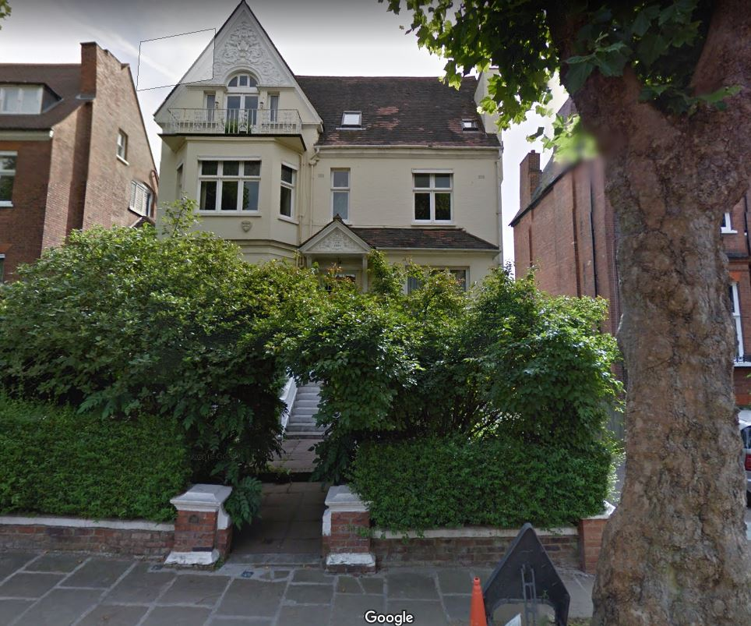

28 Maresfield Gardens is a substantial detached house, in the quiet residential area, sited on the broad, tree-lined road. Close to the junction with Nutley Terrace and 5 houses away from ‘Freud Museum London’, The site is located approximately 320 metres to the south west of St Mary’s School which is situated at 47 Fitzjohn’s Avenue.  South Hampstead High School is located approximately 300 metres  to the south east of the site at 3 Maresfield Gardens.  In general Maresfield Gardens is a predominantly residential area with substantial detached properties.

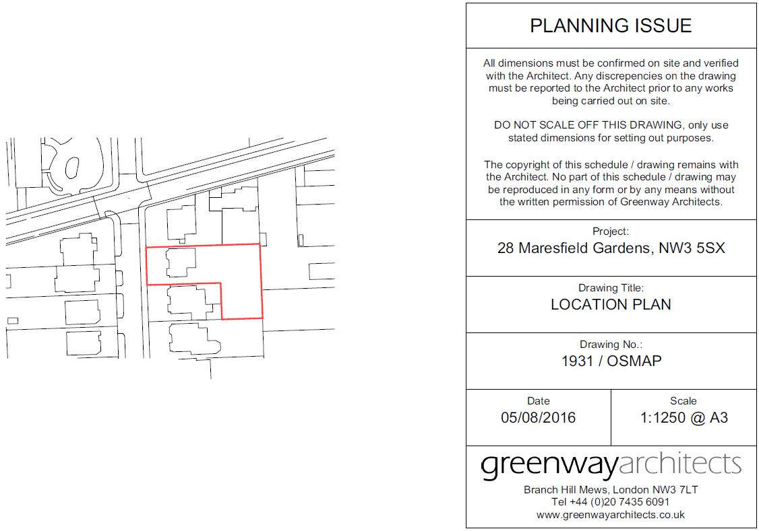

7. Please provide a very brief description of the construction works including the size and nature of the development and details of the main issues and challenges (e.g. narrow streets, close proximity to residential dwellings etc).

Small basement under approx. 20% of the garden which will overlap a small portion of lower ground floor of existing house. Single storey small extension will be added to the rear lower ground floor. Additional floorspace amounts to 218.7m2 Roof tile replacement, new dormer window for front elevation and new roof light on North elevation will be introduced to dwelling (Class C3). The site lies in close proximity to residential dwellings.

The site is located within a predominantly residential area with St Mary’s School and South Hampstead High School located in relatively close proximity to the site.  Therefore the main challenges will be to ensure that during the construction process there will be no adverse impact on any sensitive receptors in close proximity of the site by reason of vehicular movements associated with the construction traffic and ensuring that noise levels remain within the recommended standards.  All of these challenges are addressed within this CMP under the relevant headings.

8. Please identify the nearest potential receptors (dwellings, business, etc.) likely to be affected by the activities on site (i.e. noise, vibration, dust, fumes, lighting etc.).

The nearest potential receptors likely to be affected by the activities on site will be the adjacent properties, No.26 and No.30 Maresfield gardens. All necessary precautions will be undertaken to prevent any noise, vibration, dust and fumes with the erection of the hoarding around the property.

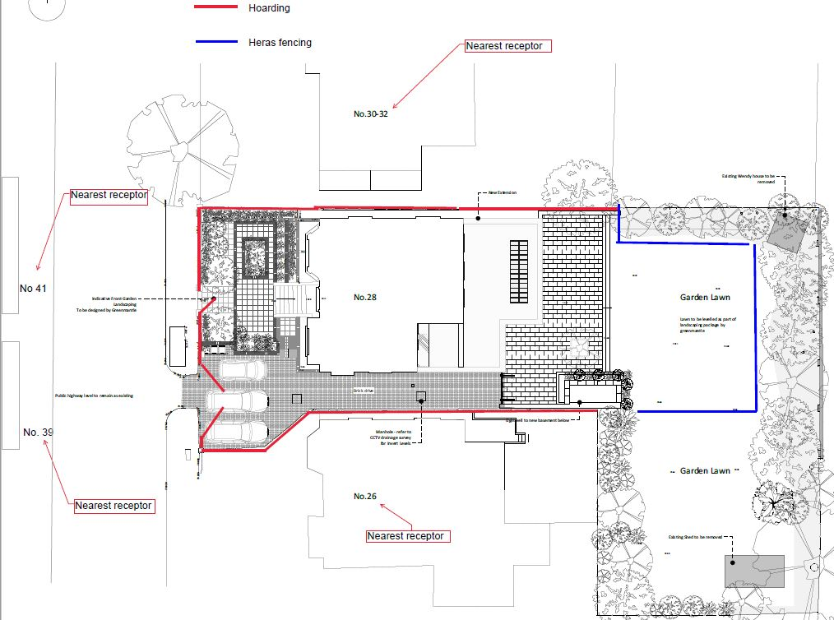

Figure 1: Local Receptors

9. Please provide a scaled plan detailing the local highway network layout in the vicinity of the site. This should include details of on-street parking bay locations, cycle lanes, footway extents and proposed site access locations.

**Please refer to the following drawings within Appendix B**

10. Please provide the proposed start and end dates for each phase of construction as well as an overall programme timescale. (A Gantt chart with key tasks, durations and milestones would be ideal).

**Start**  **Finish**

Mobilisation and soft strip: 2-3weeks 30/09/17 – 18/10/17

Demolition: 3-4weeks 21/10/17 – 08/11/17

Excavation, underpinning and structural: 14weeks 04/11/17 – 01/04/17

Construction: 18weeks 02/04/18 – 24/08/18

Ongoing interal works 40weeks 08/11/17 – 24/10/18

**Total: 55 weeks**

**We expect to begin works as soon as the appropriate permissions and licences have been received. See Appendix D**

11. Please confirm the standard working hours for the site, noting that the standard working hours for construction sites in Camden are as follows:

* 8.00am to 6pm on Monday to Friday
* 8.00am to 1.00pm on Saturdays
* No working on Sundays or Public Holidays

We confirm that Knowles will adhere to the standard working hours for construction sites in Camden.

12. Please indicate if any changes to services are proposed to be carried out that would be linked to the site during the works (i.e. connections to public utilities and/or statutory undertakers’ plant). Larger developments may require new utility services. If so, a strategy and programme for coordinating the connection of services will be required. If new utility services are required, please confirm which utility companies have been contacted (e.g. Thames Water, National Grid, EDF Energy, BT etc.) You must explore options for the utility companies to share the same excavations and traffic management proposals. Please supply details of your discussions.

There will be no change to services.

**Community Liaison**

**A neighbourhood consultation process must have been undertaken prior to submission of the CMP first draft. This consultation must relate to construction impacts, and should take place following the grant of planning permission in the lead up to the submission of the CMP. A consultation process specifically relating to construction impacts must take place regardless of any prior consultations relating to planning matters. This consultation must include all of those individuals that stand to be affected by the proposed construction works. These individuals should be provided with a copy of the draft CMP, or a link to an online document. They should be given adequate time with which to respond to the draft CMP, and any subsequent amended drafts. Contact details which include a phone number and email address of the site manager should also be provided.**

Significant time savings can be made by running an effective neighbourhood consultation process. This must be undertaken in the spirit of cooperation rather than one that is dictatorial and unsympathetic to the wellbeing of local residents and businesses.

These are most effective when initiated as early as possible and conducted in a manner that involves the local community. Involving locals in the discussion and decision making process helps with their understanding of what is being proposed in terms of the development process. **The consultation and discussion process should have already started, with the results incorporated into the CMP first draft submitted to the Council for discussion and sign off.**This communication should then be ongoing during the works, with neighbours and any community liaison groups being regularly updated with programmed works and any changes that may occur due to unforeseen circumstances through newsletters, emails and meetings.

Please note that for larger sites, details of a construction working group may be required as a separate S106 obligation. If this is necessary, it will be set out in the S106 Agreement as a separate requirement on the developer.

**Cumulative impact**

Sites located within high concentrations of construction activity that will attract large numbers of vehicle movements should consider establishing contact with other sites in the vicinity in order to manage traffic routeing and volumes. Developers in the Tottenham Court Road area have done this to great effect.

**The Council can advise on this if necessary.**

**13. Consultation**

The Council expects meaningful consultation. For large sites, this may mean two or more meetings with local residents **prior to submission of the first draft CMP**.

Evidence of who was consulted, how the consultation was conducted and a summary of the comments received in response to the consultation. Details of meetings including minutes, lists of attendees etc. must be included.

In response to the comments received, the CMP should then be amended where appropriate and, where not appropriate, a reason should be given. The revised CMP should also include a list of all the comments received. Developers are advised to check proposed approaches to consultation with the Council before carrying them out. If your site is on the boundary between boroughs then we would recommend contacting the relevant neighbouring planning authority.

Please provide details of consultation of draft CMP with local residents, businesses, local groups (e.g. residents/tenants and business associations) and Ward Councillors.

A neighbour consultation meeting was held on 1st August 2017, where this draft CMP was discussed. The meeting offered to consult neighbours in order to assist in minimising any potential adverse impact on the community.

2x neighbours attended.

Mrs Hannah Bloom from 37c Maresfield grdns

Mr Nick Jackson landlord of 39 Maresfield grdns.

No comments received from attendees as visit was made purely out of curiosity.

No other neighbours attended although 45 invitations were hand-delivered to local residents, at the following numbers in Maresfield Gardens 41, 39, 37, 37A 37B, 35D, 35C, 35B, 35A, 35, 33B, 33A, 33, 31E, 31D, 31C, 31B, 31A, 32A, 30A, 26A, 25A, 25, 24, 23, 21, 20, 19, 18, 17, 16, 16A, 15, 14, 12, 11, 10, 9D, 9C, 9B, 9A, 9, 7, 5, 4, 2 from the Nutley Road junction down to and including the South Hampstead High School. A link has been provided for viewing the CMP and the council have been notified and the response from them has been given.

The Ward Councillors were invited on the 2nd August 17 for consultation but did not respond.

In addition, prior to commencement of work, all proximate properties will be provided with a Newsletter giving full contact details of key site personnel and head office. This gives neighbours an opportunity to discuss their particular needs, requirements and preferences as well as the ability to contact both the office and the site foreman – furthermore, a periodic Newsletter to the community is posted on the site hoarding and sent by post to neighbours regularly updated to provide neighbours with news and timetable of events.

The Planning process itself is also an excellent opportunity for neighbour consultation; neighbours and local residents are encouraged to contact us at any stage of the planning process and throughout construction to discuss preferences or requirements.

We received no comments from the Ward Councillors who were invited to respond.

**Please see invitation to Neighbour’s Consultation attached in Appendix H.**

**14. Construction Working Group**

Please provide details of community liaison proposals including any Construction Working Group that will be set up, addressing the concerns of the community affected by the works, the way in which the contact details of the person responsible for community liaison will be advertised to the local community, and how the community will be updated on the upcoming works i.e. in the form of a newsletter/letter drop, or weekly drop in sessions for residents.

Prior to commencement of work, all proximate properties will be provided with a Newsletter giving full contact details of key site personnel and head office. This gives neighbours an opportunity to discuss their particular needs, requirements and preferences as well as the ability to contact both the office and the site foreman – furthermore, a periodic Newsletter to the community will be updated fortnightly and sent by post to neighbours within the vicinity of the construction site and will also be posted on the site hoarding.

**15. Schemes**

Please provide details of any schemes such as the ‘Considerate Constructors Scheme’, such details should form part of the consultation and be notified to the Council. Contractors will also be required to follow the “[Guide for Contractors Working in Camden](http://www.camden.gov.uk/ccm/cms-service/download/asset?asset_id=799001)” also referred to as “[Camden’s Considerate Contractors Manual](http://www.camden.gov.uk/ccm/cms-service/download/asset?asset_id=799001)”.

Knowles & Associates subscribe to the Considerate Constructors Scheme (Reg No: C0615) and are members of ASUC (Membership no 1029/F), both of which insist upon the highest standards of Considerate Construction and Health & Safety for site personnel and community. Please see membership certificates in Appendix A

**16. Neighbouring sites**

Please provide a plan of existing or anticipated construction sites in the local area and please state how your CMP takes into consideration and mitigates the cumulative impacts of construction in the vicinity of the site. The council can advise on this if necessary.

The Site-Manager/Foreman will be responsible for liaising with other developments in the area on a day to day basis. Alan Everett is responsible for the macro-planning of the project and will liaise with other contractors to avoid potential ‘pinch points’ in construction programmes. All foremen will be expected to comply with “Guide for Contractors Working in Camden”.

Other construction sites in the area include 2 Maresfield Gardens and 11 and 21 Fitzjohns’ Avenue as indicated on the plan below.

Due to the nature of works it will be impossible to combine/share delivery vehicles as every site is at the different stage of works and has different suppliers with different requirements.

However, project managers from nearby construction sites at 2 Maresfield Gardens, 11 Fitzjohn’s Avenue and 29 Fitzjohn’s Avenue will liaise closely and have regular meetings as necessary to coordinate any vehicle movements to/ from the sites to avoid any unnecessary disruption.  During the meetings, contractors will discuss feasibility of sharing deliveries from the same supply to further reducing impact on the local highway network for local residents.

Also worth mentioning that vehicles going to Fitzjohn’s Avenue sites do not use Maresfield gardens route therefore, there will not be excedeeding number of vehicles on Maresfield road. Any changes agreed upon at the proposed regular meetings that will take place between the project managers for 2 Maresfield Gardens, 11 Fitzjohn’s Avenue and 29 Fitzjohn’s Avenue will be documented in an updated CMP

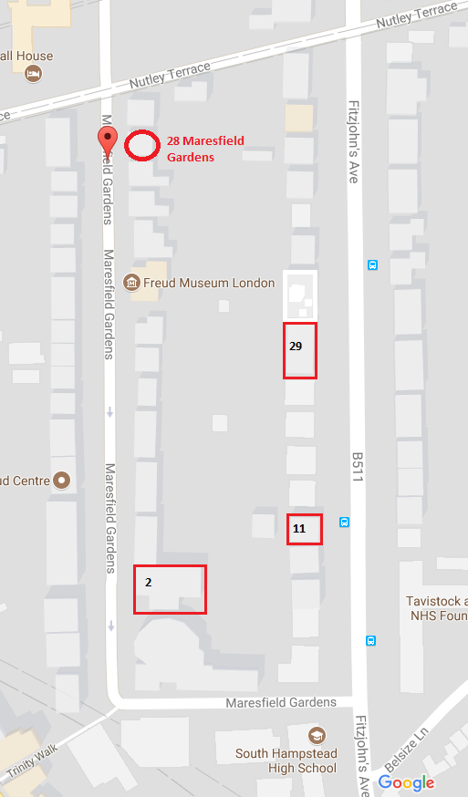 ( See page 23)

**Transport**

**This section must be completed in conjunction with your principal contractor. If one is not yet assigned, please leave the relevant sections blank until such time when one has been appointed.**

Camden is a CLOCS Champion, and is committed to maximising road safety for Vulnerable Road Users (VRUs) as well as minimising negative environmental impacts created by motorised road traffic. As such, all vehicles and their drivers servicing construction sites within the borough are bound by the conditions laid out in the [CLOCS Standard.](http://www.clocs.org.uk/wp-content/uploads/2014/09/CLOCS-Standard-v1.2.pdf)

This section requires details of the way in which you intend to manage traffic servicing your site, including your road safety obligations with regard to VRU safety. It is your responsibility to ensure that your principal contractor is fully compliant with the terms laid out in the CLOCS Standard. It is your principal contractor’s responsibility to ensure that all contractors and sub-contractors attending site are compliant with the terms laid out in the CLOCS Standard.

Checks of the proposed measures will be carried out by the council to ensure compliance. Please refer to the CLOCS Standard when completing this section. Guidance material which details CLOCS requirements can be accessed [here](http://www.camden.gov.uk/ccm/cms-service/stream/asset?asset_id=3489660&), details of the monitoring process are available [here](http://www.camden.gov.uk/ccm/cms-service/stream/asset/?asset_id=3345820&).

Please contact [CLOCS@camden.gov.uk](mailto:CLOCS@camden.gov.uk) for further advice or guidance on any aspect of this section.

**Please refer to the CLOCS Overview and Monitoring Overview documents referenced above which give a breakdown of requirements.**

**CLOCS Considerations**

17. Name of Principal contractor:

Knowles & Associates Ltd, Unit2, Silwood Business Park, Buckhurst Road, SL5 7PY

18. Please submit the proposed method for checking operational, vehicle and driver compliance with the CLOCS Standard throughout the duration of the contract (please refer to our [CLOCS Overview document](http://www.camden.gov.uk/ccm/cms-service/stream/asset?asset_id=3489660&) and [Q18 example response](http://www.camden.gov.uk/ccm/cms-service/stream/asset?asset_id=3489661&)).

The client will ensure that it is a contractual requirement for the contractor to check vehicles entering site and to take the appropriate action under the contract.

The client will also undertake regular audits of the contractor’s process and compliance checks. This audit will include random vehicle compliance checks undertaken by the client.

The client will request that every reporting period the contractor submits to the client a summary of those checks and details the corrective action taken in case of non-compliance.

Knowles will ensure that all contractors are fully compliant with CLOCS Standard for construction logistic operators and clients: Managing work related road risk. V2 2015.

As stated in this document, any FORS silver operator will automatically be compliant with CLOCS.

FORS Bronze accreditation as a minimum will be a contractual requirement, FORS Silver and Gold operators will be appointed where possible. Where FORS Bronze operators are appointed, written assurance will be sought from contractors that all vehicles over 3.5t are equipped with additional safety equipment (as per CLOCS standard P13), and that all drivers servicing the site will have undertaken approved additional training (eg. Safe Urban Driving + 1 x e-learning module). CLOCS Compliance will be included as a contractual requirement.

Desktop checks will be made against FORS database of trained drivers and accredited companies as outlined in the CLOCS Standard Managing Supplier Compliance Guide. These will be carried out as per a risk scale based on that outlined in the CLOCS Managing Supplier Guide.

A delivery booking system will be used which will require the entry of a FORS ID number in order for a delivery to be booked onto site. Random spot checks will be conducted every week to ensure compliance.

19. Please confirm that you as the client/developer and your principal contractor have read and understood the [CLOCS Standard](http://www.clocs.org.uk/wp-content/uploads/2015/05/CLOCS-Standard-v1.2-APRIL_15.pdf) and included it in your contracts. Please sign-up to join the [CLOCS Community](http://www.clocs.org.uk/links-to-partners/) to receive up to date information on the standard by expressing an interest online.

I confirm that I have included the requirement to abide by the CLOCS Standard in my contracts to my contractors and suppliers:



Please contact [CLOCS@camden.gov.uk](mailto:CLOCS@camden.gov.uk) for further advice or guidance on any aspect of this section.

**Site Traffic**

**Sections below shown in blue directly reference the CLOCS Standard requirements. The CLOCS Standard should be read in conjunction with this section.**

**20. Traffic routing**: *“Clients shall ensure that a suitable, risk assessed vehicle route to the site is specified and that the route is communicated to all contractors and drivers. Clients shall make contractors and any other service suppliers aware that they are to use these routes at all times unless unavoidable diversions occur.”* (P19, 3.4.5)

Routes should be carefully considered and risk assessed, taking into account the need to avoid where possible any major cycle routes and trip generators such as schools, offices, public buildings,museums etc. Where appropriate, on routes that use high risk junctions (i.e. those that attract high volumes of cycling traffic) installing Trixi mirrors to aid driver visibility should be considered.

Consideration should also be given to weight restrictions, low bridges and cumulative impacts of construction (including neighbouring construction sites) on the public highway network. The route(s) to and from the site should be suitable for the size of vehicles that are to be used.

a. Please indicate routes on a drawing or diagram showing the public highway network in the vicinity of the site including details of links to the [Transport for London Road Network](http://www.lscp.org.uk/lrsu/engineering_tlrn.html) (TLRN).

Vehicle size was reduced due to the difficulty of reversing into the property.Therefore we kept the same traffic route (same as the site further down the road. All construction vehicles required at the site will arrive via the TLRN network on the A41 Finchley Road. They will head northbound up B511 Fitzjohns Avenue, turn left into Nutley Terrace, and finally a left turn into Maresfield Gardens. The departure route is exactly the same but reversed.

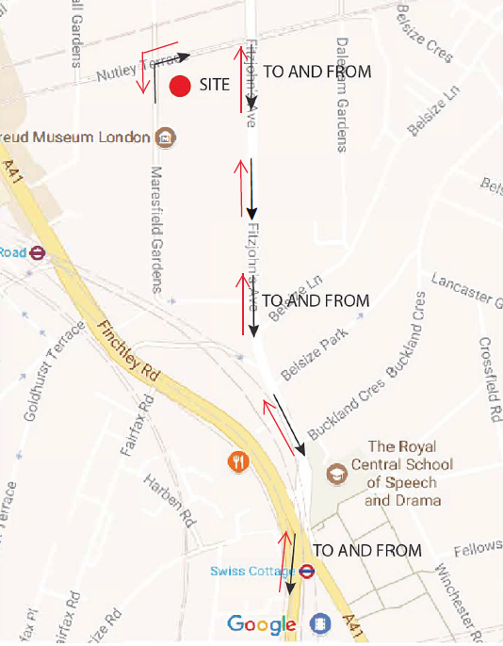

b. Please confirm how contractors, delivery companies and visitors will be made aware of the route (to and from the site) and of any on-site restrictions, prior to undertaking journeys.

All site related contractors, suppliers, personnel, etc. will be made aware by direct contact (telephone and email) of the construction route during the procurement stage and will be required to adhere strictly to the routing plan shown, without exception. The transport and routing requirements will form part of any contract. These details also are included on order confirmations.

**21. Control of site traffic, particularly at peak hours**: “*Clients shall consider other options to plan and control vehicles and reduce peak hour deliveries”* (P20, 3.4.6)

Construction vehicle movements are generally acceptable between 9.30am to 4.30pm on weekdays and between 8.00am and 1.00pm on Saturdays). If there is a school in the vicinity of the site or on the proposed access and/or egress routes, then deliveries must be restricted to between 9.30am and 3pm on weekdays during term time. (Refer to the [*Guide for Contractors Working in Camden*](http://www.camden.gov.uk/ccm/cms-service/download/asset?asset_id=799001)).

A delivery plan should ensure that deliveries arrive at the correct part of site at the correct time. Instructions explaining such a plan should be sent to all suppliers and contractors**.** Consideration should be given to the location of any necessary holding areas for large sites with high volumes of traffic. Vehicles must not wait or circulate on the public highway. Whilst deliveries should be given set times to arrive, dwell and depart, no undue time pressures should be placed upon the driver at any time.

1. Please provide details of the typical sizes of all vehicles and the approximate frequency and times of day when they will need access to the site, for each phase of construction.You should estimate the average daily number of vehicles during each major phase of the work, including their dwell time at the site. High numbers of vehicles per day and/or long dwell times may require vehicle holding procedures.

**Due to South Hampstead High School being on the route to the property, site vehicle times will be restricted to between 09:30 and 15:00 in term times, Monday to Friday and 08:00 and 13:00 on Saturday**

***Site mobilisation and soft-strip*:**

1 no. 3 axled tipper lorry (7.8m x 2.5m) per day; <45 mins dwell time (for unloading materials) for 2 weeks .

***Demolition*:**

1 no. 3 axled tipper lorry (7.8 x 2.5m) per day (demolition to be done manually due to the constricted site) for 2-3 weeks.

<45 mins dwell time

***Excavation and initial structure*:** **22weeks**

Average of 8 no. 3 axled lorries (7.8m x 2.5m) per **week**; <45 mins dwell time

2 no. ready-mix concrete lorries (7.8m x 2.5mm) per **week** for 12 weeks out of 22 weeks**;** <60mins dwell time

***Construction*: 26weeks**

1 x 3 axled grab lorry (7.80m x 2.5m) lorry per day; <40 mins dwell time

2 x ready mix concrete delivery lorries (7.80 x 2.5m) per **week** for 10 weeks out of 26weeks; <30mins dwell time

Average number of lorry visits per day – 5 in total including light vehicles, during the main construction phase and 5 vehicle per day during the excavation stage.

***Ongoing Internal works*:**

Light vehicles only e.g. transit vans (4.275m x 2.045m) – average of 10 per **week** for 42weeks

**We intend to use approx 7.8m long ready-mix concrete lorries and approx. 7.8m long 3axled tipper lorries to minimise the frequency of lorries arriving to site.**

b. Please provide details of other developments in the local area or on the route.

**The Site-Manager will be responsible for liaising with other developments in the area on a day to day basis. 2 Maresfield Gardens ‘Cosmur Construction Ltd’ project in particular. Also 2no smaller sites at No11 and No21 Fitzjohn’s Avenue . Alan Everett is responsible for the macro-planning of the project and will liaise with other contractors to avoid potential ‘pinch points’ in construction programmes. Keith Simpson (site manager) from Cosmur Construction Ltd has been contacted already in advance to maintain cooperation and synchronisation between their larger project and this significantly smaller single domestic residential project.**

c. Please outline the system that is to be used to ensure that the correct vehicle attends the correct part of site at the correct time.

• All site related vehicle movements will take place at the front of the property

• A construction phase programme and traffic management plan for the site will be strictly adhered to and copies given to all suppliers.

• A master copy will always be present on site and the project manager will update this as necessary during the course of the development and ensure all site related vehicles are only used at the appropriate time.

• This is relatively small site, so vehicles will be easily regulated, with Banksmen on hand.

d. Please identify the locations of any off-site holding areas (an appropriate location outside the borough may need to be identified, particularly if a large number of delivery vehicles are expected) and any measures that will be taken to ensure the prompt admission of vehicles to site in light of time required for any vehicle/driver compliance checks. Please refer to question 24 if any parking bay suspensions will be required for the holding area.

There are no offsite holding locations proposed for this development other than supplier source locations.

e. Please provide details of any other measures designed to reduce the impact of associated traffic (such as the use of [construction material consolidation centres](http://content.tfl.gov.uk/directory-of-london-consolidation-centres.pdf)).

We will adhere to a strict vehicle call up procedure and ensure that only one site related vehicle is present at any one time.

Due to the nature of works it will be impossible to combine/share delivery vehicles as every site is at the different stage of works and has different suppliers with different requirements.

However, project managers from nearby construction sites at 2 Maresfield Gardens, 11 Fitzjohn’s Avenue and 29 Fitzjohn’s Avenue will liaise closely and have regular meetings as necessary to coordinate any vehicle movements to/ from the sites to avoid any unnecessary disruption.  During the meetings, contractors will discuss feasibility of sharing deliveries from the same supply to further reducing impact on the local highway network for local residents.

Also worth mentioning that vehicles going to Fitzjohn’s Avenue sites do not use Maresfield gardens route therefore, there will not be excedeeding number of vehicles on Maresfield road.

**22. Site access and egress:** “*Clients shall ensure that access to and egress from the site is appropriately managed, clearly marked, understood and clear of obstacles.”* (P18, 3.4.3)

Vehicles entering and leaving the site should be carefully managed, using gates that are clearly marked and free from obstacles. Traffic Marshalls must ensure the safe passage of pedestrians, cyclists and other traffic when vehicles are entering and leaving site, particularly if reversing.

a. Please detail the proposed access and egress routes to and from the site

• These details are provided in the routing plans above together with vehicular access in Appendix B

• This is a single dwelling house and all access is via the public highway as shown.

**Please refer to the drawings within Appendix B**

b. Please describe how the access and egress arrangements for construction vehicles will be managed.

* Suitably qualified banksmen (having the Traffic Marshal qualification as a minimum) will be on hand during all site-related vehicle movements to ensure that site vehicles approach, park and leave the site in a safe manner via the public highway.
* Please see swept path analysis to show arrival and departure of vehicles

c. Please provide swept path drawings for any tight manoeuvres on vehicle routes to and from the site including proposed access and egress arrangements at the site boundary (if necessary).

Only one parking bay will be required to be suspended. Please see drawings in **Appendix B – Parking suspension.**

d. Provision of wheel washing facilities should be considered if necessary. If so, please provide details of how this will be managed and any run-off controlled.

Wheel-washing facilities will be on site and used after each visit where required, this will be reviewed regularly as part of the weekly site maintenance programme; run-off will be controlled.

**23. Vehicle loading and unloading:** *“Clients shall ensure that vehicles are loaded and unloaded on-site as far as is practicable.”* (P19, 3.4.4)

If this is not possible, Traffic Marshalls must ensure the safe passage of pedestrians, cyclists and motor traffic in the street when vehicles are being loaded or unloaded.

Please provide details of the parking and loading arrangements for construction vehicles with regard to servicing and deliveries associated with the site (e.g. delivery of materials and plant, removal of excavated material). This is required as a scaled site plan, showing all points of access and where materials, skips and plant will be stored, and how vehicles will access and egress the site. If loading is to take place off site, please identify where this is due to take place and outline the measures you will take to ensure that loading/unloading is carried out safely. Please outline in question 24 if any parking bay suspensions will be required.

All deliveries and waste removal will be through the main gate on Maresfield Gardens. No vehicles will enter or leave the site without close supervision from a banksman/ traffic marshal, who are aware of local traffic conditions (cycle route etc.). Large vehicles entering or leaving the site will have at least two members who will be trained and certified as a banksman. Temporary barriers will be placed to protect and guide pedestrians.

All vehicles will enter the site and have the gates closed behind them keeping risk to the public to a minimum.

Street trees will be protected at all times during the construction process

**Please refer to the following drawings within Appendix B – Site Layout Plan**

**Appendix B – Swept path**

**Highway interventions**

**Please note that Temporary Traffic Orders (TTOs) and hoarding/scaffolding licenses may be applied for prior to CMP submission but won’t be granted until the CMP is signed-off.**

**24. Parking bay suspensions and temporary traffic orders**

Please note, parking bay suspensions should only be requested where absolutely necessary. Parking bay suspensions are permitted for a maximum of 6 months, requirement of exclusive access to a bay for longer than 6 months you will be required to obtain [Temporary Traffic Order (TTO)](http://camden.gov.uk/ccm/content/transport-and-streets/traffic-management/temporary-road-restrictions/) for which there is a separate cost.

Please provide details of any proposed parking bay suspensions and TTO’s which would be required to facilitate construction. **Building materials and equipment must not cause obstructions on the highway as per your Considerate Contractors obligations unless the requisite permissions are secured.**

Information regarding parking suspensions can be found [here.](http://www.camden.gov.uk/ccm/navigation/transport-and-streets/parking/parking-bay-suspensions/)

We will require widening of the vehicle access for the whole duration of the project. It will also impact the on street parking facilities. We will be required to reduce the length of the existing parking bay to a single car length as agreed with the local traffic authority. **Please also see Appendix B – Parking suspension.** These alterations will be temporary, and at the end of the project the parking facilities will be returned to the original layout. The changes that we require are very minor, and do not adversely affect the overall parking capacity of the street.

**25. Scaled drawings of highway works**

Please note that use of the public highway for storage, site accommodation or welfare facilities is at the discretion of the Council and is generally not permitted. If you propose such use you must supply full justification, setting out why it is impossible to allocate space on-site. You must submit a detailed (to-scale) plan showing the impact on the public highway that includes the extent of any hoarding, pedestrian routes, parking bay suspensions and remaining road width for vehicle movements. We prefer not to close footways but if this is unavoidable, you should submit a scaled plan of the proposed diversion route showing key dimensions.

a. Please provide accurate scaled drawings of any highway works necessary to enable construction to take place (e.g. construction of temporary vehicular accesses).

**Please refer to the following drawings within Appendix B – Parking suspension**

**Appendix B – Swept path**

b.Please provide details of all safety signage, barriers and accessibility measures such as ramps and lighting etc.

• When vehicles are being loaded, suitable barriers (conforming to Chapter 8 of the traffic signs manual and NRSWA requirements) will be erected

• Appropriate signage (Chapter 8 & NRSWA compliant) will be erected on the footway approaches making pedestrians aware of work ahead

• Where any cabling or pipes are required to cross the footway, suitable low profile ramps will be provided along with ramp warning signs on the approaches

Please see **Appendix B – Site Layout Plan**

**26. Diversions**

Where applicable, please supply details of any diversion, disruption or other anticipated use of the public highway during the construction period (alternatively a plan may be submitted).

Not applicable

**27. VRU and pedestrian diversions, scaffolding and hoarding**

Pedestrians and/or cyclist safety must be maintained if diversions are put in place. Vulnerable footway users should also be considered. These include wheelchair users, the elderly, those with walking difficulties, young children, those with prams, the blind and partially sighted. Appropriate ramping must be used if cables, hoses, etc. are run across the footway.

Any work above ground floor level may require a covered walkway adjacent to the site. A licence must be obtained for scaffolding and gantries. The adjoining public highway must be kept clean and free from obstructions. Lighting and signage should be used on temporary structures/skips/hoardings etc.

A secure hoarding will generally be required at the site boundary with a lockable access.

a. Please provide details describing how pedestrian and cyclist safety will be maintained, including any proposed alternative routes (if necessary), and any Traffic Marshall arrangements.

• It is not intended to close the footway during any phase of the development. A qualified banksman (Traffic Marshal qualified or similar) will be on hand at all times to ensure safe passage that the needs of pedestrians, cyclists and motor traffic in particular vulnerable users of the highway, such as those with disabilities, the elderly, blind & partially sighted, those with children or prams, etc. are carefully monitored and managed.

• Appropriate signage (Chapter 8 & NRSWA compliant) will be erected on the footway approaches making pedestrians aware of works ahead.

• The banksman will ensure that the footway is kept free of any site activity when pedestrians are present

• Cyclist safety will be managed by all drivers confirming they have appropriate cycle safety training and all hauliers must adhere to the TFL Safer Lorry Scheme. Preference will be given at the procurement stage to those companies that are fully FORS compliant

b. Please provide details of any temporary structures which would overhang the public highway (e.g. scaffolding, gantries, cranes etc.) and details of hoarding requirements or any other occupation of the public highway.

• A hoarding will be erected to the site boundary line and no footway will be taken up by this

• The footway will be maintained clear at all times. No materials will be stored on the footway at any time.

• Parking bay that will be suspended will be required for the whole duration of the project.

Please see **Appendix B – Site Layout Plan**

SYMBOL IS FOR INTERNAL USE

**Environment**

To answer these sections please refer to the relevant sections of **Camden’s Minimum Requirements for Building Construction (**[**CMRBC**](http://www.camden.gov.uk/ccm/cms-service/download/asset?asset_id=3257318)**).**

28. Please list all [noisy operations](http://www.camden.gov.uk/ccm/content/environment/environmental-health--consumer-protection/noise/reducing-noise/noise-from-construction-sites.en?page=2)  and the construction method used, and provide details of the times that each of these are due to be carried out.

All noisy operations will be restricted within the prescribed council hours of 08:00 until 18:00 Monday to Friday and 08:00 until 13:00 on Saturdays. No noisy works will be carried out on Sundays or Bank Holidays.

- Demolition + floor removal (Strip out and remove internal finishes and structure) – this will broadly be achieved using hand-held power tools

- Underpinning (Carrying out the underpin sequence, pouring and casting in concrete)

Manual digging and 1 ½ tonne excavators will be used with low noise emissions

- Excavation (Digging up and removing earth using diggers, conveyors and lorries) manual digging and 1 ½ tonne excavators will be used with low noise emissions

- Floor installation (Installation of steels and concrete rib-deck structural floors) occasional steel cutting and power tool emissions.

All other works will also be restricted to the above times, but are not expected to be outside of reasonable noise output.

29. Please confirm when the most recent noise survey was carried out (before any works were carried out) and provide a copy. If a noise survey has not taken place please indicate the date (before any works are being carried out) that the noise survey will be taking place, and agree to provide a copy.

Noise survey was carried out 26th July and 31st July.

See Appendix I

30. Please provide predictions for [noise](http://www.camden.gov.uk/ccm/content/environment/environmental-health--consumer-protection/noise/reducing-noise/noise-from-construction-sites.en?page=2) and vibration levels throughout the proposed works.

Noise and vibration levels are predicted to comply with section 60 of the Control of Pollution Act (COPA) 1974. Annex F of BS 5228-1:2009 has been used to provide predictions for plant noise levels (LAeq, 10hr) at the nearest sensitive premises or site boundary. These have been listed below:

- Tracked excavator: 61dB - Mini tracked excavator: 65dB

- Concrete mixer truck: 75dB - Circular bench saw: 75db

- Lorry with lifting boom: 77dB - Angle Grinder (grinding steel): 75dB

- Noise predictions through the project are illustrated on the Gantt chart on the following page.

All works beyond the basement works on site that create noise will not be for sustained periods and will be intermittent. It is our intention and prediction to work within the HSE guidance for noise and to keep within 80db which is the initial action limit.

Noise – maximum 75dB (LAeq, 10hr) Action level 73dB, 1hr - a text will be sent as notification if exceeded and in the event of nuisance complaints being received. 30min respite will be arranged if nuisance complaints received, assuming agreement.

It is expected that noise will be significantly lower at site of nearest receptors during the day, but this will be reviewed on a regular weekly basis with the school and residential premises nearby.

Vibration – this is a small residential project where vibration impact to nearest receptor is not expected to be significant, however vibration levels will be kept in line with the London Good Practice Guide for Noise and Vibration – if vibration complaints are received, live monitoring will be undertaken such that any vibrations in excess of 30mms- ppv. 1st action 5.00mms ppv will result in works being stopped. Significant vibration is not expected to be an ongoing or regular occurrence, and likely to occur at all during the first demolition phase where concrete may be excavated. 30min respite windows will be provided in the event of any complaint.

Please see Gantt chart below of predicted levels.

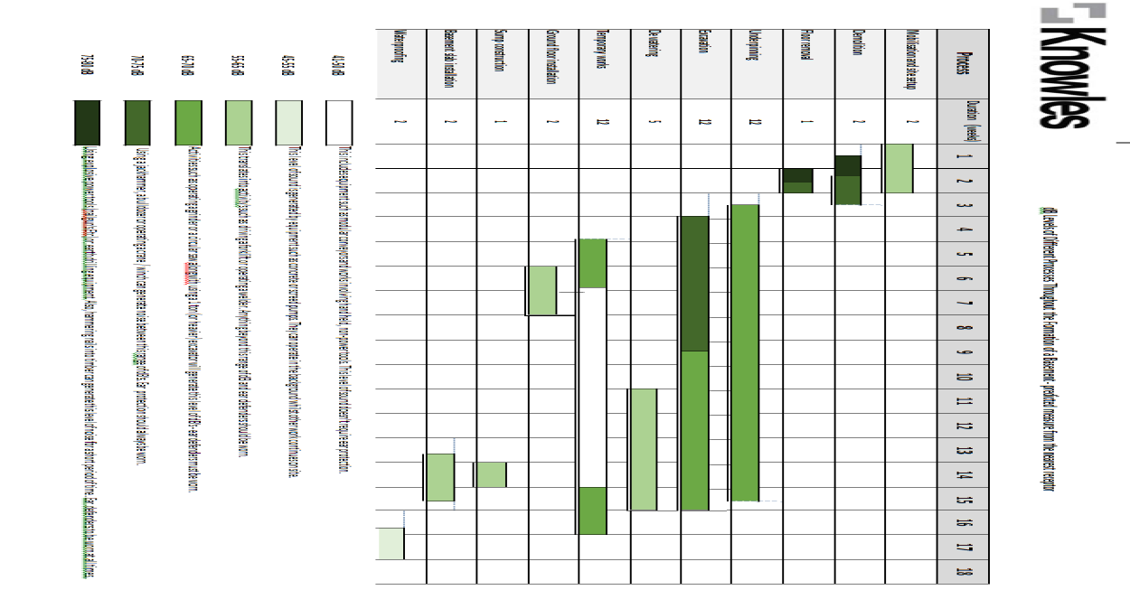

31. Please provide details describing mitigation measures to be incorporated during the construction/[demolition](http://www.camden.gov.uk/ccm/navigation/environment/building-control/demolition/) works to prevent noise and vibration disturbances from the activities on the site, including the actions to be taken in cases where these exceed the predicted levels.

Knowles & Associates are experienced contractors with knowledge of all mitigations methods and procedures for mitigating the impact of noise and vibration from demolition and basement works.

The nearest receptor is the neighbour at 26 Maresfield Gardens, with whom consultation and regular weekly nuisance assessment will be maintained. Any complaint of excessive noise, dust or vibration will result in heightened mitigation measures and periods of respite instigated.

Plant insulation and use of the most modern and efficient technology (such as mufflers and exhaust filters) are all employed to affect any excessive anticipated noise or vibration. All plant used is newly acquired such that it complies with the most recent maximum noise emission limits. Wherever possible, quieter construction methods will be utilised.

Where any complaint is received, Knowles will incorporate 2hr on/off respite periods subject to the agreement of the receptor party.

In addition the proximate receptors/neighbours will be advised at each stage of construction if any particular action is likely to incur noise, dust or vibration nuisance of any kind.

Knowles will measure noise levels with a Class 1 decibel meter, taking readings on site and building up a log of readings throughout the project duration. Knowles will aim to achieve a daily limit of 70dB (LAeq, 10hr) at the nearest sensitive façade and 73dB (LAeq, 5 minutes) at the first action level trigger.

For unattended long term noise monitoring, Knowles shall ensure the installation of two semi-permanent Class 1 sound level meters at appropriate site boundary locations, continuously monitoring a range of noise metrics. The provision of alerts via SMS or email can be provided to notify high levels of noise. Furthermore, Knowles can provide monthly noise reports to the council, on request, detailing daily noise emissions and discussing any noise trigger levels by text or email alert.The measures we will take to reduce noise pollution will be as follows:

- We will work closely and cooperate fully in terms of working in normal site hours, as set out by London Borough of Camden which also takes into account the planning condition that has been stipulated regarding working hours.

- Well maintained, sound attenuated plant will be used to carry out all operations

- reducing plant noise to acceptable levels

- Solid hoarding will be used along the boundary to the residential properties.

This will reflect sound back into the site to a significant extent. This will be supplemented locally to machinery with movable sound reflecting/absorbing barriers.

- Noise arising from Site Vehicles and plant will be managed first of all by rigorously implementing the site hours.

Careful selection of plant and vehicles is essential. All plant used on the PHS site will be sound attenuated and will be regularly serviced/maintained to ensure it is operating correctly. The site induction for plant operators will cover the issue of noise specifically and they will be warned against over revving of plant and the operation of horns in all but necessary situations. Machine operatives will be advised to isolate plant/ equipment during idle periods reducing not only noise levels but encouraging efficient running of equipment and reduced fumes.

In terms of misbehaviour of operatives and staff on the site this will be guarded against by strict rules being out in place that will form part of Supply Chain method statements and will be covered in site induction and tool box talks. Any operative found in contravention of the required standards will be warned for a first offence and removed from the site should there be a re-occurrence.

All the measures mentioned above and others will be captured and monitored in our proposals under the Considerate Contractors scheme.

As part of the CCS requirement and in line with our Company Policy, we will put in place a complaints procedure which will include 24/7 contact details for the Site Management Team, a logging system for complaints and a process for remedial actions to be identified and implemented.

32. Please provide evidence that staff have been trained on BS 5228:2009

All operatives are trained with CITB Compliant training beyond BS 5228:2009 and revised standard 2015



33. Please provide details on how dust nuisance arising from dusty activities, on site, will be prevented.

During the works dusty operations are likely to occur as follows;

Mobilisation and set-up; Minimal

Demolition; Medium to high risk - mitigation measures taken

Underpinning and Excavation; Medium risk on dry days - mitigation measures taken

Temporary works; Minimal

Ground floor and slab pour; Minimal

Construction above ground; Medium risk on dry and windy days – mitigation taken

Dust is a major cause of concern to those in the immediate environment of any building site, both to receptors and operatives. Particularly during dry summer periods, we ensure that all soil and mud inadvertently dropped onto the pavement or roadway are washed away into main drainage within 5 minutes of delivery or haulage.

Skips housing spoil and waste are covered and any passage via conveyor of excavated material is dampened as it heads to the housing skip/lorry for storage before despatch. In addition, where it is likely that neighbours will be affected at any time by dust we offer to wash down their cars and windows on a regular basis. Haulage vehicles carrying waste/spoil will be dampened and covered during dry and windy conditions.

Where working above ground we ensure that our scaffolding is wrapped with a polythene cover, both to reduce dust, but also noise to a certain extent.

Large open basement constructions have greatest potential to generate significant dust problems. However at 28 Maresfield Gardens there will be sprinkler system installed at close proximity of excavation work so when it is needed could be used to minimize dust emmisions. Site hoardings and dust-proof plastic sheeting will be erected to further minimise the release of dust from the site.

In addition it is proposed to:

- Clean / sweep the footpath and external areas around the site every evening and or as required during the day.

- Dampen excavated material as it leaves the site, this is particularly important during dry or windy periods.

- No smoking by site operatives in public.

- All dust emitting power-tools (such as drills, saws and grinders) will have vacuum filters attached

- Daily dust inspections will be undertaken by the foreman, with spot-checks by external Health & Safety consultants

34. Please provide details describing how any significant amounts of dirt or dust that may be spread onto the public highway will be prevented and/or cleaned.

Site inspections are a minimum of twice daily by the foreman to ensure that dust and dirt are kept to a minimum. All deliveries are followed by an inspection with the street and pavement swept clean if required.

In relation to dust, groundworks & demolitions is again likely to be the main source of disruption. Prior to starting daily operations wind speed and direction will be assessed and method/ sequence of works adjusted if necessary. Water spraying techniques will be utilised in necessary to suppress dust.

Apart from groundwork activities dust is likely to present a problem during long dry spells and in these periods damping down across the site will be employed to avoid windborne dust crossing the site boundary and causing inconvenience.

With regard to the risk of mud being spread on the public roads, Knowles & Associates Ltd will maintain wheel washing facilities on site and carefully maintain clean hardstanding’s across the site to ensure the surrounding public roads remain in a clean acceptable condition and are not impacted on by our work#

35. Please provide details describing arrangements for monitoring of [noise](http://www.camden.gov.uk/ccm/content/environment/environmental-health--consumer-protection/noise/reducing-noise/noise-from-construction-sites.en?page=2), vibration and dust levels.

All operatives are trained weekly by Toolbox talks with CITB Compliant training beyond BS 5228:2009 and revised standard 2015 – all Foremen and project Managers are equipped with noise monitoring equipment and manage levels to maintain safe working conditions.

Neighbours will be notified in advance of the commencement of works and thereafter regular contact maintained to monitor vibration impacts. Further targeted mitigation will be implemented to address any specific issues

In addition to the above permitted hours, further restrictions are placed on works deemed to be of ‘High Impact Activities’. This is to ensure that nearby occupiers have sufficient breaks from activities that can be extremely disruptive.

Knowles will measure noise levels with a Class 1 decibel meter, taking readings on site and building up a log of readings throughout the project duration. Knowles will aim to achieve a daily limit of 70dB (LAeq, 10hr) at the nearest sensitive façade and 73dB (LAeq, 5 minutes) at the first action level trigger.

For unattended long term noise monitoring, Knowles shall ensure the installation of two semi-permanent Class 1 sound level meters at appropriate site boundary locations, continuously monitoring a range of noise metrics. The provision of alerts via SMS or email can be provided to notify high levels of noise. Furthermore, Knowles can provide monthly noise reports to the council, on request, detailing daily noise emissions and discussing any noise trigger levels by text or email alert.

With regards to dust, the footpath and external areas around the site will be cleaned/ swept every evening and or as required during the day. Excavated material will be dampened as it leaves the site, this is particularly important during dry or windy periods. And there will be no smoking by site operatives in public.

With regard to vibration, the contractor will measure vibration at the nearest receptor (adjoining neighbour) to ensure minimum nuisance and, in any event no more than 1mms-1PPV in potential disturbance. Vibration of any significance is only likely to occur during limited periods of time, prior to which consultation will have been made with the neighbour to ensure agreement.

All monitoring will be overseen by our external consultants, Harts Health & Safety Ltd.

36. Please confirm that a Risk Assessment has been undertaken at planning application stage in line with the GLA policy. [The Control of Dust and Emissions During Demolition and Construction 2104 (SPG)](https://www.london.gov.uk/file/18750/download?token=zV3ZKTpP), that the risk level that has been identified, and that the appropriate measures within the GLA mitigation measures checklist have been applied. Please attach the risk assessment and mitigation checklist as an appendix.

Risk Assessments on all aspects of site safety and environmental impact are made prior to the commencement of works – this will be submitted in advance of works being started.

Please see RAMS folder

37. Please confirm that all of the GLA’s ‘highly recommended’ measures from the [SPG](https://www.london.gov.uk/file/18750/download?token=zV3ZKTpP) document relative to the level of risk identified in question 36 have been addressed by completing the [GLA mitigation measures checklist.](https://www.london.gov.uk/what-we-do/planning/implementing-london-plan/supplementary-planning-guidance/control-dust-and)

Please see Appendix C attached

38. If the site is a ‘High Risk Site’, 4 real time dust monitors will be required. If the site is a ‘Medium Risk Site’, 2 real time dust monitors will be required. The risk assessment must take account of proximity to sensitive receptors (e.g. schools, care homes etc), as detailed in the [SPG](https://www.london.gov.uk/file/18750/download?token=zV3ZKTpP). Please confirm the location, number and specification of the monitors in line with the SPG and confirm that these will be installed 3 months prior to the commencement of works, and that real time data and quarterly reports will be provided to the Council detailing any exceedances of the threshold and measures that were implemented to address these.

This site is assessed as a ‘Low Risk, Domestic Site’ according to the Camden SPG; the significant majority of work is outside the footprint of the house, and working with low dust emission, dampened spoil and waste. However, dust will be monitored on a regular basis and dust mitigation measures used as per Appendix C will be implemented which in most cases are measures appropriate for higher risk sites.

39. Please provide details about how rodents, including [rats](http://www.camden.gov.uk/ccm/content/environment/environmental-health--consumer-protection/pest-control/about-the-pest-control-service.en), will be prevented from spreading out from the site. You are required to provide information about site inspections carried out and present copies of receipts (if work undertaken).

Knowles & Associates Ltd are an experienced residential building contractor, with every understanding of the need to maintain site and welfare hygiene for both members of the general public and workers on site. All food waste is stored in bins with closed lids and cleared on a daily basis. All drain covers will be maintained.

CITB authorised Toolbox Talks are delivered to all site personnel in this regard to ensure minimal encouragement to rodents in regard to food waste and hygiene management.

Surface level testing for rats commenced on site on 3rd August with 2 more visits. So far there was no evidence found on possible rat infestation. See final report Appendix G.

40. Please confirm when an asbestos survey was carried out at the site and include the key findings.

We confirm that an asbestos survey has been carried out and the appropriate report for the basement and other works is attached – please see appendix E. The report is clear of asbestos and there is no indication that there is any other location of asbestos in the rest of the house given its age and method of construction. However the client has requested permission to defer further asbestos review for the above ground works until nearer the time that the structure of the house requires disturbance - they wish to remain living in the house up until nearer the commencement of works. Further surveyance at this time would be overly destructive and intrusive to permit occupation of the house (holes in ceilings and walls etc)

41. Complaints often arise from the conduct of builders in an area. Please confirm steps being taken to minimise this e.g. provision of a suitable smoking area, tackling bad language and unnecessary shouting.

All Foremen are trained to instil strict discipline in regard to antisocial behaviour. All workers are inducted when joining the site and disciplinary measures taken where noisy or abusive behaviour is discovered. Knowles have a zero tolerance on site for alcohol or substance abuse and are members of the Considerate Constructors Scheme. We have adopted their code conduct and practice wherever possible.

As per Considerate Constructors code of practice a designated smoking area will be provided for site personnel away from the site and off the public highway.

42. If you will be using non-road mobile machinery (NRMM) on site with net power between 37kW and 560kW it will be required to meet the standards set out below. The standards are applicable to both variable and constant speed engines and apply for both PM and NOx emissions.

**From 1st September 2015**

**(i) Major Development Sites** – NRMM used on the site of any major development will be required to meet Stage IIIA of EU Directive 97/68/EC

**(ii) Any development site within the Central Activity Zone -** NRMM used on any site within the Central Activity Zone will be required to meet Stage IIIB of EU Directive 97/68/EC

**From 1st September 2020**

**(iii) Any development site -** NRMM used on any site within Greater London will be required to meet Stage IIIB of EU Directive 97/68/EC

**(iv) Any development site within the Central Activity Zone -** NRMM used on any site within the Central Activity Zone will be required to meet Stage IV of EU Directive 97/68/EC

Please provide evidence demonstrating the above requirements will be met by answering the following questions:

1. Construction time period (mm/yy - mm/yy ):13months
2. Is the development within the CAZ? (Y/N): No
3. Will the NRMM with net power between 37kW and 560kW meet the standards outlined above? (Y/N): Yes
4. Please provide evidence to demonstrate that all relevant machinery will be registered on the NRMM Register, including the site name under which it has been registered:N/A
5. Please confirm that an inventory of all NRMM will be kept on site and that all machinery will be regularly serviced and service logs kept on site for inspection: Yes
6. Please confirm that records will be kept on site which details proof of emission limits, including legible photographs of individual engine plates for all equipment, and that this documentation will be made available to local authority officers as required: Yes

SYMBOL IS FOR INTERNAL USE

43. Evidence before works commence Contractors, builders, etc. have taken reasonable steps to ensure that any existing drainage serving the site is secure. This means locating the interceptors of the existing buildings and making sure that the drains are currently running free and that any interceptor (Rodding Eye) caps are in place. For straight through systems a rat block device should have been installed before any work starts. Short video recording was taking to prove that drainage in good working order prior all building works.

- Before any building works commence provide evidence if the existing drains are not to be used for the new development then these have been cemented and sealed. It will be used

- Before any building construction/de-construction works commence evidence should be provided that any additional drainage leading back from the interceptor left open, the corresponding interceptor interceptor/s are sealed. There will be no additional drainage.

**Agreement**

The agreed contents of this Construction Management Plan must be complied with unless otherwise agreed in writing by the Council. This may require the CMP to be revised by the Developer and reapproved by the Council. The project manager shall work with the Council to review this Construction Management Plan if problems arise in relation to the construction of the development. Any future revised plan must be approved by the Council in writing and complied with thereafter.

It should be noted that any agreed Construction Management Plan does not prejudice further agreements that may be required such as road closures or hoarding licences.

**Please notify that council when you intend to start work on site. Please also notify the council when works are approximately 3 months from completion.**

**Signed:** …Paul Baguzis………………………………………………………………

**Date:** …25.09.2017…………………………………………..

**Print Name:** …Paul Baguzis…………………………………………………..….

**Position:** …Project Manager………………………………………

Please submit to: [planningobligations@camden.gov.uk](mailto:planningobligations@camden.gov.uk)

End of form.