[Historic England](https://historicengland.org.uk/)

* [Menu](https://historicengland.org.uk/listing/the-list/list-entry/1379092)
* [Search](https://historicengland.org.uk/sitesearch)
* [Listing](https://historicengland.org.uk/listing/)
  + [Search the List](https://historicengland.org.uk/listing/the-list/)
  + [Enrich the List](https://historicengland.org.uk/listing/enrich-the-list/)
  + [Apply for Listing](https://historicengland.org.uk/listing/apply-for-listing/)
  + [What is Listing?](https://historicengland.org.uk/listing/what-is-designation/)
  + [Listing Guidance](https://historicengland.org.uk/listing/selection-criteria/)
* [Advice](https://historicengland.org.uk/advice/)
  + [Your Home](https://historicengland.org.uk/advice/your-home/)
  + [Planning](https://historicengland.org.uk/advice/planning/)
  + [Latest Advice & Guidance](https://historicengland.org.uk/advice/latest-guidance/)
  + [Caring for Heritage](https://historicengland.org.uk/advice/caring-for-heritage/)
  + [Technical Guidance](https://historicengland.org.uk/advice/technical-advice/)
  + [Heritage at Risk](https://historicengland.org.uk/advice/heritage-at-risk/)
  + [Constructive Conservation](https://historicengland.org.uk/advice/constructive-conservation/)
  + [Heritage Protection Guide](https://historicengland.org.uk/advice/hpg/)
* [Research](https://historicengland.org.uk/research/)
  + [Our Research Strategy and Agenda](https://historicengland.org.uk/research/agenda/)
  + [Research Methods](https://historicengland.org.uk/research/methods/)
  + [Current Research](https://historicengland.org.uk/research/current/)
  + [Research Results](https://historicengland.org.uk/research/research-results/)
  + [Support & Collaboration](https://historicengland.org.uk/research/support-and-collaboration/)
  + [Inclusive Heritage](https://historicengland.org.uk/research/inclusive-heritage/)
  + [Heritage Counts](https://historicengland.org.uk/research/heritage-counts/)
* [Images & Books](https://historicengland.org.uk/images-books/)
  + [Find Photos](https://historicengland.org.uk/images-books/photos/)
  + [Search All Publications](https://historicengland.org.uk/images-books/publications/)
  + [Buy Books](https://historicengland.org.uk/images-books/books/)
  + [The Historic England Archive](https://historicengland.org.uk/images-books/archive/)
  + [Be an Archive Detective](https://historicengland.org.uk/images-books/archive-mysteries/)
* [Services & Skills](https://historicengland.org.uk/services-skills/)
  + [Education](https://historicengland.org.uk/services-skills/education/)
  + [Grants](https://historicengland.org.uk/services-skills/grants/)
  + [Our Planning Services](https://historicengland.org.uk/services-skills/our-planning-services/)
  + [Training & Skills](https://historicengland.org.uk/services-skills/training-skills/)
  + [Archive Services](https://historicengland.org.uk/services-skills/archive-services/)
  + [Heritage Action Zones](https://historicengland.org.uk/services-skills/heritage-action-zones/)
* [Get Involved](https://historicengland.org.uk/get-involved/)
  + [100 Places](https://historicengland.org.uk/get-involved/100-places/)
  + [Support Us](https://historicengland.org.uk/get-involved/support-us/)
  + [Be a Volunteer](https://historicengland.org.uk/get-involved/volunteer/)
  + [Visit Your Heritage](https://historicengland.org.uk/get-involved/visit/)
  + [Protect Your Heritage](https://historicengland.org.uk/get-involved/protect/)
  + [Help Write History](https://historicengland.org.uk/get-involved/help-write-history/)
  + [Angel Awards](https://historicengland.org.uk/get-involved/angel-awards/)
* [What's New](https://historicengland.org.uk/whats-new/)
  + [News](https://historicengland.org.uk/whats-new/news/)
  + [In Your Area](https://historicengland.org.uk/whats-new/in-your-area/)
  + [Latest Listings](https://historicengland.org.uk/whats-new/listing/)
  + [Latest Research](https://historicengland.org.uk/whats-new/research/)
  + [Heritage Online Debate](https://historicengland.org.uk/whats-new/debate/)
  + [Statements](https://historicengland.org.uk/whats-new/statements/)
  + [Stay Up To Date](https://historicengland.org.uk/whats-new/stay-up-to-date/)
  + [50 Years of Conservation Areas](https://historicengland.org.uk/whats-new/conservation-areas-50-years/)
  + [First World War Centenary](https://historicengland.org.uk/whats-new/first-world-war-home-front/)
  + [What We Do](https://historicengland.org.uk/about/what-we-do/)
  + [Who We Are](https://historicengland.org.uk/about/who-we-are/)
  + [Jobs](https://historicengland.org.uk/about/jobs/)
  + [Contact Us](https://historicengland.org.uk/about/contact-us/)
  + [Volunteer with Historic England](https://historicengland.org.uk/about/volunteering/)
  + [Website Terms and Conditions](https://historicengland.org.uk/terms/website-terms-conditions/)
  + [Privacy and Cookies Policy](https://historicengland.org.uk/terms/privacy-cookies/)
  + [Links Policy](https://historicengland.org.uk/terms/links-policy/)
  + [Historic England Blog and Social: House Rules](https://historicengland.org.uk/terms/blog-house-rules/)
  + [Photo Competition Terms and Conditions](https://historicengland.org.uk/terms/photo-competition-terms-conditions/)
  + [Angel Awards 2017 Voting Terms and Conditions](https://historicengland.org.uk/terms/angel-awards-voting-terms-and-conditions/)
* [Home](https://historicengland.org.uk/)
* [...](https://historicengland.org.uk/listing/the-list/list-entry/1379092)
* [Listing](https://historicengland.org.uk/listing/)
* [Search the List](https://historicengland.org.uk/listing/the-list/)
* List Entry

[This browser is not fully supported](https://www.historicengland.org.uk/access/) by Historic England. Please update your browser to the latest version so that you get the best from our website.

We use cookies to give you the best possible experience online. By using this website, you consent to cookies being used in accordance with our [Cookie Policy](https://historicengland.org.uk/terms/).

* + [Map Search](https://historicengland.org.uk/listing/the-list/map/)
  + [Advanced Search](https://historicengland.org.uk/listing/the-list/advanced/)
  + [Minor Amendments](https://historicengland.org.uk/listing/the-list/minor-amendments/)
  + [Download Listing Data](https://historicengland.org.uk/listing/the-list/data-downloads/)
  + [Non-Listed Sites](https://historicengland.org.uk/listing/the-list/non-listed-sites/)
  + [About The List](https://historicengland.org.uk/listing/the-list/about-the-list/)
  + [Enrich the List](https://historicengland.org.uk/listing/the-list/enrich/)
  + [Understanding List Entries](https://historicengland.org.uk/listing/the-list/understanding-list-entries/)

**AVENUE CHAMBERS**

**List Entry Summary**

This building is listed under the Planning (Listed Buildings and Conservation Areas) Act 1990 as amended for its special architectural or historic interest.

Name: AVENUE CHAMBERS

List entry Number: 1379092

**Location**

AVENUE CHAMBERS, 1-6, VERNON PLACE

The building may lie within the boundary of more than one authority.

County: Greater London Authority

District: Camden

District Type: London Borough

Parish:

National Park: Not applicable to this List entry.

Grade: II

Date first listed: 14-May-1974

Date of most recent amendment: Not applicable to this List entry.

**Legacy System Information**

The contents of this record have been generated from a legacy data system.

Legacy System: LBS

UID: 478458

**Asset Groupings**

This list entry does not comprise part of an Asset Grouping. Asset Groupings are not part of the official record but are added later for information.

**List entry Description**

**Summary of Building**

Legacy Record - This information may be included in the List Entry Details.

**Reasons for Designation**

Legacy Record - This information may be included in the List Entry Details.

**History**

Legacy Record - This information may be included in the List Entry Details.

**Details**

CAMDEN  
  
TQ3081NW VERNON PLACE 798-1/100/1669 (North West side) 14/05/74 Nos.1-6 (Consecutive) Avenue Chambers   
  
GV II  
  
Shopping parade with offices, formerly flats, over, forming the north-west return to Sicilian Avenue (qv). 1906-10. By RJ Worley. For the Bedford Estate. Red brick with white terracotta dressings and 1st floor. EXTERIOR: 5 storeys and later C20 attic with dormers. 7 window bays plus splayed left hand return and projecting oriel on right hand return to Sicilian Avenue. Ground floor with round-headed entrance to offices in central bay flanked by later C20 shopfronts. Bays separated by Corinthian columns on plinths carrying an entablature with plain terracotta frieze at 2nd floor level. Pilasters at end bays. 1st floor with 4, 3 and 2-light square-headed casement windows except the entrance bay with a 5-light oriel, the apron with wreath and swags inscribed "Avenue Chambers". 2nd, 3rd and 4th floor with 2-light transom and mullion windows at either end, 4-light canted bay windows with transom and mullions and in the central entrance bay 4-light bow windows. Projecting oriel of 7 lights with transoms and mullions, from 2nd to 4th floor. Beneath, an arched entrance with 4 large brackets supporting a cornice over. All windows with small leaded panes, some with shields. Modillion cornice surmounted by terracotta balustrade, the central bay with a pedimented gable with 2-light transom and mullion window. To either side, tall slab chimneys. Over the left hand splayed return, a domed terracotta lantern. INTERIORS: not inspected. Nos 1-6 (consec) Vernon Place form a homogeneous development with Nos 1-29 (odd) and 6-20 (even) Sicilian Avenue (qqv), Nos 15-23, 25-35 (odd) and 35A Southampton Row (qqv).   
  
  
  
  
  
Listing NGR: TQ3045281648

**Selected Sources**

Legacy Record - This information may be included in the List Entry Details

National Grid Reference: TQ 30443 81647

**Map**

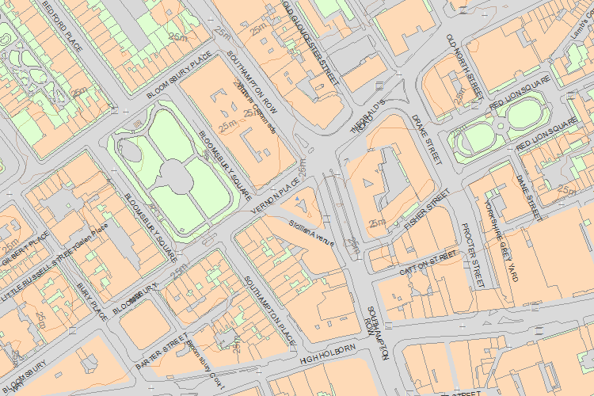© Crown Copyright and database right 2018. All rights reserved. Ordnance Survey Licence number 100024900.  
© British Crown and SeaZone Solutions Limited 2018. All rights reserved. Licence number 102006.006.  
Use of this data is subject to [Terms and Conditions](https://historicengland.org.uk/terms/website-terms-conditions/).

The above map is for quick reference purposes only and may not be to scale. For a copy of the full scale map, please see the attached PDF - [1379092 .pdf](http://mapservices.HistoricEngland.org.uk/printwebservicehle/StatutoryPrint.svc/402286/HLE_A4L_Grade%7CHLE_A3L_Grade.pdf)

The PDF will be generated from our live systems and may take a few minutes to download depending on how busy our servers are. We apologise for this delay.

This copy shows the entry on 23-May-2018 at 09:22:06.

End of official listing