

**Construction Management**

**Plan**

**317 Finchley Road, London, NW3 6EP**

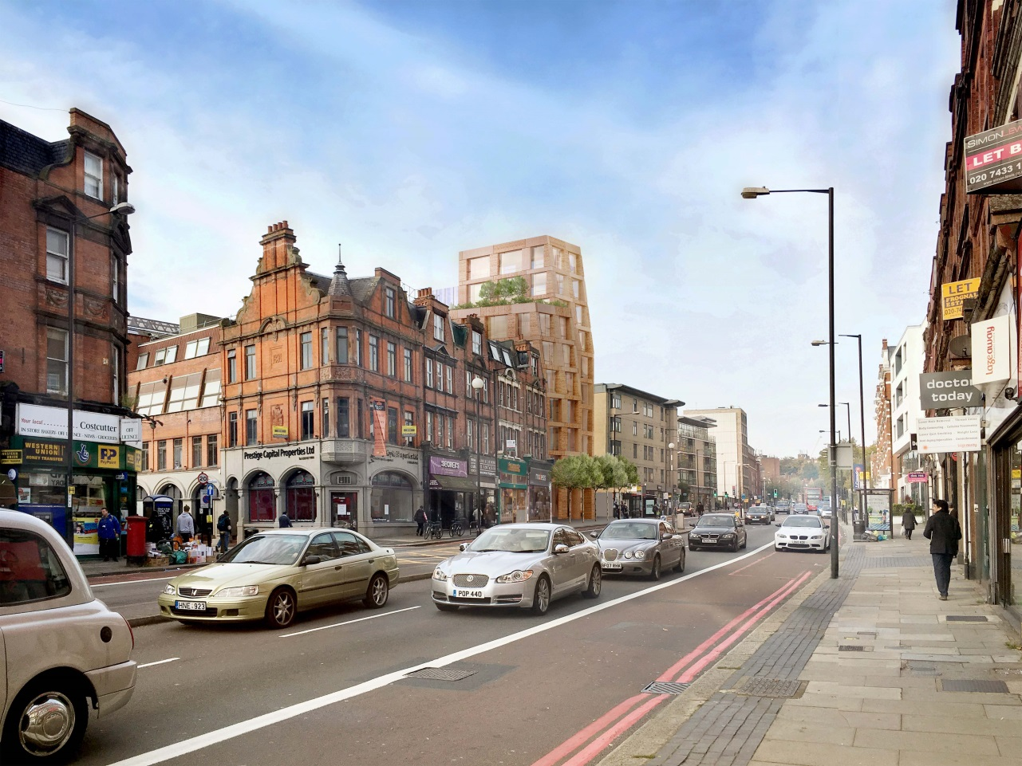

**pro forma** v2.2

**Contents**

**Revisions 3**

**Introduction 4**

**Timeframe 6**

**Contact** **7**

**Site** **9**

**Community liaison** **13**

**Transport** **17**

**Environment** **30**

**Agreement**  **35**

**Appendices:**

**Appendix A Demolition**

**Appendix B Consultation**

**Appendix C Transport for London: Highways**

**Appendix D Scaffold**

**Appendix E Noise, Vibration and Air Quality**

**Appendix F Rodents**

**Appendix G Asbestos**

Note: Appendices are available in Dropbox using the following link:

https://www.dropbox.com/sh/k0qim3o5ods9hmy/AAB2NOcCoRsgnsgnNH7Tz659a?dl=0

# Revisions & additional material

Please list all iterations here:

|  |  |  |
| --- | --- | --- |
| **Date** | **Version** | **Produced by** |
| **04/09/2017** | **1** | **W Mason** |
| **04/04/2018** | **2** | **S Newbold** |
| **19/04/2018** | **3** | **S Newbold** |

**Additional sheets**

Please note – the review process will be quicker if these are submitted as Word documents or searchable PDFs.

|  |  |  |
| --- | --- | --- |
| **Date** | **Version** | **Produced by** |
| **04/04/2018** | **2** | **S Newbold** |

# Introduction

The purpose of the **Construction Management Plan (CMP)** is to help developers to minimise construction impacts, and relates to both on site activity and the transport arrangements for vehicles servicing the site.

It is intended to be a live document whereby different stages will be completed and submitted for application as the development progresses.

The completed and signed CMP must address the way in which any impacts associated with the proposed works, and any **cumulative impacts of other nearby construction sites**, will be mitigated and managed. The level of detail required in a CMP will depend on the scale and kind of development. Further policy guidance is set out in Camden Planning Guidance [**(CPG)** 6: Amenity](http://www.camden.gov.uk/ccm/content/environment/planning-and-built-environment/two/planning-policy/supplementary-planning-documents/camden-planning-guidance.en) and [**(CPG)** 8: Planning Obligations](http://www.camden.gov.uk/ccm/content/environment/planning-and-built-environment/two/planning-policy/supplementary-planning-documents/camden-planning-guidance.en).

This CMP follows the best practice guidelines as described in [Transport for London’s](https://www.tfl.gov.uk/info-for/freight/safety-and-the-environment/improving-construction-safety) (TfL’s Standard for [Construction Logistics and Community Safety](http://www.clocs.org.uk/standard-for-clocs/) (**CLOCS**) scheme) and [Camden’s Minimum Requirements for Building Construction](http://www.camden.gov.uk/ccm/cms-service/download/asset?asset_id=3257318) **(CMRBC)**.

The approved contents of this CMP must be complied with unless otherwise agreed with the Council in writing. The project manager shall work with the Council to review this CMP if problems arise in relation to the construction of the development. Any future revised plan must also be approved by the Council and complied with thereafter.

It should be noted that any agreed CMPdoes not prejudice or override the need to obtain any separate consents or approvals such as for road closures or hoarding licences.

If your scheme involves any demolition, you need to make an application to the Council’s Building Control Service. Please complete the “[**Demolition Notice**](http://www.camden.gov.uk/ccm/content/environment/building-control/file-storage-items/demolition-notice---the-building-act-1984-section-80-notice-bc104-.en)**.**”

Please complete the questions below with additional sheets, drawings and plans as required. The boxes will expand to accommodate the information provided, so please provide as much information as is necessary. **It is preferable if this document, and all additional documents, are completed electronically and submitted as Word files to allow comments to be easily documented. These should be clearly referenced/linked to from the CMP.**

Please notify that council when you intend to start work on site. Please also notify the council when works are approximately **3 months from completion.**

(Note the term 'vehicles' used in this document refers to all vehicles associated with the implementation of the development, e.g. demolition, site clearance, delivery of plant & materials, construction, etc.)

Revisions to this document may take place periodically.Timeframe

**DEVELOPER ACTIONS**

**COUNCIL ACTIONS**

**Post app submission**

**0ommunity liaison**

**Appoint principal contractor**

**Requirement to submit CMP**

**Begin community liaison**

**Council response to second draft**

**Work can commence if draft CMP is approved**

**Resubmission of CMP if first draft refused**

**2ommunity liaison**

**3ommunity liaison**

**1ommunity liaison**

INDICATIVE TIMEFRAME (MONTHS)

**4ommunity liaison**

**Council response to draft**

**Submit draft CMP**

# Contact

1. Please provide the full postal address of the site and the planning reference relating to the construction works.

Address: 317 Finchley Road, London, NW3 6EP

Planning reference number to which the CMP applies: **2016/2910/P**

2. Please provide contact details for the person responsible for submitting the CMP.

Name: Christos Pierides

Address:

PMP Construction Ltd, Design Office, Southgate Office Village,

Block D, 2nd Floor, 286 Chase Road, London N14 6HF

Email: christos@pmpcl.com

Phone: Tel. 020 7124 4171 Mob. 07468 527216

3. Please provide full contact details of the site project manager responsible for day-to-day management of the works and dealing with any complaints from local residents and businesses.

Name: Marios Leonidas

Address:

PMP Construction Ltd, Design Office, Southgate Office Village,

Block D, 2nd Floor, 286 Chase Road, London N14 6HF

Email: mleonida@pmpcl.com

Phone: Tel. 020 7124 4171 Mob.07985 102237

4. Please provide full contact details of the person responsible for community liaison and dealing with any complaints from local residents and businesses if different from question 3. In the case of [**Community Investment Programme (CIP)**](http://www.camden.gov.uk/ccm/content/environment/planning-and-built-environment/two/placeshaping/twocolumn/the-community-investment-programme.en), please provide contact details of the Camden officer responsible.

Name: Christos Pierides

Address:

PMP Construction Ltd, Design Office, Southgate Office Village,

Block D, 2nd Floor, 286 Chase Road, London N14 6HF

Email: christos@pmpcl.com

Phone: Tel. 020 7124 4171 Mob. 07468527216

5. Please provide full contact details including the address where the main contractor accepts receipt of legal documents for the person responsible for the implementation of the CMP.

Name: Christos Pierides

Address:

PMP Construction Ltd, Design Office, Southgate Office Village,

Block D, 2nd Floor, 286 Chase Road, London N14 6HF

Email: christos@pmpcl.com

Phone: Tel. 020 7124 4171

# Site

6. Please provide a site location plan and a brief description of the site, surrounding area and development proposals for which the CMP applies.

The site is located at No. 317 Finchley Road, London, NW3 6EP. It is positioned within close proximity to Finchley Road and Frognal train station. The property currently has an alleyway (Billy Fury Way) to one side and adjoins the railway station and a neighbouring property on the other. The former public house has disused gardens to the rear.

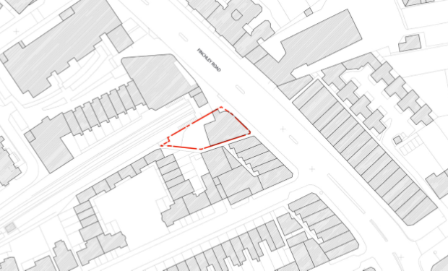

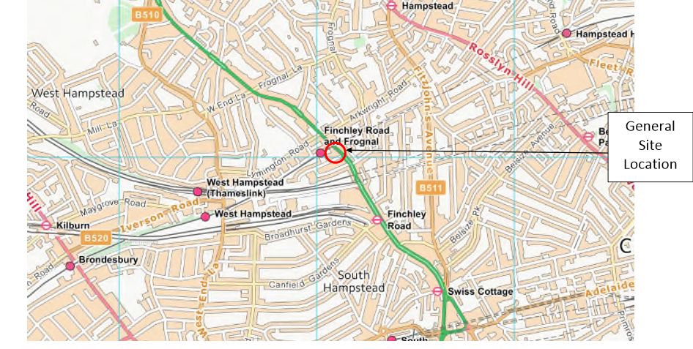

7. Please provide a very brief description of the construction works including the size and nature of the development and details of the main issues and challenges (e.g. narrow streets, close proximity to residential dwellings etc).

Demolition of existing public house and the subsequent construction of a part 7, part 10 storey building comprising of 22 flats and a flexible commercial unit..

The site is bordered by a railway line and station, a public footpath at the front aspect, a public footpath adjacent to the building which provides access to neighbouring properties (Billy Fury Way).

The site is located on a busy highway and a bus lane and bus stop is located directly outside the site.

Residential dwellings are next to and behind the site.

The key aspect of the logistical challenges with this project involves the sites close proximity to the Network Rail train lines. Therefore a set of existing guidelines must be followed as set out by Network Rail. This has specific regard to elements of building works that have the potential to fall beyond the site boundary. With this project this is likely to be the tower crane and its associated components (crane base etc.) and the elevation scaffolds. It must be noted that it is not envisaged that access will be required onto Network Rail’s land.

8. Please identify the nearest potential receptors (dwellings, business, etc.) likely to be affected by the activities on site (i.e. noise, vibration, dust, fumes, lighting etc.).

Billy Fury Way runs adjacent to the site and access will be maintained at all times as access is required to serve fire escapes and residential properties.

The site is positioned within close proximity to Finchley Road and Frognal train station

9. Please provide a scaled plan detailing the local highway network layout in the vicinity of the site. This should include details of on-street parking bay locations, cycle lanes, footway extents and proposed site access locations.

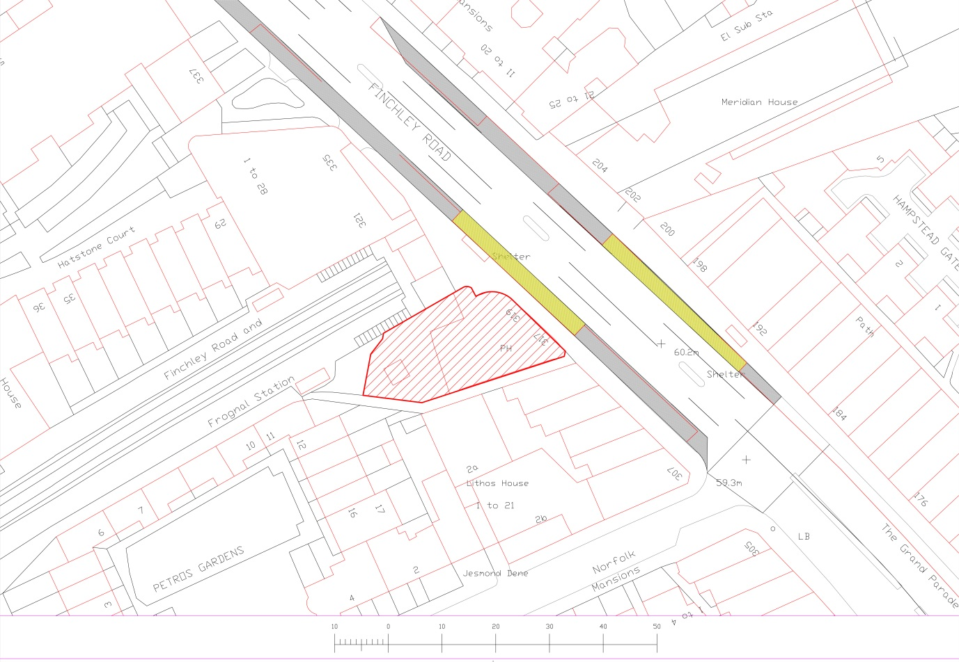

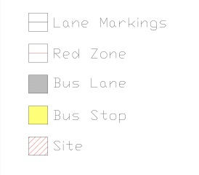10. Please provide the proposed start and end dates for each phase of construction as well as an overall programme timescale. (A Gantt chart with key tasks, durations and milestones would be ideal).

|  |  |  |
| --- | --- | --- |
| **Task Name** | **Start** | **Finish** |
| Demolitions | 16.04.2018 | 01.06.2018 |
| Earthworks | 04.06.2018 | 17.08.2018 |
| Piling | 07.06.2018 | 25.07.2018 |
| Basement Structure | 20.08.2018 | 09.11.2018 |
| Ground Floor Structure | 10.11.2018 | 10.12.2018 |
| 1st to 9th Floor Structure | 11.12.2018 | 04.07.2019 |
| Structural Stone | 18.02.2019 | 18.10.2019 |
| Roof Works | 29.04.2019 | 01.11.2019 |
| Communal Staircase | 06.02.2019 | 15.11.2019 |
| Blockwork | 25.09.2018 | 15.11.2019 |
| Dry lining 1st Fix | 25.09.2018 | 05.12.2019 |
| Mechanical 1st Fix | 19.11.2018 | 18.12.2019 |
| Electrical 1st Fix | 19.11.2018 | 17.01.2020 |
| Dry lining Second Fix | 21.01.2019 | 17.02.2020 |
| Mechanical Second Fix | 19.07.2019 | 19.03.2020 |
| Electrical Second Fix | 19.07.2019 | 19.03.2020 |
| Doors | 19.08.2019 | 07.02.2020 |
| Wardrobes | 21.10.2019 | 31.01.2020 |
| Kitchens | 19.07.2019 | 06.02.2020 |
| Painting & Finishing | 18.02.2019 | 28.02.2020 |
| Lift Shaft | 02.10.2019 | 03.03.2020 |
| Lift | 06.11.2019 | 19.03.2020 |
| External works | 18.11.2019 | 03.04.2020 |
| Testing & commissioning | 20.03.2020 | 16.04.2020 |

11. Please confirm the standard working hours for the site, noting that the standard working hours for construction sites in Camden are as follows:

* 8.00am to 6pm on Monday to Friday
* 8.00am to 1.00pm on Saturdays
* No working on Sundays or Public Holidays
* 8.00am to 6pm on Monday to Friday
* 8.00am to 1.00pm on Saturdays
* No working on Sundays or Public Holidays

12. Please indicate if any changes to services are proposed to be carried out that would be linked to the site during the works (i.e. connections to public utilities and/or statutory undertakers’ plant). Larger developments may require new utility services. If so, a strategy and programme for coordinating the connection of services will be required. If new utility services are required, please confirm which utility companies have been contacted (e.g. Thames Water, National Grid, EDF Energy, BT etc.) You must explore options for the utility companies to share the same excavations and traffic management proposals. Please supply details of your discussions.

UKPN – full application made June 2017; we have been informed by UKPN that a new 500kVA on-site substation will be required. Discussions on location of substation are ongoing.

BT – full application made June 2017; initial response received from BT September 2017, discussions ongoing.

Thames Water – no direct contact; network capacity checks have been carried-out, and confirmed ok, for both cold water supply and waste connection.

Gas – Upgrade to supply will be required, no application made.

B

Community Liaison

**A neighbourhood consultation process must have been undertaken prior to submission of the CMP first draft. This consultation must relate to construction impacts, and should take place following the granting of planning permission in the lead up to the submission of the CMP. A consultation process specifically relating to construction impacts must take place regardless of any prior consultations relating to planning matters. This consultation must include all of those individuals that stand to be affected by the proposed construction works. These individuals should be provided with a copy of the draft CMP, or a link to an online document. They should be given adequate time with which to respond to the draft CMP, and any subsequent amended drafts. Contact details which include a phone number and email address of the site manager should also be provided.**

Significant time savings can be made by running an effective neighbourhood consultation process. This must be undertaken in the spirit of cooperation rather than one that is dictatorial and unsympathetic to the wellbeing of local residents and businesses.

These are most effective when initiated as early as possible and conducted in a manner that involves the local community. Involving locals in the discussion and decision making process helps with their understanding of what is being proposed in terms of the development process. **The consultation and discussion process should have already started, with the results incorporated into the CMP first draft submitted to the Council for discussion and sign off.**This communication should then be ongoing during the works, with neighbours and any community liaison groups being regularly updated with programmed works and any changes that may occur due to unforeseen circumstances through newsletters, emails and meetings.

Please note that for larger sites, details of a construction working group may be required as a separate S106 obligation. If this is necessary, it will be set out in the S106 Agreement as a separate requirement on the developer.

**Cumulative impact**

Sites located within high concentrations of construction activity that will attract large numbers of vehicle movements and/or generate significant sustained noise levels should consider establishing contact with other sites in the vicinity in order to manage these impacts.

**The Council can advise on this if necessary.**

**13. Consultation**

The Council expects meaningful consultation. For large sites, this may mean two or more meetings with local residents **prior to submission of the first draft CMP**.

Evidence of who was consulted, how the consultation was conducted and a summary of the comments received in response to the consultation should be included. Details of meetings including minutes, lists of attendees etc. should be appended.

In response to the comments received, the CMP should then be amended where appropriate and, where not appropriate, a reason given. The revised CMP should also include a list of all the comments received. Developers are advised to check proposed approaches to consultation with the Council before carrying them out. If your site is on the boundary between boroughs then we would recommend contacting the relevant neighbouring planning authority.

Please provide details of consultation of draft CMP with local residents, businesses, local groups (e.g. residents/tenants and business associations) and Ward Councillors.

Initial letter posted to local businesses and residents 25.01.2018 advising of forthcoming works and of PMP Construction contact details.

Second letter posted 07.02.2018 with invitation to attend an open meeting on 14.02.2018. Email response from one local business, not able to attend but with some queries.

Open meeting held on 14.02.2018 with presentation by Architect and by PMP Construction. Attended by only one local business and no residents. Q&A session covered queries regarding length of works and periods of most disturbance. No changes to CMP necessary.

Third letter posted 04.04.2018 advising that CMP is available for inspection online or hard copy at PMP Construction offices, and inviting any further comments and queries.

Transport for London has been consulted and licences granted for scaffolding, and for use of bus lane for construction vehicles and temporary relocation of bus stop.

There have been lengthy and detailed consultations with Network Rail regarding the carrying out of the works, scaffolding and hoarding. Formal approvals have been sought and will be in place before any relevant works commence.

Please refer to appended documents in Appendix B.

**14. Construction Working Group**

Please provide details of community liaison proposals including any Construction Working Group that will be set up, addressing the concerns of the community affected by the works, the way in which the contact details of the person responsible for community liaison will be advertised to the local community, and how the community will be updated on the upcoming works i.e. in the form of a newsletter/letter drop, or weekly drop in sessions for residents.

* Regular letter drop to local businesses and residents giving updates on the works and contact details.
* Hoarding around the site will have contact details of the person responsible for community liaison.

**15. Schemes**

Please provide details of your ‘Considerate Constructors Scheme’ registration, and details of any other similar relevant schemes as appropriate. Contractors will also be required to follow the “[Guide for Contractors Working in Camden](http://www.camden.gov.uk/ccm/cms-service/download/asset?asset_id=799001)” also referred to as “[Camden’s Considerate Contractors Manual](http://www.camden.gov.uk/ccm/cms-service/download/asset?asset_id=799001)”.

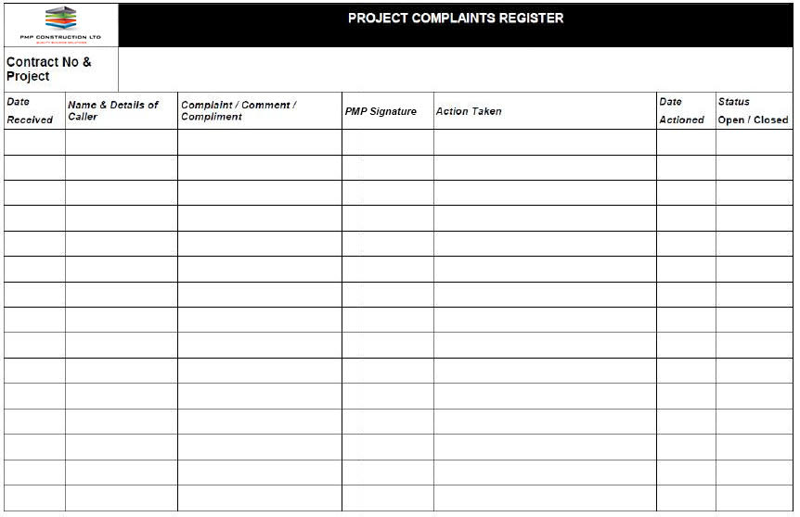

PMP have applied for registration of the site under the Considerate Constructors Scheme for the duration of the project (application ref 65014). The works will be carried out in accordance with the Considerate Constructors Scheme and in such a way as to minimise the impact on the local environment and amenities. A contact board will be displayed outside the site providing contact details. This will include names and telephone numbers of key construction staff so that neighbours and the general public can contact us should they have cause to do so. This will include 24 hour contact details.

A complaints / contact book will be kept on site, which will be used to record details of any complaints. This will include the name of the person making the complaint, the date, time and nature of the complaint and the action necessary to resolve the complaint. The complaints book will be regularly reviewed to ensure that any complaints are dealt with and resolved promptly (sample below).

**16. Neighbouring sites**

Please provide a plan of existing or anticipated construction sites in the local area and please state how your CMP takes into consideration and mitigates the cumulative impacts of construction in the vicinity of the site. The council can advise on this if necessary.

We are not aware of any other construction sites in the local area.

Our CMP and project arrangements will involve the monitoring of the area and work taking place and will ensure that other developments are reviewed and liaison meetings will take place in order to coordinate traffic movements and minimise disruptions to the local community.

# 

# Transport

**This section must be completed in conjunction with your principal contractor. If one is not yet assigned, please leave the relevant sections blank until such time when one has been appointed.**

Camden is a CLOCS Champion, and is committed to maximising road safety for Vulnerable Road Users (VRUs) as well as minimising negative environmental impacts created by motorised road traffic. As such, all vehicles and their drivers servicing construction sites within the borough are bound by the conditions laid out in the [CLOCS Standard.](http://www.clocs.org.uk/)

This section requires details of the way in which you intend to manage traffic servicing your site, including your road safety obligations with regard to VRU safety. It is your responsibility to ensure that your principal contractor is fully compliant with the terms laid out in the CLOCS Standard. It is your principal contractor’s responsibility to ensure that all contractors and sub-contractors attending site are compliant with the terms laid out in the CLOCS Standard.

Checks of the proposed measures will be carried out by the council to ensure compliance. Please refer to the CLOCS Standard when completing this section. Guidance material which details CLOCS requirements can be accessed [here](http://www.camden.gov.uk/ccm/cms-service/stream/asset?asset_id=3550016&), details of the monitoring process are available [here](http://www.camden.gov.uk/ccm/cms-service/stream/asset?asset_id=3550014&).

Please contact [CLOCS@camden.gov.uk](mailto:CLOCS@camden.gov.uk) for further advice or guidance on any aspect of this section.

**Please refer to the CLOCS Overview and Monitoring Overview documents referenced above which give a breakdown of requirements.**

**CLOCS Contractual Considerations**

17. Name of Principal contractor:

PMP Construction Ltd

18. Please submit the proposed method for checking operational, vehicle and driver compliance with the CLOCS Standard throughout the duration of the contract (please refer to our [CLOCS Overview document](http://www.camden.gov.uk/ccm/cms-service/stream/asset?asset_id=3550016&) and [Q18 example response](http://www.camden.gov.uk/ccm/cms-service/stream/asset?asset_id=3550015&)).

Contracts

Contracts FORS Bronze accreditation as a minimum will be a contractual requirement, FORS Silver or Gold operators will be appointed where possible. Where FORS Bronze operators are appointed, written assurance will be sought from contractors that all vehicles over 3.5t are equipped with additional safety equipment (as per CLOCS Standard P13), and that all drivers servicing the site will have undertaken approved additional training (eg. Safe Urban Driving + 1 x e-learning module OR Work Related Road Risk Vulnerable Road User training + on-cycle hazard awareness course + 1 x e-learning module etc.). CLOCS Compliance will be included as a contractual requirement.

Desktop checks

Desktop checks Desktop checks will be made against the FORS database of trained drivers and accredited companies as outlined in the CLOCS Standard Managing Supplier Compliance guide. These will be carried out as per a risk scale based on that outlined in the CLOCS Managing Supplier Compliance guide.

Site checks

Checks of FORS ID numbers will form part of the periodic checks and will be carried out as per an appropriate risk scale.

Random spot checks will be carried out by site staff on vehicles and drivers servicing the site at a frequency based on the aforementioned risk scale. These will include evidence of further training, license checks, evidence of routing information, and checks of vehicle safety equipment. Results from these checks will be logged and retained, and enforced upon accordingly. Where the contractors own vehicles and drivers are used the above approach will be modified accordingly. Collision reporting data will be requested from operators and acted upon when necessary.

19. Please confirm that you as the client/developer and your principal contractor have read and understood the [CLOCS Standard](http://www.clocs.org.uk/wp-content/uploads/2015/05/CLOCS-Standard-v1.2-APRIL_15.pdf) and included it in your contracts. Please sign-up to join the [CLOCS Community](http://www.clocs.org.uk/links-to-partners/) to receive up to date information on the standard by expressing an interest online.

I confirm that I have included the requirement to abide by the CLOCS Standard in my contracts to my contractors and suppliers:

Confirmed: Christos Pierides for PMP Construction Ltd.

Please contact [CLOCS@camden.gov.uk](mailto:CLOCS@camden.gov.uk) for further advice or guidance on any aspect of this section.

**Site Traffic**

**Sections below shown in blue directly reference the CLOCS Standard requirements. The CLOCS Standard should be read in conjunction with this section.**

**20. Traffic routing**: *“Clients shall ensure that a suitable, risk assessed vehicle route to the site is specified and that the route is communicated to all contractors and drivers. Clients shall make contractors and any other service suppliers aware that they are to use these routes at all times unless unavoidable diversions occur.”* (P19, 3.4.5)

Routes should be carefully considered and risk assessed, taking into account the need to avoid where possible any major cycle routes and trip generators such as schools, offices, public buildings,museums etc. Where appropriate, on routes that use high risk junctions (i.e. those that attract high volumes of cycling traffic) installing Trixi mirrors to aid driver visibility should be considered.

Consideration should also be given to weight restrictions, low bridges and cumulative impacts of construction (including neighbouring construction sites) on the public highway network. The route(s) to and from the site should be suitable for the size of vehicles that are to be used.

1. Please indicate routes on a drawing or diagram showing the public highway network in the vicinity of the site including details of how vehicles will be routed to the [Transport for London Road Network](http://www.lscp.org.uk/lrsu/engineering_tlrn.html) (TLRN) on approach and departure from the site.

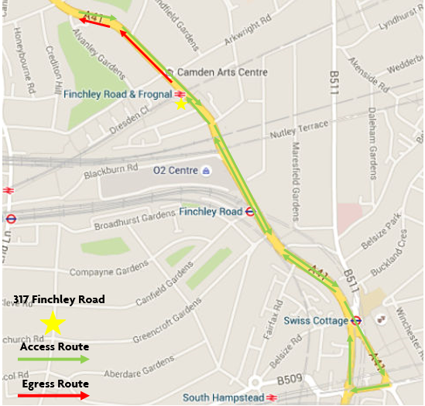

b. Please confirm how contractors, delivery companies and visitors will be made aware of the route (to and from the site) and of any on-site restrictions, prior to undertaking journeys.

The route will be communicated to suppliers and delivery vehicles prior to appointment and they will be required to provide all drivers with the information.

**21. Control of site traffic, particularly at peak hours**: “*Clients shall consider other options to plan and control vehicles and reduce peak hour deliveries”* (P20, 3.4.6)

Construction vehicle movements are generally acceptable between 9.30am to 4.30pm on weekdays and between 8.00am and 1.00pm on Saturdays). If there is a school in the vicinity of the site or on the proposed access and/or egress routes, then deliveries must be restricted to between 9.30am and 3pm on weekdays during term time. (Refer to the [*Guide for Contractors Working in Camden*](http://www.camden.gov.uk/ccm/cms-service/download/asset?asset_id=799001)).

A delivery plan should ensure that deliveries arrive at the correct part of site at the correct time. Instructions explaining such a plan should be sent to all suppliers and contractors**.** Consideration should be given to the location of any necessary holding areas for large sites with high volumes of traffic. Vehicles must not wait or circulate on the public highway. Whilst deliveries should be given set times to arrive, dwell and depart, no undue time pressures should be placed upon the driver at any time.

a. Please provide details of the typical sizes of all vehicles and the approximate frequency and times of day when they will need access to the site, for each phase of construction.You should estimate the average daily number of vehicles during each major phase of the work, including their dwell time at the site. High numbers of vehicles per day and/or long dwell times may require vehicle holding procedures.

PMP will endeavour to ensure that all heavy vehicle traffic is limited to times outside the rush hour, namely from 10.00am to 3.30pm on Monday to Friday, and 8.00am to 1.00pm on Saturdays. PMP will liaise with the other Main Contractors operating in the adjoining roads to ensure, so far as is reasonably practical, that deliveries and other construction operations are coordinated to minimise any negative impact on the residents and users of the roads. Deliveries will be managed on a ‘just-in-time’ basis. Deliveries will be carefully planned, pre-booked and managed on site to ensure no back up of vehicles in Finchley Road or the adjacent roads and timed to minimise disruption to neighbours. See preliminary traffic movement plan below indicating maximum weekly traffic movements during the construction period based on the PMP Construction Ltd preliminary construction programme in section 3.1 above. One traffic movement is classed as a return journey to site for one vehicle.

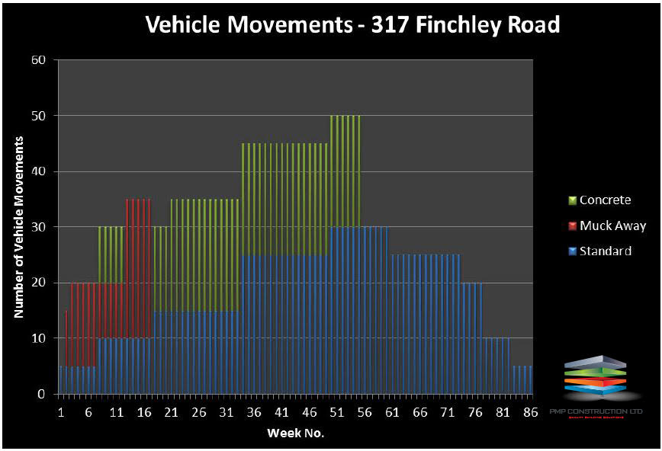

All deliveries to site will be undertaken with full regard paid to:-

• Reduction and control of plant movements

• Reversing vehicles directed by a Competent Person

• Pedestrian and vehicle directional signage – suitable barriers will be erected when deliveries arrive to prevent pedestrians accessing the unloading area.

• Mobile plant will only be operated by a competent person with a banks person in attendance to any movements

Consultation with Camden Council will continue throughout the project to ensure:-

• Construction methods minimise the potential impact on nearby residents

• Maintenance of the existing public highway

• Segregation of all pedestrians, public or employees, on or in the vicinity of the site

b. Please provide details of other developments in the local area or on the route.

We are not aware of any other developments in the local area.

c. Please outline the system that is to be used to ensure that the correct vehicle attends the correct part of site at the correct time.

PMP will endeavour to ensure that all heavy vehicle traffic is limited to times outside the rush hour, namely from 10.00am to 3.30pm on Monday to Friday, and 8.00am to 1.00pm on Saturdays.

PMP will liaise with the other Main Contractors operating in the adjoining roads to ensure, so far as is reasonably practical, that deliveries and other construction operations are coordinated to minimise any negative impact on the residents and users of the roads

Deliveries will be managed on a ‘just-in-time’ basis. Deliveries will be carefully planned, pre-booked and managed on site to ensure no back up of vehicles in Finchley Road or the adjacent roads and timed to minimise disruption to neighbours.

Only one access point will be available and a traffic management operative will be provided to accept deliveries and manage traffic.

d. Please identify the locations of any off-site holding areas (an appropriate location outside the borough may need to be identified, particularly if a large number of delivery vehicles are expected) and any measures that will be taken to ensure the prompt admission of vehicles to site in light of time required for any vehicle/driver compliance checks. Please refer to question 24 if any parking bay suspensions will be required for the holding area.

Bus lane is a red route with no stopping from Mon – Sat 7am – 7pm, except for 30mins at set times.

Transport for London has approved the following traffic management arrangements:

▪ Bus stop repositioned temporarily from directly outside the site to 39 metres north. Please see repositioning diagrams below;

▪ Bus lane temporarily suspended when loading bay in operation;

▪ Loading bay operation:

Monday to Friday – all day except Evening Peak period (3.30pm to 7.00pm)

Saturday and Sunday – 24 hours

Please refer to appended documents in Appendix B.

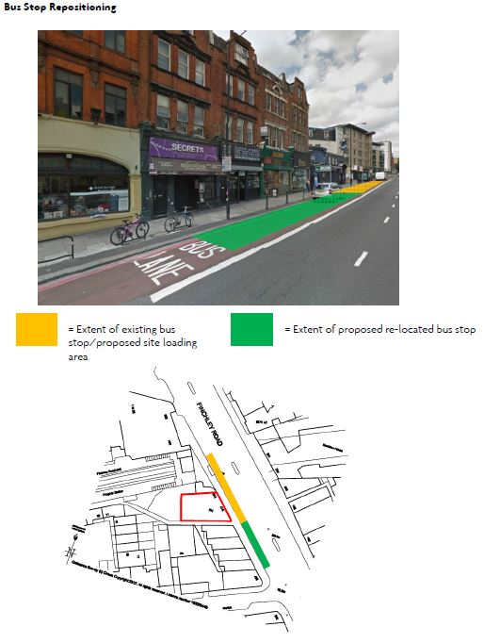



e. Please provide details of any other measures designed to reduce the impact of associated traffic (such as the use of [construction material consolidation centres](https://www.google.co.uk/url?sa=t&rct=j&q=&esrc=s&source=web&cd=2&cad=rja&uact=8&ved=0ahUKEwi5hKjPiLjRAhVqLcAKHQduC_gQFggkMAE&url=http%3A%2F%2Fcontent.tfl.gov.uk%2Fdirectory-london-construction-consolidation-centres.pdf&usg=AFQjCNFhB34aaqw3M3fmDpJYUUBw_PjbdA&sig2=KXhGnTR3slzf0kN4XMOcQg&bvm=bv.143423383,d.ZWM)).

PMP will endeavour to ensure that all heavy vehicle traffic is limited to times outside the rush hour, namely from 10.00am to 3.30pm on Monday to Friday, and 8.00am to 1.00pm on Saturdays.

PMP will liaise with the other Main Contractors operating in the adjoining roads to ensure, so far as is reasonably practical, that deliveries and other construction operations are coordinated to minimise any negative impact on the residents and users of the roads

Deliveries will be managed on a ‘just-in-time’ basis. Deliveries will be carefully planned, pre-booked and managed on site to ensure no back up of vehicles in Finchley Road or the adjacent roads and timed to minimise disruption to neighbours.

Only one access point will be available and a traffic management operative will be provided to accept deliveries and manage traffic.

**22. Site access and egress:** “*Clients shall ensure that access to and egress from the site is appropriately managed, clearly marked, understood and clear of obstacles.”* (P18, 3.4.3)

Vehicles entering and leaving the site should be carefully managed, using gates that are clearly marked and free from obstacles. Traffic marshals must ensure the safe passage of all traffic on the public highway, in particular pedestrians and cyclists, when vehicles are entering and leaving site, particularly if reversing.

Traffic marshals, or site staff acting as traffic marshals, should hold the relevant qualifications required for directing large vehicles when reversing. Marshals should be equipped with ‘STOP – WORKS’ signs (not STOP/GO signs) if control of traffic on the public highway is required. Marshals should have radio contact with one another where necessary.

a. Please detail the proposed access and egress routes to and from the site

Please refer to Site Establishment Plan 2 below.

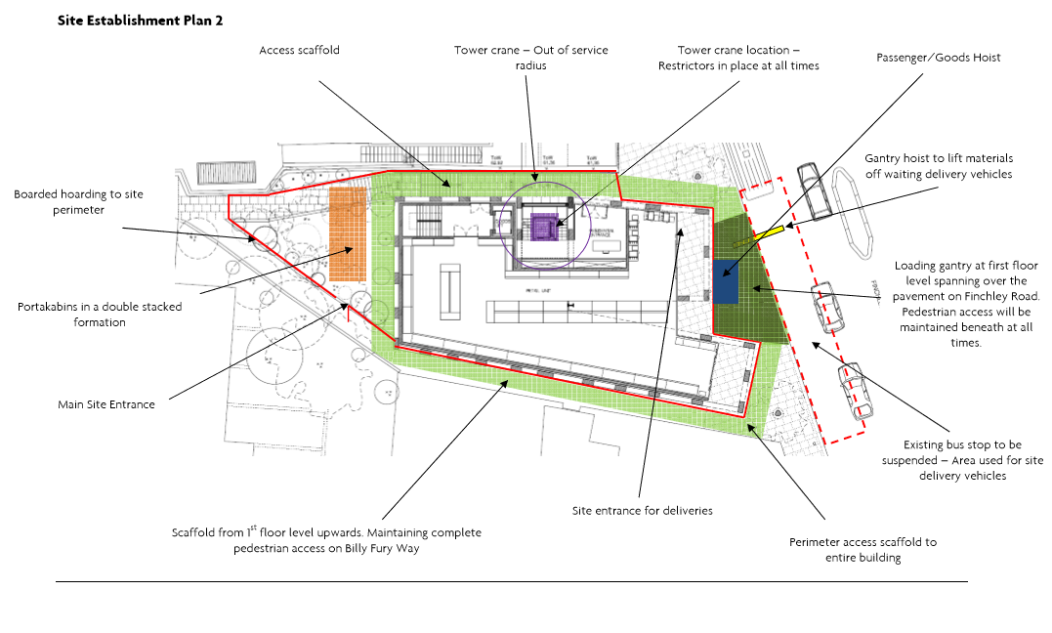

b. Please describe how the access and egress arrangements for construction vehicles will be managed.

Traffic marshals will ensure the safe passage of all traffic on the public highway, in particular pedestrians and cyclists. Traffic marshals, or site staff acting as traffic marshals, will hold the relevant qualifications required for directing large vehicles when reversing. Marshals will be equipped with ‘STOP – WORKS’ signs (not STOP/GO signs) where control of traffic on the public highway is required. Marshals will have radio contact with one another where necessary.

Transport for London has approved the traffic management arrangements and requires:

▪ adequate pedestrian signage to be provided for pedestrian diversion during the works;

▪ a minimum of 1.8 metre footpath to be retained during the works;

▪ banksman to manage traffic during all hours of operation.

Please refer to appended documents in Appendix C.

c. Please provide swept path drawings for any tight manoeuvres on vehicle routes to and from the site including proposed access and egress arrangements at the site boundary (if necessary).

Not applicable.

d. Provision of wheel washing facilities should be considered if necessary. If so, please provide details of how this will be managed and any run-off controlled.

Not anticipated as vehicles cannot access the site compound.

**23. Vehicle loading and unloading:** *“Clients shall ensure that vehicles are loaded and unloaded on-site as far as is practicable.”* (P19, 3.4.4)

If this is not possible, Traffic Marshalls must ensure the safe passage of pedestrians, cyclists and motor traffic in the street when vehicles are being loaded or unloaded.

Please provide details of the parking and loading arrangements for construction vehicles with regard to servicing and deliveries associated with the site (e.g. delivery of materials and plant, removal of excavated material). This is required as a scaled site plan, showing all points of access and where materials, skips and plant will be stored, and how vehicles will access and egress the site. If loading is to take place off site, please identify where this is due to take place and outline the measures you will take to ensure that loading/unloading is carried out safely. Please outline in question 24 if any parking bay suspensions will be required.

It is not possible to load or unload vehicles on-site. Vehicles will use the suspended bus lane, and this will be managed by Traffic Marshalls as previously described.

**Highway interventions**

**Please note that Temporary Traffic Orders (TTOs) and hoarding/scaffolding licenses may be applied for prior to CMP submission but won’t be granted until the CMP is signed-off.**

**If the site is on or adjacent to the TLRN, please provide details of preliminary discussions with Transport for London in the relevant sections below.**

**24. Parking bay suspensions and temporary traffic orders**

Please note, parking bay suspensions should only be requested where absolutely necessary. Parking bay suspensions are permitted for a maximum of 6 months, requirement of exclusive access to a bay for longer than 6 months you will be required to obtain [Temporary Traffic Order (TTO)](http://camden.gov.uk/ccm/content/transport-and-streets/traffic-management/temporary-road-restrictions/) for which there is a separate cost.

Please provide details of any proposed parking bay suspensions and TTO’s which would be required to facilitate construction. **Building materials and equipment must not cause obstructions on the highway as per your Considerate Contractors obligations unless the requisite permissions are secured.**

Information regarding parking suspensions can be found [here.](http://www.camden.gov.uk/ccm/navigation/transport-and-streets/parking/parking-bay-suspensions/)

Three parking spaces are to be suspended for the course of the works and this has been approved by Transport for London.

Please refer to appended documents in Appendix C.

**25. Scaled drawings of highway works**

Please note that use of the public highway for storage, site accommodation or welfare facilities is at the discretion of the Council and is generally not permitted. If you propose such use you must supply full justification, setting out why it is impossible to allocate space on-site. You must submit a detailed (to-scale) plan showing the impact on the public highway that includes the extent of any hoarding, pedestrian routes, parking bay suspensions and remaining road width for vehicle movements. We prefer not to close footways but if this is unavoidable, you should submit a scaled plan of the proposed diversion route showing key dimensions.

a. Please provide accurate scaled drawings of any highway works necessary to enable construction to take place (e.g. construction of temporary vehicular accesses).

Please refer to Site Establishment Plans 1 and 2 below.

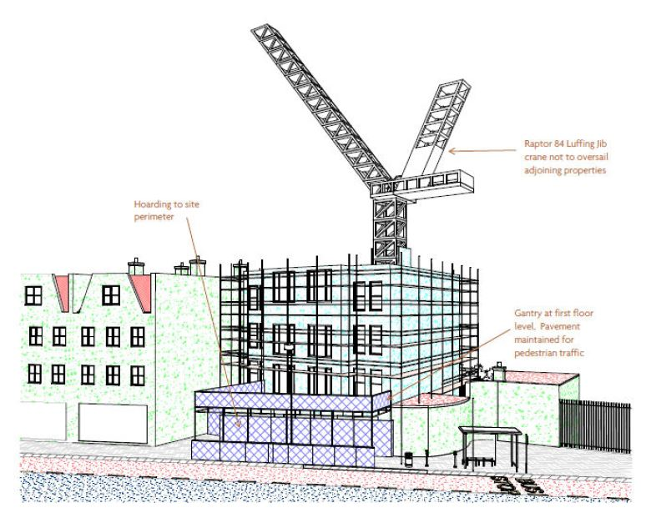



b.Please provide details of all safety signage, barriers and accessibility measures such as ramps and lighting etc.

A secure hoarding will be provided at the site boundary with a lockable access. Appropriate safety signage will be clearly displayed on the Finchley Road frontage and along Billy Fury Way warning of the dangers of the construction site and of any impediments to pedestrian access along the footpaths.

A licence from Transport for London has been obtained for the scaffolding and gantry on the Finchley Road frontage. That part of Billy Fury Way where scaffolding is to be erected is within the property boundary, but safe access will be maintained to neighbouring properties as necessary. Scaffold standards will be protected by Hi-Viz foam sleeves. Solid hoarding panels will be used where the structures are in close proximity to the road with lighting provided.

Lighting and signage will be used on temporary structures, skips, hoardings etc. The adjoining public highway will be kept clean and free from obstructions.

Pedestrian safety will be maintained and vulnerable footway users will be considered. These include wheelchair users, the elderly, those with walking difficulties, young children, those with prams, the blind and partially sighted. Appropriate ramping will be used if cables, hoses, etc. are run across the footway.

**26. Diversions**

Where applicable, please supply details of any diversion, disruption or other anticipated use of the public highway during the construction period (alternatively a plan may be submitted).

Transport for London has approved the following traffic management arrangements:

▪ Bus stop repositioned temporarily from directly outside the site to 39 metres north. Please see repositioning diagrams below;

▪ Bus lane temporarily suspended when loading bay in operation;

▪ Loading bay operation:

Monday to Friday – all day except Evening Peak period (3.30pm to 7.00pm)

Saturday and Sunday – 24 hours

Please refer to appended documents in Appendix C.

**27. VRU and pedestrian diversions, scaffolding and hoarding**

Pedestrians and/or cyclist safety must be maintained if diversions are put in place. Vulnerable footway users should also be considered. These include wheelchair users, the elderly, those with walking difficulties, young children, those with prams, the blind and partially sighted. Appropriate ramping must be used if cables, hoses, etc. are run across the footway.

Any work above ground floor level may require a covered walkway adjacent to the site. A licence must be obtained for scaffolding and gantries. The adjoining public highway must be kept clean and free from obstructions. Lighting and signage should be used on temporary structures/skips/hoardings etc.

A secure hoarding will generally be required at the site boundary with a lockable access.

a. Please provide details describing how pedestrian and cyclist safety will be maintained, including any proposed alternative routes (if necessary), and any Traffic Marshall arrangements.

Routes will be maintained at all times.

During any crossing of the highway, mobile barriers and banksmen will be provided to secure the area and prevent conflict.

The existing Billy Fury Way will be maintained open during the works. Site hoarding and scaffolding will be positioned to allow a clear passage of at least 900mm.

There will be a period of approximately 2 weeks when sheet piling is inserted in Billy Fury Way when the hoarding will at times need to be temporarily removed in sections, as the sheet piling progresses down Billy Fury Way. Traffic Marshalls will be positioned at each end of the passageway during these times to ensure safe passage for the public and for residents

Pedestrian safety will be maintained and vulnerable footway users will be considered. These include wheelchair users, the elderly, those with walking difficulties, young children, those with prams, the blind and partially sighted. Appropriate ramping will be used if necessary.

b. Please provide details of any temporary structures which would overhang the public highway (e.g. scaffolding, gantries, cranes etc.) and details of hoarding requirements or any other occupation of the public highway.

Please see response to query 25a and b. A detailed scaffold drawing is appended.

Please refer to appended documents in Appendix D.

SYMBOL IS FOR INTERNAL USE

# Environment

To answer these sections please refer to the relevant sections of **Camden’s Minimum Requirements for Building Construction (**[**CMRBC**](http://www.camden.gov.uk/ccm/cms-service/download/asset?asset_id=3257318)**).**

28. Please list all [noisy operations](http://www.camden.gov.uk/ccm/content/environment/environmental-health--consumer-protection/noise/reducing-noise/noise-from-construction-sites.en?page=2)  and the construction method used, and provide details of the times that each of these are due to be carried out.

Please refer to the appended Construction Noise, Vibration & Dust Management Plan dated 15 March 2018 prepared by Clement Acoustics for this site, ref 13298-CNMP-01.

Please refer to appended documents in Appendix E.

29. Please confirm when the most recent noise survey was carried out (before any works were carried out) and provide a copy. If a noise survey has not taken place please indicate the date (before any works are being carried out) that the noise survey will be taking place, and agree to provide a copy.

A copy of Philip Acoustic LTD’s noise and vibration survey dated May 2016 is appended.

Please refer to appended documents in Appendix E.

30. Please provide predictions for [noise](http://www.camden.gov.uk/ccm/content/environment/environmental-health--consumer-protection/noise/reducing-noise/noise-from-construction-sites.en?page=2) and vibration levels throughout the proposed works.

Please refer to the appended Construction Noise, Vibration & Dust Management Plan dated 15 March 2018 prepared by Clement Acoustics for this site, ref 13298-CNMP-01.

Please refer to appended documents in Appendix E.

31. Please provide details describing mitigation measures to be incorporated during the construction/[demolition](http://www.camden.gov.uk/ccm/navigation/environment/building-control/demolition/) works to prevent noise and vibration disturbances from the activities on the site, including the actions to be taken in cases where these exceed the predicted levels.

Please refer to the appended Construction Noise, Vibration & Dust Management Plan dated 15 March 2018 prepared by Clement Acoustics for this site, ref 13298-CNMP-01.

Please refer to appended documents in Appendix E.

32. Please provide evidence that staff have been trained on BS 5228:2009

Clement Acoustics will provide on-site training to all of our staff.

33. Please provide details on how dust nuisance arising from dusty activities, on site, will be prevented.

Please refer to the appended Construction Noise, Vibration & Dust Management Plan dated 15 March 2018 prepared by Clement Acoustics for this site, ref 13298-CNMP-01.

Please refer to appended documents in Appendix E.

34. Please provide details describing how any significant amounts of dirt or dust that may be spread onto the public highway will be prevented and/or cleaned.

Please refer to the appended Construction Noise, Vibration & Dust Management Plan dated 15 March 2018 prepared by Clement Acoustics for this site, ref 13298-CNMP-01.

Please refer to appended documents in Appendix E.

35. Please provide details describing arrangements for monitoring of [noise](http://www.camden.gov.uk/ccm/content/environment/environmental-health--consumer-protection/noise/reducing-noise/noise-from-construction-sites.en?page=2), vibration and dust levels.

Please refer to the appended Construction Noise, Vibration & Dust Management Plan dated 15 March 2018 prepared by Clement Acoustics for this site ref 13298-CNMP-01, and the appended Proposed Methodology for Air Quality Monitoring dated 9 August 2017 prepared by Hann Tucker Associates for this site ref HT: 24674 and the appended subsequent emails dated 15.01.2018 and 13.02 2018.

Please refer to appended documents in Appendix E.

36. Please confirm that a Risk Assessment has been undertaken at planning application stage in line with the GLA policy. [The Control of Dust and Emissions During Demolition and Construction 2104 (SPG)](https://www.london.gov.uk/file/18750/download?token=zV3ZKTpP), that the risk level that has been identified, and that the appropriate measures within the GLA mitigation measures checklist have been applied. Please attach the risk assessment and mitigation checklist as an appendix.

A Risk Assessment has been undertaken at planning application stage in line with the GLA policy, the risk level has been identified and the appropriate measures within the GLA mitigation measures checklist have been applied.

Please refer to the appended Air Quality Assessment dated May 2016 prepared by REC Ltd for this site ref AQ100339r5. Mitigation measures checklist is included on page 24.

Please refer to appended documents in Appendix E.

37. Please confirm that all of the GLA’s ‘highly recommended’ measures from the [SPG](https://www.london.gov.uk/file/18750/download?token=zV3ZKTpP) document relative to the level of risk identified in question 36 have been addressed by completing the [GLA mitigation measures checklist.](https://www.london.gov.uk/what-we-do/planning/implementing-london-plan/supplementary-planning-guidance/control-dust-and)

Confirmed.

38. If the site is a ‘High Risk Site’, 4 real time dust monitors will be required. If the site is a ‘Medium Risk Site’, 2 real time dust monitors will be required. The risk assessment must take account of proximity to sensitive receptors (e.g. schools, care homes etc), as detailed in the [SPG](https://www.london.gov.uk/file/18750/download?token=zV3ZKTpP). Please confirm the location, number and specification of the monitors in line with the SPG and confirm that these will be installed 3 months prior to the commencement of works, and that real time data and quarterly reports will be provided to the Council detailing any exceedances of the threshold and measures that were implemented to address these.

Please refer to the appended Proposed Methodology for Air Quality Monitoring dated 9 August 2017 prepared by Hann Tucker Associates for this site ref HT: 24674 and the appended subsequent emails dated 15.01.2018 and 13.02 2018.

Monthly ongoing Airborne Particle Monitoring Reports have been provided to the Council since October 2017.

Please refer to appended documents in Appendix E.

39. Please provide details about how rodents, including [rats](http://www.camden.gov.uk/ccm/content/environment/environmental-health--consumer-protection/pest-control/about-the-pest-control-service.en), will be prevented from spreading out from the site. You are required to provide information about site inspections carried out and present copies of receipts (if work undertaken).

A rodent control specialist registered with the British Pest Control Association (BPCA) has been appointed. Mouse and rat boxes were placed in all areas on 13.02.2018 and there is no evidence of rats or mice being present on the site. Before the demolition work begins the following measures will be undertaken:

▪ Any existing drainage serving the site will be made secure. The interceptors of the existing buildings will be located and checked to ensure that the drains are currently running free and that any interceptor (Rodding Eye) caps are in place. For straight through systems a rat block device will be installed before any work starts.

▪ Where existing drains are not to be used for the new development then these will be cemented and sealed.

▪ Where any additional drainage leading back from the interceptor is left open, the corresponding interceptor interceptor/s will be sealed.

▪ Any rodents found living on the site will be systematically destroyed and/or prevented escaping the site prior commencing the works and during the works.

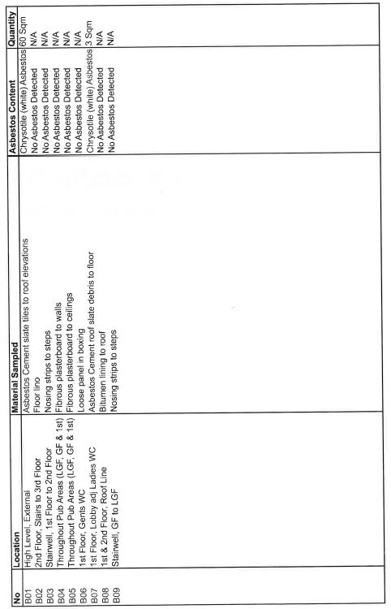

During the works the monitoring for rodents will continue and mouse and rat boxes will be maintained in place so as to ensure that the site is kept free of rodents at all times, so far as is reasonably practicable. Contact details of the specialist pest control company will be kept on site in the event that any termination is required.

The site shall be kept free of food waste as much as possible and wherever practicable, using regular waste removal to reduce the risk of a habitable environment for unwanted rodents/attracting rodents to site (pursuant to Pests Act 1949).

Please refer to appended documents in Appendix F.

40. Please confirm when an asbestos survey was carried out at the site and include the key findings.

Please see snapshot below of key findings taken from the appended Asbestos Survey Report prepared by Airsafe Surveys Ltd dated 27th January 2015.

Please refer to appended documents in Appendix G.

41. Complaints often arise from the conduct of builders in an area. Please confirm steps being taken to minimise this e.g. provision of a suitable smoking area, tackling bad language and unnecessary shouting.

An appropriate area within the site compound behind the office and welfare accommodation will be designated as a smoking area. Smoking will not be permitted anywhere else on site.

As part of our site rules bad language and unnecessary shouting are not tolerated. All site personnel are site inducted and regular toolbox talks are given on site conduct. All personnel are made aware of the requirements and goals set out in the Considerate Constructors Scheme.

42. If you will be using non-road mobile machinery (NRMM) on site with net power between 37kW and 560kW it will be required to meet the standards set out below. The standards are applicable to both variable and constant speed engines and apply for both PM and NOx emissions.

**From 1st September 2015**

**(i) Major Development Sites** – NRMM used on the site of any major development will be required to meet Stage IIIA of EU Directive 97/68/EC

**(ii) Any development site within the Central Activity Zone -** NRMM used on any site within the Central Activity Zone will be required to meet Stage IIIB of EU Directive 97/68/EC

**From 1st September 2020**

**(iii) Any development site -** NRMM used on any site within Greater London will be required to meet Stage IIIB of EU Directive 97/68/EC

**(iv) Any development site within the Central Activity Zone -** NRMM used on any site within the Central Activity Zone will be required to meet Stage IV of EU Directive 97/68/EC

Please provide evidence demonstrating the above requirements will be met by answering the following questions:

1. Construction time period: *04/18 - 04/20*
2. Is the development within the CAZ? (Y/N):  *NO*
3. Will the NRMM with net power between 37kW and 560kW meet the standards outlined above? (Y/N):  *YES*
4. Please provide evidence to demonstrate that all relevant machinery will be registered on the NRMM Register, including the site name under which it has been registered:

*The site is on the NRMM Register ref: 317FinchleyRoad2018*

1. Please confirm that an inventory of all NRMM will be kept on site and that all machinery will be regularly serviced and service logs kept on site for inspection:

*The Site Manager will be responsible for monitoring and record keeping of all machinery on site.*

1. Please confirm that records will be kept on site which details proof of emission limits, including legible photographs of individual engine plates for all equipment, and that this documentation will be made available to local authority officers as required:

*The Site Manager will have the appropriate documents and photographs filed on site.*

SYMBOL IS FOR INTERNAL USE

# Agreement

The agreed contents of this Construction Management Plan must be complied with unless otherwise agreed in writing by the Council. This may require the CMP to be revised by the Developer and reapproved by the Council. The project manager shall work with the Council to review this Construction Management Plan if problems arise in relation to the construction of the development. Any future revised plan must be approved by the Council in writing and complied with thereafter.

It should be noted that any agreed Construction Management Plan does not prejudice further agreements that may be required such as road closures or hoarding licences.

**Please notify that council when you intend to start work on site. Please also notify the council when works are approximately 3 months from completion.**

**Signed:** Christos Pierides

**Date:** 04 April 2018

**Print Name:**  Christos Pierides

**Position:** Director

Please submit to: [planningobligations@camden.gov.uk](mailto:planningobligations@camden.gov.uk)

End of form.