[Historic England](https://historicengland.org.uk/)

* [Menu](https://historicengland.org.uk/listing/the-list/list-entry/1078328)
* [Search](https://historicengland.org.uk/sitesearch)
* [Listing](https://historicengland.org.uk/listing/)
  + [Search the List](https://historicengland.org.uk/listing/the-list/)
  + [Enrich the List](https://historicengland.org.uk/listing/enrich-the-list/)
  + [Apply for Listing](https://historicengland.org.uk/listing/apply-for-listing/)
  + [What is Listing?](https://historicengland.org.uk/listing/what-is-designation/)
  + [Listing Guidance](https://historicengland.org.uk/listing/selection-criteria/)
* [Advice](https://historicengland.org.uk/advice/)
  + [Your Home](https://historicengland.org.uk/advice/your-home/)
  + [Planning](https://historicengland.org.uk/advice/planning/)
  + [Latest Advice & Guidance](https://historicengland.org.uk/advice/latest-guidance/)
  + [Caring for Heritage](https://historicengland.org.uk/advice/caring-for-heritage/)
  + [Technical Guidance](https://historicengland.org.uk/advice/technical-advice/)
  + [Heritage at Risk](https://historicengland.org.uk/advice/heritage-at-risk/)
  + [Constructive Conservation](https://historicengland.org.uk/advice/constructive-conservation/)
  + [Heritage Protection Guide](https://historicengland.org.uk/advice/hpg/)
* [Research](https://historicengland.org.uk/research/)
  + [Our Research Strategy and Agenda](https://historicengland.org.uk/research/agenda/)
  + [Research Methods](https://historicengland.org.uk/research/methods/)
  + [Current Research](https://historicengland.org.uk/research/current/)
  + [Research Results](https://historicengland.org.uk/research/research-results/)
  + [Support & Collaboration](https://historicengland.org.uk/research/support-and-collaboration/)
  + [Inclusive Heritage](https://historicengland.org.uk/research/inclusive-heritage/)
  + [Heritage Counts](https://historicengland.org.uk/research/heritage-counts/)
* [Images & Books](https://historicengland.org.uk/images-books/)
  + [Find Photos](https://historicengland.org.uk/images-books/photos/)
  + [Search All Publications](https://historicengland.org.uk/images-books/publications/)
  + [Buy Books](https://historicengland.org.uk/images-books/books/)
  + [The Historic England Archive](https://historicengland.org.uk/images-books/archive/)
  + [Be an Archive Detective](https://historicengland.org.uk/images-books/archive-mysteries/)
* [Services & Skills](https://historicengland.org.uk/services-skills/)
  + [Education](https://historicengland.org.uk/services-skills/education/)
  + [Grants](https://historicengland.org.uk/services-skills/grants/)
  + [Our Planning Services](https://historicengland.org.uk/services-skills/our-planning-services/)
  + [Training & Skills](https://historicengland.org.uk/services-skills/training-skills/)
  + [Archive Services](https://historicengland.org.uk/services-skills/archive-services/)
  + [Heritage Action Zones](https://historicengland.org.uk/services-skills/heritage-action-zones/)
* [Get Involved](https://historicengland.org.uk/get-involved/)
  + [100 Places](https://historicengland.org.uk/get-involved/100-places/)
  + [Support Us](https://historicengland.org.uk/get-involved/support-us/)
  + [Be a Volunteer](https://historicengland.org.uk/get-involved/volunteer/)
  + [Visit Your Heritage](https://historicengland.org.uk/get-involved/visit/)
  + [Protect Your Heritage](https://historicengland.org.uk/get-involved/protect/)
  + [Help Write History](https://historicengland.org.uk/get-involved/help-write-history/)
  + [Angel Awards](https://historicengland.org.uk/get-involved/angel-awards/)
* [What's New](https://historicengland.org.uk/whats-new/)
  + [News](https://historicengland.org.uk/whats-new/news/)
  + [In Your Area](https://historicengland.org.uk/whats-new/in-your-area/)
  + [Latest Listings](https://historicengland.org.uk/whats-new/listing/)
  + [Latest Research](https://historicengland.org.uk/whats-new/research/)
  + [Heritage Online Debate](https://historicengland.org.uk/whats-new/debate/)
  + [Statements](https://historicengland.org.uk/whats-new/statements/)
  + [Stay Up To Date](https://historicengland.org.uk/whats-new/stay-up-to-date/)
  + [50 Years of Conservation Areas](https://historicengland.org.uk/whats-new/conservation-areas-50-years/)
  + [First World War Centenary](https://historicengland.org.uk/whats-new/first-world-war-home-front/)
  + [What We Do](https://historicengland.org.uk/about/what-we-do/)
  + [Who We Are](https://historicengland.org.uk/about/who-we-are/)
  + [Jobs](https://historicengland.org.uk/about/jobs/)
  + [Contact Us](https://historicengland.org.uk/about/contact-us/)
  + [Volunteer with Historic England](https://historicengland.org.uk/about/volunteering/)
  + [Website Terms and Conditions](https://historicengland.org.uk/terms/website-terms-conditions/)
  + [Privacy and Cookies Policy](https://historicengland.org.uk/terms/privacy-cookies/)
  + [Links Policy](https://historicengland.org.uk/terms/links-policy/)
  + [Historic England Blog and Social: House Rules](https://historicengland.org.uk/terms/blog-house-rules/)
  + [Photo Competition Terms and Conditions](https://historicengland.org.uk/terms/photo-competition-terms-conditions/)
  + [Angel Awards 2017 Voting Terms and Conditions](https://historicengland.org.uk/terms/angel-awards-voting-terms-and-conditions/)
* [Home](https://historicengland.org.uk/)
* [...](https://historicengland.org.uk/listing/the-list/list-entry/1078328)
* [Listing](https://historicengland.org.uk/listing/)
* [Search the List](https://historicengland.org.uk/listing/the-list/)
* List Entry

[This browser is not fully supported](https://www.historicengland.org.uk/access/) by Historic England. Please update your browser to the latest version so that you get the best from our website.

We use cookies to give you the best possible experience online. By using this website, you consent to cookies being used in accordance with our [Cookie Policy](https://historicengland.org.uk/terms/).

* + [Map Search](https://historicengland.org.uk/listing/the-list/map/)
  + [Advanced Search](https://historicengland.org.uk/listing/the-list/advanced/)
  + [Minor Amendments](https://historicengland.org.uk/listing/the-list/minor-amendments/)
  + [Download Listing Data](https://historicengland.org.uk/listing/the-list/data-downloads/)
  + [Non-Listed Sites](https://historicengland.org.uk/listing/the-list/non-listed-sites/)
  + [About The List](https://historicengland.org.uk/listing/the-list/about-the-list/)
  + [Enrich the List](https://historicengland.org.uk/listing/the-list/enrich/)
  + [Understanding List Entries](https://historicengland.org.uk/listing/the-list/understanding-list-entries/)

**KINGS CROSS STATION**

**List Entry Summary**

This building is listed under the Planning (Listed Buildings and Conservation Areas) Act 1990 as amended for its special architectural or historic interest.

Name: KINGS CROSS STATION

List entry Number: 1078328

**Location**

KINGS CROSS STATION, EUSTON ROAD

The building may lie within the boundary of more than one authority.

County: Greater London Authority

District: Camden

District Type: London Borough

Parish:

National Park: Not applicable to this List entry.

Grade: I

Date first listed: 10-Jun-1954

Date of most recent amendment: Not applicable to this List entry.

**Legacy System Information**

The contents of this record have been generated from a legacy data system.

Legacy System: LBS

UID: 477247

**Asset Groupings**

This list entry does not comprise part of an Asset Grouping. Asset Groupings are not part of the official record but are added later for information.

**List entry Description**

**Summary of Building**

Legacy Record - This information may be included in the List Entry Details.

**Reasons for Designation**

Legacy Record - This information may be included in the List Entry Details.

**History**

Legacy Record - This information may be included in the List Entry Details.

**Details**

CAMDEN  
  
TQ3083SW EUSTON ROAD 798-1/85/420 (North side) 10/06/54 King's Cross Station   
  
GV I   
  
Railway terminus. 1850-52. By Lewis Cubitt (architect), and Sir William and Joseph Cubitt (engineers). Yellow stock brick. 2 train sheds (originally 1 for arrivals, the other for departure) closed by monumental plain brick screen of 2 glazed semicircular openings, framed with recessed arches (echoing the train sheds behind) with central and flanking towers; ground storey obscured by late C20 additions. Central tower with rectangular clock turret with pyramidical roof, eaves cornice and weather vane. To the west, 3 storey 3 window office block with booking hall and service rooms at rear; 1st floor with thin, debased Venetian windows, cornice at 2nd floor level, 2nd floor segmental-arched sashes (flanking bays tripartite), cornice. On east side, an extension with archway to the cab drive (now bricked up); rusticated surround to arch and quoins; cornice above which 3 tripartite sashes and parapet. INTERIOR: train sheds separated by round-arched brick colonnade. Originally, train shed roofs of laminated wood, inspired by the Crystal Palace, but these rapidly deteriorated and were replaced by the present iron-ribbed roofs to the eastern shed 1869-70, to the western 1886-7. (Laminated wood trusses successfully used at 26 Pancras Road (qv). HISTORICAL NOTE: when opened as the terminus of the Great Northern Railway, was the largest station in England and is the earliest great London terminus still intact. The contrast of its functional simplicity with St Pancras Station next door (qv) is powerful. (Hunter M and Thorne R: Change at King's Cross: London: -1990: 59-64).   
  
  
  
  
  
Listing NGR: TQ3026983130

**Selected Sources**

**Books and journals**  
Hunter, M, Thorne, R, Change at Kings Cross, (1990), 59-64

National Grid Reference: TQ 30269 83130

**Map**

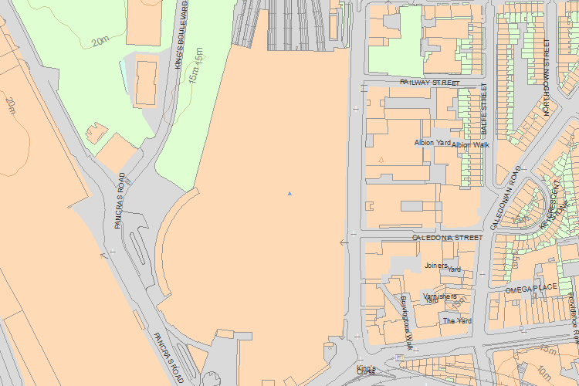© Crown Copyright and database right 2018. All rights reserved. Ordnance Survey Licence number 100024900.  
© British Crown and SeaZone Solutions Limited 2018. All rights reserved. Licence number 102006.006.  
Use of this data is subject to [Terms and Conditions](https://historicengland.org.uk/terms/website-terms-conditions/).

The above map is for quick reference purposes only and may not be to scale. For a copy of the full scale map, please see the attached PDF - [1078328 .pdf](http://mapservices.HistoricEngland.org.uk/printwebservicehle/StatutoryPrint.svc/79137/HLE_A4L_Grade%7CHLE_A3L_Grade.pdf)

The PDF will be generated from our live systems and may take a few minutes to download depending on how busy our servers are. We apologise for this delay.

This copy shows the entry on 14-May-2018 at 12:31:37.

End of official listing