Exterior Sensor Lighting

There will be 3x exterior sensor lights as shown on the diagram and be positioned 8 feet from the ground.

OVERVIEW

Luceco Slimline 22W 5000K LED PIR Floodlight - Black

Die cast aluminium LED floodlight

Average life expectancy 30,000 hours

IP65 rated (PIR IP44 rated)

Directional PIR sensor with 10 metre detection zone

Light level before activation adjustable and time-on adjustable

PIR has a manual override for when not required

Pre-wired with 1 metre cable

Slimline design

Size: H 135 x W 125 x D 130mm

SPECIFICATION

|  |  |
| --- | --- |
| Colour | Black |
| Colour Temperature | 5000 |
| Description | With PIR |
| Dimmable | No |
| Finish | Black |
| IP Rating | IP65 |
| Lumens | 1800 |
| PIR | Yes |
| Sensor Type | PIR |
| Type | With PIR Sensor |
| Voltage | 240 |
| Wattage | 22 |

IMAGE

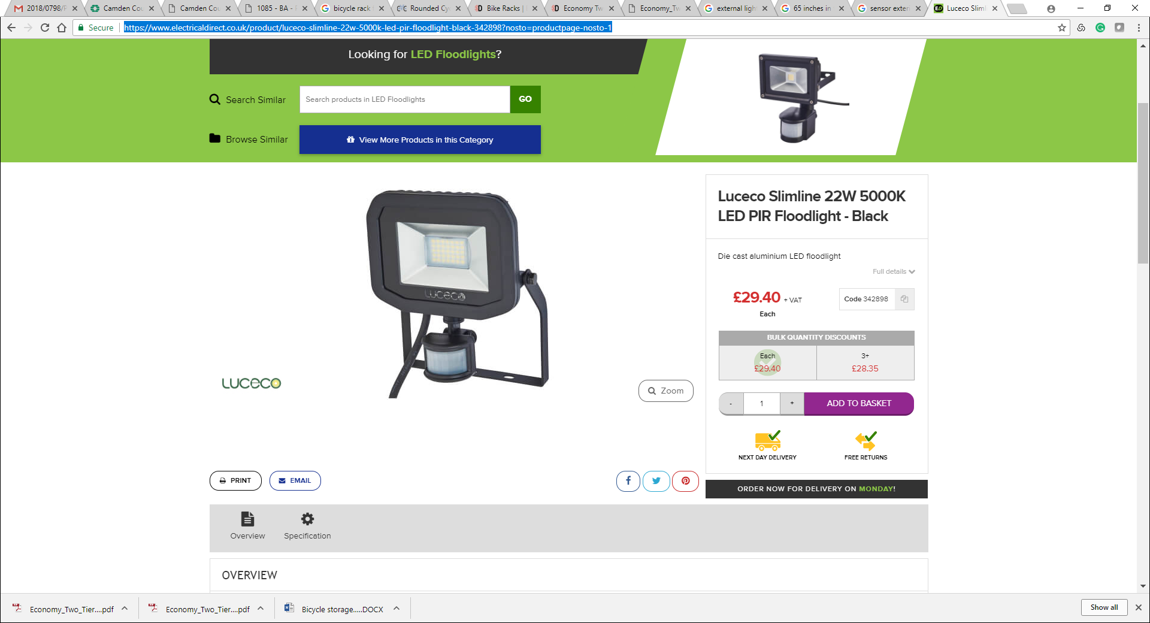

<https://www.electricaldirect.co.uk/product/luceco-slimline-22w-5000k-led-pir-floodlight-black-342898?nosto=productpage-nosto-1>

Interior Sensor Lighting

OVERVIEW  
Round LED ceiling light Bulkhead with sensor

The Bulkhead LED ceiling light offers very cost-effective illumination of corridors, hallways and entrance areas, as the LED lighting technology requires just 8 watts of electricity to create a light output of 550 lumens. A day/night sensor and motion sensor ensure that the light only switches on when it is dark and movement is detected.

SPECIFICATION

|  |  |
| --- | --- |
| Material | plastic |
| Colour | white |
| Luminous colour | cool white (4,000 K) |
| Light bulb | LED 8 W in total |
| Height | 5,6 cm |
| Diameter | 17,6 cm |
| Light output | 550 lm |
| Total luminous flux | 550 |
| Supply voltage in volts | 230 |
| IP code | IP54 |
| Protection class | II |
| Light bulb included | Yes |
| Energy efficiency class | A+ |

IMAGE

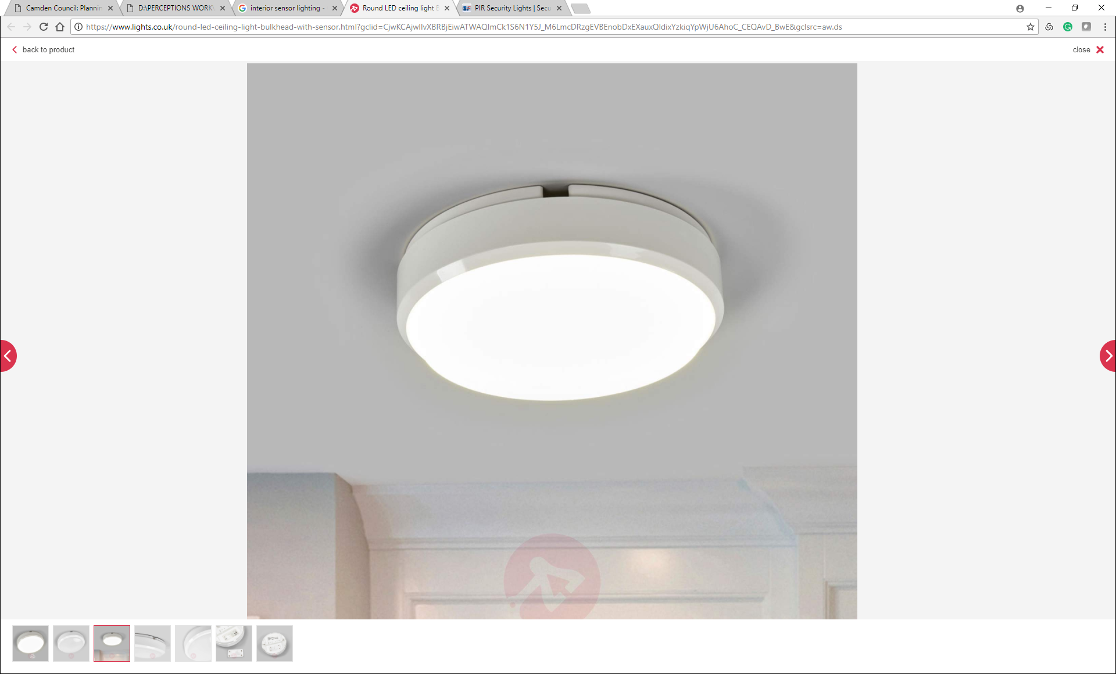

https://www.lights.co.uk/round-led-ceiling-light-bulkhead-with-sensor.html?gclid=CjwKCAjwlIvXBRBjEiwATWAQImCk1S6N1Y5J_M6LmcDRzgEVBEnobDxEXauxQldixYzkiqYpWjU6AhoC_CEQAvD_BwE&gclsrc=aw.ds