LONDON BOROUGH OF CAMDEN
PLANNING

CONSERVATION AND URBAN DESIGN
Proposed Development at: Flat 8
21 John Street
London
WC1N 2BF
Proposal:  Roof extension at 8th floor level to provide additional living space for existing residential flat at 7th floor level. |  | Case No:  2018/0509/P  2018/1110/L
Case Officer: Robert Lester |  | Date:  12th April 2018
 |  | Conservation Area | Y
 |  | Listed Building | Y
 |  | Adjoining Listed Building | Y
 |  | TPO
 |  | Local Design Policy

OBSERVATIONS:

Policy
The building is within the Bloomsbury conservation area, forms part of a grade II listed building and affects the setting of a grade Il listed buildings and terraces.

Special regard has been attached to the desirability of preserving the special interest of the listed building under s.16 of the Listed Buildings and Conservation Areas Act 1990 as amended by the Enterprise and Regulatory Reform Act (ERR) 2013 as well as the setting of the adjoining listed building under section 66 and preserving and enhancing the character and appearance of the Hampstead Conservation Area under 72 of the Listed Buildings and Conservation Areas Act 1990 as amended by the Enterprise and Regulatory Reform Act (ERR) 2013.

The site's planning history was taken into account when coming to this decision.

The proposal has been against policies D1 and D2 London Borough of Camden Local Plan; Camden design guidance and the Bloomsbury Conservation Area Appraisal and Management Strategy.

The proposed has also been assessed against policy 3.5; 5.3 and 7.8 of the London Plan 2016, and paragraphs 14, 17 and 126-141 of the National Planning Policy Framework.

Site
The site is located on the west side of John Street, Roger Street and Doughty mews within the Bloomsbury conservation area.

The building is grade II listed. It was built in the 1930 and is an attractive deco style missed use development. Its significance largely comprises one of the first missed used developments including office, residential and a public house.

The building is comprises 4 story block of flats along Doughty mews, 3 storey pub on the corner of doughty mews and roger street and the tall 8 storey commercial block fronting John Street.
The upper 6 floors were converted to residential accommodation in 2012.

The building contains a small brick built service and lift overrun structure on the roof which has limited visibility other than long views north and south and is particularly apparent anent from Mecklenburgh Square and its environ.

A roof terrace to the roof was granted permission as part of the recent change of use. However, only part of the roof was to be used with the terrace set back from the edge of the roof to reduce the view and impact of the balustrading (refer approved plan below).

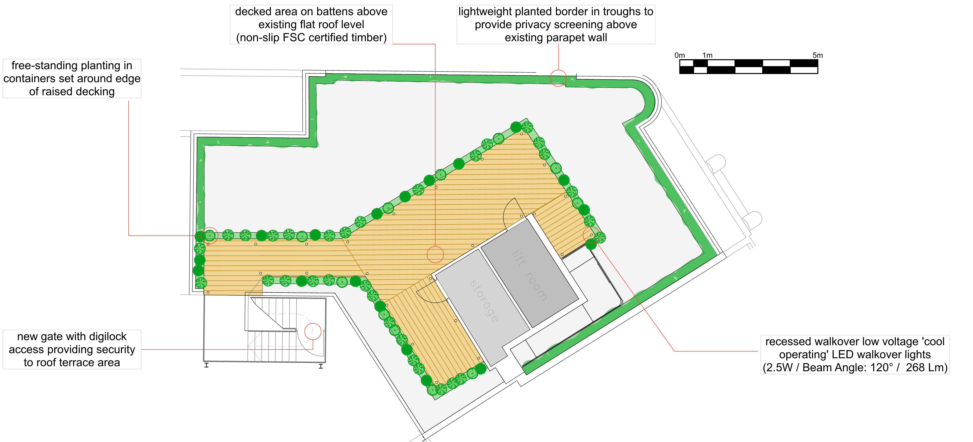

The ‘as-built’ arrangement has a terrace covering the whole of the roof with reed matting or similar around the perimeter of the roof edge. This is not lawful and cannot be taken into account when considering the impact of the roof extension. In my view it has a bearing on the assessment of the proposed scheme because when seen in long views the screening created by the terrace enclosure reduces the refined ‘brim’ of the existing roof and adds to the existing perceived clutter on the roof.

Impact

The building is already the tallest in John Street which predominantly contains a strict pattern of listed Georgian townhouse of consistent scale and height. This forms part of its important character. The host listed host building is the only building which punctures the general height and does so with a style and elegance expected of a building of national importance.

Camden guidance states that building already taller than their neighbours are not normally appropriate for roof extensions. Moreover the building already has a terminating floor which is more glazed than the façade below, is set in and has an attractive soffit. Camden guidance states that where a building has already been terminating floor it is not normally appropriate to add additional floors. In this regard the proposal contradicts Camden guidance.

Design
The design, particularly when compared to the previous proposal, does respond to the architectural language and detailing found on the existing building however the existing building has been designed as a set piece which terminates successfully and elegantly at roof level.
The proposed additional unit would be add additional bulk and less refinement at roof level.

Visibility
The extension would be visible from the public realm and upper floors of neighbouring properties. It would also be highly visible in long view north and south along John Street. These views are specifically mentioned in the Bloomsbury CAAMS as important.

The extension, which would extend above the height of the existing roof structure and would extend westward filling the majority of the roof space. It would be prominent in the long range views and add undue dominance and to an otherwise low and quiet roofscape and skyline. This is considered to be at odds with the street, which comprises almost entirely listed buildings.

The extension is considered unnecessary and undesirable and would diminish the original architectural expression, form and scale of the listed building as well as harm the setting of the adjoining and adjacent listed Georgian townhouse’s

The fact a structure already exists at roof level is not considered to be justification for the proposed works. It is small and positioned to be concealed as far as possible. It is also designed not to draw attention to its presence. Any additional structure would push the terrace to the outer edge of the roof and result in a more prominent balustrade and screening resulting in a more the building appearing more prominent in the street.

Considerable weight and importance should be placed on any harm caused to the heritage assets set out above.

Harm vs public benefit

Harm is caused to the architectural integrity of the host building due to the form and design of the extension. Harm is also caused to the setting of the adjoining listed building by drawing undue attention to the building in long important views when the established and largely unbroken roofscape and skyline of the Georgian terrace street should be the dominant characteristic. This would also result in harm to the character and appearance of the conservation area.

The creation of 1 additional small residential unit is not considered to outweigh the identified harm to heritage assets

Conclusion
The prominence of the discordant element with regard height and original scale and composition of the building is considered to harm the special character and significance of the listed building.

The prominence of the additional storey with particular regard to the height of the existing building and the importance of the identified conservation area views is considered to result in harm to the character and appearance of the conservation area.

The additional height and prominence of the roofscape is considered to cause harm to the setting of the adjacent groups of listed terraces townhouses

Consideration has been given to any public benefit or other conservation benefits which may outweigh the harm caused. However it this instance with proposal does not provide any public benefit. No new residential units are created and the fact that existing unit is good quality and above the residential housing standards

Enforcement action should be taken to remove the matting and reduce the roof terrace subsequent to the decision of this application.

Recommendation
Refuse the scheme and enforce against the unauthorised roof terrace and screening

Negotiate
Approve
Refuse | Y

C Rose
Signed----------------------------------------------------------------------------- Date-------------------------------

