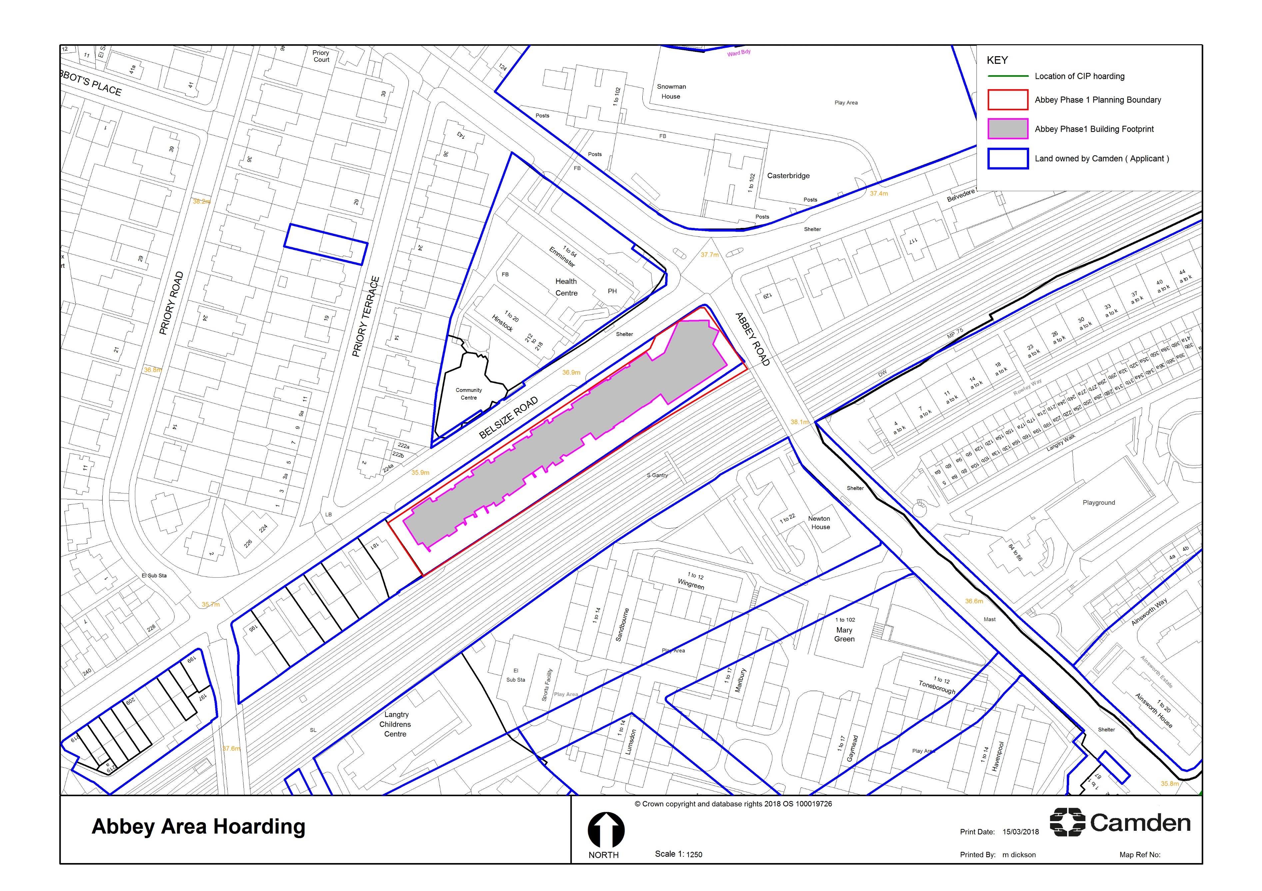

SALES HOARDING

CIP HOARDING