Dear Sirs

**Re- Application** [**29 Dartmouth Park Road NW5 1SU**](https://maps.google.com/?q=Dartmouth+Park+Road____+__%C2%A0__+_29+Dartmouth+Park+Road+NW5+1SU_&entry=gmail&source=g) **-****2018/1318/P**

Please find below our general comments on the application followed by our planning based objections.

* 1. There is missing and inaccurate information in the application. Again the scheme omits drawings that would show the impact on the surrounding properties. As this is a conservation area the side elevation from Bellgate Mews is a key view not provided, the top of the roof will be 4.1m from the ground level of the mews this will have an adverse impact on the streetscape; it is particularly dominant due to the set back of the gardens from 31. This would give a feeling of overbearing in the mews. The site/location plans have been clipped at this point we argue to hide the full impact of the proposal. The applicant proposes covering the walls in planting to perhaps camouflage the structure, even ignoring the obvious maintenance and well-being of the plants in this position; the issue here is the building is elevated above the ground so it will not be viewed against other planting but against the sky thus no amount of “Dad’s Army” camouflage will mask the shape of the building against the sky. The application does not contain a full design and access statement. The application shows a trellis on top of the wall we attach a photograph from last year; the existing wall is 2.75m high as such the raising of it with the trellis would require consent. So there would need to be an application for this work. The light and shadow shown on the drawing is in summer at noon. The key impact of overshadowing will be in the other seasons late in the day as the scheme blocks the western light.
  2. As the previous application last year the title of the application is disingenuous, the proposal is referred to as shed this is clearly considerably more than a shed, when we look at the plan the internal space is designated as a playroom. The previous application again referred to the scheme as a shed initially, and then the applicant added further information when an objection raised the possibility of it being used as a separate unit in attempting to counter that point making it clear the use of the room was ancillary space to the main house. This would bring activities that would generate noise and other disruption within 5m of habitable rooms in the mews behind. The other point to make is that this potential nuisance would be at the same level as the bedrooms of the mews properties. The additional information provided in the last application also stated there would be no insulation in the structure which again would mean increased noise transfer, even though this is a minor point as due to the windows and doors airborne noise from whatever activities were to take place would be carried to the habitable areas of the mews houses. We understand why someone would want a playroom away from their own living areas even though this is a house in excess of 300 square metres over 4+ floors but to move it adjacent to others residential properties is less than neighbourly.
  3. The proposal is in conflict with Camden’s policy and guidance notes. If we refer to Camden’s UDP/Framework document we find in a conservation area in 2.1.7 we find the following; “Rear garden shed/greenhouse in a conservation area exceeding 10 cubic metres shall be treated as an extension for the house. This is clearly a garden room that will be use as part of the house with the potential for a variety of uses; it is located less than 5m from the windows of residential buildings in the mews at the level of the bedrooms.
  4. The foundation solution/protection of trees in the conservation area. As per the previous foundation solution this is not appropriate to the site conditions; the plan form of the building shows a cut out for the tree which is very tight to the trunk. This presents a number of potential problems that have not been identified or addressed in the tree report. The tree is not a single straight trunk but 2 separate ones the one to the house side spreading at an 75deg angle we doubt if there would be sufficient space for the tree to move in the wind or to take account of future growth, the roof of the new structure will also divert water away from the roots placing the viability of the tree at risk in periods of low rain fall. The foundation solution relies on 400mm deep holes to be dug and would need to follow the perimeter of the structure or have an element of canter lever to the structural base if this were not possible. With respect to the first point in the area of the cut out next to the trunk the roots will be very dense in this area as such the method statement stated in the application could not be followed. We would expect the roots to be close to surface and the exact location and size should be established in order to make an informed comment on the impact on the tree which should be checked by the council’s experts. If there is the need to cantilever then it will dramatically increase in thickness of the base which could only be accommodated by raising the height of the building. We would argue that there would also need to be a gap under the base to take account of heave and to give air flow to migrate against rot, thus the height would not be as shown. The intrusive nature of the foundation proposal so close to the root bowl would put the tree at risk and we suspect the end goal is the complete removal of the tree. The exact thickness of the base is a material consideration as it will directly relate to the eventual height and it is in no one’s interest to have to revisit this matter during construction.
  5. The proposal will have an adverse impact on the daylighting to the ground floor habitable rooms in the mews. In particular the late afternoon outside the summer months when the light level are lower thus will have a material effect on daylighting to these rooms.
  6. Omitted information, we have provided the missing elevation and a photograph of the wall from December 2017 showing the wall from the mews without trellis. It is also worth noting the section through the mews omits to show the bedrooms that sit forward of the building in the terrace zone with opening Velux style windows.

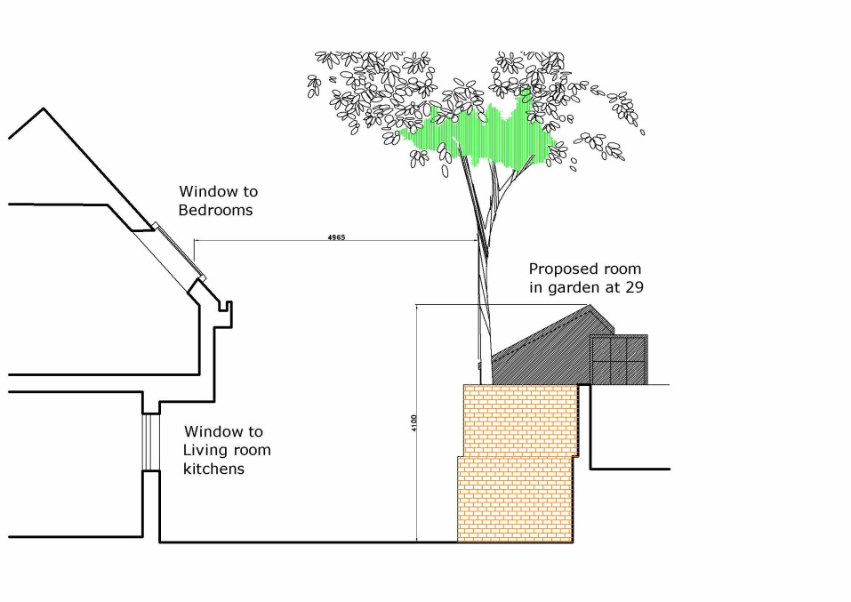

**Figure 1** Elevation from Bellgate Mews looking southwest.

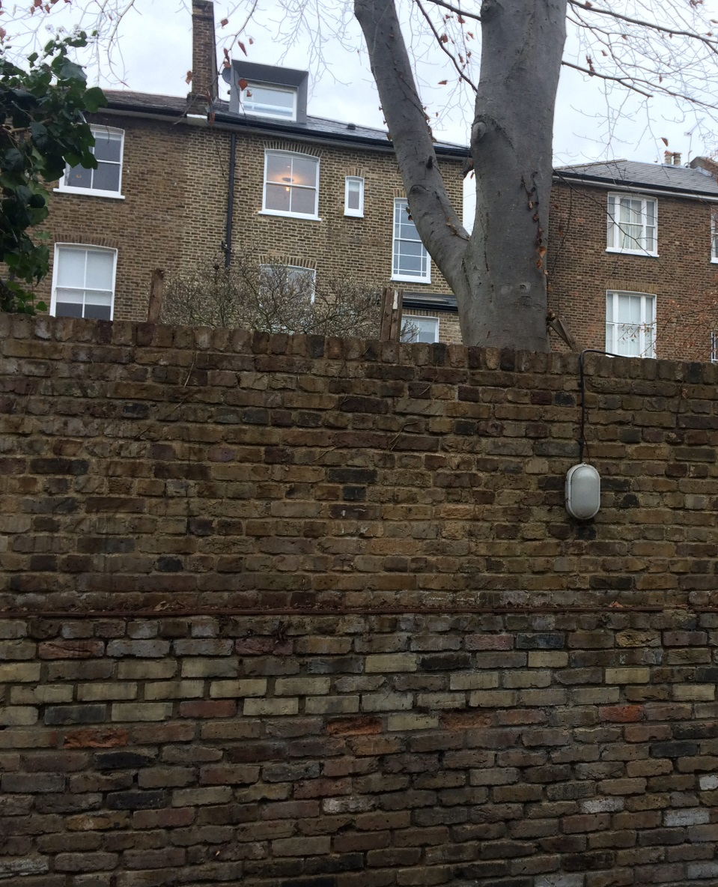

**Figure 2** Photograph of the garden wall December 2017.

**2.0 The built reality compared to the drawn proposal. Again with the limited information on the drawing assumptions have to be made, these are made with a justification given.**

* 1. The raft or base appears to be 100mm deep (estimated in the absence of a section) this is shown bearing directly on the ground this cannot be the case for a number of reasons the structure would remain damp and rot, also this does not allow for seasonal movement or heave of the roots thus the reality would be this would be a suspended structure as such the thickness would need to increase and again due the limited headroom in the building the roof would have to increase in height. If as we suspect areas need to be cantilevered this would substantially increase the depth further and thus add to the problem.
  2. The proposal states a planted roof will be used but again this would mean there will drainage and a soil layer we assert this would be 100mm minimum, there would need to be a water proofing membrane protective layer and deck we argue would add a further 30mm. Even though the span is only around 3m the dead load would be high due the construction as such we would expect the structural depth to be around 250mm. When this build up is compared to the dimensions on the drawing (ref to the elevation) the actual internal ceiling height would not work. It is clear the purpose of the room is some of sort of party, music, hobby office space this ceiling height would not be suitable for these purposes thus we would expect the as-built to migrate higher during the construction. This would place Camden in a difficult position as enforcement would be both costly for the residents of Camden plus could result in a case brought against Camden by the residents of Bellgate Mews if infractions were let go, neither of which is in the communities interest.

1. **Planning considerations.**

3.1 Size bulk and scale. The proposal although drawn as a building at the end of a residential garden in fact sits in an elevated position (ground level 1.5m above street level in mews) directly in front of habitable room windows. The massing and scale will produce an oppressive and an overbearing sense of enclose to the front of the houses and in the mews.

3.2 Loss of light to residential properties. One would need a daylight study to quantify this but there will be loss of light, to the lower rooms and the public areas in Bellgate Mews. In particular after 3pm where the SW light would be blocked by the proposed structure.

3.3 Noise and environmental nuisance. It is clear that the building is not a shed due to its size and fenestration despite the head description. The likely use by the applicant or subsequent residents of 29 as a play room or other purposes would both increase the activity and noise at the end of their garden. This is within 5m and at the same level as the bedrooms of the residential properties in the mews their right of privacy and quiet enjoyment of their home will be affected.

3.4 Risk to trees and landscape which provide a positive contribution to the Conservation Areas. These trees are not just at the bottom of a private garden but are principle landscape features within the mews.

3.5 Detriment to the street scape of Bellgate Mews and the conservation area as a whole. The design of the building in an elevated position at the end of the mews harms the Conservation Areas by it form, materials used, its’ scale and location.

3.6 Risk of precedent. Granting of such a scheme would set a dangerous precedent which would be used by the other houses in the road to adversely affect the environmental quality of the residents of Bellgate Mews and similar locations.

We would ask the Authority to consider the above comments and would urge that this application and any further variations be refused.

Yours faithfully

Bellgate Mews residents association.