Enforcement Delegated Report |  |  |  |  | Receipt date:
Officer |  |  |  | Enforcement Case
John Sheehy |  |  |  | EN18/0177
Breach Address |  |  |  | Photos & Other material
1a Highgate Road
London NW5 1JY
PO 3/4 | Area Team Signature |  | C&UD | Authorised Officer Signature
 |  |  |  | 5th April 2018

Alleged Breach
Construction of a residential development providing 13 residential units.
Recommendation: |  | Issue an Enforcement Notice Requiring Cessation of Residential Use

Priority:

Site Description
This backland site to the west of Highgate Road contains a building which is currently under construction. This replaces a previous warehouse, demolished in Summer 2017, and last used as a piano factory and warehouse. The authorised planning use of the site is Class B8 Storage and Distribution.

The replacement building occupies the same footprint as the piano warehouse, covering most of the site. It seeks to match the external appearance of the warehouse building. When completed, it will be two storeys in height and finished in brick with clay roof tiles.

The site is accessed via a narrow cobbled alleyway leading from Highgate Road which passes between the Bull and Gate public house and 1 Highgate Road, the last house of a 4-storey residential terrace 1-7 Highgate Road (all listed Grade II). Access is also possible through Murphy’s builders yard to the north/ rear.

The site is not located in a Conservation Area and the previous warehouse building was not listed.

Planning and Investigation History
Planning History

April 2015 Planning permission for demolition of existing warehouse buildings (Class B8) and redevelopment to provide 5 dwelling houses (2 x 2-bed and 3 x 3-bed) and a two storey office building
(Class B1), with associated landscaping, refuse and recycling storage, and cycle parking was refused on loss of amenity to neighbours (light, outlook, privacy). ref. 2014/1689/P.

February 2016 GPDO Prior Approval Class P Change of use of B8 to C3- Change of use from warehouse (Class B8) to 16 x residential units (Class C3) - refused on insufficient evidence and lack of S106, ref. 2016/0091/P.

June 2016 GPDO Prior Approval Class P Change of use of B8 to C3 - Change of use from warehouse (Class B8) to 11 self-contained residential units (Class C3) granted subject to S106 and conditions, ref. 2016/2279/P.

November 2016 Application to discharge details required by conditions 2 (noise assessment), 3 (sound insulation), 4 (building vibration levels), 5 (contamination assessment), 6 (contamination investigation), 8 (cycle storage) and 9 (drainage strategy) – granted, ref. 2016/4862/P.

November 2016 GDPO prior approval granted subject to S106 Legal Agreement for change of use from warehouse (Class B8) to 13 self-contained residential units (Class C3), ref. 2016/5336/P.

The legal agreement secured the following:

- Car-free housing;
- Construction Management Plan and Implementation Contribution, discharged on 10-3-2017;
- Highways Contribution, discharged on 1-1-2017; and
- Level Plans, outstanding.

December 2016 Planning application for alterations to roof and elevations of building, including changes to roof profiles, new rooflights, new doors and windows in front and rear elevations, plus new paving and fencing in front entrance courtyard – granted, ref. 2016/4663/P.

November 2017 Permission granted for variation of condition 4 (development in accordance with approved plans) of planning permission ref 2016/4663/P dated 20.12.16 (for Alterations to roof and elevations of warehouse building (Class B8), including changes to roof profiles, new rooflights, new doors and windows in front and rear elevations, plus new paving and fencing in front entrance courtyard), namely to allow further design alterations to roof, facades, fenestration and courtyard, ref. 2017/3428/P.

******************

Investigation history

July 2017 Complaint received and enforcement case opened.

During the investigation there has been regular correspondence between enforcement officers and the planning agent.

Officers have visited both the site and neighbouring properties at regular intervals.

The Council has monitored the site and gathered the following information:

- Planning history – a series of applications for residential redevelopment of the site have been submitted in the recent past, for planning permission and GPDO prior approval;
- Correspondence – since the complaint was received, officers have requested an explanation about the works that are taking place. The agent has not denied that a residential development is under construction;
- On site works – the internal subdivision of spaces under construction matches the drawings submitted with 2016/5336/P and makes it clear that a residential development is being constructed rather than works to a warehouse;
- The concrete floor of the original warehouse building has been excavated and a new concrete floor has been poured at a lower level, approximately 0.5m below the previous level;
- Thirteen self-contained residential units have been registered with the Royal Mail for this address under the name Hurley Apartments;
- A website for the development states that the developer is IDM Properties: http://www.idmproperties.com/property/hurleyapartmentsnw5/. On this site the development is described as being “all sold”;
- The following are available to view online at the above website: apartment floorplans; apartment specifications; a marketing brochure; information on the local area; distances to local transport connections; local transport; local amenities; details of the design team; and information about the development company.
The works are ongoing and are not yet finished. Nevertheless, based on the information that has been gathered there is a clear intention on the part of the developer to provide thirteen self-contained residential units at the site.
The construction of this residential development is in breach of planning control for the reasons set out below. Although occupation has not taken place it is expedient to issue an enforcement notice at this stage because of the overwhelming evidence that a breach of planning control is in the process of taking place and rectification of the breach would be much more difficult to secure if the building was occupied.
The planning agent has been advised that an enforcement notice will be issued.

Relevant policies / GPDO Category
Camden Local Plan 2017
A1 Managing the Impact of Development
A2 Open Space
A4 Noise and Vibration
D1 Design
D2 Heritage
H1 Maximising Housing Supply
H4 Maximising the Supply of Affordable Housing
H6 Housing choice and Mix
H7 Large and Small Homes
C2 Community Facilities
T1 Prioritising Walking, Cycling and Public Transport
T2 Parking and Car Free Development
CC1 Climate Change Mitigation
CC2 Adapting to Climate Change
CC3 Water and Flooding
CC4 Air Quality
CC5 Waste

Camden Planning Guidance (CPG)
CPG 1 Design 2015
CPG 2 Housing 2015
- Draft Interim Housing CPG 2017
CPG 3 Sustainability 2015
CPG 6 Amenity 2011
- Draft Amenity CPG 2017
CPG 7 Transport 2011
CPG 8 Planning obligations 2015

National Planning Policy Framework 2012
Draft National Planning Policy Framework 2018

London Plan 2016
Mayor London Housing Supplementary Planning Guidance 2016

General Permitted Development Order Class P

Assessment
The following works have been carried out:
- The original warehouse building has been demolished;
- A new building has been erected at the site.
- This is over a similar footprint to the original and of similar scale, with the ground floor lowered by approximately 0.5m compared to the previous piano warehouse building.
The owner is seeking to rely on the permitted development rights set out in Part P of the GPDO which permit warehouse buildings to be occupied as residential units.
Permitted development is allowed by Part P on the following basis:
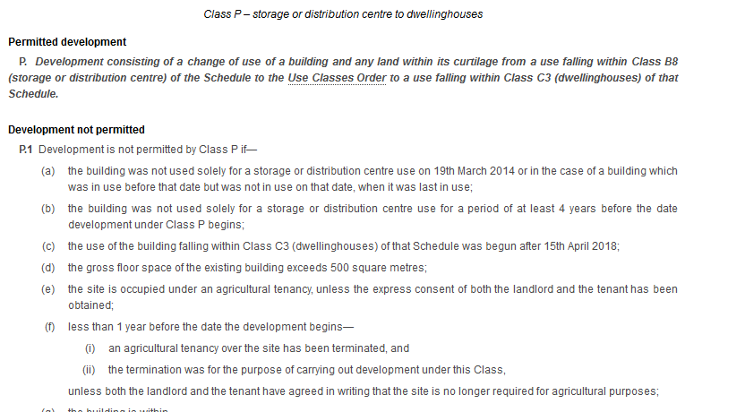
At the site, the change of use to residential units is not permitted development under Part P for the following reasons:
- Part P (a) refers to ‘the building’, meaning the existing building, i.e. the piano warehouse building which has been demolished;

- The new building, not being the same warehouse building, is no longer a storage or distribution centre and does not meet Class P conditions (a) & (b) requiring the building to be in prior use as a distribution centre;

- Section 55 (1A) of the Town and Country Planning Act lists demolition and rebuilding as development, (2) (a) (ii) states that works of repair and maintenance and works that does not materially affect the external appearance of the building is not development requiring planning permission;

- The removal of all the external walls of the warehouse and the excavation and lowering of the floor goes far beyond works of repair and maintenance and the rebuilding works in themselves require planning permission under S55(1)(A)b;

- The replacement building incorporates the works granted under 2016/4663/P and 2017/3428/P. Otherwise, it is similar in appearance to the original warehouse, but not identical. The roof lanterns are marginally wider and higher and the facing materials do not have the patina and colour of the warehouse. There is a material difference in appearance between the original building and the incomplete replacement.

In building out this scheme, the owner would appear to be relying on the GPDO Prior Approval application 2016/5336/P, approved in November 2016.
Most of the Legal Agreement requirements attached to this Prior Approval have been discharged. However, the Council’s position is that 2016/5336/P has not been implemented because the works fall outside the scope of permitted development. They fail to fulfil the criteria of Part P and full planning permission is required.
A series of planning obligations generated by 2016/5336/P were secured by Legal Agreement. These include financial requirements which have been discharged, with contributions paid. Because the Council’s position is that this GPDO scheme has not been implemented, these contributions will need to be returned. This matter will be dealt with separately.
****************
Officers have assessed the works that have been carried out against adopted planning policies and guidance.
The failure to comply with a number of policy areas establishes a list of reasons for issuing an Enforcement Notice which is set out below.
Steps to rectify the breach and a timeframe are also set out at the end of the report below.
Reasons
Housing mix
The development provides a mix of twelve 1-bedroom flats and one 2-bedroom flat. This does not represent a diverse range of housing to cater for the spectrum of need as required by policy H6. The development will not provide a range of homes of different sizes that will contribute to creation of mixed, inclusive and sustainable communities or match housing need.
The works fail to comply with policy H6; this is a reason for issuing the Enforcement Notice.
Housing Quality/ Internal Amenity
The Council’s Supplementary Planning Guidance 2015 and 2017 (draft) on Housing set out key principles and standards that would be expected to be achieved within residential developments.
The development is accordingly assessed against these standards:
- Sunlight, daylight, outlook: adequate levels of sunlight, daylight and outlook should be provided in order to ensure the amenity of future occupiers. However, units, nos. 11, 12 and 13 do not provide any aspect, and the only natural light in these units is provided by rooflights;
- Dual Aspect: Camden Planning Guidance states that a good proportion of the units in a development should be dual aspect. None of the units in this development meet this criterion;
- Space Standards: many of the one-bedroom units would appear to be two-person properties. The Nationally Described Space Standards set out the minimum internal floorspace for 2-person units over two storeys as 58sqm.
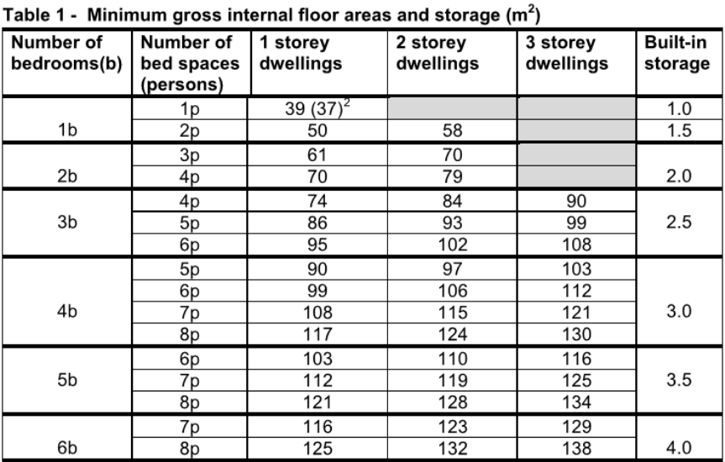
The following units are below this minimum floor area:
Apartment 2 | 42.8sqm | Apartment 12 | 41.1sqm
Apartment 5 | 44.6sqm | Apartment 13 | 40.6sqm
Apartment 11 | 47.0sqm

- Space Standards: the failure to meet minimum space standards results in residential units of an unacceptable quality;
- External Space: open space should be provided on-site at a rate of 9sqm per occupant in order to comply with Policy A2. The only open space provided as part of this development is a terrace of circa 5sqm to flat 10. As a result the development is in breach of Policy A2;
- Storage: a minimum area of 1.5sqm of storage is required by the Nationally Described Space Standards. There are no identified areas of storage provided within the units;
- Circulation space: the Council Housing SPG recognises the importance of quality circulation spaces and seeks to ensure there is no excessive corridor length or wasted space. At this development the ground floor contains two long narrow corridors which are completely dependent on artificial light for illumination.
The general layout of the units is unacceptable as it fails to provide residential spaces of an acceptable standard. This is in breach of Policy A1 and A2 of the Camden Local Plan as well as Camden and London-wide housing guidance.
The poor quality of accommodation provided is a reason for issuing the Enforcement Notice. The failure to provide an acceptable level of external open space is a further reason for issuing the Notice.
Neighbour amenity
The first floor terrace of Flat 10 would provide views deep into the rear rooms of the facing residential terrace 1-7 Highgate Road. These are from a short distance (6.0m approx.); they directly face each other and, as a result, open up a view that causes a loss of privacy to occupiers of the residential terrace and in particular to occupiers of 1 Highgate Road.
Privacy screens around the terrace would be incongruous in this location in terms of visual appearance. The terrace would be visible from Highgate Road and would not integrate with this light industrial style building in design terms. As a result, the development results in a loss of privacy for neighbours, in breach of policy A1.
The proposal results in a marginal loss of sunlight/ daylight to neighbouring occupiers. A report was prepared for GPDO application 2016/5336/P which demonstrated compliance with sunlight/ daylight standards for a very similar building envelope. While the works deviate from those assessed in terms of sunlight and daylight, the differences are slight and based on the similarity between the 2016/5336/P layout and the current works, it would not be reasonable to issue an Enforcement Notice against the works for loss of sunlight/ daylight to neighbours.
The loss of privacy to neighbouring occupiers is in breach of Policy A1 and is a reason for issuing the Enforcement Notice.
Affordable Housing
Policy H4 Maximising the Supply of Affordable Supply states that the Council will expect a contribution to affordable housing from all developments that provide one or more additional homes and involve a total residential Gross Internal Area of 100sqm or more.
This development of 13 units triggers the requirement and the failure to provide affordable housing as part of the development is in breach of policy H4. As a result, this is a reason for issuing the Enforcement Notice.
Wheelchair Housing

Policy H6 Housing Choice and Mix requires 10% of new build self-contained housing in each development to be suitable for occupation by a wheelchair user or easily adaptable for wheelchair occupation.

This is a new build scheme of self-contained housing. In order to be acceptable it needs to satisfy the 10% wheelchair housing policy requirement, however this requirement is not satisfied by the works.
The failure to provide the required quantum of wheelchair housing is in breach of Policy H6 and is a reason for issuing the Enforcement Notice.
Community Infrastructure Levy (CIL)

If the proposal was deemed to be acceptable it would be liable for both Mayoral CIL and Camden CIL.

This would be calculated based on the floor area of the building and would be subject to verification by the Council’s CIL team.

Transport
In the case of a scheme at the site that was acceptable in planning terms, the Council would seek to enter into a Legal Agreement with the owner to secure car-free housing, a construction management plan, a highways contribution and level plans.
It is recognised that several of these requirements have been secured under 2016/5336/P, however the Council’s position is that this scheme has not been implemented.

The failure to secure car-free housing and a highways contribution as part of an approved planning scheme is a reason for issuing the Enforcement Notice.

There is no reason to issue the Notice for failure to secure a Construction Management Plan via a planning permission. This is because the works at the site are almost completed it would not be a justifiable reason to issue the Notice.

The London Plan Cycle Parking Standards, which apply in Camden, require one space per studio or one-bedroom unit and two spaces for all other units. This development generates a total requirement for 14 spaces. In the proposed drawings 9 spaces are proposed. As a result, the development fails to provide the required quantum of cycle parking and is in breach of policy T1.

The failure to provide the required number of cycle parking spaces as part of the development is a reason for issuing the Enforcement Notice.

Resources and Energy

Policy CC1 (Climate Change Mitigation) states that the Council will require development to incorporate sustainable design and construction measures. All developments are expected to reduce their carbon dioxide emissions by following the steps in the energy hierarchy (be lean, be clean and be green) to reduce energy consumption.

A sustainability statement should show how the development will implement sustainable design principles.

An energy statement should show how the development would follow the hierarchy of energy efficiency, decentralised energy and renewable energy technologies set out in the London Plan Chapter 5 (particularly Policy 5.2) to secure a minimum 19% reduction in regulated CO2 emissions below the maximum threshold allowed under Part L 2013.

In line with the Camden Local Plan and CPG requirements, all new residential schemes of five or more units are expected to achieve a 20% reduction in carbon dioxide emissions from on-site renewable energy generation. Schemes of 5 units or more are expected to optimise resource efficiency particularly with regard to embodied carbon. Likewise, all developments are required to incorporate water efficiency measures.

None of the above requirements have been secured as part of the development.

The failure to incorporate sustainable design and construction measures into the development is a reason for issuing the Enforcement Notice.

Contaminated Land

Prior to the development the site was completely hard surfaced both inside and outside the building; the ground level was a concrete floor.

This has been excavated by approximately 0.5m.

A Contamination report dated December 2015, submitted with 2016/5336/P states that the risk of any contamination is likely to be low. However, the site is located on a former Welding and Engineering Works which are considered to be at medium to high risk of ground contamination. In addition, the floor level has been lowered, into an area of the site that may have contamination.

Were an application for the site acceptable, a condition would be attached requiring submission of a scheme of assessment, site investigation and remediation scheme.

In the absence of such a scheme the works are unacceptable in the context of Policy A1.

Flooding and Drainage

The site lies within Flood Risk Zone 1 (low risk) and does not fall within one of Camden’s Local Flood Risk Zones. The immediate development site is not in an area identified in Camden’s Strategic Flood Risk Assessment as being at risk of surface water flooding and therefore the site itself is not at risk from flooding. However the Strategic Flood Risk Assessment maps indicate high risk of surface water flooding south of the site. There has been a history of flooding in nearby streets, and the floor level of the site has been lowered by approximately 0.5m.

The development should reduce run-off in order to reduce downstream impacts and flood risk to nearby properties. Thames Water, in response to Prior Approval applications, was concerned at potential additional strains imposed on existing drainage and sewage infrastructure. A condition was imposed requiring a drainage strategy to be submitted and approved before development takes place.

The failure to address flood risk and to incorporate attenuation measures into the development is a reason for issuing the Enforcement Notice.

*****************
Conclusion
The works do not fulfil the criteria required by Part P; they fall outside the scope of permitted development and would need planning permission, which would not be granted.
While the residential development has not been occupied, the evidence gathered during investigations strongly indicates that this will take place in the short term.
An enforcement notice will require the premises to not be used for residential purposes.
The authorised planning use is Class B8 Storage and Distribution. The recently implemented subdivided layout with internal walls and a first floor level may be a limiting factor for the property’s authorised use. Nevertheless, as these are internal works, planning permission would not be needed in the future to remove these subdivisions.
***
In addition to the above points, enforcement action is required in this case because the Council does not consider that it is appropriate to permit this development to proceed without planning permission. Local authorities have an administrative duty to control development in the public interest, particularly where the development conflicts with Development Plan policy, has impacts that require mitigation in accordance with the provisions of the Development Plan and which gives rise to collection of the Council's Community Infrastructure Levy (CIL).

The National Planning Policy Framework advises (at paragraph 207) that, “effective enforcement is important as a means of maintaining public confidence in the planning system”. The Commissioner for Local Administration (the local ombudsman) has held, in a number of investigated cases, that there is “maladministration” if the local planning authority fails to take enforcement action which is plainly necessary.

In deciding whether it is expedient to take enforcement action the Council must have regard to the provisions of the Development Plan and to any other material considerations.

The Planning Practice Guidance advises that:

"Effective enforcement is important to:

•tackle breaches of planning control which would otherwise have unacceptable impact on the amenity of the area;

•maintain the integrity of the decision-making process;

•help ensure that public acceptance of the decision-making process is maintained.

Paragraph: 005 Reference ID: 17b-005-20140306
Recommendation: that the Borough Solicitor be instructed to issue an Enforcement Notice under Section 172 of the Town & Country Planning Act 1990 as amended to secure the cessation of the unauthorised use as 13 residential flats and to pursue any legal action necessary to secure compliance. Officers be authorised in the event of non-compliance to prosecute under section 179 or appropriate power and/or take direct action under 178 in order to secure the cessation of the breach of planning control.
The notice shall allege the following breaches of planning control: Construction of a residential development providing 13 residential units.

WHAT ARE YOU REQUIRED TO DO:
- Permanently cease the use of the building for residential purposes.
PERIOD OF COMPLIANCE: three months.
REASONS WHY THE COUNCIL CONSIDER IT EXPEDIENT TO ISSUE THE NOTICE:
- The development, by reason of the small proportion of family sized units in the residential mix and the over-provision of one-bedroom units, fails to contribute to the creation of mixed and inclusive communities, contrary to policy H6 (Housing Choice and Mix) of the London Borough of Camden Local Plan 2017.
- A number of the residential units, by reason of their poor internal space levels, the poor quality of their outlook, daylight and sunlight, and their single-aspect design, provide sub-standard accommodation which would be harmful to the amenities of future occupiers and contrary to policies D1 (Design) and A1 (Managing the Impact of Development on Occupiers and Neighbours) of the London Borough of Camden Local Plan 2017.
- The development provides sub-standard levels of external amenity space within site. The failure to make adequate provision for external amenity space is likely to be harmful to the amenities of future occupiers and is contrary to policy A2 (Open Space) of the London Borough of Camden Local Plan 2017
- The private terrace at first floor level would result in overlooking to residential occupiers of 1 Highgate Road result in a loss of privacy to the detriment of the amenity of residents of this property. This is contrary to policy A1 (Managing the Impact of Development on Occupiers and Neighbours) of the London Borough of Camden Local Plan 2017.
- The development, by reason of the failure to provide affordable housing fails to maximise the contribution of the site to the supply of affordable housing in the borough. As such it is contrary to policy H4 (Maximising the Supply of Affordable Housing) of the London Borough of Camden Local Plan 2017.
- The development, by reason of not providing 10% of the units in accordance with wheelchair housing standards, fails to give access to a range of housing types suitable for people with mobility difficulties, contrary to policy H6 (Housing Choice and Mix) of the London Borough of Camden Local Plan 2017.
- The development, by reason of the failure to provide contributions towards public highway works and public realm and environmental improvements, is likely to harm the borough's transport and public realm infrastructure and to fail to contribute to the promotion of sustainable pedestrian and cycling movements. This is contrary to policy T1 (Prioritising Walking, Cycling and Public Transport) of the London Borough of Camden Local Plan 2017.
- The development, in the absence of a legal agreement to secure a car-free development, is likely to contribute unacceptably to parking stress and congestion in the surrounding area, contrary to policy T2 (Parking and Car Free Development) of the London Borough of Camden Local Plan 2017
- The development, by reason of the unsatisfactory amount of cycle parking provided, would discourage the ownership and use of cycles as a sustainable form of transport, contrary to policy T1 (Prioritising Walking, Cycling and Public Transport) of the London Borough of Camden Local Plan 2017.
- The development, in the absence of evidence that it has incorporated sustainable design and construction principles, including water efficiency measures, fails to ensure proper standards of sustainability in the development, contrary to policies CC1 (Climate Change Mitigation) and CC2 (Adapting to Climate Change) of the London Borough of Camden Local Plan 2017.

- The development, in the absence of evidence that it has carried out appropriate investigations and remedial measures for contaminated land, fails to protect future occupiers of the development from the possible presence of ground contamination at the site, contrary to policy A1 (Managing the Impact of Development on Occupiers and Neighbours) of the London Borough of Camden Local Plan 2017.

