**Commentary on proposal 2017/6978/P**

The site, 152 Royal College Street, is located within Camden Broadway Conservation Area. The map below shows the boundaries of the conservation area, and highlights the adjacent building (no 154) as a 'positive building'.

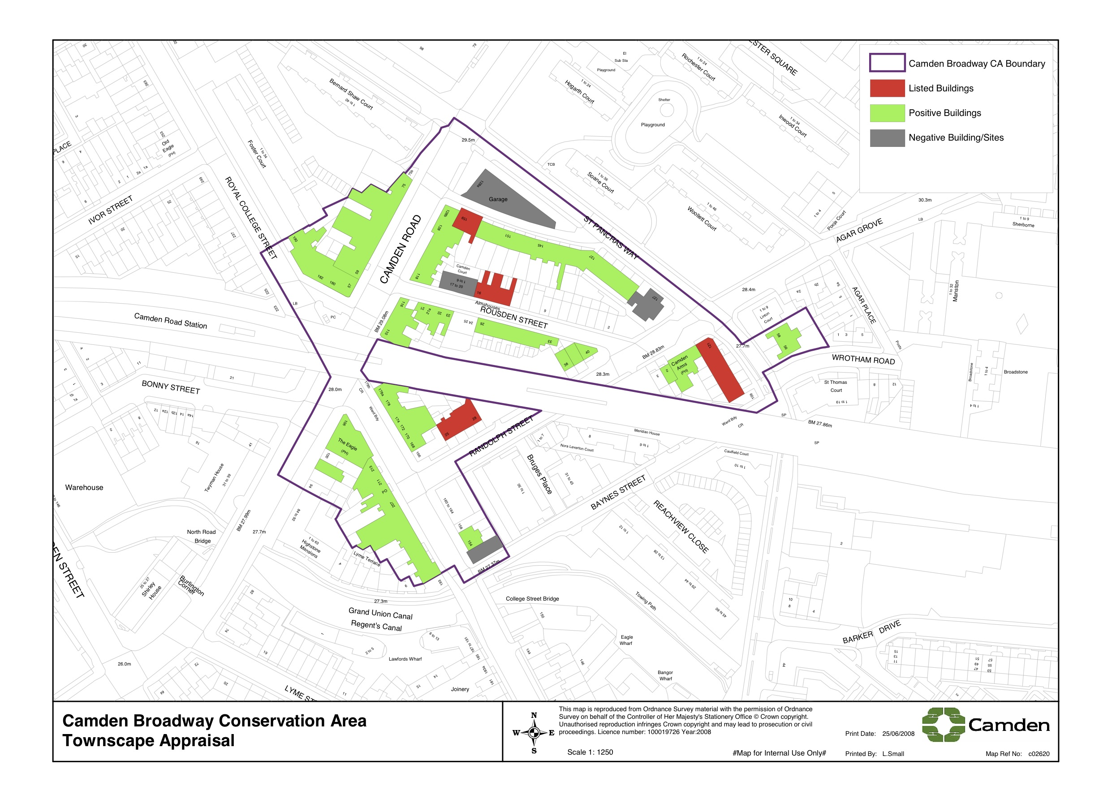

**Conservation Area Appraisal and Management Strategy**

The adjacent building on Royal College Street (no 154) has been designated under "BUILDINGS WHICH MAKE A POSITIVE CONTRIBUTION" and "HISTORIC SHOPFRONTS".

Royal College Street and Camden Road were laid out in c.1820 and, with the exception of the north side of Camden Road, a map of 1832 shows that the conservation area’s street pattern and built environment was complete by that date. The whole of the area bounded by Randolph Street, St Pancras Way, Camden Road and Royal College Street was built by 1832, giving the area a distinct architectural unity.

The Appraisal and Management Strategy places significant emphasis on the importance of well-designed shopfronts within the conservation area:

*“Shopfronts are an important element in the character of the commercial part of the Camden Broadway Conservation Area.*

*The installation of a new shopfront, shutters or grilles or other alterations to the shopfront will need planning permission. Poorly designed shopfronts detract from the character and appearance of the*

*conservation area, and the Council expects the quality, design and materials of new shopfronts to respond sensitively to their historic setting.*

*Detailed guidance on shopfronts can be found in section 43 of Camden’s Supplementary Planning Guidance, which is available on the Council’s website.”*

**Proposal - General Design Quality**

The applicant presented the revised designs at our CAAC meeting in January. Since our members decided not to object to the previous proposal ([2015/4396/P](http://planningrecords.camden.gov.uk/Northgate/PlanningExplorer17/Generic/StdDetails.aspx?PT=Planning%20Applications%20On-Line&TYPE=PL/PlanningPK.xml&PARAM0=411837&XSLT=/Northgate/PlanningExplorer17/SiteFiles/Skins/Camden/xslt/PL/PLDetails.xslt&FT=Planning%20Application%20Details&PUBLIC=Y&XMLSIDE=/Northgate/PlanningExplorer17/SiteFiles/Skins/Camden/Menus/PL.xml&DAURI=PLANNING)), they decided not to comment on aspects of the application that hadn't fundamentally changed, but resolved to submit the below concerns as comment.

**Proposal - Ground floor unit**

Members concerns focussed on the ground floor and any associated railing outside the ground floor facade. They welcomed the labelling of the ground floor unit as live/ work, however as the application description refers to a residential unit the resulting ambiguity of the ground floor use remains our main concern.

Within the context of the local centre around Camden Broadway, and in particularly in the context of recent improvements within the retail along this stretch of Royal College Street, our members felt that this prominent corner should be given over to an active commercial use. To ensure the viability of such a use, the ground floor facade must not be obscured by any railings.

Members agreed to not object to this planning application on the basis of two key aspects safeguarded in the form of conditions:

* Commercial use of the ground floor and presentation of an active ground floor frontage, i.e. retail use;
* No blind glazing, curtains or other associated device obstructing views through the ground floor street and corner window into the the ground floor
* no railing outside the ground floor, to ensure accessibility and attractiveness of commercial ground floor unit and also to ensure this important corner is appropriately expressed in streetscape terms. Members felt a railing would also create a visibility issue from Baynes St.