**Demolition Management**

**Plan**

**pro forma** v2.2

**Contents**

**Revisions 3**

**Introduction 4**

**Timeframe 6**

**Contact** **7**

**Site** **9**

**Community liaison** **12**

**Transport** **15**

**Environment** **25**

**Agreement**  **30**

# Revisions & additional material

Please list all iterations here:

|  |  |  |
| --- | --- | --- |
| **14.12.17** | **A** | **AB – Minor Amendments** |
| **20.12.17** | **B** | **AB – Incorporating Tibbalds Comments** |
| **15.03.18** | **C** | **AB – New Format and Additional Information** |
|  |  |  |

**Additional sheets**

Please note – the review process will be quicker if these are submitted as Word documents or searchable PDFs.

|  |  |  |
| --- | --- | --- |
| **Date** | **Version** | **Produced by** |
|  |  |  |

# Introduction

The purpose of the **Demolition Management Plan (DMP)** is to help to minimise demolition impacts and relates to both on site activity and the transport arrangements for vehicles servicing the site.

It is intended to be a live document whereby different stages will be completed and submitted for application as the development progresses.

The DMP will address the way in which any impacts associated with the proposed works, and any cumulative impacts of other nearby construction sites, will be mitigated and managed.

All works will be carried out in an environmentally responsible manner to meet the best practice guidelines as described in [Transport for London’s](https://www.tfl.gov.uk/info-for/freight/safety-and-the-environment/improving-construction-safety) (TfL’s Standard for [Construction Logistics and Community Safety](http://www.clocs.org.uk/standard-for-clocs/) (**CLOCS**) scheme) and [Camden’s Minimum Requirements for Building Construction](http://www.camden.gov.uk/ccm/cms-service/download/asset?asset_id=3257318) **(CMRBC)** and to minimise disruption to the surrounded businesses, residents, visitors and members of the public.

The DMP will be kept on site available for inspection at the request of an Authorised Officer of LB Camden. The approved contents of this DMP will be complied with unless otherwise agreed with the Council in writing. The project manager shall work with the Council to review this DMP if problems arise in relation to the demolition works associated with the development. Any future revised plan must also be approved by the Council and complied with thereafter.

It should be noted that any agreed DMPdoes not prejudice or override the need to obtain any separate consents or approvals such as for road closures or hoarding licences.

If your scheme involves any demolition, you need to make an application to the Council’s Building Control Service. Please complete the “[**Demolition Notice**](http://www.camden.gov.uk/ccm/content/environment/building-control/file-storage-items/demolition-notice---the-building-act-1984-section-80-notice-bc104-.en)**.**”

The developer agrees to contact the council when works are intended to start work on site. They will also notify the council when works are approximately **3 months from completion.**

(Note the term 'vehicles' used in this document refers to all vehicles associated with the implementation of the development, e.g. demolition, site clearance, delivery of plant & materials, construction, etc.)

Revisions to this document may take place periodically.Timeframe

**DEVELOPER ACTIONS**

**COUNCIL ACTIONS**

**Post app submission**

**0ommunity liaison**

**Appoint principal contractor**

**Requirement to submit CMP**

**Begin community liaison**

**Council response to second draft**

**Work can commence if draft CMP is approved**

**Resubmission of CMP if first draft refused**

**2ommunity liaison**

**3ommunity liaison**

**1ommunity liaison**

INDICATIVE TIMEFRAME (MONTHS)

**4ommunity liaison**

**Council response to draft**

**Submit draft CMP**

# Contact

**1. Please provide the full postal address of the site and the planning reference relating to the construction works.**

**Address:** The project situated at former 32-33 Liddell Road, London, NW6 2EW

**Planning reference number to which the DMP applies:** 2014/7651/P

**2. Please provide contact details for the person responsible for submitting the DMP.**

**Management Responsibilities**

**Director:**

**Name:** TBC on appointment of Main Contractorand submission of CMP

**Telephone Number:**

*Responsibilities*

Has overall responsibility for all project related risks on site. He will ensure that any reasonable request for additional resources to reduce the risk of l impacts are provided at the request of the Contracts Manager / Project Manager.

**Contracts Manager / Project Manager Name:**

**Name:** TBC on appointment of Main Contractorand submission of CMP **Telephone Number:**

*Responsibilities*

The Contracts Manager/Project Manager shall be responsible for ensuring compliance with local environmental legislation i.e. dust risk assessment and registering all non-mobile plant with the relevant online register. The contracts manager will also be responsible for the ongoing monitoring recording and auditing of hazardous issues identified within this plan i.e. noise, dust, vibration. It is his responsibility to ensure that all environmental issues are planned and managed prior to, and during the construction phase.

**3. Please provide full contact details of the site project manager responsible for day-to-day management of the works and dealing with any complaints from local residents and businesses.**

**Site Manager / Site Foreman**

**Name:** TBC on appointment of Main Contractorand submission of CMP

**Telephone Number:**

*Responsibilities*

The Site Manager will be present on site at all times during the construction period to manage any incidents on a day to day basis. The Site Manager must also ensure that all staff and contractors receive the required training and information. He will also be responsible for implementing and monitoring the requirements of the Demolition Plan. The Site Manager will also be responsible for liaising with local residents and other stakeholders.

**Employees and Contractors**

*Responsibilities*

To work in a safe manner that does not create site risks. Follow tool box talks and the company health and safety and environmental standards. Use the correct tools and equipment for the job, and report all hazards to the Site Manager.

**4. Please provide full contact details of the person responsible for community liaison and dealing with any complaints from local residents and businesses if different from question 3. In the case of** [**Community Investment Programme (CIP)**](http://www.camden.gov.uk/ccm/content/environment/planning-and-built-environment/two/placeshaping/twocolumn/the-community-investment-programme.en)**, please provide contact details of the Camden officer responsible.**

Name: TBC on appointment of Main Contractorand submission of CMP

Address:

Email:

Phone:

**5. Please provide full contact details including the address where the main contractor accepts receipt of legal documents for the person responsible for the implementation of the DMP.**

Name: TBC on appointment of Main Contractorand submission of CMP

Address:

Email:

Phone:

# Site

**6. Please provide a site location plan and a brief description of the site, surrounding area and development proposals for which the DMP applies.**

The site is accessed via Maygrove Road, northeast of Kilburn underground station and west of West Hampstead Thameslink station.

The site has been cleared during a previous phase and comprises of compacted hard-core with three bays of a concrete floor slab remaining from previous demolition. The site is entirely enclosed by a 2.4m wooden fence and has its own dedicated access road off Maygrove Road.

To the north is Kingsgate Primary School and to the south are residential units along Maygrove Road. The site is screened from the residential units via a bank and trees.

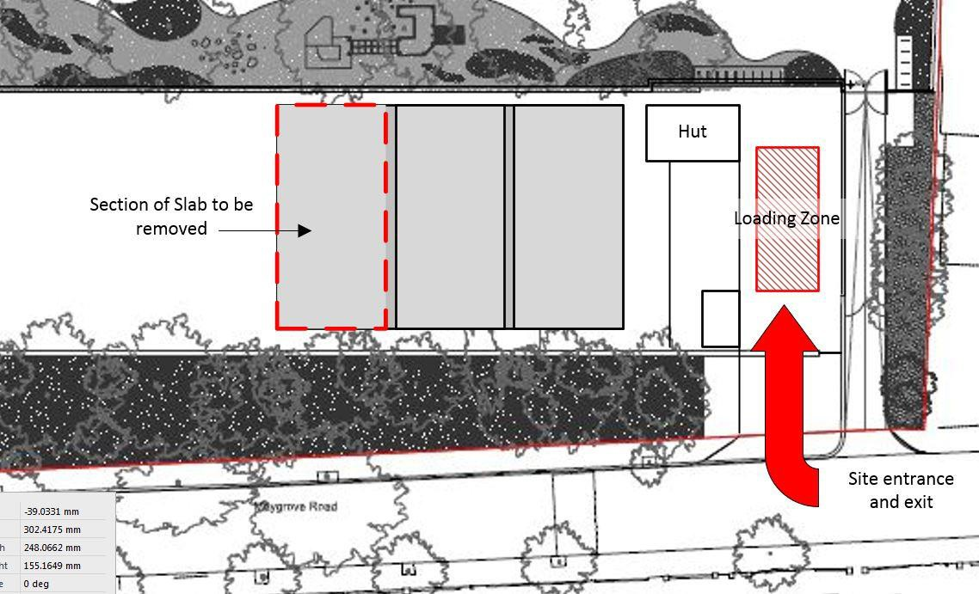

**7. Please provide a very brief description of the demolition works including the size and nature of the development and details of the main issues and challenges (e.g. narrow streets, close proximity to residential dwellings etc**).

The proposals involve the removal of a section of concrete slab and the clearance of the arising’s from site.

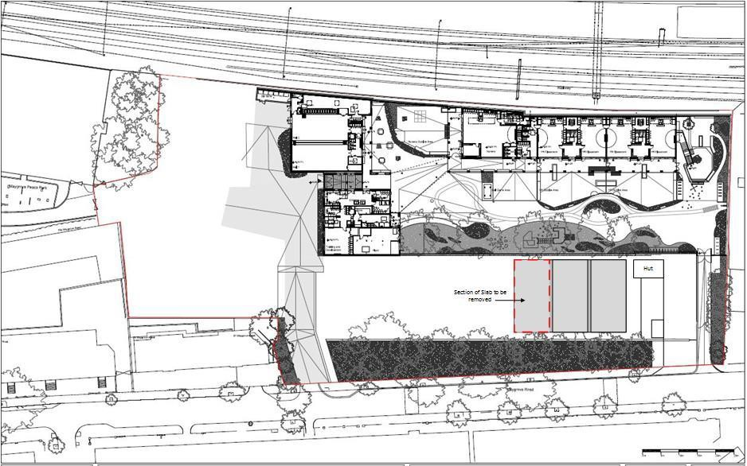

One bay of reinforced concrete slab will be removed up to but excluding the spine beam which will be left as a clean and tidy edge on site. The slab will be broken and lifted out in sections using a 360-degree excavator with a pneumatic breaker. Once broken the sections will be removed from site via waste lorries.

All drainage and services were disconnected in the previous phase, so no live hazards exist in the vicinity of the area of slab to be removed.

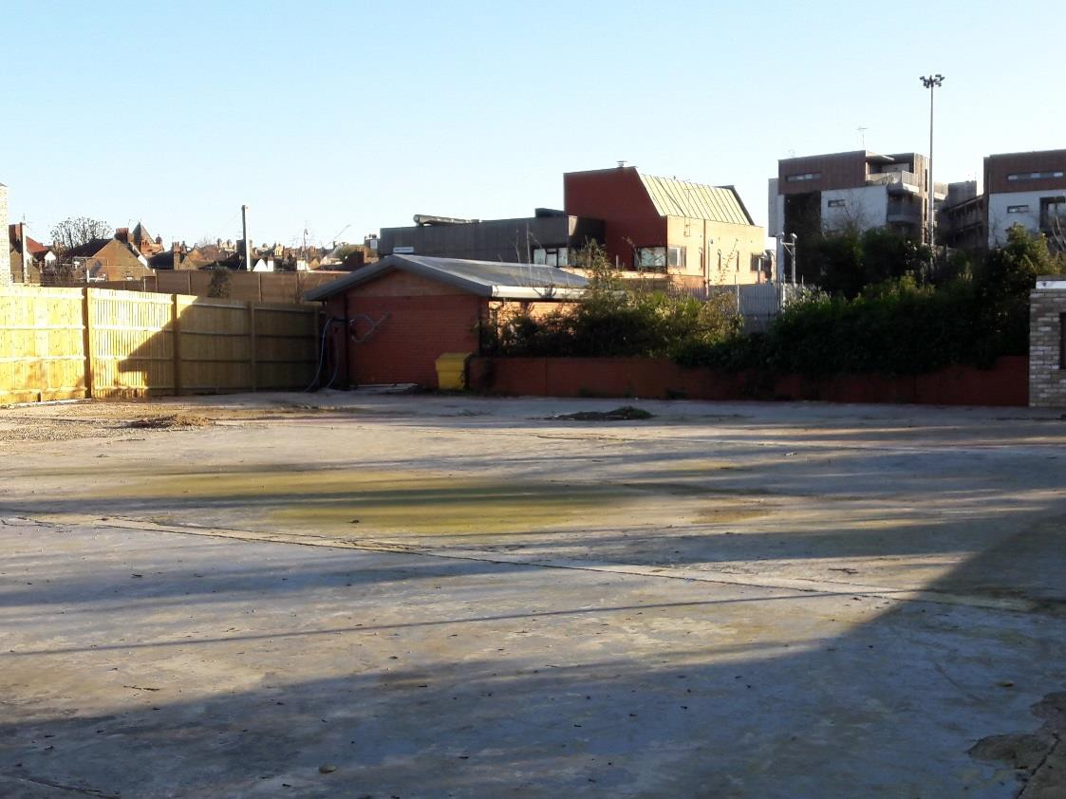

Photo 1: Showing current site and extent of existing concrete slab.

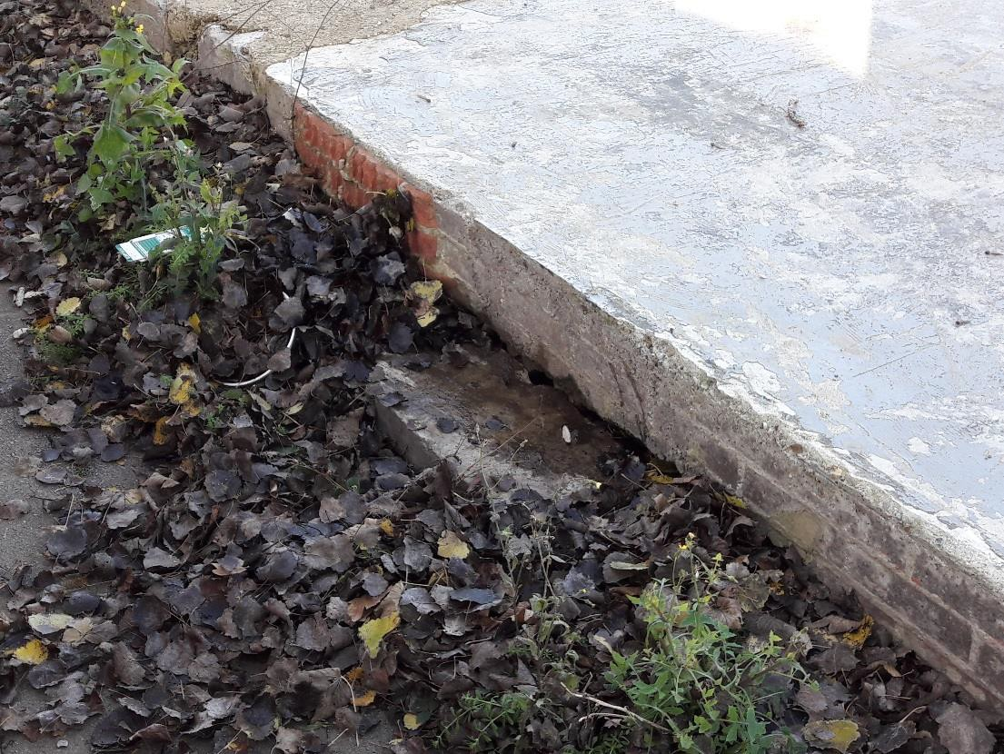

Photo 2: Showing edge of slab to be removed.

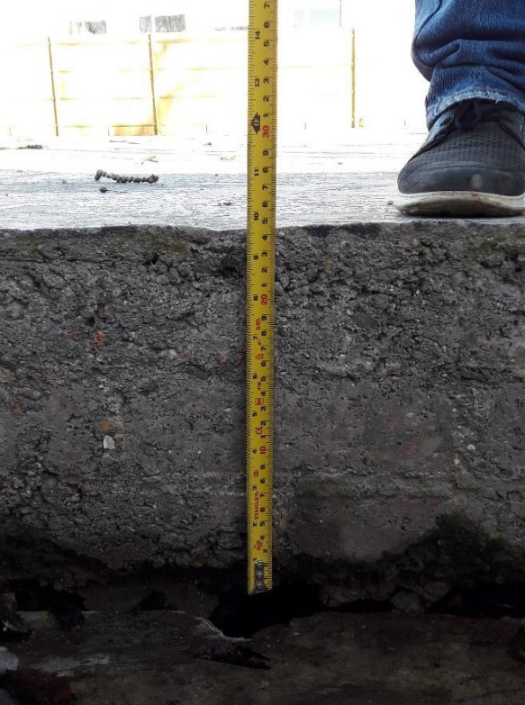

Photo 3: Edge of Slab to be removed depth 250mm

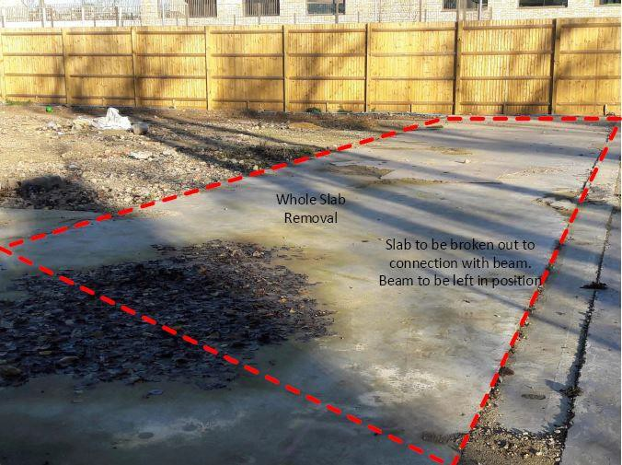

Photo 4: Slab to left of beam to be removed and beam left in position.

**8. Please identify the nearest potential receptors (dwellings, business, etc.) likely to be affected by the activities on site (i.e. noise, vibration, dust, fumes, lighting etc.).**

The proposal is to undertake the works whilst the adjacent Kingsgate Primary School is closed for February Half Term to minimise disruption and risk.

In order to minimise disruption to surrounding residential properties, the works will be carried out on Mondays to Fridays 9.00am to 5.30pm and no work will take place on Saturdays, Sundays and Bank Holidays.

All works will be undertaken in accordance with the public protection measures as required in British Standard BS 6187:2000: Code of Practice for Demolition.

• Site is to be protected and closed off using Heras Palisade Fencing (HSG-151 compliant) where openings in the existing wooden fencing are made.

• Vehicle access and egress will be via Liddell Road by turning off from Maygrove

Road.

These public and property protection measures will be reviewed at the time of contract award for the Works to ensure alignment with proposed preferred methodologies and sequencing developments and to ensure that the safety of the general public is maintained at all times.

To the north of the site there is Kingsgate Primary School which is adjacent to the Network Rail track which runs North-east from West Hampstead Thameslink station. There are also a row of houses along the south-western border of the site and a couple of flats further away on the western side of the site. Finally, another industrial site is located on the eastern side of the site.

Information will need to be provided by the contractor within their Health and Safety Plan as part of the requirement as Principal Contractor under the Construction (Design and Management) Regulations 2015.

**9. Please provide a scaled plan detailing the local highway network layout in the vicinity of the site. This should include details of on-street parking bay locations, cycle lanes, footway extents and proposed site access locations.**

We are not aware of any construction in the vicinity that will affect the works.

**10. Please provide the proposed start and end dates for each phase of construction as well as an overall programme timescale. (A Gantt chart with key tasks, durations and milestones would be ideal).**

Proposed start date: February 2018

Proposed Contract Duration: 1 Week

Proposed Practical Completion: February 2018

It is proposed that the works will be undertaken to coincide with the adjacent Kingsgate Primary School Half Term week to avoid any disruption to the School and Children.

**11. Please confirm the standard working hours for the site, noting that the standard working hours for construction sites in Camden are as follows:**

* **8.00am to 6pm on Monday to Friday**
* **8.00am to 1.00pm on Saturdays**
* **No working on Sundays or Public Holidays**

Works will be undertaken on Monday to Friday 9.00am to 5.30pm and no work will take place on Saturdays, Sundays and Bank Holidays in accordance with LB Camden CMP

guidelines.

**12. Please indicate if any changes to services are proposed to be carried out that would be linked to the site during the works (i.e. connections to public utilities and/or statutory undertakers’ plant). Larger developments may require new utility services. If so, a strategy and programme for coordinating the connection of services will be required. If new utility services are required, please confirm which utility companies have been contacted (e.g. Thames Water, National Grid, EDF Energy, BT etc.) You must explore options for the utility companies to share the same excavations and traffic management proposals. Please supply details of your discussions.**

All drainage and services were disconnected in the previous phase, so no live hazards exist in the vicinity of the area of slab to be removed.

Underground services will be located using plans etc.

Full details of underground services will be obtained in advance from the relevant authority, including Television Relay Companies and private property owners.

Plans, permits to dig and cable location equipment will be available before work starts. Plans will not be assumed to be accurate, and location devices will be used in addition. Trial holes will be dug, using hand digging and insulated tools to confirm locations, taking account of physical indications such as junction boxes and manholes. The lines of services will be marked, using paint, wooden pegs etc. All services will be assumed to be live until proven otherwise.

The Contractor will ensure that services are located and marked before further work begins. Full consultation will be held with the relevant authorities to agree precautions will be carried out before work begins. All staff, machine operators and subcontractors will be fully briefed before they begin work. All temporary services will be properly marked.

Mobile phones will be used where distance communication is required, instead of hand-held radios, to prevent TV/Radio reception issues.

# Community Liaison

**A neighbourhood consultation process must have been undertaken prior to submission of the DMP first draft. This consultation must relate to construction impacts and should take place following the granting of planning permission in the lead up to the submission of the DMP. A consultation process specifically relating to construction impacts must take place regardless of any prior consultations relating to planning matters. This consultation must include all of those individuals that stand to be affected by the proposed construction works. These individuals should be provided with a copy of the draft DMP, or a link to an online document. They should be given adequate time with which to respond to the draft DMP, and any subsequent amended drafts. Contact details which include a phone number and email address of the site manager should also be provided.**

Significant time savings can be made by running an effective neighbourhood consultation process. This must be undertaken in the spirit of cooperation rather than one that is dictatorial and unsympathetic to the wellbeing of local residents and businesses.

These are most effective when initiated as early as possible and conducted in a manner that involves the local community. Involving locals in the discussion and decision making process helps with their understanding of what is being proposed in terms of the development process. **The consultation and discussion process should have already started, with the results incorporated into the DMP first draft submitted to the Council for discussion and sign off.**This communication should then be ongoing during the works, with neighbours and any community liaison groups being regularly updated with programmed works and any changes that may occur due to unforeseen circumstances through newsletters, emails and meetings.

Please note that for larger sites, details of a construction working group may be required as a separate S106 obligation. If this is necessary, it will be set out in the S106 Agreement as a separate requirement on the developer.

**Cumulative impact**

Sites located within high concentrations of construction activity that will attract large numbers of vehicle movements and/or generate significant sustained noise levels should consider establishing contact with other sites in the vicinity in order to manage these impacts.

**The Council can advise on this if necessary.**

**13. Consultation**

The Council expects meaningful consultation. For large sites, this may mean two or more meetings with local residents **prior to submission of the first draft DMP**.

Evidence of who was consulted, how the consultation was conducted, and a summary of the comments received in response to the consultation should be included. Details of meetings including minutes, lists of attendees etc. should be appended.

In response to the comments received, the DMP should then be amended where appropriate and, where not appropriate, a reason given. The revised DMP should also include a list of all the comments received. Developers are advised to check proposed approaches to consultation with the Council before carrying them out. If your site is on the boundary between boroughs, then we would recommend contacting the relevant neighbouring planning authority.

**Please provide details of consultation of draft DMP with local residents, businesses, local groups (e.g. residents/tenants and business associations) and Ward Councillors.**

The works are not classified as a large construction site for the purposes of these works.

Consultation was undertaken by Camden Regeneration and Development with the adjacent Kingsgate Primary School on the timing of the works.

Following consultation it was agreed that the works would be undertaken during the February half term to minimise any interaction between the school’s staff, pupils and their parents.

The contractor will keep residents and others informed about unavoidable disturbance such as from noise, dust, or disruption of traffic, it is not envisaged that any of these nusiances will occur due to the very limited scope of the intended works.

Where required, clear information will be given well in advance and in writing.

**14. Construction Working Group**

Please provide details of community liaison proposals including any Construction Working Group that will be set up, addressing the concerns of the community affected by the works, the way in which the contact details of the person responsible for community liaison will be advertised to the local community, and how the community will be updated on the upcoming works i.e. in the form of a newsletter/letter drop, or weekly drop in sessions for residents.

These details will be provided as part of the main scheme CMP.

Occupiers in the vicinity who may be affected by noise from the works will be notified of the nature of the works, a contact name, telephone number (including that to be used outside normal working hours), and address to which any enquiries should be directed. Such notification shall take place, where possible, within 2 weeks but, in any event, at least 1 week prior to the works commencing.

The Contractor will ensure that a staffed telephone enquiry line is maintained at all times when site works are in progress to deal with enquiries and complaints from the local community.

**Complaints**

Should complaints about noise/vibration/dust arise from the building construction/building works, these will be recorded in a Complaints Register. The Complaints Register will provide information on day, time, details of complaint, details of monitoring carried out and any additional mitigation works. This will be made available to LBC on request.

Should complaints be received concerning works/activities, then all works/activities being the cause of complaint will cease (Tasks in progress accepted due to structural integrity issues), until such time as further agreement to work is negotiated.

The site rules for the project will cover the provision of a suitable smoking area, no bad language and no unnecessary shouting.

**Incident Logbook**

An incident logbook shall be maintained and all incidents shall be recorded stating date, time and worker(s) involved and action taken.

**15. Schemes**

Please provide details of your ‘Considerate Constructors Scheme’ registration, and details of any other similar relevant schemes as appropriate. Contractors will also be required to follow the “[Guide for Contractors Working in Camden](http://www.camden.gov.uk/ccm/cms-service/download/asset?asset_id=799001)” also referred to as “[Camden’s Considerate Contractors Manual](http://www.camden.gov.uk/ccm/cms-service/download/asset?asset_id=799001)”.

The duration of the works is less than 1 day so registration with the Considerate Contractors scheme is not possible or meaningful. The Demolition contractor will abide by the spirit and good practice laid out in the Considerate Contractor Scheme without registering.

The Main Contractor when appointed will register with the Considerate Contractors Scheme and this information will be issued as part of the CMP.

**16. Neighbouring sites**

**Please provide a plan of existing or anticipated construction sites in the local area and please state how your DMP takes into consideration and mitigates the cumulative impacts of construction in the vicinity of the site. The council can advise on this if necessary.**

We are not aware of any construction in the vicinity that will affect the works.

# Transport

**This section must be completed in conjunction with your principal contractor. If one is not yet assigned, please leave the relevant sections blank until such time when one has been appointed.**

Camden is a CLOCS Champion, and is committed to maximising road safety for Vulnerable Road Users (VRUs) as well as minimising negative environmental impacts created by motorised road traffic. As such, all vehicles and their drivers servicing construction sites within the borough are bound by the conditions laid out in the [CLOCS Standard.](http://www.clocs.org.uk/)

This section requires details of the way in which you intend to manage traffic servicing your site, including your road safety obligations with regard to VRU safety. It is your responsibility to ensure that your principal contractor is fully compliant with the terms laid out in the CLOCS Standard. It is your principal contractor’s responsibility to ensure that all contractors and sub-contractors attending site are compliant with the terms laid out in the CLOCS Standard.

Checks of the proposed measures will be carried out by the council to ensure compliance. Please refer to the CLOCS Standard when completing this section. Guidance material which details CLOCS requirements can be accessed [here](http://www.camden.gov.uk/ccm/cms-service/stream/asset?asset_id=3550016&), details of the monitoring process are available [here](http://www.camden.gov.uk/ccm/cms-service/stream/asset?asset_id=3550014&).

Please contact [CLOCS@camden.gov.uk](mailto:CLOCS@camden.gov.uk) for further advice or guidance on any aspect of this section.

**Please refer to the CLOCS Overview and Monitoring Overview documents referenced above which give a breakdown of requirements.**

**CLOCS Contractual Considerations**

**17. Name of Principal contractor:**

To be advised as part of the Main Contractors (when appointed) CMP

**18. Please submit the proposed method for checking operational, vehicle and driver compliance with the CLOCS Standard throughout the duration of the contract (please refer to our** [**CLOCS Overview document**](http://www.camden.gov.uk/ccm/cms-service/stream/asset?asset_id=3550016&) **and** [**Q18 example response**](http://www.camden.gov.uk/ccm/cms-service/stream/asset?asset_id=3550015&)**).**

To be advised as part of the Main Contractors (when appointed) CMP

**19. Please confirm that you as the client/developer and your principal contractor have read and understood the** [**CLOCS Standard**](http://www.clocs.org.uk/wp-content/uploads/2015/05/CLOCS-Standard-v1.2-APRIL_15.pdf) **and included it in your contracts. Please sign-up to join the** [**CLOCS Community**](http://www.clocs.org.uk/links-to-partners/) **to receive up to date information on the standard by expressing an interest online.**

I confirm that I have included the requirement to abide by the CLOCS Standard in my contracts to my contractors and suppliers:

To be advised as part of the Main Contractors (when appointed) CMP

Please contact [CLOCS@camden.gov.uk](mailto:CLOCS@camden.gov.uk) for further advice or guidance on any aspect of this section.

**Site Traffic**

**Sections below shown in blue directly reference the CLOCS Standard requirements. The CLOCS Standard should be read in conjunction with this section.**

**20. Traffic routing: *“Clients shall ensure that a suitable, risk assessed vehicle route to the site is specified and that the route is communicated to all contractors and drivers. Clients shall make contractors and any other service suppliers aware that they are to use these routes at all times unless unavoidable diversions occur.”* (P19, 3.4.5)**

Routes should be carefully considered and risk assessed, taking into account the need to avoid where possible any major cycle routes and trip generators such as schools, offices, public buildings,museums etc. Where appropriate, on routes that use high risk junctions (i.e. those that attract high volumes of cycling traffic) installing Trixi mirrors to aid driver visibility should be considered.

Consideration should also be given to weight restrictions, low bridges and cumulative impacts of construction (including neighbouring construction sites) on the public highway network. The route(s) to and from the site should be suitable for the size of vehicles that are to be used.

1. **Please indicate routes on a drawing or diagram showing the public highway network in the vicinity of the site including details of how vehicles will be routed to the** [**Transport for London Road Network**](http://www.lscp.org.uk/lrsu/engineering_tlrn.html) **(TLRN) on approach and departure from the site.**

**Access From A40**

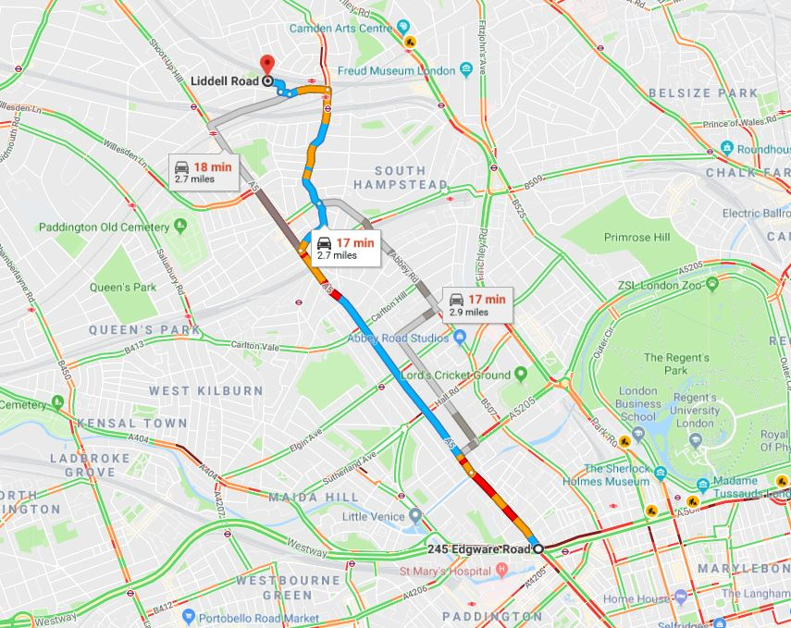

**Access from the North Circular M1**

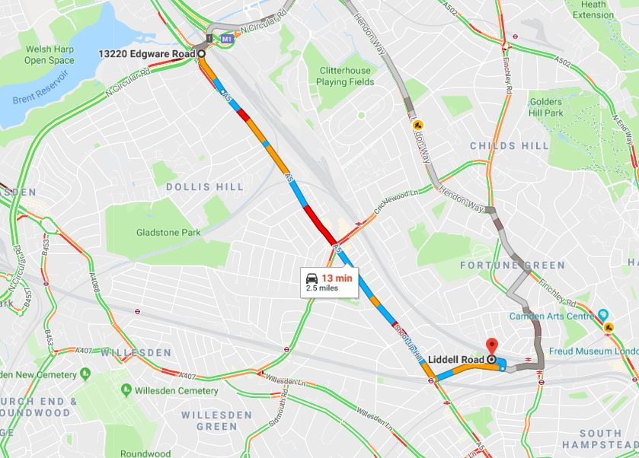

**b. Please confirm how contractors, delivery companies and visitors will be made aware of the route (to and from the site) and of any on-site restrictions, prior to undertaking journeys.**

The contractor will maintain safe and unobstructed access to adjacent properties to minimise any delays created by the works.

The site has a dedicated entrance and access road located on Liddell Road just off Maygrove Road. Vehicles will reverse into the access road and site as there is insufficient turning space in the access road to allow them to turn in and then turn out without being required to reverse. At all times these activities will be supervised by Banksman to ensure there is no risk to other road users, cyclists and pedestrians.

**21. Control of site traffic, particularly at peak hours: “*Clients shall consider other options to plan and control vehicles and reduce peak hour deliveries”* (P20, 3.4.6)**

Construction vehicle movements are generally acceptable between 9.30am to 4.30pm on weekdays and between 8.00am and 1.00pm on Saturdays). If there is a school in the vicinity of the site or on the proposed access and/or egress routes, then deliveries must be restricted to between 9.30am and 3pm on weekdays during term time. (Refer to the [*Guide for Contractors Working in Camden*](http://www.camden.gov.uk/ccm/cms-service/download/asset?asset_id=799001)).

A delivery plan should ensure that deliveries arrive at the correct part of site at the correct time. Instructions explaining such a plan should be sent to all suppliers and contractors**.** Consideration should be given to the location of any necessary holding areas for large sites with high volumes of traffic. Vehicles must not wait or circulate on the public highway. Whilst deliveries should be given set times to arrive, dwell and depart, no undue time pressures should be placed upon the driver at any time.

**a. Please provide details of the typical sizes of all vehicles and the approximate frequency and times of day when they will need access to the site, for each phase of construction.You should estimate the average daily number of vehicles during each major phase of the work, including their dwell time at the site. High numbers of vehicles per day and/or long dwell times may require vehicle holding procedures.**

No deliveries will be made before 9:30, between 15:25 - 16:15pm and after 5.30pm. Any additional hours will be by prior arrangement only.

It is anticipated that there will be 2 vehicle movements over 2 days ( 1 per day), one to deliver the required mini excavator on day 1 and one to remove the it on day 2.

**b. Please provide details of other developments in the local area or on the route.**

We are not aware of any construction in the vicinity that will affect the works.

**c. Please outline the system that is to be used to ensure that the correct vehicle attends the correct part of site at the correct time.**

There is only one section of the site, with a single access and only 2 vehicle movements are anticipated for the entire project.

**d. Please identify the locations of any off-site holding areas (an appropriate location outside the borough may need to be identified, particularly if a large number of delivery vehicles are expected) and any measures that will be taken to ensure the prompt admission of vehicles to site in light of time required for any vehicle/driver compliance checks. Please refer to question 24 if any parking bay suspensions will be required for the holding area.**

Not applicable - 2 vehicle movements required over whole project.

**e. Please provide details of any other measures designed to reduce the impact of associated traffic (such as the use of** [**construction material consolidation centres**](https://www.google.co.uk/url?sa=t&rct=j&q=&esrc=s&source=web&cd=2&cad=rja&uact=8&ved=0ahUKEwi5hKjPiLjRAhVqLcAKHQduC_gQFggkMAE&url=http%3A%2F%2Fcontent.tfl.gov.uk%2Fdirectory-london-construction-consolidation-centres.pdf&usg=AFQjCNFhB34aaqw3M3fmDpJYUUBw_PjbdA&sig2=KXhGnTR3slzf0kN4XMOcQg&bvm=bv.143423383,d.ZWM)**).**

Not applicable – 2 vehicle movements required over whole project.

**22. Site access and egress: “*Clients shall ensure that access to and egress from the site is appropriately managed, clearly marked, understood and clear of obstacles.”* (P18, 3.4.3)**

Vehicles entering and leaving the site should be carefully managed, using gates that are clearly marked and free from obstacles. Traffic marshals must ensure the safe passage of all traffic on the public highway, in particular pedestrians and cyclists, when vehicles are entering and leaving site, particularly if reversing.

Traffic marshals, or site staff acting as traffic marshals, should hold the relevant qualifications required for directing large vehicles when reversing. Marshals should be equipped with ‘STOP – WORKS’ signs (not STOP/GO signs) if control of traffic on the public highway is required. Marshals should have radio contact with one another where necessary.

**a. Please detail the proposed access and egress routes to and from the site**

The site has a dedicated entrance and access road located on Liddell Road just off Maygrove Road. Vehicles will reverse into the access road and site as there is insufficient turning space in the access road to allow them to turn in and then turn out without being required to reverse. At all times these activities will be supervised by Banksman to ensure there is no risk to other road users, cyclists and pedestrians.

**b. Please describe how the access and egress arrangements for construction vehicles will be managed.**

**Pedestrian Protection**

No mechanical plant or vehicles shall be permitted to cross a paved public footway unless there is a permanent footway crossing in existence, or a temporary footway of sufficient width and strength. Vehicles are not permitted to reverse onto the site without guidance from a competent Banksman.

**c. Please provide swept path drawings for any tight manoeuvres on vehicle routes to and from the site including proposed access and egress arrangements at the site boundary (if necessary).**

Not applicable.

**d. Provision of wheel washing facilities should be considered if necessary. If so, please provide details of how this will be managed, and any run-off controlled.**

Wheel washing is not required, delivery of plant only from concrete hardstanding.

**23. Vehicle loading and unloading: *“Clients shall ensure that vehicles are loaded and unloaded on-site as far as is practicable.”* (P19, 3.4.4)**

If this is not possible, Traffic Marshalls must ensure the safe passage of pedestrians, cyclists and motor traffic in the street when vehicles are being loaded or unloaded.

Please provide details of the parking and loading arrangements for construction vehicles with regard to servicing and deliveries associated with the site (e.g. delivery of materials and plant, removal of excavated material). This is required as a scaled site plan, showing all points of access and where materials, skips and plant will be stored, and how vehicles will access and egress the site. If loading is to take place off site, please identify where this is due to take place and outline the measures you will take to ensure that loading/unloading is carried out safely. Please outline in question 24 if any parking bay suspensions will be required.

**Pedestrian Protection**

No mechanical plant or vehicles shall be permitted to cross a paved public footway unless there is a permanent footway crossing in existence, or a temporary footway of sufficient width and strength. Vehicles are not permitted to reverse onto the site without guidance from a competent Banksman.

**Highway interventions**

**Please note that Temporary Traffic Orders (TTOs) and hoarding/scaffolding licenses may be applied for prior to CMP submission but won’t be granted until the CMP is signed-off.**

**If the site is on or adjacent to the TLRN, please provide details of preliminary discussions with Transport for London in the relevant sections below.**

**24. Parking bay suspensions and temporary traffic orders – NB: Not required**

Please note, parking bay suspensions should only be requested where absolutely necessary. Parking bay suspensions are permitted for a maximum of 6 months, requirement of exclusive access to a bay for longer than 6 months you will be required to obtain [Temporary Traffic Order (TTO)](http://camden.gov.uk/ccm/content/transport-and-streets/traffic-management/temporary-road-restrictions/) for which there is a separate cost.

Please provide details of any proposed parking bay suspensions and TTO’s which would be required to facilitate construction. **Building materials and equipment must not cause obstructions on the highway as per your Considerate Contractors obligations unless the requisite permissions are secured.**

Information regarding parking suspensions can be found [here.](http://www.camden.gov.uk/ccm/navigation/transport-and-streets/parking/parking-bay-suspensions/)

No parking suspensions are required.

**25. Scaled drawings of highway works – NB: Not required**

Please note that use of the public highway for storage, site accommodation or welfare facilities is at the discretion of the Council and is generally not permitted. If you propose such use you must supply full justification, setting out why it is impossible to allocate space on-site. You must submit a detailed (to-scale) plan showing the impact on the public highway that includes the extent of any hoarding, pedestrian routes, parking bay suspensions and remaining road width for vehicle movements. We prefer not to close footways but if this is unavoidable, you should submit a scaled plan of the proposed diversion route showing key dimensions.

a. Please provide accurate scaled drawings of any highway works necessary to enable construction to take place (e.g. construction of temporary vehicular accesses).

No highway works are required.

b.Please provide details of all safety signage, barriers and accessibility measures such as ramps and lighting etc.

All light will be downward facing and where required shielded to prevent stray light causing nuisance.

External lighting will be switched off during daylight hours unless required for safety or work reasons.

Internal lighting will be reduced to emergency lighting only when the site is closed.

**26. Diversions – NB: Not required**

Where applicable, please supply details of any diversion, disruption or other anticipated use of the public highway during the construction period (alternatively a plan may be submitted).

No diversions are required

**27. VRU and pedestrian diversions, scaffolding and hoarding**

Pedestrians and/or cyclist safety must be maintained if diversions are put in place. Vulnerable footway users should also be considered. These include wheelchair users, the elderly, those with walking difficulties, young children, those with prams, the blind and partially sighted. Appropriate ramping must be used if cables, hoses, etc. are run across the footway.

Any work above ground floor level may require a covered walkway adjacent to the site. A licence must be obtained for scaffolding and gantries. The adjoining public highway must be kept clean and free from obstructions. Lighting and signage should be used on temporary structures/skips/hoardings etc.

A secure hoarding will generally be required at the site boundary with a lockable access.

**a. Please provide details describing how pedestrian and cyclist safety will be maintained, including any proposed alternative routes (if necessary), and any Traffic Marshall arrangements.**

**Pedestrian Protection**

No mechanical plant or vehicles shall be permitted to cross a paved public footway unless there is a permanent footway crossing in existence, or a temporary footway of sufficient width and strength. Vehicles are not permitted to reverse onto the site without guidance from a competent Banksman.

**b. Please provide details of any temporary structures which would overhang the public highway (e.g. scaffolding, gantries, cranes etc.) and details of hoarding requirements or any other occupation of the public highway.**

No temporary structures or hoarding will be on or overhang the the public highway.

# Environment

To answer these sections please refer to the relevant sections of **Camden’s Minimum Requirements for Building Construction (**[**CMRBC**](http://www.camden.gov.uk/ccm/cms-service/download/asset?asset_id=3257318)**).**

Environmental goals and objectives will be displayed on the site office notice board and will be brought to the attention of the workforce at the induction stage.

The Site Manager will be responsible for undertaking an environmental audit on a periodic basis or ensuring that this is done by another competent person.

Records will be maintained on site for inspection purposes.

Where required, competent persons will be engaged to ensure that compliance with local legislation is achieved.

**28. Please list all** [**noisy operations**](http://www.camden.gov.uk/ccm/content/environment/environmental-health--consumer-protection/noise/reducing-noise/noise-from-construction-sites.en?page=2) **and the demolition method used, and provide details of the times that each of these are due to be carried out.**

The Contractor will comply with BS5228 in order to ensure that noise levels produced on site will not affect neighbouring residential premises. Reasonable measures will be used to control noise, vibration and dust.

The breaking out of the concrete slab will be carried out using non-percussive tools with crushers being used to reduce noise at the boundary and any potential nuisance.

The Contractor we will take a proactive approach to noise pollution by minimising risk and disturbance to residents, operatives, neighbours and the general public.

**Time of operations:**

Time of operations and ancillary works which are audible at the site boundary shall normally be carried out between the following hours:

• Mondays to Fridays: 9.00am to 5.00pm

No work shall take place on Saturdays, Sundays and Bank Holidays.

Consideration of the use of Quiet Hours will be assessed for use during the demolition activities which following assessment of the available mitigation measures still present a high risk of significant and prolonged noise breakout beyond the site boundary.

Where deemed appropriate the Quiet Hours will be defined as:

• 10:00 – 12:00 (Monday to Friday)

• 14:00 – 16:00 (Monday to Friday)

**29. Please confirm when the most recent noise survey was carried out (before any works were carried out) and provide a copy. If a noise survey has not taken place, please indicate the date (before any works are being carried out) that the noise survey will be taking place and agree to provide a copy.**

Not applicable, these will be provided as part of the CMP

**30. Please provide predictions for** [**noise**](http://www.camden.gov.uk/ccm/content/environment/environmental-health--consumer-protection/noise/reducing-noise/noise-from-construction-sites.en?page=2) **and vibration levels throughout the proposed works.**

Not applicable, these will be provided as part of the CMP

**31. Please provide details describing mitigation measures to be incorporated during the construction/**[**demolition**](http://www.camden.gov.uk/ccm/navigation/environment/building-control/demolition/) **works to prevent noise and vibration disturbances from the activities on the site, including the actions to be taken in cases where these exceed the predicted levels.**

The main method of minimizing impacts will be to restrict noisy works to within 9 am and

4pm, Monday to Friday with no noisy works permitted on Saturdays, Sundays or public and bank holidays.

The quietest and newest vehicles/plant machinery will be used at all times. All vehicles and mechanical plant used for the purpose of the works will be fitted with effective exhaust silencers, will be maintained in good and efficient working order and operated in such a manner as to minimise noise emissions.

Where the measured noise levels are more than 3 dB (A) above the predicted noise levels or in the event of a complaint of noise, an investigation will be carried out to ascertain the cause of the breach or the complaint and to check that Best Practicable Means will be used to control the noise in accordance with the steps set out in the application for ‘prior consent’. Noise levels will be reduced further if it is reasonably practicable to do so.

All sub-contractors will implement best practice to minimise noise in accordance with current regulations. Prior to any noisy work starting, a noise assessment will be submitted within the sub-contractor Method Statement, to state how they will mitigate noise emissions.

Vehicles and plant engines will be shut down when not in use - ‘No idling Policy’ shall be

enforced.

Vehicle and plant alarms will include broadband/white noise types and a risk assessment will be undertaken to review the volume and reduce where appropriate.

Equipment and plant that could potentially cause a noise nuisance will be enclosed by acoustic covers. Plant shall be directed away from sensitive receptors and sited behind physical barriers.

Anti-social behaviour such as shouting, radios and swearing will not be permitted or accepted on site.

**32. Please provide evidence that staff have been trained on BS 5228:2009**

Not applicable, will be submitted as part of the CMP

**33. Please provide details on how dust nuisance arising from dusty activities, on site, will be prevented.**

The Contractor will use the following 3 principles to control dust on and off site

1. Prevention

2. Suppression

3. Containment

These three principles are well established and are central to the control strategies to control dust. They follow a hierarchy to control the emissions.

This project has been reviewed in line with GLA’s SPG on Control of Dust and Emissions from

Construction and Demolition.

All operations will be carefully considered with dust prevention and control measures clearly set out and agreed as part of the Risk and Method Statement reviews prior to any activity taking place.

The following activities and operations will give rise to dust

•   Demolition works – Removal of concrete floor slab

**34. Please provide details describing how any significant amounts of dirt or dust that may be spread onto the public highway will be prevented and/or cleaned.**

It is anticipated that dust will be contained at source to prevent airbourne spread outside.

**35. Please provide details describing arrangements for monitoring of** [**noise**](http://www.camden.gov.uk/ccm/content/environment/environmental-health--consumer-protection/noise/reducing-noise/noise-from-construction-sites.en?page=2)**, vibration and dust levels.**

The local wind speed and direction will be monitored, to inform dust control measures. These inspections will increase in frequency when activities with a high potential to produce dust and emissions are being carried out, especially during dry or windy periods.

All waste removal Lorries will utilise load covers.

Where available at source dust extraction and containment will be utilised on all tools and plant.

Damping down will be used on all dusty work faces.

Dust and Air Quality measures will form part of our Toolbox Talks at Induction.

Regular site inspections will be undertaken to monitor compliance with air quality and dust control procedures, and to ensure the dust management plan is updated as appropriate.

**Vibration**

Where appropriate, the Contractor will ensure measured vibration levels are compared with the criteria in BS5228: 2009 part 2 (i.e. 1mms־¹ PPV for potential disturbance in residential and using a suggested trigger criterion of 2mms־¹ for commercial). Lower limits will be agreed with LBC if there is a risk that vibration levels may interfere with vibration sensitive equipment or other vibration sensitive objects.

The following measures will also be undertaken in order to reduce environmental vibration on site.

Reducing the need to adopt percussive and vibrating machinery.

All plant and machinery will be switched off when not in use and not left idling.

Drop heights will be minimised during deconstruction and during the loading of arising’s into lorries for removal from site.

Plant and equipment to be maintained in-line with manufacturers’ instructions.

Staff to report operating problems with plant and equipment.

Staff will be given sufficient information, instruction, training and supervision on environmental vibration topics.

**Waste and Recycling**

Our environmental goals and objectives will be brought to the attention of the workforce at induction stage. Whilst we would normally expect waste to landfill to not exceed 10 **%** of the total waste arising, it is anticipated that 100% of the arising’s from the removal of the slab should be recycled.

Waste removal will be organised frequently to avoid accumulation of large quantities.

Waste will be removed from site by wait and load and will be restricted to the standard working hours. Waste transfer will be accompanied by a full description of the waste and a waste transfer note and be disposed of lawfully.

A spill kit will be kept close to the storage area and the staff will be trained on how to use these correctly. Staff will prevent any liquid wastes leaching from bins or skips – including dry waste that may become wet. Any damaged leaking or empty drums will be removed from site immediately and disposed via a registered waste disposal contractor. Staff will ensure hazardous waste is not mixed with other hazardous waste or non-hazardous waste.

**Outline Pollution Control**

**Emergency Spill Response**

|  |  |  |
| --- | --- | --- |
| **Ref** | **Action** | **Evidence**  **Required** |
| 13.1.1 | Establish spill response procedure (Consult EWP2)  Spill response posters to be distributed on boards around site. | Site inspection |
| 13.1.2 | Communicate procedure to all site personnel and post instructions at suitable places around site. | Induction Records Posters |
| 13.1.3 | Place and maintain stocks of spill response equipment appropriate to materials on site | Site inspection |
| 13.1.4 | Train personnel on use of spill response equipment and update training as appropriate. Training to be included with the site induction and tool box talks. | Site inspection |
| 13.1.5 | Report significant spills immediately | Incident records |

**Waste Control**

|  |  |  |
| --- | --- | --- |
| **Ref** | **Action** | **Evidence**  **Required** |
| 13.2.1 | Ensure Site Waste Management Plan in place to include Waste  Minimisation strategy. | Reports |
| 13.2.2 | Skips should be covered (if material can be blown away or if it is a plasterboard-only skip). | Site Inspection  Reports |
| 13.2.3 | Label waste skips with allowable contents | Site Inspection  Reports |
| 13.2.4 | Manage wastes in accordance with Site Waste Management Plan. | Duty of care records.  Waste Transfer  Notes |

**Controlled Water Courses and Discharges**

|  |  |  |
| --- | --- | --- |
| **Ref** | **Action** | **Evidence**  **Required** |
| 13.4.1 | Obtain consent from local water company before discharging to storm or foul sewers. | Records of consent |
| 13.4.2 | Monitor discharges in accordance with requirements of consent. Visually inspect discharge quality and take remedial action as necessary | Monitoring  Records |
| 13.4.3 | Report any significant noncompliance with consent conditions  Reports immediately to Project Manager. | Reports |

**Oils, Fuels and Chemicals Storage**

|  |  |  |
| --- | --- | --- |
| **Ref** | **Action** | **Evidence**  **Required** |
| 13.6.1 | Locate storage facilities in marked zones away from sewers, gullies and at least 10m from channels and water courses. If not feasible, take or adequate measures to protect against pollution. | Site Inspection  Records  Site Plan |
| 13.6.2 | Store fuels, oils and COSHH materials in accordance with good practice. Locate storage facilities on impermeable surfaces where possible.  Ensure storage bunds/trays/pallets are minimum volume of 110% and maintained in good condition. Empty buds/trays/pallets regularly and in accordance with waste disposal procedures.  Protect fuel facility from vandalism and lock when not in use. | Site Inspection Records Contract Manager inspection record |
| 3.6.2 | Appoint responsible individuals trained in emergency response. Communicate emergency responses in site induction. | Site Induction  Records |
| 3.6.3 | Keep spill response equipment, appropriate to the size of the facility, in close proximity to the facility. | Site Inspection  Reports |
| 3.6.4 | Appoint designated person for fuel-filling operation. | Appointment record |
| 3.6.5 | Vehicle re-fuelling to take place on an impermeable surface. | Site Rules |

**Noise and Vibration**

|  |  |  |
| --- | --- | --- |
| **Ref** | **Action** | **Evidence**  **Required** |
| 3.7.1 | Prior to the commencement of works, identify all potentially noise and vibration sensitive properties and boundaries and carry out baseline noise and vibration surveys. | Noise and vibration surveys |
| 3.7.2 | Carry out environmental and occupational health noise and vibration surveys during the Works as necessary | Noise and vibration surveys |
| 3.7.3 | Detail any necessary measures to mitigate noise and vibration impacts in risk assessments (RAs) and method statements (MSs). Select  construction methods and plant that minimise noise and vibration | Environmental  Risk Assessment |
| 3.7.4 | Communicate noise and vibration issues to site personnel and visitors. | Induction records |
| 3.7.5 | Monitor measures to mitigate noise and vibration periodically to ensure effectiveness | Site Inspection records |
| 3.7.6 | Adopt Best Practicable Means for noise reduction. Consult EWP 04 and  EWP 07 for Guidance. | Site Inspection records |
| 3.7.7 | Establish procedure for notifying local authority, local residents (and general public if necessary) of extended working hours, with one week  notice period whenever possible. | Site Records |

**Dust and Fumes**

|  |  |  |
| --- | --- | --- |
| **Ref** | **Action** | **Evidence**  **Required** |
| 3.8.1 | Maintain high standard of housekeeping. Avoid infestation with vermin. | Site inspection  Reports |
| 3.8.2 | Monitor cleanliness of access routes regularly and use road sweepers when required |
| 3.8.3 | Damp down surfaces during periods of dry weather to prevent dust nuisance. |
| 3.8.4 | Provide wheel-washing facilities at exits onto public roads, where required. | Site setup  Site layout Plan |
| 3.8.5 | Establish and monitor speed limits on approach roads. | Site Rules |
| 3.8.6 | Stockpile shall be located downwind of sensitive receptor sites | Site Inspection reports |

**Contaminated Land**

|  |  |  |
| --- | --- | --- |
| **Ref** | **Action** | **Evidence**  **Required** |
| 3.9.1 | Establish plans of action for dealing with identified contaminants | Action plans  Site inspections |
| 3.9.2 | Ensure there is adequate planned prevention of pollution of any watercourses, land or air contained in method statements. |
| 3.9.3 | Report any significant contamination identified on site during construction | Incident Report |
| 3.9.4 | Correct planning for the removal of contaminated soils first when on site | Site Assessment  Report  Pre-Construction  Report |

**Ecology, Archaeology and Built Heritage**

Archaeology and Built Heritage are/are not a concern for this project.

|  |  |  |
| --- | --- | --- |
| **Ref** | **Action** | **Evidence**  **Required** |
| 3.10.  1 | Report any protected animals, habitats, plant, building, structure, etc, discovered during construction. | Ecological and Archaeological survey |
| 3.10.  2 | Identify any protective/mitigation measures required by regulatory bodies. | Site inspections |
| 3.10.  3 | Protect habitats, protected trees and hedgerows, nesting birds or archaeological remains from disturbance. | Incident Records |
| 3.10.  4 | If unexpected archaeological remains or geological features of interest are uncovered then:  • Stop work immediately in the area;  • Protect the finds with fencing and notify the Local Authority County  Archaeologist for advice. | Incident Records |

**Construction Plant**

|  |  |  |
| --- | --- | --- |
| **Ref** | **Action** | **Evidence**  **Required** |
| 3.11.1 | Create dedicated plant storage area. | Site Inspection  Reports |
| 3.11.2 | Locate plant from sensitive noise boundaries and water bodies. | Site Inspection  Reports |
| 3.11.3 | **Never leave plant running unnecessarily.** Ensure it is well maintained, fit for purpose and in a safe condition. Where appropriate, place drip trays beneath static plant and maintain. Keep emergency spill kits either on or near working plant. Ensure exhausts do not point towards ground. | Site Inspection  Reports  Site Rules |
| 3.11.4 | Report major environmental incidents or problems involving plant. | Environmental  Incident Report |

**Energy Efficiency and use of Natural Resources**

|  |  |  |
| --- | --- | --- |
| **Ref** | **Action** | **Evidence**  **Required** |
| 3.12.1 | Operate construction plant in accordance with point 3.11.3 | Site Inspection  Reports |
| 3.12.2 | Use artificial lighting only where and when required. May be necessary for security reasons. Turn lighting and heating off after use. | Site Inspection  Reports |
| 3.12.3 | Store materials properly to guard against breakage, theft and damage. | Site Inspection  Reports |
| 3.12.4 | Where appropriate, resource use shall be reduced, reused and/or recycled. | Incident Reports |
| 3.12.5 | Where possible, use local suppliers to minimise travel distances. | Purchase Records |
| 3.12.5 | Report examples of good site practice and report energy figures, where available, for sustainability returns | Energy usage reports - Invoices |

**Transportation & Haulage**

|  |  |  |
| --- | --- | --- |
| **Ref** | **Action** | **Evidence**  **Required** |
| 3.13.1 | Site deliveries to be limited to between 09:30hrs and 16:00hrs Monday to Friday | Delivery Tickets |

|  |  |  |
| --- | --- | --- |
| 3.13.2 | All vehicles to enter / exit site in a forward direction except where space restrictions do not allow this.  Where vehicles are required to reverse a competent banksman is to be provided. | Site Inspection reports |
| 3.13.3 | All access onto the highway should be sufficient width to accommodate  2-way traffic where practical | Site Inspection reports |
| 3.13.4 | Haul roads to be constructed of suitable surface for use | Site Inspection reports |
| 3.13.5 | Vehicle protection zone of 10m from rivers to be provided. Protection zone to be fenced. For works within 10m of watercourse, a method statement and risk assessment shall be prepared to mitigate, reduce impact upon watercourses | Environmental  Risk Assessment |

**Concrete Washout**

|  |  |  |
| --- | --- | --- |
| **Ref** | **Action** | **Evidence**  **Required** |
| 3.14.1 | Perform washout of concrete trucks offsite or in designated concrete washout areas only | Site design  Site Inspection |
| 3.14.2 | Do not wash out concrete trucks onto the ground, or into storm drains, open ditches, streets or drains. | Site design  Site Inspection |
| 3.14.3 | Do not allow excess concrete to be dumped onsite, except in designated concrete washout areas | Site design  Site Inspection |
| 3.14.4 | Washout area is at least 10 meters away from sensitive areas such as storm drains or water bodies. | Site Design |
| 3.14.5 | Once concrete wastes are washed into the designated area and allowed to harden, the concrete should be broken up, removed, and disposed of per applicable solid waste regulations. Dispose of hardened concrete on a regular basis. | Site inspection |

**36. Please confirm that a Risk Assessment has been undertaken at planning application stage in line with the GLA policy.** [**The Control of Dust and Emissions During Demolition and Construction 2104 (SPG)**](https://www.london.gov.uk/file/18750/download?token=zV3ZKTpP)**, that the risk level that has been identified, and that the appropriate measures within the GLA mitigation measures checklist have been applied. Please attach the risk assessment and mitigation checklist as an appendix.**

Not applicable to these works, to be submitted as part of the CMP

**37. Please confirm that all of the GLA’s ‘highly recommended’ measures from the** [**SPG**](https://www.london.gov.uk/file/18750/download?token=zV3ZKTpP) **document relative to the level of risk identified in question 36 have been addressed by completing the** [**GLA mitigation measures checklist.**](https://www.london.gov.uk/what-we-do/planning/implementing-london-plan/supplementary-planning-guidance/control-dust-and)

Not applicable to these works, to be submitted as part of the CMP

**38. If the site is a ‘High Risk Site’, 4 real time dust monitors will be required. If the site is a ‘Medium Risk Site’, 2 real time dust monitors will be required. The risk assessment must take account of proximity to sensitive receptors (e.g. schools, care homes etc), as detailed in the** [**SPG**](https://www.london.gov.uk/file/18750/download?token=zV3ZKTpP)**. Please confirm the location, number and specification of the monitors in line with the SPG and confirm that these will be installed 3 months prior to the commencement of works, and that real time data and quarterly reports will be provided to the Council detailing any exceedances of the threshold and measures that were implemented to address these.**

Not applicable to these works, to be submitted as part of the CMP

**39. Please provide details about how rodents, including** [**ra****ts**](http://www.camden.gov.uk/ccm/content/environment/environmental-health--consumer-protection/pest-control/about-the-pest-control-service.en)**, will be prevented from spreading out from the site. You are required to provide information about site inspections carried out and present copies of receipts (if work undertaken).**

The Contractor will take the necessary measures to ensure proper control of rodents.

Whilst given the nature of the work it is not anticipated that rodents will be encountered, there is a risk that they may be encountered under the suspended floor slab.

Any open drainage runs encountered under the slab will be sealed during the construction process.

At all times the site shall be kept free, so far as is reasonable practicable, from rats and mice. (Prevention of Damage by Pests Act 1949**,** part ‘H’ of the Building Regulations (Drainage & Waste Disposal).

**40. Please confirm when an asbestos survey was carried out at the site and include the key findings.**

An asbestos survey was not required for these works.

**41. Complaints often arise from the conduct of builders in an area. Please confirm steps being taken to minimise this e.g. provision of a suitable smoking area, tackling bad language and unnecessary shouting.**

Should complaints about noise/vibration/dust arise from the building construction/building works, these will be recorded in a Complaints Register. The Complaints Register will provide information on day, time, details of complaint, details of monitoring carried out and any additional mitigation works. This will be made available to LBC on request.

Should complaints be received concerning works/activities, then all works/activities being the cause of complaint will cease (Tasks in progress accepted due to structural integrity issues), until such time as further agreement to work is negotiated.

The site rules for the project will cover the provision of a suitable smoking area, no bad language and no unnecessary shouting.

**42. If you will be using non-road mobile machinery (NRMM) on site with net power between 37kW and 560kW it will be required to meet the standards set out below. The standards are applicable to both variable and constant speed engines and apply for both PM and NOx emissions.**

**From 1st September 2015**

**(i) Major Development Sites** – NRMM used on the site of any major development will be required to meet Stage IIIA of EU Directive 97/68/EC

**(ii) Any development site within the Central Activity Zone -** NRMM used on any site within the Central Activity Zone will be required to meet Stage IIIB of EU Directive 97/68/EC

**From 1st September 2020**

**(iii) Any development site -** NRMM used on any site within Greater London will be required to meet Stage IIIB of EU Directive 97/68/EC

**(iv) Any development site within the Central Activity Zone -** NRMM used on any site within the Central Activity Zone will be required to meet Stage IV of EU Directive 97/68/EC

The site is located within the Central Activity Zone (CAZ), therefore only plant compliant with

Stage IIIB EU emission Stage must be used.

An inventory of all NRMM will be kept on-site stating the emission limits for all equipment, and the relevant records saved on the NRMM website.

All machinery will be regularly serviced and service logs available for inspection.

**Appendix A.**

**DUST CONTROL GUIDANCE**

|  |  |
| --- | --- |
| **Potential dust source** | **Dust control guidance** |
| Visible exhaust smoke | Vehicles and equipment should not emit black smoke from exhaust systems except during ignition at start-up. |
| Location of plant and equipment | Plant and equipment should be operated away from residential areas or sensitive receptors near to the site. |
| Material handling operations | Always keep the number of handling operations to a minimum by  ensuring that dusty material isn’t moved or handled unnecessarily. |
| Cutting, grinding, drilling, sawing, Cutting on site should be avoided by using trimming, planing, sanding | Cutting on site should be avoided by using trimming, planing, sanding prefabrication whenever possible.  Avoid cutting out errors and re-bars.  Employ equipment and techniques that minimise dust emissions, using best available dust suppression measures.  Use water sprays to minimise dust from cutting equipment. Local exhaust ventilation should be used where possible. |
| Cutting roadways, pavements, Use a diamond bladed floor saw with water blocks etc. | Use a diamond bladed floor saw with water blocks etc. pumped through to suppress dust.  Standard angle grinders and disk cutters with no dust control should not be used for this purpose. |
| Raking out mortar/pointing | Standard angle grinders and disk cutters with no dust control should not be used.  Use plugging chisels when appropriate to limit dust. |
| Angle grinders and disk cutters | Dust extraction/minimisation systems should always be used. |
| Mixing and granular materials | The use of pre-mixed plasters and masonry compounds is recommended.  The mixing of concrete or bentonite slurries should take place in enclosed or shielded areas.  Fine materials should be palletised and shrink wrapped where possible. |
| Painting and decorating | Sanding and cutting machinery should be fitted with dust suppression or collection equipment.  Vacuum cleaning should be used wherever possible. |
| Fitting out Ð plastering, rendering, Cutting and sanding machinery should be decorative finishing, furniture fitting | Cutting and sanding machinery should be decorative finishing, furniture fitting fitted with dust suppression/collection equipment. Vacuum cleaning should be used whenever possible. |
| Installation of electrical systems and plumbing | Cutting and sanding machinery should be fitted with dust suppression/collection equipment.  Vacuum cleaning should be used whenever possible |
| Cleaning processes | Dry sweeping should be avoided and only carried out with vacuum extraction methods attached.  Damp sweeping using fine mist should be used.  Washing and damping down should be carried out whenever necessary. |

**Appendix B**

MONITORING, MEASURING AND RESPONSE

Inspections and Audits

The following audits and monitoring will occur on a regular basis and as required:

• Regular site surveillances to check environmental good practice and compliance with the code of construction practice

•     Regular site surveillances to assess compliance with the environmental management system

The on-site Safety, Health, Environmental and Procedures (SHEQ) Representative will undertake monthly inspections.

The Safety, Health, Environmental and Procedures (SHEP) Manager shall also carry out random inspections of site and complete an inspection report. External Health and Safety Advisors may also carry out site inspections on behalf of the company.

A copy of the SHEP Inspection Reports shall be issued to the Project Manager for action. The Project Manager shall be responsible for ensuring, by review, that such items have been addressed. Additional copies of the SHEP Manager’s Reports will be given to the Contracts Manager responsible for the project.

The project may be visited by the EA or Local Authority.

Measuring

**On Site Measuring**

The project is required to report as a minimum on:

•     Site Electric usage (where we have own meter)

•     Fuel usage

•     Delivery logs (transport type, distance travelled)

•     Any work package specific requirements

All environmental incidents, dangerous occurrences or near misses will be recorded by the contractor on using an Accident/Incident Report. Once an incident is reported and recorded, actions will be identified to avoid a recurrence and the site procedures will be updated accordingly.

All accidents/incidents, dangerous occurrences and near misses will be reviewed by a Director and, where necessary, changes to working practices/procedures will be implemented.

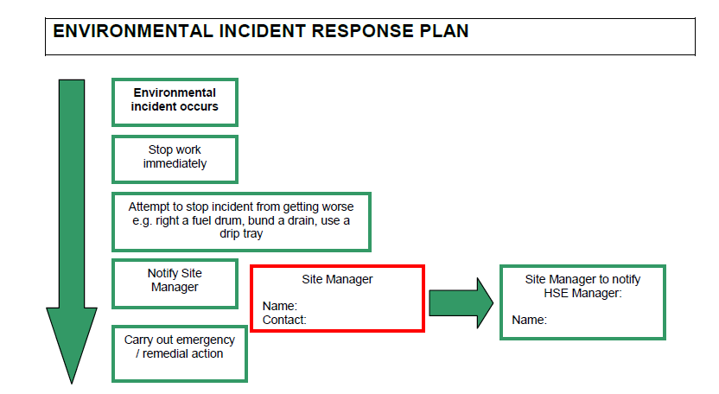

***Client and External Party Reporting***

The project progress report will be issued as and when required by the client.

***Project Monthly Reporting***

Monthly reports will be issued to the Director in charge who will collate and analyse the data, and feed back to the site team.

Environmental KPIs will be assessed weekly for the project. The KPi’s are related to the Project Targets.

EMERGENCY RESPONSE

The Environmental Emergency Response Controls are set out to:

• Establish the emergency response management procedure for the Liddell Road project.

• Outline the controls for any uncontrolled spillages or unforeseen emissions or events which effect 3rd Parties.

• State the measures applicable to the project under the requirements of company procedure

Emergency Preparedness.

• Ensure all project activities comply with applicable statutory United Kingdom and European Legislation, the Code of Construction Practice, and client requirements and statutory approvals.

Definitions

For the purpose of implementing the PEMP the following definitions apply.

***Minor/Incident***

An uncontrolled and unexpected release of a substance with the potential to pollute air, land and water resources but that can be contained and mitigated against using on-site equipment and personnel. After controlling this incident, inform the Environmental Manager.

***Intermediate/Incident***

An accident where the effects of the event cannot be controlled, e.g., discharge of large volume of silt, oil and fire water to river or large spillages of hazardous materials, and outside assistance from external bodies (Environment Agency) is required to bring it under control.

***Major/Incident***

A major accident may attract the interest of local press or environmental regulators, i.e., Environment Agency, Local Authority, Natural heritage, etc. It could have an adverse effect on the company name or a major financial impact.

Contact details for key site and emergency response personnel with responsibilities relating to the protection of the environment will be kept and publicised in key locations on site.

Key contacts will include:

• Contractor’s Project Manager

• Construction Manager

• Client Project Manager

• Environment Agency

Control Measures and Reporting

When an incident is able to be controlled by facilities on site, and no intervention is required from a third party or a statutory authority, controls should be implemented, the incident cleaned up and reported in the site diary. All incidents are being recorded.

Where an environmental incident occurs that has been dealt with in a manner which follows best practice and poses no further threat to the environment, an entry is made in the environmental incident log to record the issue. The environmental Non-Conformance/Incident Log will also be used to identify any trends in environmental incidents.

Where an uncontrolled incident is classed as an emergency or a major incident, the Director in charge of the Project may wish to investigate the root causes, communication systems and issue a “lessons learnt” memo to the workforce concerned in addition to any NCRs that may have been raised.

This procedure also relates to environmental emergencies relating to complaints raised from 3rd parties that involve the statutory authorities whereby the NCR process is being followed.

Summary of the Emergency arrangements for Environmental Incidents

|  |  |  |  |
| --- | --- | --- | --- |
| **Environment incidents** | Spills of diesel or other liquids including chemicals | • Locate the spill and try to stop it.  • Contain the spill – use spill kits materials (absorbent granules / booms), sand or drip tray  • Check the spill has not reached any drains or watercourse  • Report to management – details required are:  • Location  • What was spilled  • Whether it entered drains /  watercourses  • Clear up using spill kits  • Dispose of used spill kits as hazardous waste | **Emergency Service Contact**  LB Camden Council |
| Fly tipping of non- hazardous/hazardous waste | • Report to Director in Charge  • Details required are:  • Quantity  • Location i.e. risk of pollution of land or watercourses, or is obstructing or causing potential flooding in watercourses  • Do not touch waste and stay up-wind  • Do not disturb, as evidence of “fly-tipper”  may be lost  | **Emergency Service Contact**  LB Camden Council |
| Discovery of potentially contaminated land | • Stop excavation / piling / ground breaking works, immediately  • Report to management  • Fence off area  • Contact site environmental advisor and health and safety advisor  • The site environmental manager will contact a specialist to inspect the material | **Emergency Service Contact**  LB Camden Council |
| Discharge of silty water or other pollutants into a drain or watercourse | • Stop works immediately  • Stop pumps  • Report to Management  • Contain the discharge – build a bund, use spill kits  • Install a settlement tank or trap | **Emergency Service Contact**  LB Camden Council |
| Disturbing or damaging protected species and/or adjacent residents or stakeholders | • Stop works immediately  • Report to– Details required are:  • What/Who has been disturbed or damaged (resident/stakeholder/plant or animal)  • Where it occurred  • How it happened  • Fence off area | **Emergency Service Contact**  LB Camden Council |

|  |  |  |  |
| --- | --- | --- | --- |
|  | Discovery of items of conservation value (flora/fauna/heritage) | • Fence off the area as a “no go” zone and contact the site Manager or Project manager immediately for further action | **Emergency Service Contact**  LB Camden Council |
|  | Waste Contractor not submitting waste tickets and/or illegally disposing waste in an authorized facility | • Immediately contact contractor to establish reasons  • Hold all payments to contractor  • Request waste tickets for approved facility  • Notify local council where waste in being disposed | **Emergency Service Contact**  LB Camden Council |

# Agreement

The agreed contents of this Construction Management Plan must be complied with unless otherwise agreed in writing by the Council. This may require the CMP to be revised by the Developer and reapproved by the Council. The project manager shall work with the Council to review this Construction Management Plan if problems arise in relation to the construction of the development. Any future revised plan must be approved by the Council in writing and complied with thereafter.

It should be noted that any agreed Construction Management Plan does not prejudice further agreements that may be required such as road closures or hoarding licences.

**Please notify that council when you intend to start work on site. Please also notify the council when works are approximately 3 months from completion.**

**Signed:** …………………………………………………………………

**Date:** ……………………………………………..

**Print Name:** ……………………………………………………..….

**Position:** …………………………………………

Please submit to: [planningobligations@camden.gov.uk](mailto:planningobligations@camden.gov.uk)

End of form.