19th March 2018

Heritage Statement – South Villa, Vale of Health, London NW3 1AX.

South Villa is an early 19thC semi-detached house Grade II situated in the Vale of Health in Hampstead and is shown in Historic England’s entry summary as listed under the Planning (Listed Buildings and Conservation Areas) Act 1990, and was first listed on 14th May 1974. The list entry number is 137909, with location shown as North Villa and South Villa and attached railings and gates and the full description is shown as follows: -

*Semi-detached pair of houses with main frontage on west side. Early C19. Yellow stock brick. Stucco band at 1st floor level, cornice and blocking course. 3 storeys and semi-basements. 1 window each. Basement doorways with half glazed doors. South Villa with canopy carried on cast-iron columns. Architraved tripartite sashes, ground floor of North Villa with blind box. INTERIORS: not inspected. SUBSIDIARY FEATURES: attached cast-iron railings and gates with brick gateway piers.*

Mr & Mrs Wiese bought the house, as a family home, in a dilapidated state in 1983, and have renovated and modernised it to high standards over the past 35 years. They have carried out a number of alterations, listed below, but were unaware of the Grade II listed status of the house and the need to make an application for the works. This application is for retrospective Listed Building Consent for the works.

1983 - Removal of the wall between the dining room and kitchen on the first floor, see Photo D and marked-up ground plan. The dining room and kitchen retain the compartmentalisation of the front and rear rooms of the original house and the cornice, skirting and door casement details have been retained. The rooms function as two separate areas, with the opening between them slightly higher than the doorway to the stair landing, seen on the right of the photo. A Certificate of Completion was issued by The Building Control Department of LB Camden.

1990 - All the windows in the house, except the ground floor rear window (Photo C) were replaced on a ‘like for like’ basis in first grade softwood joinery with hardwood cills and fitted with 12mm double glazed units; the joinery is painted. The joinery matches the windows removed and complements the windows of North Villa which forms the other half of the pair of semi-detached houses. Although the windows on the front elevation of North Villa are ‘two over two’ corded box sashes, with the exception of the ground floor window (Photo G) we understand the original windows of South Villa were ‘one over one’ corded box sashes. The design and layout of the first, second and third floor front windows, with pairs of narrow sashes either side of a wider central, sash set within a single brick window opening surrounded by a moulded stucco frame, creates a harmonious composition to the elevation of the linked four storey houses. The addition of the thin double-glazed panes in the one over one sashes on the upper three floors does not detract from the composition or the detailing, retaining the harmony of the frontage (Photo A). The detail of the ground floor front window similarly respects the original design and layout. (Photo G).

The one over one layout of the box sash windows on the rear elevation and garage extension are of painted softwood joinery with hardwood cills and fitted with 12mm double glazed units. These windows replicate the original sashes. Although the windows at North Villa are of a different layout the openings are the same size and the addition of double glazed units in the new windows of South Villa is not noticeable and has no impact on the composition or look of the exterior of the listed houses.

2006 - Mr & Mrs Wiese removed a wall in the ground floor sitting room top open up between the front and rear parts of the house. The Building Control Department of LB Camden was involved in inspection of these works and a Certificate of Completion issued.

The work has been carried out to a high standard and sections of cornice and skirting fitted to match the adjacent mouldings where the wall was removed. (Photo E).

Mr & Mrs Wiese have lived in this house for 35 years and restored it to the high standards a Grade II listed house merits. They have respected the historic details of the house and ensured that the new work replicates the details of the original even though they were unaware of its listed status. We consider the works set out in this Statement merit the granting of Listed Building Consent retrospectively.

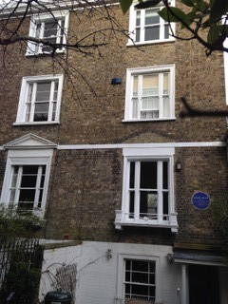

Photo A - Front elevation, with South Villa on the right of the photograph.

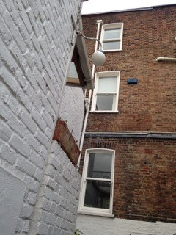

Photo B - Windows on the rear elevation and side wall of the garage block

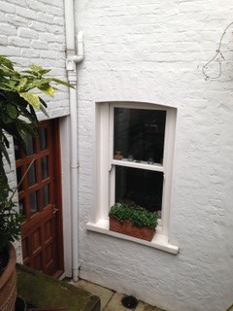

Photo C - Ground floor rear window

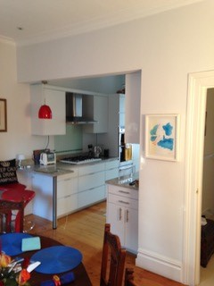

Photo D - First floor kitchen opening, with retained cornice and joinery details.

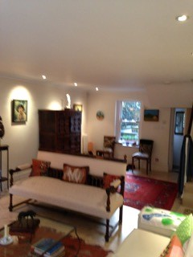

Photo E - Ground floor reception room view towards the rear.

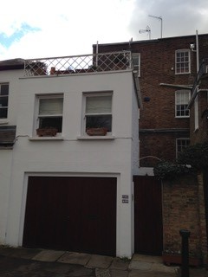

Photo F - Rear elevation of South Villa and white painted garage block. Rear windows of North Villa on the right of the photo.

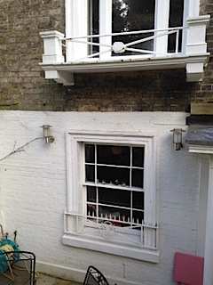

Photo G Ground floor front window detail