[Historic England](https://historicengland.org.uk/)

* [Menu](https://historicengland.org.uk/listing/the-list/list-entry/1379030)
* [Search](https://historicengland.org.uk/sitesearch)
* [Listing](https://historicengland.org.uk/listing/)
  + [Search the List](https://historicengland.org.uk/listing/the-list/)
  + [Enrich the List](https://historicengland.org.uk/listing/enrich-the-list/)
  + [Apply for Listing](https://historicengland.org.uk/listing/apply-for-listing/)
  + [What is Listing?](https://historicengland.org.uk/listing/what-is-designation/)
  + [Listing Guidance](https://historicengland.org.uk/listing/selection-criteria/)
* [Advice](https://historicengland.org.uk/advice/)
  + [Your Home](https://historicengland.org.uk/advice/your-home/)
  + [Planning](https://historicengland.org.uk/advice/planning/)
  + [Latest Advice & Guidance](https://historicengland.org.uk/advice/latest-guidance/)
  + [Caring for Heritage](https://historicengland.org.uk/advice/caring-for-heritage/)
  + [Technical Guidance](https://historicengland.org.uk/advice/technical-advice/)
  + [Heritage at Risk](https://historicengland.org.uk/advice/heritage-at-risk/)
  + [Constructive Conservation](https://historicengland.org.uk/advice/constructive-conservation/)
  + [Heritage Protection Guide](https://historicengland.org.uk/advice/hpg/)
* [Research](https://historicengland.org.uk/research/)
  + [Our Research Strategy and Agenda](https://historicengland.org.uk/research/agenda/)
  + [Research Methods](https://historicengland.org.uk/research/methods/)
  + [Current Research](https://historicengland.org.uk/research/current/)
  + [Research Results](https://historicengland.org.uk/research/research-results/)
  + [Support & Collaboration](https://historicengland.org.uk/research/support-and-collaboration/)
  + [Inclusive Heritage](https://historicengland.org.uk/research/inclusive-heritage/)
  + [Heritage Counts](https://historicengland.org.uk/research/heritage-counts/)
* [Images & Books](https://historicengland.org.uk/images-books/)
  + [Find Photos](https://historicengland.org.uk/images-books/photos/)
  + [Search All Publications](https://historicengland.org.uk/images-books/publications/)
  + [Buy Books](https://historicengland.org.uk/images-books/books/)
  + [The Historic England Archive](https://historicengland.org.uk/images-books/archive/)
  + [Be an Archive Detective](https://historicengland.org.uk/images-books/archive-mysteries/)
* [Services & Skills](https://historicengland.org.uk/services-skills/)
  + [Education](https://historicengland.org.uk/services-skills/education/)
  + [Grants](https://historicengland.org.uk/services-skills/grants/)
  + [Our Planning Services](https://historicengland.org.uk/services-skills/our-planning-services/)
  + [Training & Skills](https://historicengland.org.uk/services-skills/training-skills/)
  + [Archive Services](https://historicengland.org.uk/services-skills/archive-services/)
  + [Heritage Action Zones](https://historicengland.org.uk/services-skills/heritage-action-zones/)
* [Get Involved](https://historicengland.org.uk/get-involved/)
  + [100 Places](https://historicengland.org.uk/get-involved/100-places/)
  + [Support Us](https://historicengland.org.uk/get-involved/support-us/)
  + [Be a Volunteer](https://historicengland.org.uk/get-involved/volunteer/)
  + [Visit Your Heritage](https://historicengland.org.uk/get-involved/visit/)
  + [Protect Your Heritage](https://historicengland.org.uk/get-involved/protect/)
  + [Help Write History](https://historicengland.org.uk/get-involved/help-write-history/)
  + [Angel Awards](https://historicengland.org.uk/get-involved/angel-awards/)
* [What's New](https://historicengland.org.uk/whats-new/)
  + [News](https://historicengland.org.uk/whats-new/news/)
  + [In Your Area](https://historicengland.org.uk/whats-new/in-your-area/)
  + [Latest Listings](https://historicengland.org.uk/whats-new/listing/)
  + [Latest Research](https://historicengland.org.uk/whats-new/research/)
  + [Heritage Online Debate](https://historicengland.org.uk/whats-new/debate/)
  + [Statements](https://historicengland.org.uk/whats-new/statements/)
  + [Stay Up To Date](https://historicengland.org.uk/whats-new/stay-up-to-date/)
  + [50 Years of Conservation Areas](https://historicengland.org.uk/whats-new/conservation-areas-50-years/)
  + [First World War Centenary](https://historicengland.org.uk/whats-new/first-world-war-home-front/)
  + [What We Do](https://historicengland.org.uk/about/what-we-do/)
  + [Who We Are](https://historicengland.org.uk/about/who-we-are/)
  + [Jobs](https://historicengland.org.uk/about/jobs/)
  + [Contact Us](https://historicengland.org.uk/about/contact-us/)
  + [Volunteer with Historic England](https://historicengland.org.uk/about/volunteering/)
  + [Website Terms and Conditions](https://historicengland.org.uk/terms/website-terms-conditions/)
  + [Data Protection](https://historicengland.org.uk/terms/data-protection-information-charter/)
  + [Privacy and Cookies](https://historicengland.org.uk/terms/privacy-cookies/)
  + [Links Policy](https://historicengland.org.uk/terms/links-policy/)
  + [Historic England Blog and Social: House Rules](https://historicengland.org.uk/terms/blog-house-rules/)
  + [Photo Competition Terms and Conditions](https://historicengland.org.uk/terms/photo-competition-terms-conditions/)
  + [Angel Awards 2017 Voting Terms and Conditions](https://historicengland.org.uk/terms/angel-awards-voting-terms-and-conditions/)
* [Home](https://historicengland.org.uk/)
* [...](https://historicengland.org.uk/listing/the-list/list-entry/1379030)
* [Listing](https://historicengland.org.uk/listing/)
* [Search the List](https://historicengland.org.uk/listing/the-list/)
* List Entry

[This browser is not fully supported](https://www.historicengland.org.uk/access/) by Historic England. Please update your browser to the latest version so that you get the best from our website.

We use cookies to give you the best possible experience online. By using this website, you consent to cookies being used in accordance with our [Cookie Policy](https://historicengland.org.uk/terms/).

* + [Map Search](https://historicengland.org.uk/listing/the-list/map/)
  + [Advanced Search](https://historicengland.org.uk/listing/the-list/advanced/)
  + [Minor Amendments](https://historicengland.org.uk/listing/the-list/minor-amendments/)
  + [Download Listing Data](https://historicengland.org.uk/listing/the-list/data-downloads/)
  + [Non-Listed Sites](https://historicengland.org.uk/listing/the-list/non-listed-sites/)
  + [About The List](https://historicengland.org.uk/listing/the-list/about-the-list/)
  + [Enrich the List](https://historicengland.org.uk/listing/the-list/enrich/)
  + [Understanding List Entries](https://historicengland.org.uk/listing/the-list/understanding-list-entries/)

**GLEN HOUSE**

**List Entry Summary**

This building is listed under the Planning (Listed Buildings and Conservation Areas) Act 1990 as amended for its special architectural or historic interest.

Name: GLEN HOUSE

List entry Number: 1379030

**Location**

GLEN HOUSE, 200-208, TOTTENHAM COURT ROAD  
GLEN HOUSE, ALFRED MEWS

The building may lie within the boundary of more than one authority.

County: Greater London Authority

District: Camden

District Type: London Borough

Parish:

National Park: Not applicable to this List entry.

Grade: II

Date first listed: 11-Jan-1999

Date of most recent amendment: Not applicable to this List entry.

**Legacy System Information**

The contents of this record have been generated from a legacy data system.

Legacy System: LBS

UID: 478395

**Asset Groupings**

This list entry does not comprise part of an Asset Grouping. Asset Groupings are not part of the official record but are added later for information.

**List entry Description**

**Summary of Building**

Legacy Record - This information may be included in the List Entry Details.

**Reasons for Designation**

Legacy Record - This information may be included in the List Entry Details.

**History**

Legacy Record - This information may be included in the List Entry Details.

**Details**

CAMDEN  
  
TQ2981NE ALFRED MEWS 798-1/99/1641 Glen House   
  
GV II  
  
See under: Nos.200-208 Glen House TOTTENHAM COURT ROAD.   
  
  
  
CAMDEN  
  
TQ2981NE TOTTENHAM COURT ROAD 798-1/99/1641 (East side) Nos.200-208 (Consecutive) Glen House   
  
GV II  
  
Includes: Glen House ALFRED MEWS. Light industrial building, now offices. Southern half, Nos 204-8, 1913-14 by Hobden and Porri; northern half, Nos 200-3, built c1923 in fascimile by Ernest Souster. Originally built for the Bosch Magneto Co. Mannerist style. 5 storeys. 13 bays. Pillars with grooved panels and rectangular blocks flank ground floor openings. Upper floors have austere full height pilasters culminating in intricate Mannerist brackets supporting the parapet with geometrically patterned cast-iron railings flanked by stone dies. 1st to 3rd floor windows metal framed half-columns transom and mullion with enriched spandrel panels; 3rd floor under stone arched heads. 4th floor metal framed with stone half columns flanked by the brackets. Clock inscribed "Glen House" on elaborately enriched wall bracket at 1st floor level. Design continues on returns to Alfred Mews and Chenies Street; Alfred Mews facade with triple doorway of grooved pilasters. INTERIOR: not inspected.   
  
  
  
  
  
Listing NGR: TQ2955281849

**Selected Sources**

Legacy Record - This information may be included in the List Entry Details

National Grid Reference: TQ 29552 81849

**Map**

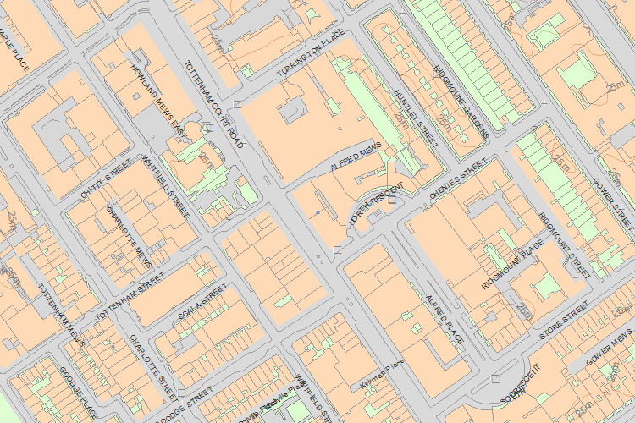© Crown Copyright and database right 2018. All rights reserved. Ordnance Survey Licence number 100024900.  
© British Crown and SeaZone Solutions Limited 2018. All rights reserved. Licence number 102006.006.  
Use of this data is subject to [Terms and Conditions](https://historicengland.org.uk/terms/website-terms-conditions/).

The above map is for quick reference purposes only and may not be to scale. For a copy of the full scale map, please see the attached PDF - [1379030 .pdf](http://mapservices.HistoricEngland.org.uk/printwebservicehle/StatutoryPrint.svc/341999/HLE_A4L_Grade%7CHLE_A3L_Grade.pdf)

The PDF will be generated from our live systems and may take a few minutes to download depending on how busy our servers are. We apologise for this delay.

This copy shows the entry on 12-Mar-2018 at 02:49:15.

End of official listing