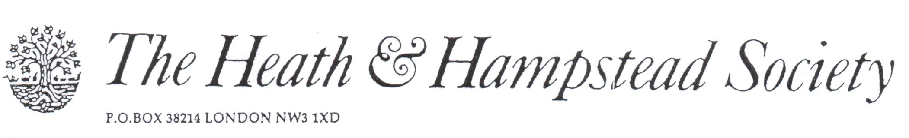
The Society examines all Planning Applications relating to Hampstead, and assesses them for their impact on conservation and on the local environment.

To London Borough of Camden, Development Control Team

Planning Ref: 2018/0512/P
Address: 4-4a Lindfield Gdns NW3
Description: Garden room
Case Officer: Tony Young Date: 9 March 2018

This proposal is described as an “outbuilding”: it is no such thing. It is an extensive building as large as a small house, occupying a large part of the ends of the two properties.

It seems to be designed as a joint office building, with shared facilities. It is unnecessarily high—about 4 metres overall—and significantly obtrusive. An area of paving reduces the extent of grass around it. At least one large tree would be lost.

Its use is said to be solely residential, but this is questionable; it looks to us that what the applicant really has in mind is Office use. If so, then a Change of Use application would be necessary, which we would oppose. This is a wholly residential area, and should remain so.

A clearly unsatisfactory application; please refuse.

