Design and access statement – Redundant fuel Store Demolition at Keats House

1. It is proposed that the redundant fuel store at Keats House is demolished and removed. The fuel store is no longer used and has fallen into disrepair, (please se Photographs 1, 2 & 3 below) it now represents an eyesore and potential health and safety risk.

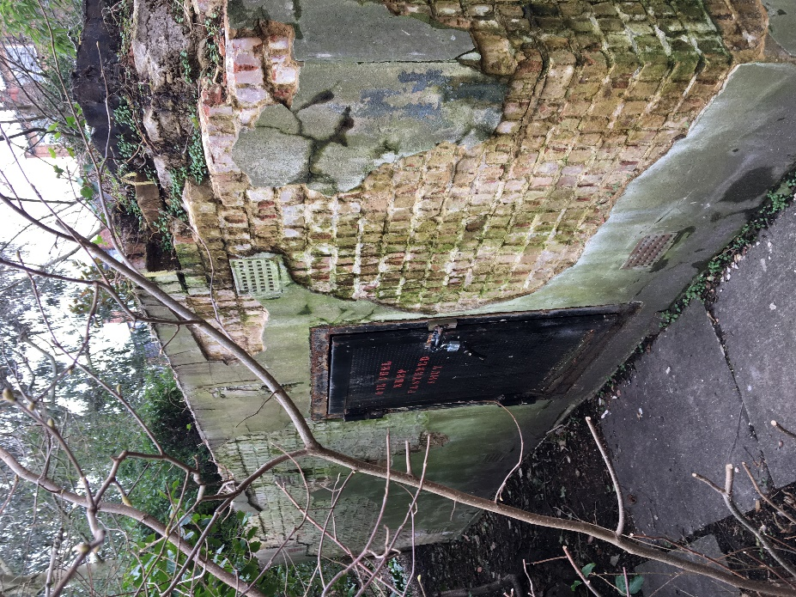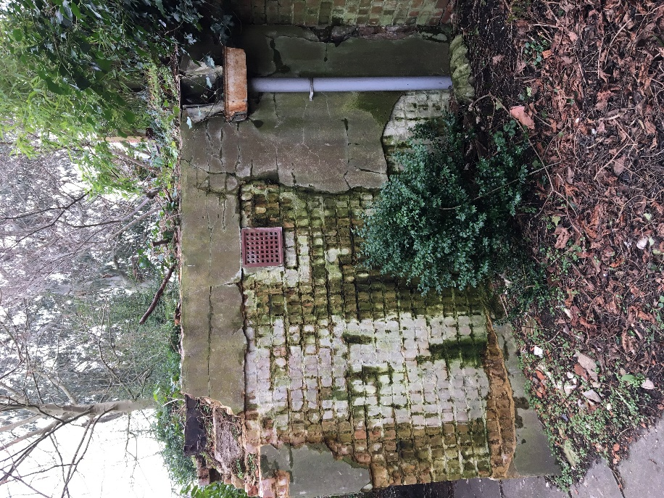

Photo 1: North Elevation of Fuel Store Photo 2 West Elevation of Fuel Store

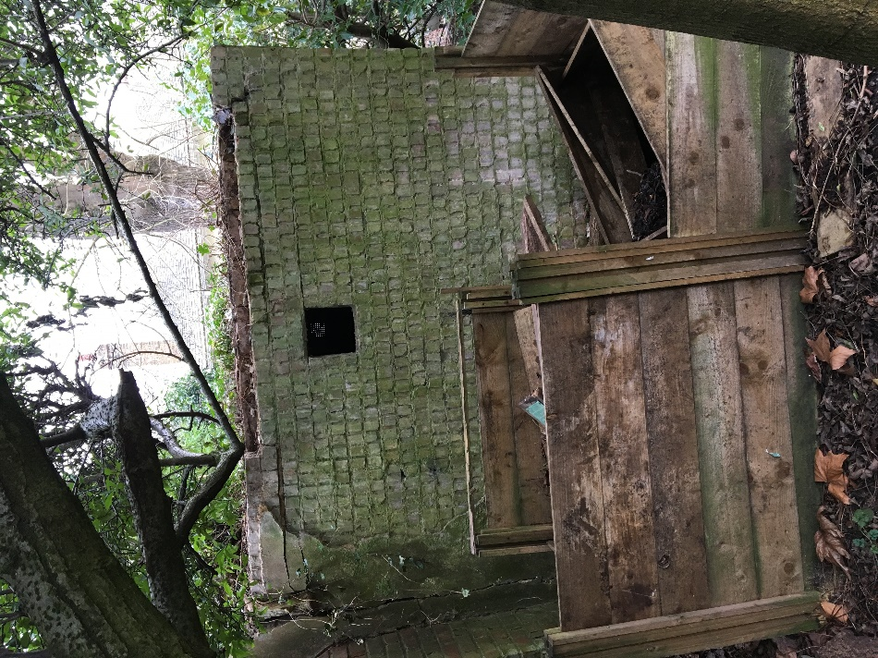

Photo 3 East Elevation of Fuel Store

1.1 A pre-demolition asbestos survey has been carried at the fuel store, this identified an asbestos containing durasteel door, this is programmed for removal before demolition works begin. The complete asbestos report has been included in the supporting document as part of this application.

1.2 A structural survey was carried out of the boundary wall that abuts the fuel store and the fuel store itself, this is also included as part of the supporting information to this application. Within this report a method for safely demolishing this fuel store was described (including drawings).

1.3 An access route has been agreed with the site occupants, the site route is approximated on the drawing attached to this application. The whole of this route will be closed off to the public for the duration of the works using Harris Fencing and kickboards. It is envisaged that wheelbarrows will be used to transport demolition material from the site of the fuel store to the skip that will be located on the lawn close to Keats Grove.

1.4 Ground protection will be provided to all areas of lawn and bedding that will be affected by the demolition (including the siting of the skip) by the ground staff of the Open Spaces Department. It has been agreed that all necessary replanting/reseeding of the area will be carried out following completion of the works.