**Garrett Apartments 56 58 Bartholomew Road NW5 2BF**

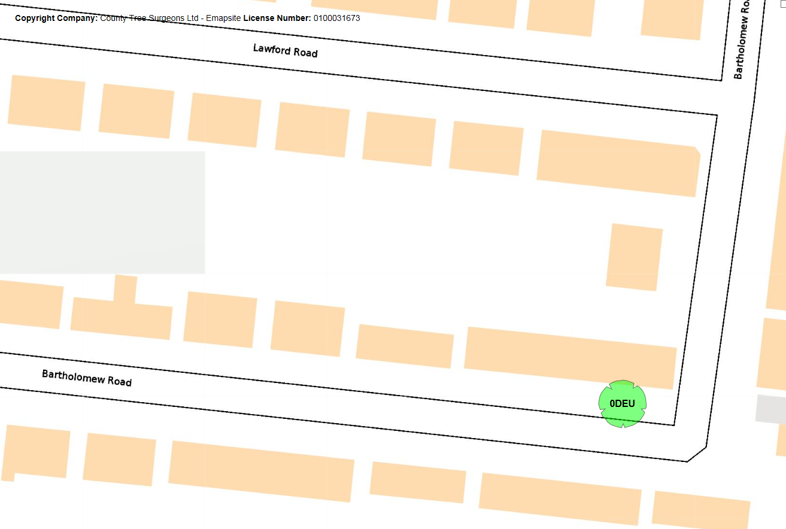



**Proposed works to reduce crown to previous and appropriate pruning points to maintain canopy size and mitigate encroachment issues**